Chapter 2 Arrays

Exercise 1:

WAP to write functions to perform the following operations:

1. insert()
2. del()
3. display()
4. reverse()
5. search()

Step 1: create an array arr that contains 5 ints

Step 2: The base address of this array is passed to functions like insert(), del(), display(), reverse() and search()

Step 3: The insert() function takes two arguments, the position pos at which the new number has to be inserted and the number num that has to be inserted:

Step 4: The del() function deletes the element present at the given position pos.

Step 5: In reverse(), we have to reverse the entire array by swapping the elements

Step 6: The search() function searches the array for the specified number.

Step 7: The display() function displays the elements of an array

Array: 11, 13, 14, 16, 1

Insert 444 in position 2: 11, 444, 13, 14, 16

Delete: del(arr, 5):11, 444, 13, 14, 0

Reverse: 0, 14, 13, 444, 11

Exercise 2:

WAP to Merge two arrays:

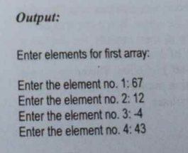

Exercise 3:

WAP to Add, multiply two arrays and display the transpose of the first array.

Output:

Exercise 4: More Matrix operations

1. For 3x3 matrix, take the elements, calculate the determinant, then display whether the matrix is singular or not(If the determinant is 0, then it is singular else not.), then determine if the matrix is orthogonal or not.

Output:  
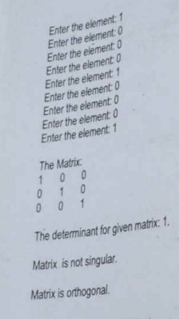

Exercise 5: Add two polynomials:

Exercise 6: Multiply two polynomials

15.Usually a polynomial is stored in an array with exponents of each term in decreasing order. Write a procedure to reverse this order, so that now the terms are arranged in increasing order.

