Q1 WAP to implement operations shown in the above table 4-1

After getting the above output, read below:

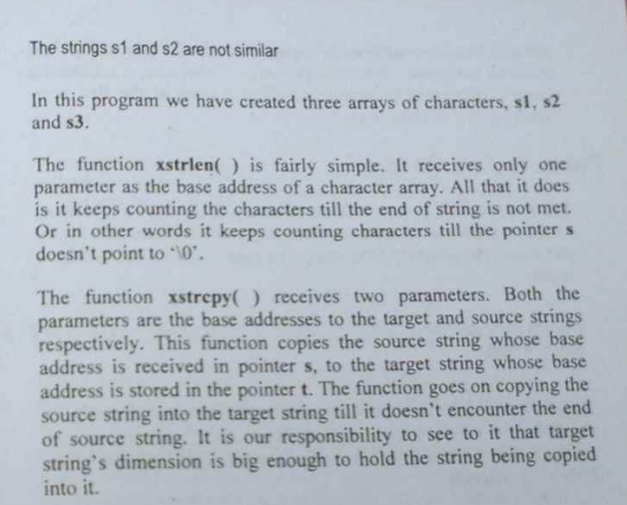

Q2 WAP to type your name and then check your name against a master list to see if you are worthy of entry to the palace.