**Problems and Questions**

**Chapter 3 Vectors**

**Questions**

1. Can the sum of the magnitudes of two vectors ever be equal to the magnitude of the sum of the same two vectors? If no, why not? If yes, when?
2. The two vectors shown in Fig. 3-21 lie in an xy plane. What are the signs of the x and y components, respectively, of (a) ~ + Ch, (b) ~ - Ch,and (c) Ch - ~?

1. Being part of the "Gators," the University of Florida golfing team must play on a putting green with an alligator pit. Figure 3-22 shows an overhead view of one putting challenge of the team; an xy coordinate system is superimposed. Team members must putt from the origin to the hole, which is at xy coordinates (8 m, 12 m), but they can putt the golf ball using only one or more of the following displacements, one or more times: -a: = (8 m)i + (6 m)], Ch = (6 m)], C4 = (8 m)i. The pit is at coordinates (8 m, 6 m). If a team member putts the ball

into or through the pit, the member is automatically transferred to Florida State University, the arch rival. What sequence of displacements should a team member use to avoid the pit?

1. Which of the arrangements of axes in Fig. 3-23 can be labeled "right-handed coordinate system"? As usual, each axis label indicates the positive side of the axis.

**Problems**

**Sec3-4 Components Of Vectors**

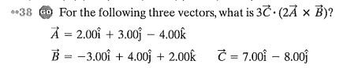

Additional Problems:



