***Gifted and Talented Language Arts 7A***

***Unit 2: Writing Informative Text Portfolio***

***Apollo 13 Mission: A “Successful Failure”***

***By Shandilya Nookala***

For the crew of Apollo 13, the dream of walking on the moon was close at hand. Command Module pilot, Ken Mattingly, was the first to have his dream shattered. Having been exposed to measles, Mattingly was disqualified from the flight. Apollo 13 took off on April 11, 1970. The launch went off without a hitch. The ship was headed for a region on the moon called Fra Mauro.

The Bust

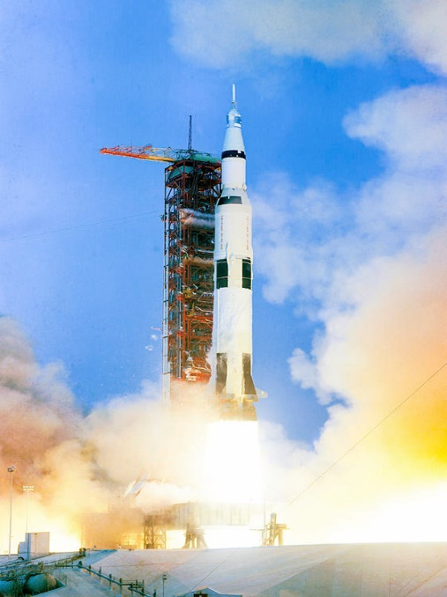

Apollo 13’s mission was to land on

the moon.

Americans watched a live broadcast of the astronauts headed for the moon. This primitive version of “reality TV” showed the astronauts floating weightlessly. The mission was on track for success. Only 9 minutes after astronaut James Lovell said “good night” to America, the Command and Service Module, called *Odyssey*, began its nightmare.

A sharp bang and vibration jolted the *Odyssey*. A explosion destroyed oxygen tank No. 2, and the remaining tank was quickly leaking its contents into space. The astronauts were in serious danger. Ground Control determined that the *Odyssey* had 15 minutes of power left.

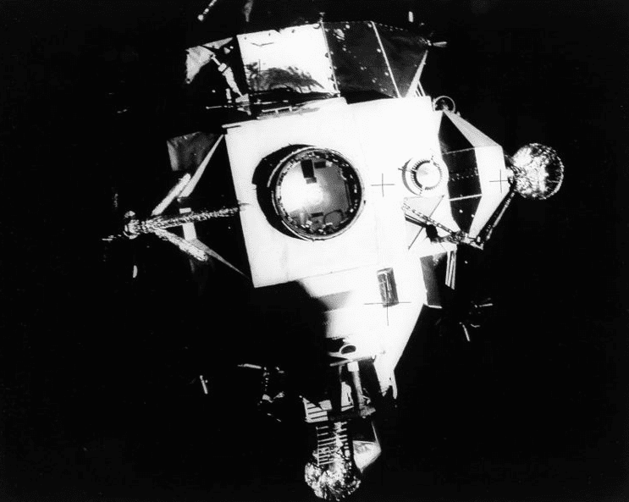

The Lunar Module *Aquarius*

The crew was forced to seek refuge in the Lunar Module, *Aquarius*. The *Aquarius* was attached to the Command and Service Module. It was designed for the men to use in the landing on the moon, not to support three men on their return to Earth.

The Plan

The astronauts had to conserve power, heat, and water to survive in the *Aquarius*. Meanwhile, Ground Control devised a plan to keep the men from dying of dangerous carbon dioxide poisoning. Using plastic bags, cardboard, and tape—all supplies that the astronauts had onboard—they fixed the problem just in time. The three astronauts were on their way home.

After the Fact

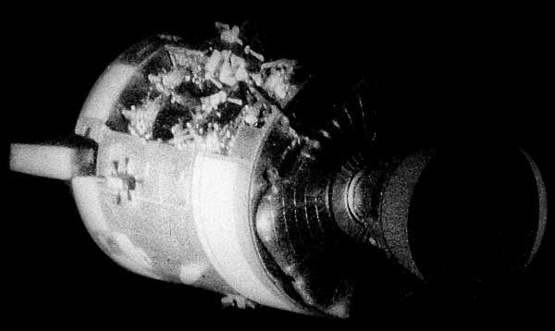

A whole panel of the Service Module section of *Odyssey* was blown

off in the explosion.

In spite of careful planning and precautions, one big error was overlooked. The faulty oxygen tank No. 2 had a history of failure. Due to a number of contributing factors, including a change in permissible voltage to the heaters in the oxygen tanks, tank No. 2 as a bomb waiting to go off. The big error almost cost the astronauts their lives. The mission was declared a “successful failure” because the astronauts survived.