Important events took place in the late 1800s and the early 1900s. They **impacted**, or had a strong effect on, how the United States expanded overseas. These events include the Monroe Doctrine, the Spanish-American War, and the Panama Canal.

The Monroe Doctrine

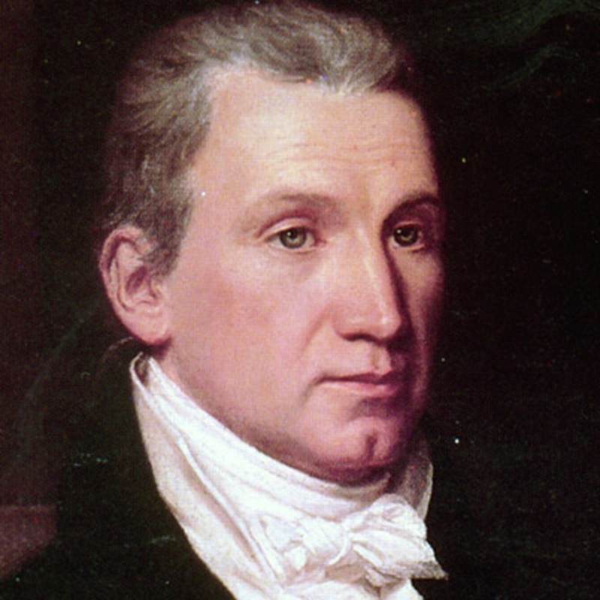

President James Monroe served until 1825. He is best remembered for the **Monroe Doctrine**. A doctrine is a policy. In his speech to Congress in 1823, Monroe warned European leaders not to get involved with North or South America. Monroe made it clear that the United States would not allow other countries to form colonies inside the United States. These ideas became known as the Monroe Doctrine. The doctrine reflected America’s desire to be more involved in North and South America. It also led the United States to look beyond its own borders.

The Spanish-American War

In the late 1800s, Cuba was under Spanish rule, but Cubans fought to be free. The United States supported Cuba because Americans did business with Cuba. American businesses had millions of dollars at risk. They used Cuban ports for trade.

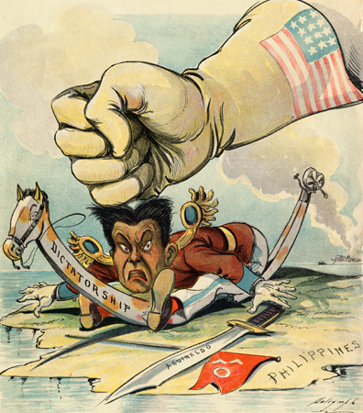

Americans were also upset about how Spain treated the Cuban people. American newspapers published stories that increased negative feelings toward Spain. The newspapers exaggerated facts. This practice came to be known as **yellow journalism**.

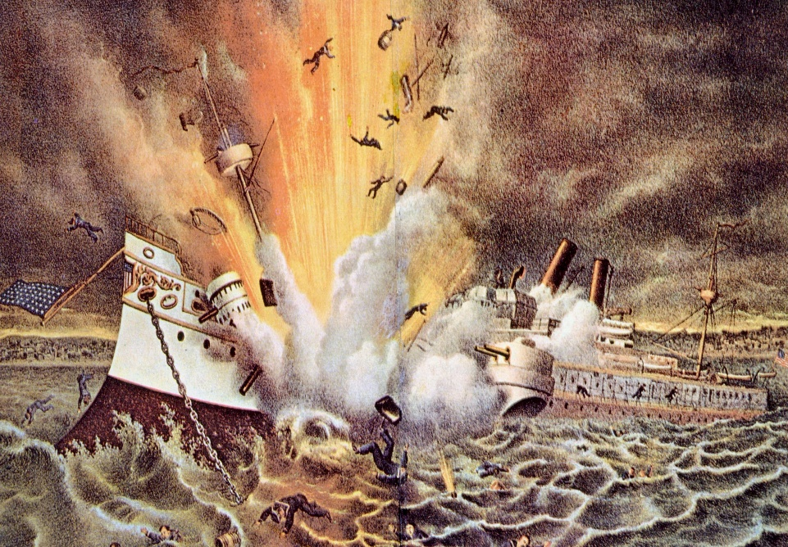

Congress wanted to declare war. President William McKinley did not want war. Instead, the U.S. sent a battleship to protect businesses owned by Americans. It was called the USS *Maine*. The USS *Maine* arrived in Havana, Cuba at the end of 1897. On February 15, 1898, the ship exploded and sank. Many men aboard the ship died. The newspapers blamed Spain. In April, the war between the U.S. and Spain began.

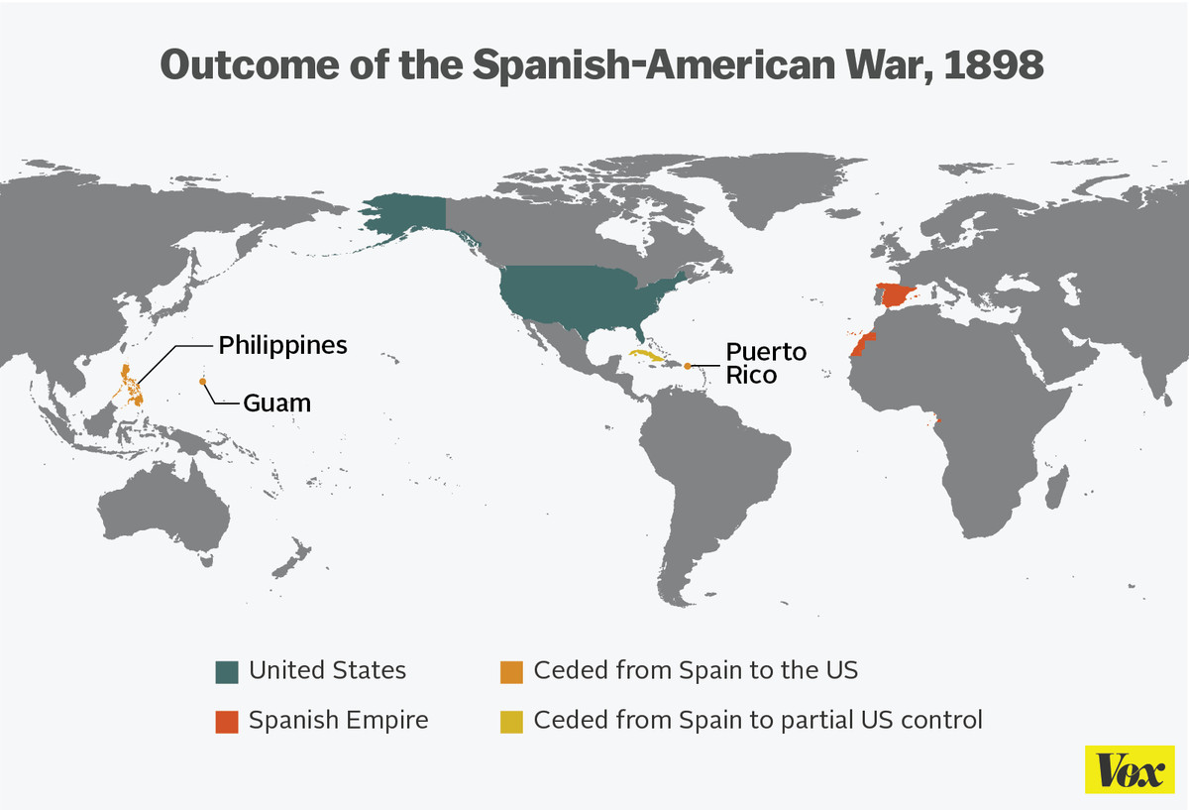 Soon after, an agreement to stop fighting was signed, and the fighting ended. As a result of the war, Spain gave up claims to Cuba. The war protected the Cuban trade ports that Americans relied on for global trade. The United States also **annexed**, or added, Guam, Puerto Rico, and the Philippines. The location of the Philippines would help the United States pursue trade in Asia and Europe.

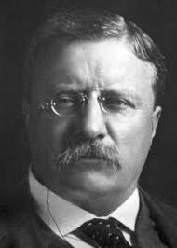

Theodore Roosevelt was the assistant secretary of the navy in the Spanish-American War. He came home from Cuba a war hero. During the war, ships had to sail around the tip of South America. They had to sail through the dangerous Cape Horn. From his time in the war, Roosevelt saw that the United States needed a better route between the Pacific and Atlantic Oceans.

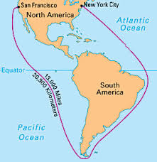

Route Ships Had to Take from East to West Coast Before Panama Canal

When Roosevelt became president in 1901, he pushed the country to build a canal. He believed it would help both the military and trade. The U.S. traded **raw materials** with countries all over the world. A raw material is a basic material used to make a finished product. For example, timber is used to make furniture and houses. The United States also traded finished products with other countries. American businesses wanted faster shipping routes. They wanted to save time and money.

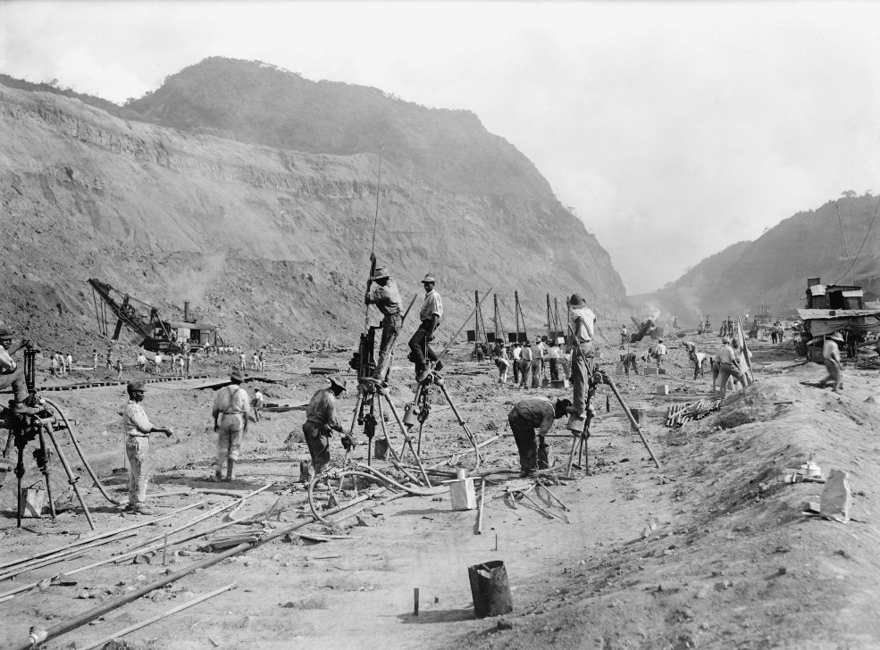

France had started to build the canal across the **Isthmus** of Panama but stopped. An isthmus is a narrow stretch of land with water on both sides. It connects two larger pieces of land. Roosevelt oversaw the purchase of the unfinished canal from France. Work started in 1904.

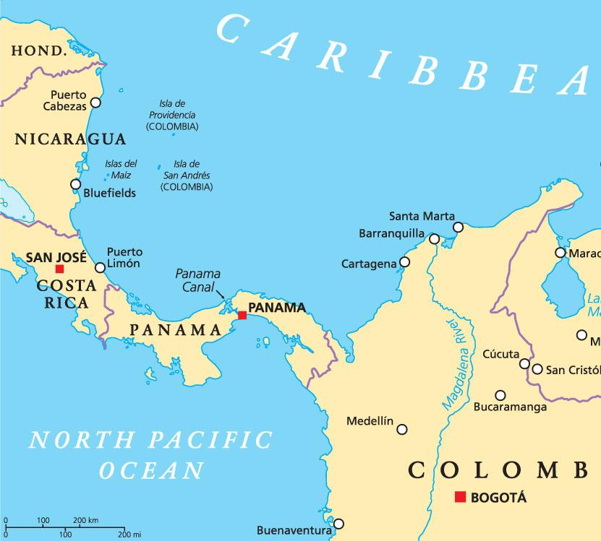

The canal was completed after a decade and opened in 1914. Travel became safer, faster, and cheaper. Ships could avoid sailing all the way around South America. Travel was cut by 5,000 miles. As a result, the Panama Canal increased **global**, or worldwide, trade.