The Constitutional Convention​

In 1787, **delegates**, or representatives, from twelve states met to write a new plan of government. These delegates included George Washington, Benjamin Franklin, James Madison, and Alexander Hamilton. This Constitutional Convention met in Philadelphia. They wrote the US Constitution. The delegates had many problems to solve. They often disagreed. They had to make **compromises**. Neither side got everything it wanted. Both sides had to give up a little to come to an agreement.

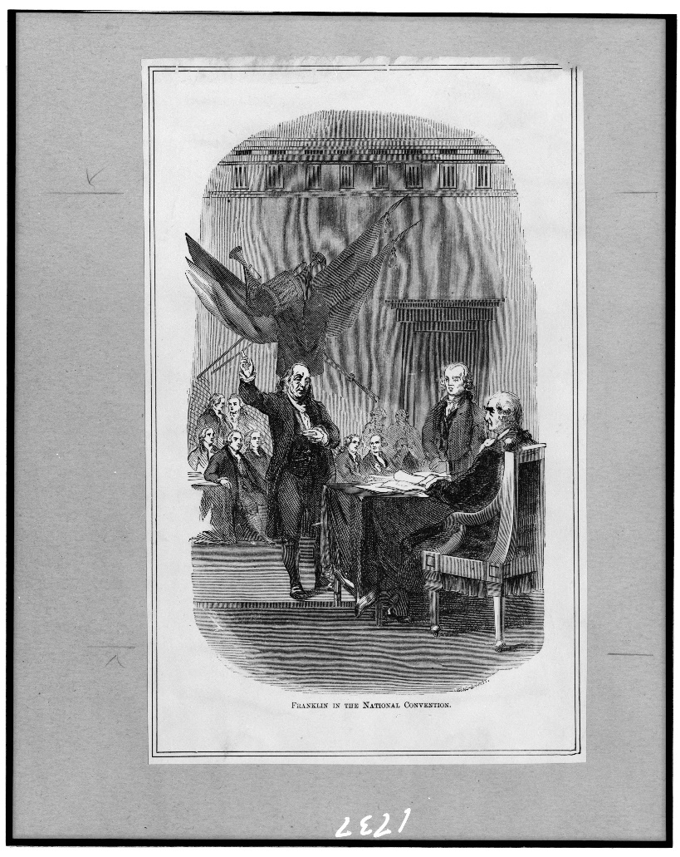

​Ben Franklin represented Pennsylvania, a northern state, at the Constitutional Convention.​

​​​The Question of Representation​

The delegates talked about representation in government. States with large populations favored the Virginia Plan, proposed by James Madison of Virginia. The Virginia plan stated the larger the population, the more representatives that state should have in government. States with small populations favored the New Jersey Plan, proposed by William Paterson of New Jersey. It proposed equal representation for every state.

​​​The problem was solved by the delegates from Connecticut, specifically, Roger Sherman. It became known as the Connecticut Compromise or the Great Compromise. These delegates proposed a legislature with two houses. In the Senate, every state would have an equal number of representatives. In the House of Representatives, representation would be based on population. This way, both types of representation had a place in the US government.

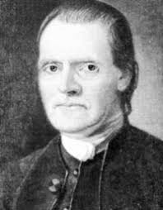

​​​The Question of Slavery​

Northern states were against slavery. Southern states were pro-slavery. This caused several problems at the Constitutional Convention. Delegates from the North wanted the Constitution to outlaw slavery. Delegates from the South thought slavery should be a state issue. The two sides agreed Congress could begin regulating slavery in 1808.

Another problem arose over how to count slave populations. Southern states had many slaves. Their delegates wanted slaves counted as part of the population. This would give them more representatives in government. Northern delegates argued that since slaves weren’t citizens, they shouldn’t be counted. The two sides came to an agreement. Three-fifths of a state’s slave population could count toward its representation. This became known as the Three-Fifths Compromise.

​​​The Question of Trade and Taxes​

In 1787, the North was more industrialized than the South. The North produced many finished goods. The South produced raw agricultural materials. It got many of its finished goods from Britain. Delegates from the North wanted Congress to tax imports on goods from other countries. This would encourage the South to get more of their goods from the North. The northern delegates also wanted Congress to tax exports from the South to other nations. This would bring more money into the US. Of course, delegates from the South didn’t like either of these proposed taxes. In the end, the Convention approved one of the taxes. Congress could tax imports from other countries. It couldn’t tax exports from the US.

​​​The Question of Ratification​

Each state had to vote on the Constitution for it to be **ratified**, or approved. The delegates agreed if nine or more states ratified it, the Constitution would take effect. In the end, two states refused to ratify it. North Carolina and Rhode Island refused to ratify the Constitution until it included a Bill of Rights. With eleven states’ approval, the Constitution was approved on June 21, 1788. Later, a Bill of Rights was added. Then all states ratified the Constitution.

The Constitution has a Preamble, or an introduction, that starts with the words “We the People.” The delegates wrote this to enforce that the American people, not the states, were in charge of creating and maintaining the government.

