Battles of Lexington and Concord

Colonial leaders Samuel Adams and John Hancock lived in the Boston area. British General Thomas Gage planned to arrest them, but the American colonists found out. Paul Revere rode from Boston to Lexington, Massachusetts, to warn Adams and Hancock on April 18, 1775. Revere also warned colonists along the way that the British were coming to steal weapons and gunpowder.

On April 19, 1775, people fought against the British for the first time in the **Battles of Lexington and Concord**. These battles started the American Revolution. American soldiers surprised the British first at Lexington and then at Concord. Though both sides lost soldiers, these battles were a major win for the colonists.

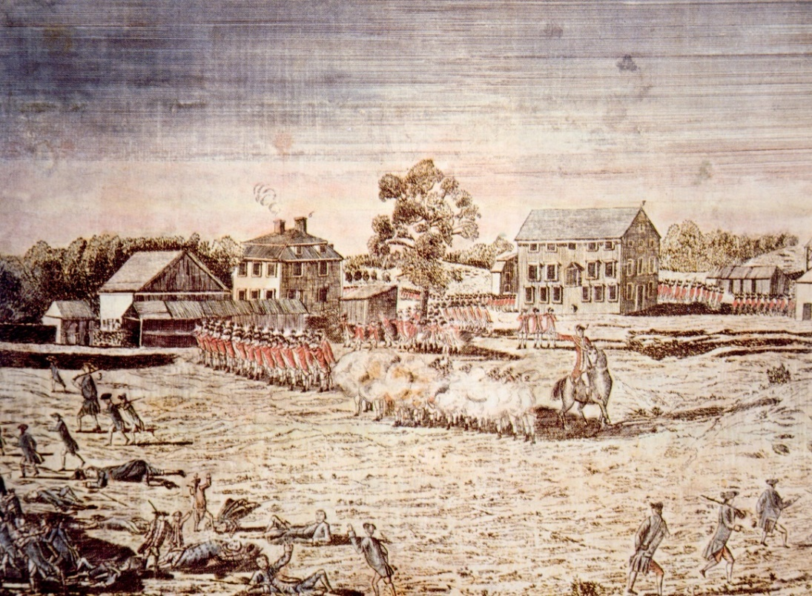

After shots were fired in the small town of Lexington, the British moved on to Concord, Massachusetts, to destroy American supplies.

Battle of Bunker Hill

After the Battles of Lexington and Concord, Colonel William Prescott led American troops to protect the hills around Boston. The troops were supposed to build trenches and walls on top of Bunker Hill. Instead, they built up Breed’s Hill, which was smaller and closer to Boston.

On June 17, 1775, while troops were still building up the hill, the British charged. This started the **Battle of Bunker Hill**. It was one of the most violent battles in the American Revolution. The British soldiers were well-trained, but about half of their 2,000 men were killed or wounded. The Americans were doing well until they ran out of ammunition.

Though the British captured the hill, it was at a great cost. They ended up leaving Boston. The American troops had proven that they were willing to fight hard to defeat the British. After the Battle of Bunker Hill, King George III of England issued a Proclamation of Rebellion in August of 1775. It was a declaration of war against the colonists.

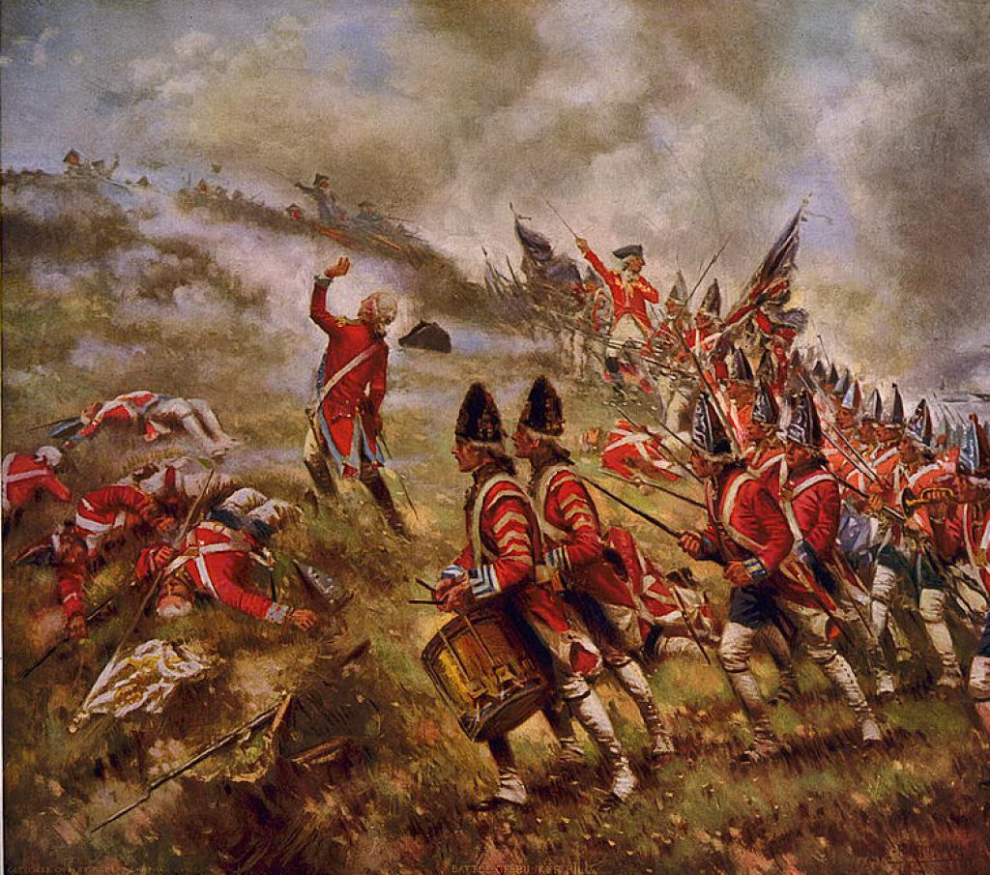 British soldiers marching up Bunker Hill

The Battle of Saratoga

Fought in 1777, the **Battle of Saratoga** was a turning point in the Revolutionary War. This battle was made up of two parts. The first was fought on September 19 on an abandoned farm. The Americans were forced back, but the British lost twice as many men.

The second battle happened in October just over two weeks later. American troops had grown, and the British were running out of supplies while they waited for reinforcements. Under General Horatio Gates, the American army surrounded the British. They stopped the British from taking over northern New York and the Hudson River.

On October 17, British General John Burgoyne surrendered his army. The American’s strong victory in the second battle encouraged the troops. The Continental Army’s performance also convinced the Dutch, Spanish, and French to join the Americans against the British. The French even sent money and soldiers to the Continental Army to help them win.

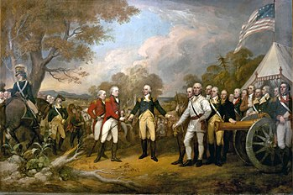 Surrender at the Battle of Saratoga

The Battle of Yorktown

Another major battle happened in Yorktown, Virginia, in 1781. It was called the **Battle of Yorktown**. This battle ended the fighting of the Revolutionary War in the American colonies. George Washington and over 14,000 French and Continental troops defeated British General Charles Cornwallis and his 9,000 troops.

This battle was fought both on land and sea. It lasted three weeks. While the French guarded the sea, the American troops attacked over land. The French and Americans also had plenty of ammunition, cannons and other heavy weapons, and the support of the warships. Working together, Washington and his French ally, General Rochambeau were able to force Cornwallis to surrender. This victory ended the fighting of the American Revolution in the American colonies.

When Cornwallis surrendered on October 19, 1781, the last major battle of the Revolutionary War ended. The victory brought American colonies a giant step closer to freedom. In 1782, Peace Treaty talks began in Paris.

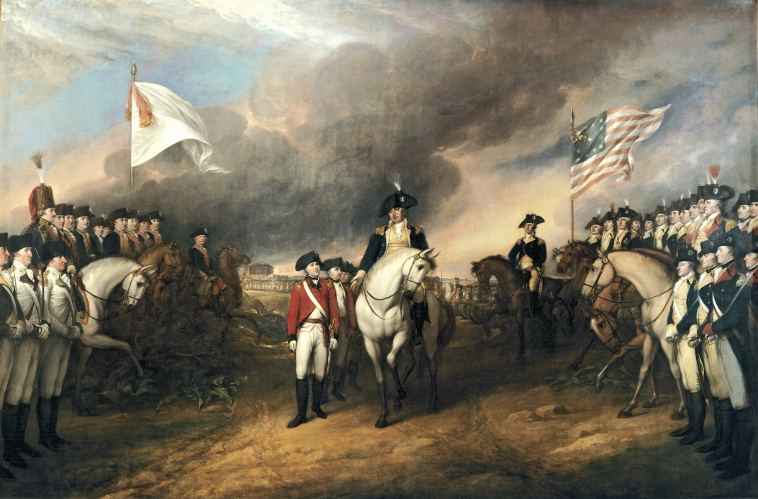 General Cornwallis surrendered to General Washington at Yorktown, Virginia. American and French troops worked together to trap the British army by land and sea.

George Washington, Nathanael Greene, and General Rochambeau

Meanwhile in Philadelphia, the Continental Congress quickly met and began to organize the Continental Army. Many people know **George Washington** was the first United States president, but he was also the first Commander-in-Chief of the Continental Army. The Continental Congress appointed him on June 15, 1775. Washington had fought in the French and Indian War. He had also served the First Continental Congress in 1774. He had strong leadership skills and knew how to motivate people and bring them together. On July 3, 1775, Washington went to Cambridge, Massachusetts to take charge of the American army.

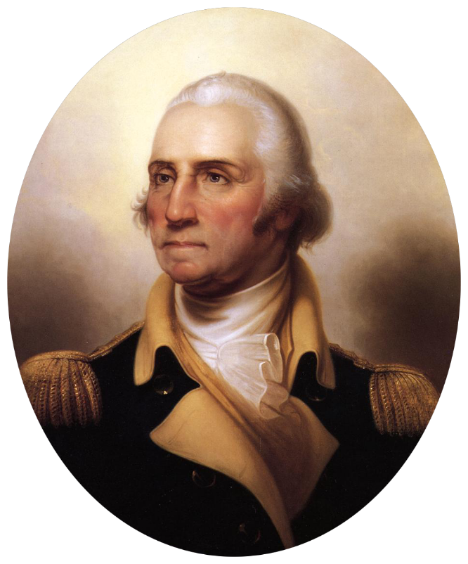

George Washington

Another important person in the American Revolution was **Nathanael Greene**. He served with George Washington in Boston. Washington made Greene a major general in 1776. Before that, Greene was the youngest brigadier general in the Continental Army. He played an important role in many battles throughout the Revolutionary War. He was innovative. He had his men live off the land rather than only rely on the delivery of supplies. He also organized his troops into two groups. This allowed his troops to move quickly and easily. The British army depended on supply lines. They couldn’t move until they had the supplies they needed. People were always attacking the supply lines which led to delays and shortages.

Washington was impressed with Greene’s military talent. The two men stayed friends for life. Greene was known for his strategic and leadership skills. Washington appointed him quartermaster general on March 2, 1778. Greene became responsible for the transportation, food, and supplies of the Continental Army.

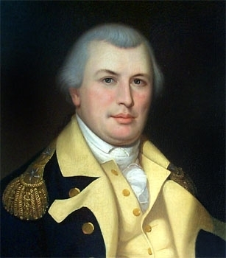 Nathanael Greene

In 1781, Washington wanted to march toward New York and attack the British there. His French ally, General Rochambeau, convinced Washington to attack British General Cornwallis at Yorktown, Virginia, instead. Rochambeau was older and had a lot of battle experience. Washington didn’t speak French, and Rochambeau was just learning English. The two leaders found a new way to communicate. They used translators or they spoke in Latin!

Rochambeau and Washington used a creative approach to plan attacks on the British. They decided to use both land and sea resources to trap the British. French Admiral de Grasse had twenty-four warships. He kept the British from escaping. He also stopped supplies from coming in. This would help the British from getting more ammunition.

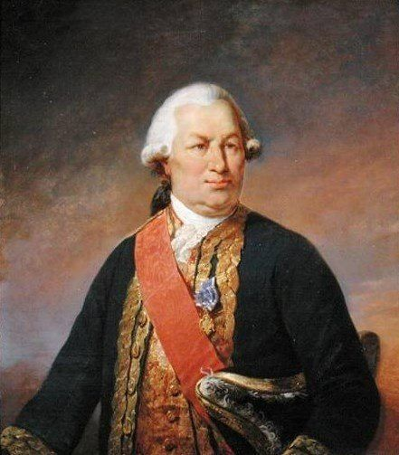

General Rochambeau