K-9 Search and Rescue Dog

If you ever saw an Australian shepherd puppy, you might say, “That’s the cutest puppy in the world!” You would want to hold him and rub his soft tummy. You might take him home. You would care for him, train him, and play with him.

Soon, he would know his name. He would follow commands. With some coaxing, he might find a hidden toy. Then, you would give him treats. In the end, you would have a wonderful pet. The professional word for cuddling and playing with your puppy is “socialization.”

K-9 search and rescue team dogs are trained in these ways. But they are also given extra training by their handlers. Together, they solve crimes and save lives. Many of these dogs are rescued from shelters. Others are raised as puppies to do this special job. Their training is serious business. It is a challenge to finish it. Hard work is required for both the dog and its handler.

Dogs can do work that humans cannot do. Because of their incredible sense of smell, they have long been used to find lost people. They are also small enough to squeeze into tight places like ruined buildings.

These dogs have to be calm around humans. They have to obey their handlers in dangerous situations. Fetching a ball is important. It teaches a dog to find something that is lost.

You have probably seen dogs sweeping their heads back and forth. Their noses spread open to pick up scents. This is called “air-scenting.” Other dogs do “ground-scenting.” They sweep their noses along the ground to find a scent. A piece of clothing from a missing person is all a dog needs. It will follow tiny clues left behind. Dogs also have the ability to do “odorlayering.” They can pick out and follow dozens of different smells. This helps in a disaster like an earthquake. Dogs use their noses to sniff out trapped victims and find people deep in the foundation of a fallen building.

K-9 teams also work with fire departments. They are trained to smell traces of fuels like gasoline. They can help find the cause of a fire. This helps firefighters tell if it was started on purpose. These brave dogs also help find people trapped inside burning buildings.

The next time you see a cute puppy, don’t just pet him. Think about all the extraordinary ways dogs help humans. They are truly our best friends.

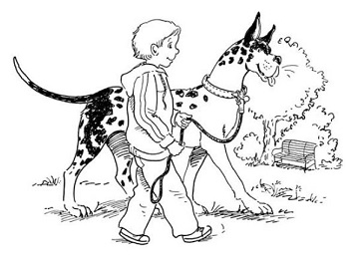

1. Which statements describe the author's view about regular dog training? Pick **two** choices.

* 

A.

It is not necessary for every dog.

* 

B.

It will make dogs into wonderful pets.

* 

C.

It will result in a search-and-rescue dog.

* 

D.

It will help people enjoy their dogs more.

* 

E.

It is not done that often by most dog owners.

* 

F.

It will be difficult because dogs do not listen well.

The Ideal Basketball Team

Most people think a basketball team needs one tall player to score all the points. It never hurts to have a superstar. But the great teams succeed because they have a variety of players.

Only five players are allowed on the court at a time. Each of these teammates has a role. Different players have different talents. A good team works together, and all these talents come together at just the right moment.

Teams need at least one tall player. This player rebounds the ball. He grabs the ball when someone misses. Without tall players, or a big jumper, the other team will get all the rebounds. This tall player is usually the center. This player roams around in the center near the basket.

The next key player is called a point guard. The point guard has a big job that involves the responsibility of controlling the game. He must dribble well. Then no one can take the ball away. Another player is the guard. He plays far from the basket and passes the ball to players near the net.

The two other players are shooters. They can be a guard who shoots long shots. They can also be a tall player who plays closer to the basket. He is called a forward. His job is to put the ball in the basket. Forwards are fast. They are tremendous jumpers who can also dribble well. They move easily to the basket to get easier shots.

Some of the best basketball teams win almost every game they play. They have great players in every position, but they also play good defense. They have stars, but the players work together. They make winning look easy because of their great talents.

Every position on a team is hard. A huge center may be tall, but he gets hit a lot under the basket. Quick guards have to run fast throughout the game. Forwards have to do some of what guards and centers do. On the best teams, the players can play any position and they all work well together.

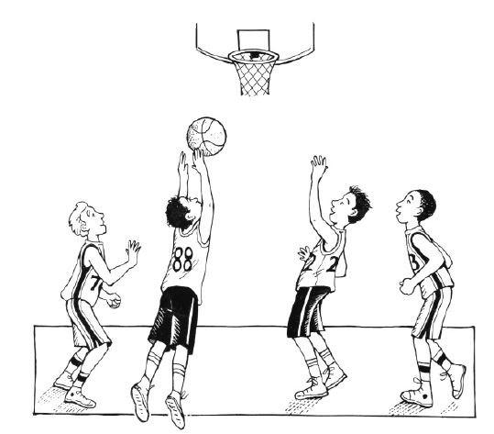

1. This question has two parts. First, answer Part A. Then, answer Part B.

**Part A**

Read the sentences from the article.

Forwards are fast. They are **tremendous** jumpers who can also dribble well.

What does **tremendous** mean in the sentences?

* 

A.

great

* 

B.

normal

* 

C.

slow

* 

D.

smart

**Part B**

Which word from the sentences helps to show what **tremendous** means?

* 

A.

forwards

* 

B.

fast

* 

C.

jumpers

* 

D.

dribble

1. This question has two parts. First, answer Part A. Then, answer Part B.

### Part A

Which sentence best describes the main idea of the article?

* 

A.

One player has to shoot the ball well and score.

* 

B.

Each player on the court has only one job to do.

* 

C.

A good basketball team plays together and wins.

* 

D.

Most basketball teams have only five good players.

### Part B

Which sentence from the article **best** states the main idea?

* 

A.

"Most people think a basketball team needs one tall player to score all the points."

* 

B.

"A good team works together, and all these talents come together at just the right moment."

* 

C.

"Without tall players, or a big jumper, the other team will get all the rebounds."

* 

D.

"They make winning look easy because of their great talents."

1. Organize the similarities and differences between the key points in “The Ideal Basketball Team” and “K-9 Search and Rescue Dogs.”

* **Dogs have special skills that let them do things people can’t.**
* **A team or partnership with many different skills is more successful than just one person by him- or herself.**
* **There are five different players on the court during a basketball game.**
* **“K-9 Search and Rescue Dogs”**
* **“The Ideal Basketball Team”**
* **both**

1. Select the correctly spelled word in each sentence.

Do you remember the number of problums we have to complete?

That felow does not follow directions well.

We keep our rabbit in a hutch and our chickken in a coop.

1. Choose the correct verb form in each sentence.

My big sister does many tasks to help our family. She   her own bed every morning. She   out little sister to the sitter. After supper, she   the dishes and helps us   ready for bed.

1. Use the drop-down menus to select the correct vocabulary word in each sentence.

The   of the speech was to convince us to vote.

Our sports   was loaded into a van.

Not every forest fire turns out to be  .

1. Which words have the same root word? Select the **three** correct choices.

* 

A.

active

* 

B.

basket

* 

C.

react

* 

D.

sack

* 

E.

action

* 

F.

Straight