***Moby Dick***

***Chapter 11 –Nightgown***

***Summary:***

* Ishmael and Queequeg lie in bed talking and napping. Ishmael tells us that Queequeg is "now and then affectionately throwing his brown tattooed legs over [his]" (11.1).
* Before dawn, they’re ready to get up, but it’s still very cold, so they sit up in bed still snuggled under the covers.
* Ishmael opens his eyes (he’s been keeping them closed to enjoy snuggling down in the warm bed) and is irritated by the fact that it’s still dark.
* They light a lamp and share a pipe—apparently, Ishmael no longer objects to Queequeg smoking in bed.
* While they sit there, Queequeg tells Ishmael about his homeland and history (see the next chapter).

***Brief Analysis:***

Queequeg and Ishmael awaken in the middle of the night. It is cold and the warmth of the bed and of their companionship is pleasant. They share a smoke, and Queequeg begins to recount his life story.

***Detailed Summary:***

Queequeg and Ishmael lie in bed, napping at short intervals and often chatting. Upon opening his eyes, Ishmael finds that his strong repugnance to Queequeg smoking in bed begins to fade, for he now likes nothing better to have him smoking because he seems to full of serene household joy.

Melville continues to show the intense bond between Queequeg and Ishmael in this chapter, further continuing the analogy of marriage to demonstrate how Ishmael has become progressively more tolerant toward Queequeg. This also suggests that Ishmael longs for a domestic life that he lacks as sailor, appreciating the intimacy that he shares with Queequeg as a replacement for a conventional household life.

***Significance:***

The more so, I say, because truly to enjoy bodily warmth, some small part of you must be cold, for there is no quality in this world that is not what it is merely by contrast. Nothing exists in itself. If you flatter yourself that you are all over comfortable, and have been so a long time, then you cannot be said to be comfortable any more. This is a philosophical expression of a physical phenomenon. If your house is set to 70° F year round, it will feel warm when you come in from outside in the winter, and cool in the summer. But it goes further than this, because Ishmael is also saying that one cannot appreciate what one has until one experiences its lack. Does anyone in a developed country appreciate electricity (and its corollaries, such as a hot meal and a hot shower) so much as when it returns after a one-week outage? The situation Ishmael describes is one in which one can have the benefits of a creature comfort simultaneously with the reminder of what one would miss without it.

"Because no man can ever feel his own identity aright except his eyes be closed; as if darkness were indeed the proper element of our essences, though light be more congenial to our clayey part." Melville returns again to the contrast of light and darkness, and again he prefers darkness to light.

"Be it said, that though I had felt such a strong repugnance to his smoking in the bed the night before, yet see how elastic our stiff prejudices grow when love once comes to bend them. For now I liked nothing better than to have Queequeg smoking by me, even in bed, because he seemed to be full of such serene household joy then." What Ishmael is expressing is more than the love (a.k.a. "charity") of I Corinthians: "Love suffereth long, and is kind; ... Beareth all things, believeth all things, hopeth all things, endureth all things. [I Corinthians 13:4,7] Ishmael does not endure Queequeg's smoking, or bear it, but actually wants it and enjoys it. He does not, as it were, "close his eyes and think of England."

***Critical Study:***

Ishmael and Queequeg lay in bed chatting and napping at intervals, their legs crossed over each other—[#bromance](https://chasingflukes.com/reading_guide-overview/chapter_summaries-home/chapter-summaries-part1/#bosom-friend)—“so entirely sociable and free”—they sit up, awake before morning—”the clothes well tucked around us […] with [our four knees drawn up close together, and our two noses bending over them, as if our knee-pans were warming-pans](https://chasingflukes.com/reading_guide/glossary/11warming-pan/)“—it takes some part of the body being cold for the whole to appreciate genuine warmth—Ishmael likes to keep his eyes closed—the self-imposed darkness helps him understand his comfort—Ishmael realizes he is now comfortable with Queequeg smoking in bed—“strange what love can make you comfortable with”—Queequeg relates his personal history.

***Critical Analysis:***

# **“OUR FOUR KNEES DRAWN UP CLOSE TOGETHER, AND OUR TWO NOSES BENDING OVER THEM, AS IF OUR KNEE-PANS WERE WARMING-PANS”**

The title of Chapter 11 of Moby-Dick, “Nightgown,” does not refer to Ishmael’s or Queequeg’s pajamas, but rather to the cold enveloping the pair’s bodies as they pass their second night together at the Spouter-Inn in New Bedford. Indeed, most of the point of this chapter, besides to show the deepening of Ishmael and Queequeg’s relationship, seems to be for the former to deliver his recommendations as to how to accustom oneself to wearing the cold like an outer garment, to have it always brushing against one’s bodily warmth. This is not entirely an unexpected recommendation from a man about to set sail on a three y[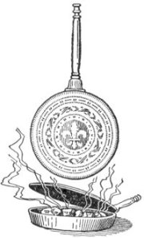](https://chasingflukes.files.wordpress.com/2013/10/warmingpan1.jpg)ear’s journey in the dead of a bitter, New England winter, but notably we find him perfectly content in the absence of “the luxurious discomforts of the rich”: “We felt very nice and snug, the more so since it was so chilly out of doors; indeed out of bed-clothes too, seeing that there was no fire in the room.” Ishmael’s image of he and Queequeg reclined against the headboard with their four knees drawn close together indicates another creature comfort missing from the room besides a fire.

In centuries past, a warming-pan was an implement used to heat bedclothes to a more desirable temperature in cold months. Hot coals would be shoveled into an open pan (often made of copper) with a closing lid featuring (sometimes quite artful) patterns of holes and slits so the hot air would emit from the pan and warm the sheets into which the pan would be slid with the help of a long, wooden handle. Now, it is unlikely that Peter Coffin kept a ready supply of warming-pans for his lodgers, though it is not impossible to imagine him coming along with one to cozy Ishmael and Queequeg’s nest. Even had he made the offer, we are made to think that Ishmael would have declined it. With a simile that calls attention to the similarity in shape of a patella and a warming-pan basin, and also takes advantage of a lexical similarity of Melville’s day—knee caps were then also known as “knee-pans”; cf. Elements of the Anatomy of the Human Body in its S[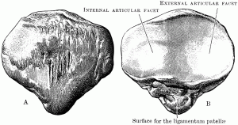](https://chasingflukes.files.wordpress.com/2013/10/patella2.gif)ound State (1831), by Alexander Monro, M.D.—Ishmael represents he and his bedfellow as perfectly, contentedly wrapped in the gown of a cold New Bedford night. The connection between the knee-pan and the warming-pan is made not owing to Ishmael’s longing for the latter. Their “knee-pans were warming-pans,” in the sense of emitting the only heat they needed: not emitting from the knee-pan especially, but from their entire bodies. The warmth of their bodies emitting, comingling, and returning, Ishmael and Queequeg make their own heat.

[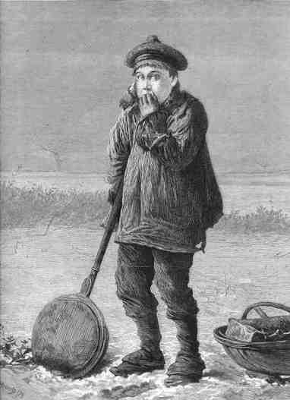](https://chasingflukes.files.wordpress.com/2013/10/boywithwarmingpan.jpg)

***Summary and Analysis Part by Part:***

***Summary Part 1:***

[**Ishmael**](https://www.litcharts.com/lit/moby-dick/characters/ishmael) muses on his second night in bed with **[Queequeg](https://www.litcharts.com/lit/moby-dick/characters/queequeg)**. The two spend much of the first part of the evening “chatting and napping” next to one another. Ishmael thinks to himself that to be warm in a bed requires that one feel the cold outside one’s blankets. He therefore says that rich men, with fireplaces in their bedrooms, are “missing” an important part of warmth, which is the proximity of coolness. Ishmael opens his eyes around midnight to see that Queequeg is smoking indoors from his tomahawk-pipe. The two share the pipe, and Ishmael encourages Queequeg to tell him of his upbringing, and how he has found his way to New Bedford.

***Analysis Part 1:***

In this scene, Ishmael and Queequeg once again mimic the behavior of a married couple, although it is not clear, here as before, whether Melville intends this as a sign of their brotherly connection, or as a hint, perhaps, at a more significant and romantic attachment. In either case, the literal “sharing of the pipe” is sufficient to cement a bond between the two men that will remain throughout the novel, even as Ahab’s quest overtakes the action aboard the Pequod.