WEATHER EXPLORER
Full Stack Weather Data Explorer Application
Project Completion & Deployment Report
Prepared By: Sreevalli
Status: Successfully Completed and Deployed
Attribute | Details
Technology Stack | React, Vite, Tailwind CSS, FastAPI, Python, Docker
Deployment Status | Live — Frontend (Vercel) & Backend (Render)
Repository | github.com/Sreevalli20/fullstack
Frontend URL | frontend-roan-rho-30.vercel.app
Backend URL | weather-explorer-backend-s600.onrender.com
GitHub Repository:
https://github.com/Sreevalli20/fullstack.git
Live Frontend:
https://frontend-roan-rho-30.vercel.app
Live Backend:
https://weather-explorer-backend-s600.onrender.com

Table of Contents
Table of Contents 1
1. Project Overview 1
Key Highlights 1
2. Project Objectives 1
3. System Architecture 1
Component Description 1
4. Technology Stack 1
Frontend 1
Backend 1
Storage 1
Deployment 1
5. Backend Implementation 1
API Endpoints 1
POST /store-weather-data 1
GET /list-weather-files 1
GET /weather-file-content/{file} 1
Additional Backend Considerations 1
6. Storage Design 1
Module Structure 1
Environment Behavior 1
7. Frontend Implementation 1
Weather Input Form 1
Core Features 1
Stored Files Section 1
Visualization 1
Data Table 1
Responsive Design 1
8. API Integration 1
API Endpoint 1
Variables Used 1
Request Flow 1
9. DevOps and Deployment 1
Backend Deployment 1
Frontend Deployment 1
10. Docker Implementation 1
Benefits 1
11. Testing 1
Backend Testing 1
Frontend Testing 1
12. Git Version Control 1
13. Security and Design Decisions 1
14. Deployment Verification 1
15. Screenshots 1
16. Future Improvements 1
17. Conclusion 1

1. Project Overview
Weather Explorer is a full stack web application that allows users to fetch historical weather information using geographic coordinates and date ranges. The system retrieves historical weather data from the Open-Meteo API, stores complete JSON responses, and provides an interactive dashboard for visualization and analysis.
The application was designed and built following industry-standard full stack engineering practices, combining a modern React-based frontend with a robust FastAPI backend, cloud deployment, and a flexible storage abstraction layer.

Key Highlights
- Full stack architecture separating frontend presentation and backend business logic
- Cloud deployment across Vercel (frontend) and Render (backend)
- Seamless integration with the Open-Meteo historical weather API
- Storage abstraction layer supporting both local and cloud-based storage
- Responsive, interactive dashboard for data visualization and exploration

2. Project Objectives
The project was undertaken with the following objectives in mind:
- Build a complete, production-ready weather data explorer application
- Create scalable and well-structured backend APIs
- Integrate external weather services reliably and efficiently
- Store and manage retrieved weather responses in a structured format
- Visualize temperature trends through interactive charts and tables
- Deploy a fully functional, production-ready application accessible to end users

3. System Architecture
The application follows a layered, cloud-native architecture. Each layer has a distinct responsibility, enabling clean separation of concerns, scalability, and maintainability.
User Browser
End user accessing the application
↓
React + Vite + Tailwind Frontend
Interactive weather dashboard UI
↓
Vercel Hosting
Global CDN frontend deployment
↓
FastAPI Backend
REST API and business logic
↓
Render Cloud Deployment
Dockerized backend hosting
↓
Open-Meteo Historical Weather API
External weather data provider
↓
Storage Layer
Abstraction over storage backends
↓
Local Storage / Google Cloud Storage Adapter
Persisted weather JSON responses

Component Description
- User Browser: The entry point where users interact with the Weather Explorer dashboard.
- React + Vite + Tailwind Frontend: Provides the responsive, component-driven user interface.
- Vercel Hosting: Serves the compiled frontend assets globally via CDN with automatic deployments.
- FastAPI Backend: Exposes REST endpoints that handle validation, orchestration, and business logic.
- Render Cloud Deployment: Hosts the containerized backend service in production.
- Open-Meteo Historical Weather API: External data source providing historical weather records.
- Storage Layer: An abstraction that decouples the application from any specific storage backend.
- Local Storage / GCS Adapter: Persists weather JSON responses either locally or in Google Cloud Storage.

4. Technology Stack

Frontend
- React — component-based UI library
- Vite — fast build tool and development server
- Tailwind CSS — utility-first styling framework
- Recharts — declarative charting library for React
- React Testing Library — component and integration testing

Backend
- Python — core backend language
- FastAPI — high-performance asynchronous web framework
- Pydantic — data validation and settings management
- HTTPX — asynchronous HTTP client for external API calls
- Uvicorn — ASGI server for running the FastAPI application

Storage
- Storage abstraction design for backend-agnostic persistence
- Local filesystem storage for development
- Google Cloud Storage adapter, ready for production use

Deployment
- GitHub — source control and version history
- Render — backend hosting and deployment
- Vercel — frontend hosting and deployment
- Docker — containerization for consistent backend environments

5. Backend Implementation
The backend is implemented using FastAPI and exposes a set of clean, well-validated REST endpoints for retrieving, storing, and listing weather data.

API Endpoints

POST /store-weather-data
Purpose: Fetch and store historical weather information for a given location and date range.
Input Parameters:
- latitude
- longitude
- start_date
- end_date
Validation Rules:
- Latitude must be between -90 and 90
- Longitude must be between -180 and 180
- Maximum date range is 31 days

GET /list-weather-files
Purpose: Returns metadata for all stored weather files, including filename, size, and creation date.

GET /weather-file-content/{file}
Purpose: Returns the stored weather JSON content for a specific file.

Additional Backend Considerations
- Centralized error handling for predictable, informative API responses
- Structured logging for observability and debugging
- CORS support enabling secure cross-origin requests from the frontend
- Clean, consistent JSON API response formats across all endpoints

6. Storage Design
Weather Explorer uses a storage abstraction pattern so the application logic is decoupled from the underlying storage mechanism. This design allows the same codebase to run in development using local storage and in production using cloud storage, without code changes.

Module Structure
- storage/storage_interface.py — defines the common storage contract
- storage/local_storage.py — implements filesystem-based storage for development
- storage/gcs_storage.py — implements a Google Cloud Storage adapter for production

Environment Behavior
- Development: Uses local filesystem storage with no external credentials required
- Production: Uses the Google Cloud Storage adapter, configured entirely through environment variables
It should be noted that no AWS services were used anywhere in this project; all cloud storage capability is built around Google Cloud Storage.

7. Frontend Implementation
The frontend delivers an interactive dashboard experience for exploring historical weather data.

Weather Input Form
- Latitude
- Longitude
- Start date
- End date

Core Features
- Fetch and store weather data through the backend API
- Loading indicators during asynchronous operations
- Comprehensive error handling with user-friendly messages
- Success messages confirming completed actions

Stored Files Section
Displays a list of previously stored weather files with the following details:
- Filename
- File size
- Created date

Visualization
Line charts are used to visualize:
- Maximum temperature
- Minimum temperature

Data Table
An interactive data table presents the following columns:
- Date
- Maximum Temperature
- Minimum Temperature
- Apparent Maximum
- Apparent Minimum
Pagination options: 10, 20, and 50 rows per page.

Responsive Design
The dashboard is fully responsive and optimized for mobile, tablet, and desktop viewports.

8. API Integration
Weather Explorer integrates with the Open-Meteo Historical Weather API to retrieve accurate, reliable historical weather records.

API Endpoint
https://archive-api.open-meteo.com/v1/archive

Variables Used
- temperature_2m_max
- temperature_2m_min
- apparent_temperature_max
- apparent_temperature_min

Request Flow
- The frontend collects latitude, longitude, start date, and end date from the user.
- The backend validates the input parameters against defined constraints.
- The backend constructs and sends a request to the Open-Meteo Historical Weather API.
- The API response is received, parsed, and persisted through the storage layer.
- The frontend retrieves and renders the stored data as charts and tables.

9. DevOps and Deployment

Backend Deployment
Setting | Value
Platform | Render
Configuration | Docker-based deployment
Root Directory | backend
Runtime | Python 3.12 Docker container
Environment Variable | STORAGE_TYPE=local

Frontend Deployment
Setting | Value
Platform | Vercel
Framework | Vite
Root Directory | frontend
Build Command | npm run build
Output Directory | dist
Environment Variable | VITE_API_URL

10. Docker Implementation
Docker was used to containerize the backend service, ensuring a consistent runtime environment across development and production.

Benefits
- Consistent environment across all stages of development and deployment
- Reproducible deployments regardless of host machine configuration
- Cloud compatibility with container-based hosting platforms such as Render

11. Testing

Backend Testing
Framework: pytest
Coverage includes:
- Input validation logic
- API endpoint behavior
- Storage services
- Weather service integration

Frontend Testing
Framework: React Testing Library
Coverage includes:
- Form submission workflows
- API integration behavior
- Pagination functionality
- Chart rendering

12. Git Version Control
The project was developed using a structured commit history, reflecting a clear and logical development progression:
- Project initialization — set up the base repository structure and tooling.
- Backend architecture — established the FastAPI project structure and core modules.
- Weather API integration — implemented the Open-Meteo API client.
- Storage abstraction — introduced the storage interface and local/GCS adapters.
- API endpoints — implemented the core REST endpoints for storing and retrieving data.
- Frontend setup — scaffolded the React and Vite project with Tailwind CSS.
- Dashboard UI — built the weather input form and overall dashboard layout.
- Charts and tables — implemented Recharts visualizations and the paginated data table.
- Testing implementation — added backend pytest suites and frontend React Testing Library tests.
- Docker deployment — containerized the backend for cloud deployment.
- Documentation — finalized README and supporting project documentation.

13. Security and Design Decisions
- No secrets were committed to the repository
- Environment variables are used for all sensitive or environment-specific configuration
- No AWS dependency exists anywhere in the project
- No hardcoded credentials are present in the codebase
- The storage abstraction improves scalability and future flexibility
- API-level validation prevents invalid or malformed requests from being processed

14. Deployment Verification
The following checklist confirms that all critical aspects of the deployment were verified prior to project completion:
✓ Backend deployed successfully
✓ Frontend deployed successfully
✓ Frontend connected with backend
✓ Weather API integration working
✓ Storage working
✓ Charts loading
✓ Tables working
✓ Pagination working
✓ Production URLs accessible

15. Screenshots
The following screenshots illustrate key areas of the application. Replace these placeholders with actual application screenshots before final distribution.
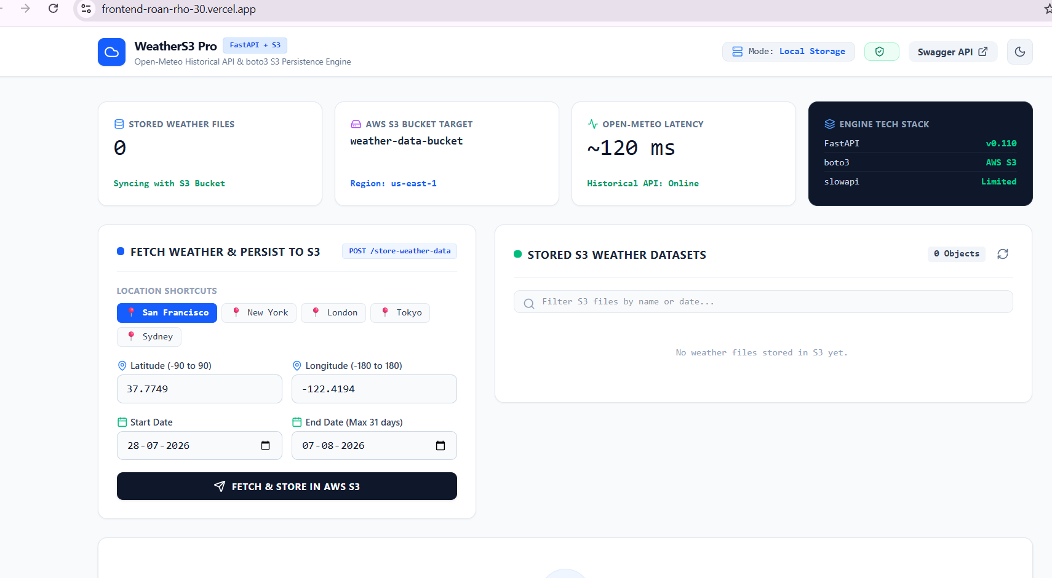

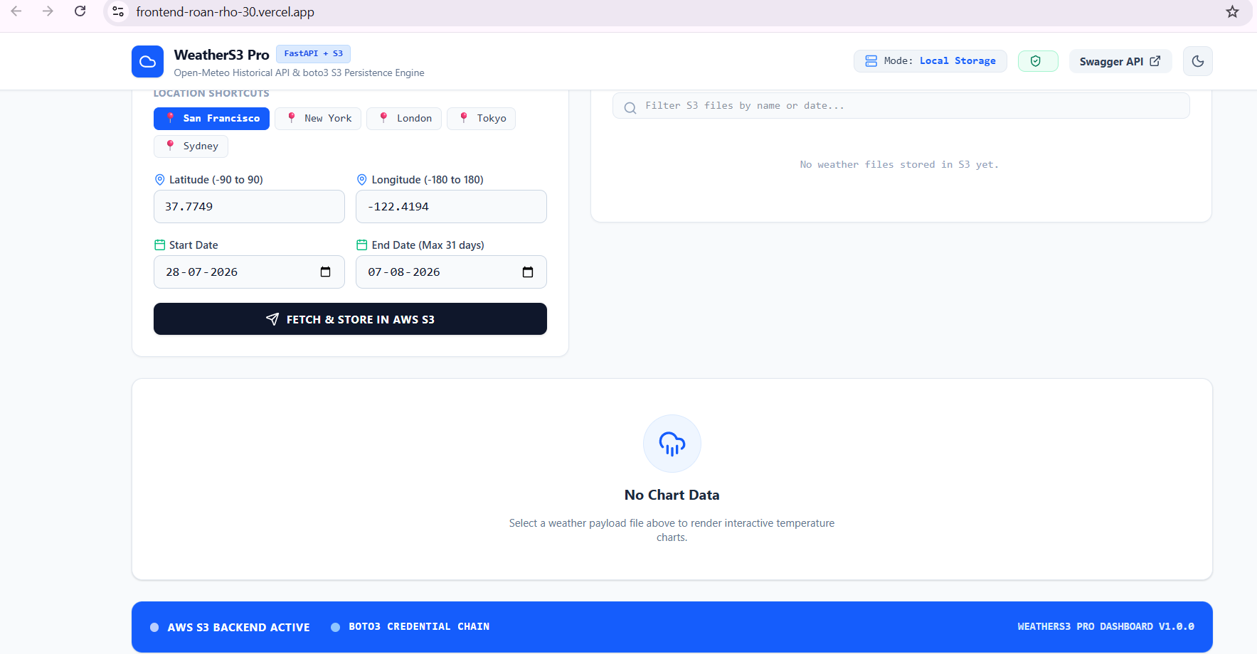

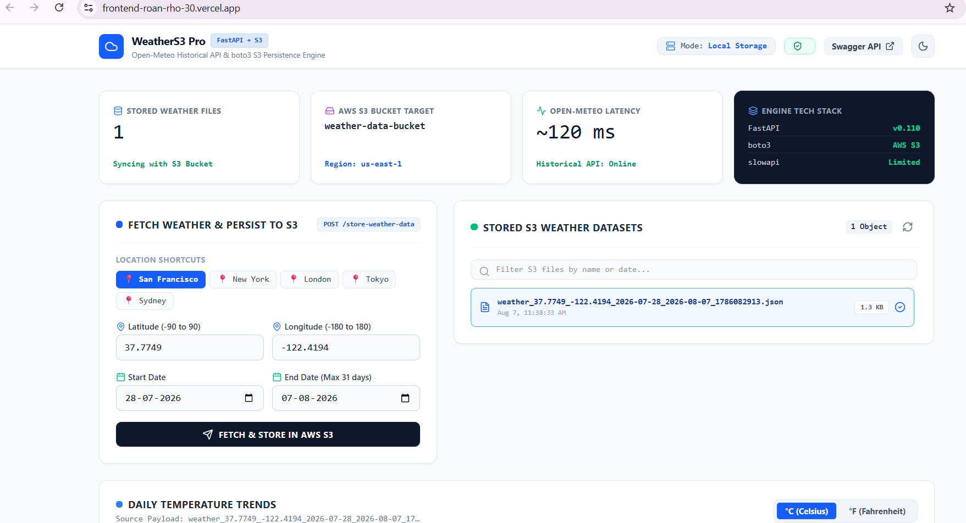

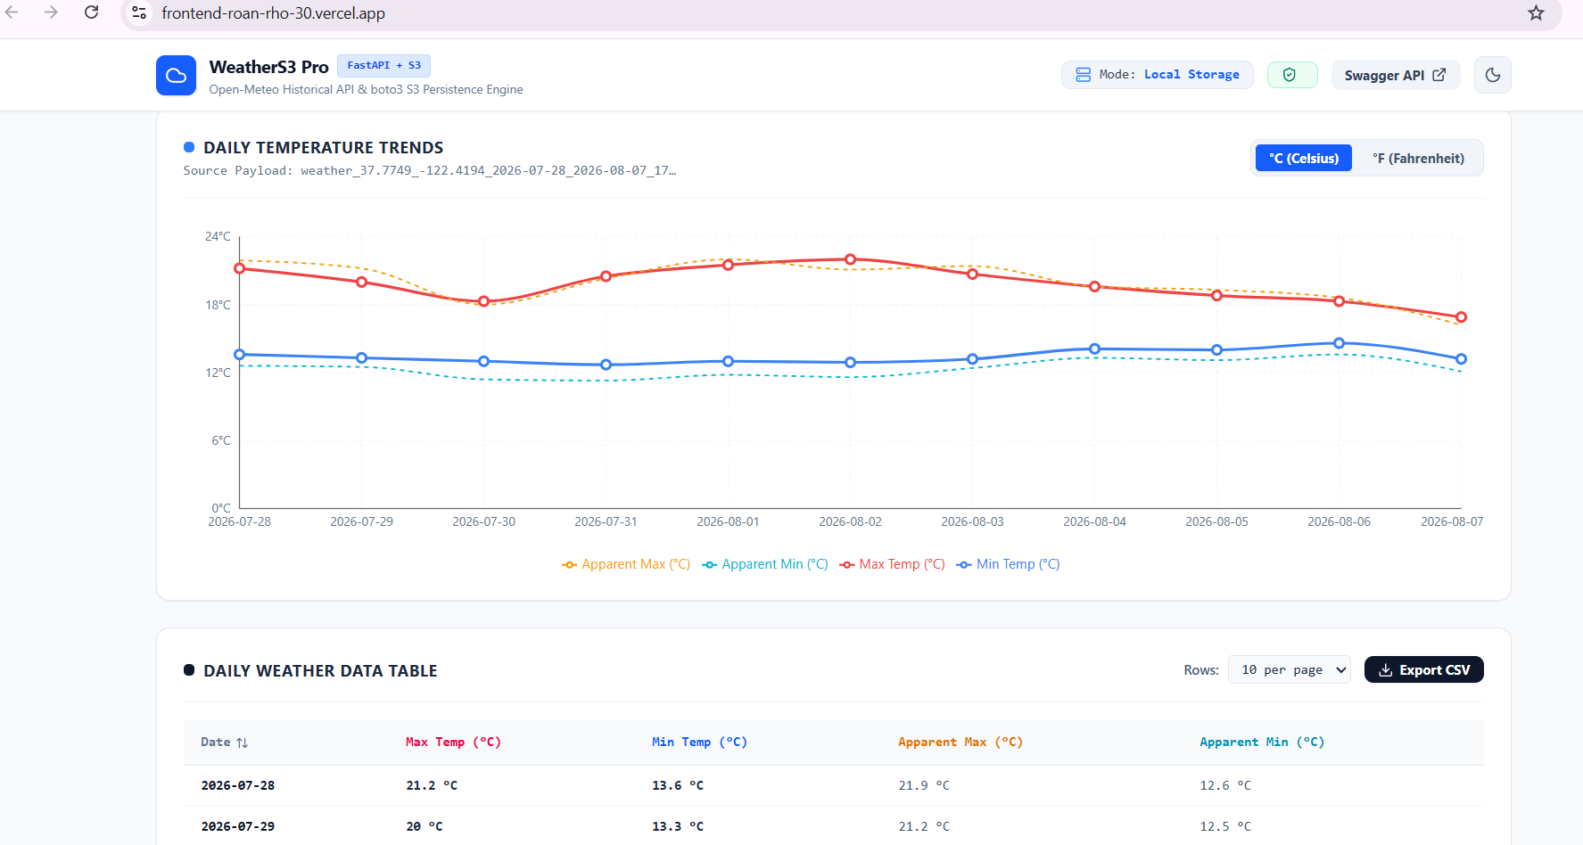

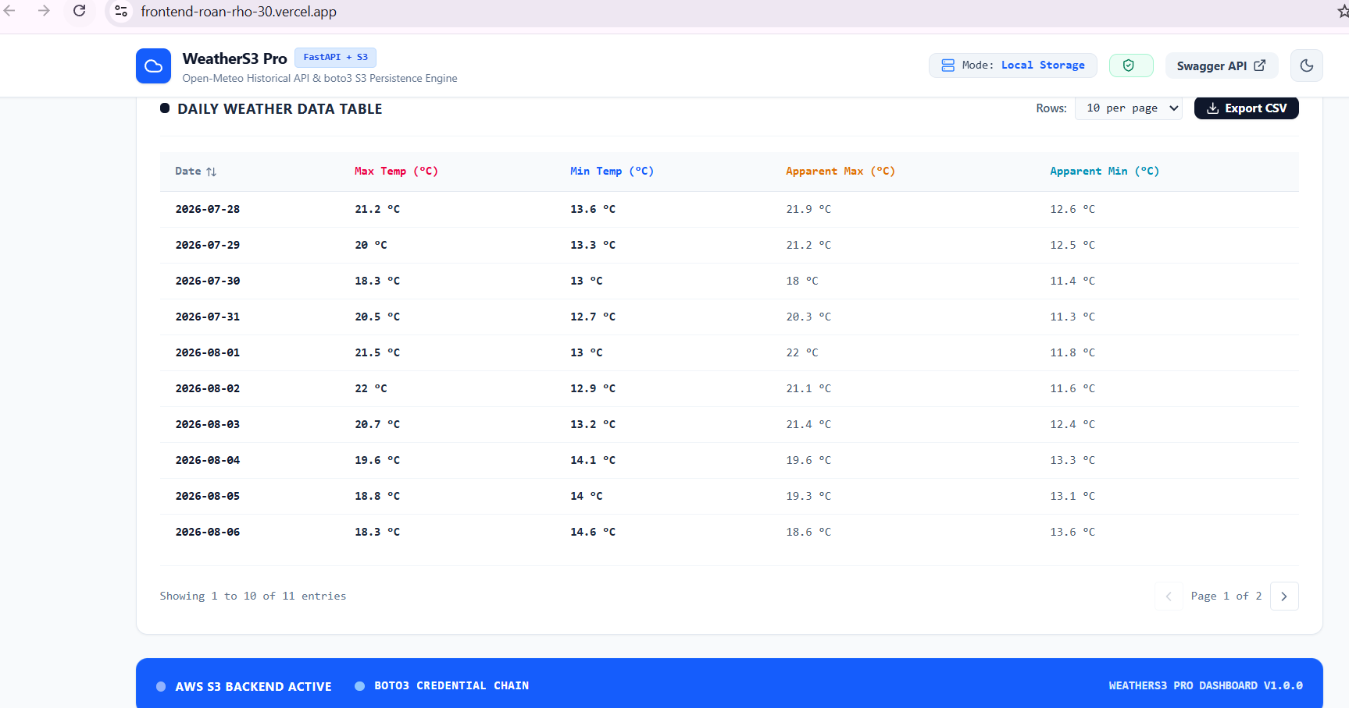

16. Future Improvements
- User authentication and authorization
- Weather forecasting in addition to historical data
- Migration to a full database storage solution
- Advanced analytics and trend insights
- Notifications for significant weather events
- Map-based location selection for improved usability
- CI/CD pipeline automation for streamlined deployments

17. Conclusion
The Weather Explorer project successfully demonstrates a complete full stack development lifecycle, including frontend development, backend API engineering, external API integration, storage design, testing, Docker containerization, and cloud deployment.
From a well-structured FastAPI backend to a responsive, data-rich React dashboard, the project reflects strong engineering practices across the entire technology stack. The application is fully deployed, verified, and accessible in production, making it a strong representation of modern full stack development suitable for a professional portfolio and technical interviews.
Repository: github.com/Sreevalli20/fullstack
Live Frontend: frontend-roan-rho-30.vercel.app
Live Backend: weather-explorer-backend-s600.onrender.com

