Semiconductor Science and Information Devices | Volume 02 | Issue 02 | October 2020


Semiconductor Science and Information Devices

https://ojs.bilpublishing.com/index.php/ssid

REVIEW

Machine Learning: A Review

Isonkobong Christopher Udousoro*

Department of Information Technology, School of Computing and Information Technology, Federal University of Tech-nology, Owerri

ARTICLE INFO

Article history

Received: 28 May 2020

Accepted: 2 July 2020

Published Online: 31 October 2020

Keywords:

Machine learning

Supervised learning

Unsupervised learning

Reinforcement learning

Semi-supervised learning

Multitask learning

Ensemble learning

Neural Network

Instance-Based

ABSTRACT

Due to the complexity of data, interpretation of pattern or extraction of information becomes difficult; therefore application of machine learning is used to teach machines how to handle data more efficiently. With the increase of datasets, various organizations now apply machine learning applications and algorithms. Many industries apply machine learning to extract relevant information for analysis purposes. Many scholars, mathe-maticians and programmers have carried out research and applied several machine learning approaches in order to find solution to problems. In this paper, we focus on general review of machine learning including various machine learning techniques. These techniques can be applied to different fields like image processing, data mining, predictive analysis and so on. The paper aims at reviewing machine learning techniques and algorithms. The research methodology is based on qualitative analysis where various literatures is being reviewed based on machine learning.

1. Introduction
Questions have been asked with regards to com-puters if they are capable of learning on their own. Human beings have over the years created

different tools to enable them solve various tasks which led to the invention and production of different machines ^{[57]}. With the rapid developments, the difference between humans and machines has remained intelligence. A human brain analyses information and makes decision according-ly but machines are not able to analyse and take decisions ^{[1]}. Automating tasks has generated high interest in the in-formation technology field where some designs and oper-

ations can be handed over to machines ^{[13]}. Recently, with the introduction of artificial intelligence, machines have been created to have the same level of intelligence as the human brains. Artificial intelligence started in 1943 when the first Neural Network Model was introduced ^{[12]}.

A machine is expected to learn whenever there is chang-es in the structure, program or data, this is based on the in-put or response to the external environment which improves its expected results ^{[51]}, therefore, machine learning can be defined as a part of artificial intelligence that explains that fact that machines can learn on their own when given the right data thereby solving a specific problem ^{[80]}. With the help of mathematics and statistics, machine learning can

*Corresponding Author:

Isonkobong Christopher Udousoro,

Department of Information Technology, School of Computing and Information Technology, Federal University of Technology, Owerri; Email: isonkobongudousoro@gmail.com

Distributed under creative commons license 4.0 DOI: https://doi.org/10.30564/ssid.v2i2.1931 5

Semiconductor Science and Information Devices | Volume 02 | Issue 02 | October 2020

perform intellectual tasks independently that are always generally performed by human beings ^{[82]}.

Machine learning is a part of computer science that emanated from the study of pattern recognition and com-putational learning theory all in artificial intelligence. Al-gorithms are used to make predictions on data ^{[52]}. Before now the field of machine learning was mainly algorithms and theory of optimization but recently machine learning covers several other disciplines which includes statistics, information theory, theory of algorithms, probability and functional analysis ^{[24]}. Machine learning and computa-tional statistics are always closely related because of their specialty in prediction making and mathematical optimi-zation which brings about methods, theories and applica-tion to the field ^{[1]}. In machine learning, strictly static pro-gram instructions are not followed, rather, algorithms are used to build a model from input which are used to make data-driven prediction or decisions ^{[80]}.

Currently, research on machine learning focuses on ar-eas like pattern recognition, natural language processing, cognitive computing, image processing, knowledge rep-resentation, traffic classification, cognitive radio and in-trusion detection, optical networks and so on ^{[13]}. Machine learning problems and tasks are mostly classified into three broad categories because of the signal and feedback that is being fed into the learning system ^{[53]}. These cate-gories are explained below:

- Supervised Learning where the computer is being supplied with example input and their desired output which learns a rule that is able to map inputs to outputs ^{[9]}

- Unsupervised Learning where no label is given to the learning algorithm and its allowed to determine the structure of its input ^{[70]}.

- Semi-Supervised Learning lies between supervised and unsupervised learning where the teacher gives an in-complete input or signal where some of the target outputs are missing, it can also be regarded as Transduction ^{[46]}.

- Reinforcement Learning where an environment interacts with the computer to be able to perform a certain goal without any input or interference of a teacher telling it what to do ^{[28]}.

There are various reasons why machine learning is im-portant:
- Machine learning is important in adjusting its struc-ture to produce desired outputs due to the heavy amount of data input into the system ^{[57]}.

- Machine learning is also suitable for data mining because of the little amount of important data hidden in the heavy chunk of data that can be important for process-ing of output ^{[10]}.

- Machine learning is important for jobs that are on

the go thereby improving the existing machine designs because some designers produce non- workable machines that are not desired in the environment ^{[50]}.

Knowledge computation is being carried out by ma-chines easily which will be a bit difficult for humans due to the large amount of knowledge available for certain tasks ^{[26]}. Redesigning of systems due to change in en-vironment is reduced with the introduction of machine learning because environments change overtime ^{[51]}. New knowledge, new task, new data is being gotten and dis-covered by humans on every day, with machine learning, tracking of new knowledge is made easy ^{[26]}.

In this paper, a general overview of the application of machine learning is carried out. An introductory highlight on the use of machine learning, its methods, techniques and applications in various fields is considered. We also carry out a survey on the existing work with machine learning so far. This paper is organized as follows: Section 2 describes machine learning, its applications and current work being carried out. It also highlights the number of journals and their sources being used for this paper. Sec-tion 3 introduces and highlights the techniques and meth-ods used in machine learning while section 4 presents the conclusion of the paper.

2. Review of Literature

Machine learning is a fast growing field and one of the latest technologies being used recently in the information technology field. Machine learning has been deployed to solve different problems in different aspects of life like medical, engineering, agricultural etc. This section dis-cusses various applications of machine learning in differ-ent aspects of life.

Machine learning is recently deployed in National Innovation Performance data analysis where the impact of government decisions and policies are still not clear. A machine learning approach is proposed which includes clustering, correlation analysis, Bayesian Neural network and breakdown for decomposing innovation output pre-diction. This approach has shown improvement for bench-marking national innovation profiles ^{[29]}.

Machine learning is combined with satellite imaging to predict poverty. A study carried out from five African countries which are Nigeria, Tanzania, Uganda, Malawi and Rwanda. Here a neural network is used and trained to capture and identify image features that explains local economic outcomes ^{[41]}.

Scientist are now called upon and required to use ad-vanced machine learning and many other artificial intelli-gence technologies to help find new scientific discoveries in the analysis of their data. This is important for applica-

6 Distributed under creative commons license 4.0 DOI: https://doi.org/10.30564/ssid.v2i2.1931

Semiconductor Science and Information Devices | Volume 02 | Issue 02 | October 2020

tions like object recognition, natural language processing, deep learning and automatic translation ^{[39]}.

Machine learning is applied in databases that are compiled using symmetry-based calculations which contains thousands of topological insulators and semimetals. Using the gradient boosted trees approach of machine learning. The model pre-dicts the topology of a given existent material. Although the model has errors which can be overcome ^{[21]}.

In the field of chemistry, a machine learning approach known as graph neural networks is proposed for solving problem of quantitative structure-odor relationship which relationship between molecules structure and its odor re-mains difficult ^{[78]}.

Based on widely analysed classification model, patient data is being analysed for the predictability of the patient to have liver disease. There are five phases highlighted. The first is the min-max algorithm application followed by the use of PSO feature selection for demarcation of at-tributes, then classification algorithm is used for compar-ative analysis and categorization. The fourth phase is the accuracy calculation and finally evaluation phase ^{[26]}.

Decision Tree based algorithm is used to evaluate in-dividual and ensemble model performance for predicting secondary progressive multiple sclerosis disability pro-gression ⁺.

Machine learning is a branch of artificial intelligence that is deployed and most suited for medical applications especially in the detection and prediction of cancer and prognosis. A number of publications have shown that ma-chine learning methods can be used to improve the accu-racy of predicting cancer susceptibility, reoccurrence and mortality ^{[23]}.

The use of Bayesian deep learning method as machine learning technique to address the analysis challenges of future surveys. This technique will enable multibendpass, multi-instrument processing of individual images, target-ing science objectives ^{[4]}.

In order to manage and control the operational environ-ment while also predicting future actions, IoT application developers tend to buy data from IoT owners in order to train machine learning models by combining edge com-puting resources with data sources ^{[76]}.

Machine learning is used in the multimedia world for conversion assignment. The audio/video data is recorded from a location and converted to text data. The text data is then analysed and tagged to each individual based on attributes. Self learning software designed using machine learning algorithm is generated based on the tagging ^{[24]}.

Machine learning approach has also be deployed in the discovery of drugs. The use of virtual screening evolving from traditional similarity searching to an advanced appli-

cation domain for data mining and machine learning ap-proaches. The advanced approach requires large training set compounds to learn robust decision rules ^{[50]}.

Wireless sensor networks work dynamically due to the external factors or initiated by the system designers. Therefore, machine learning is used to adapt to these con-ditions and eliminate the need for unnecessary and also prolong the lifespan of the network ^{[1]}.

Quantum systems are said to be faster and produce pat-terns that classical systems cannot which means quantum computers may outperform classical computers in terms of machine learning. Although hardware and software challenges still exist, quantum algorithms could act as a building block for machine learning programs ^{[6]}.

In project management, project delay is one of the press-ing challenges faced by the construction sector due to com-plexity and delay risk sources. Machine learning algorithms identified and developed in order to facilitate accurate delay risk analysis and prediction using objective data sources. Two machine learning algorithms which are decision tree and naive Bayesian classification were trained using the data set for predicting project delay events ^{[32]}.

In order to minimize investment risks while evaluating the potential business impact, machine learning systems is used to leverage business transformation ^{[64]}.

Retrieval of patients data rightly and at the right time is vital, therefore, a learning electronic medical record (LEMR) is developed that learns statistical models of cli-nician information seeking behaviour and applies it to the direct display of data for future patients ^{[45]}.

3. Machine Learning Techniques

Machine learning is simply about designing algorithm that will allow a computer to be able to learn ^{[52]}. This is based on the input and desired outcome of the algorithm. Some of the machine learning techniques will define how humans can approach a task ^{[64]}. Several mathematicians and programmers have come up with solutions on the approaches and techniques for machine learning which is narrowed down as shown in the diagram below.
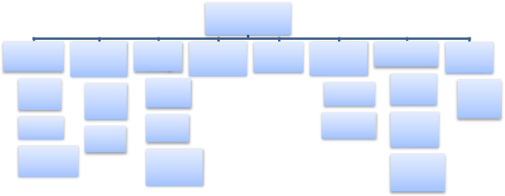

Machine learning

Supervised |  | Unsupervised |  |  | Semi- | Reinforcement |  | Multi-task |  | Ensemble |  | Neural Network |  |  |  | Instance
 |  |  |  | supervised |  |  |  |  |  |  |  |  |  |  |  |  | based
 | learning |  | learning |  |  |  | learning | learning |  |  | learning
 |  |  |  | learning |  |  |  |  |  |  |  |  |  |  |  | learning
 |  |  |  |  | Generative |  |  |  |  |  |  |  |  |  | Supervised
 | Decision |  | Principal |  |  |  |  |  |  |  | Boosting |  |  |  | Neural |  | K-nearest
 | Tree |  |  |  | Models |  |  |  |  |  |  |  |  |  | Network
 |  |  | Component |  |  |  |  |  |  |  |  |  |  |  |  |  | neighbor
 |  |  | Analysis |  |  |  |  |  |  |  |  |  |  |  | Unsupervised
 | Naive Bayes |  |  |  | Self Training |  |  |  |  |  | Bagging
 |  |  |  |  |  |  |  |  |  |  |  |  |  |  | Neural
 | Support Vector |  | K-Means |  | Transductive |  |  |  |  |  |  |  |  |  | Network
 | Machine |  |  |  | Support Vector |  |  |  |  |  |  |  |  |  | Reinforcement
 |  |  |  |  | Machine |  |  |  |  |  |  |  |  |  | Neural Network

Figure 1. Machine Learning Techniques ^{[25]}

Distributed under creative commons license 4.0 DOI: https://doi.org/10.30564/ssid.v2i2.1931 7

Semiconductor Science and Information Devices | Volume 02 | Issue 02 | October 2020

The various techniques of machine learning is dis-cussed below and the different applications that follow the techniques are also highlighted:

- SUPERVISED LEARNING: In supervised learning, a correct classification is already assigned to train a data sample from the data source ^{[22]}. It can also be seen as a for-malization of a certain idea of learning from examples where there is an input and desired output ^{[25]}. Here, the learner which could be a computer program is provided with a train-ing set and test set of data. The trainer is required to learn from the training set with examples of labelled set which will be used to identify the unlabelled examples in the test set with highest possible accuracy ^{[15]}. The supervised learning technique requires external assistance. The work flow of the supervised learning technique is shown below.
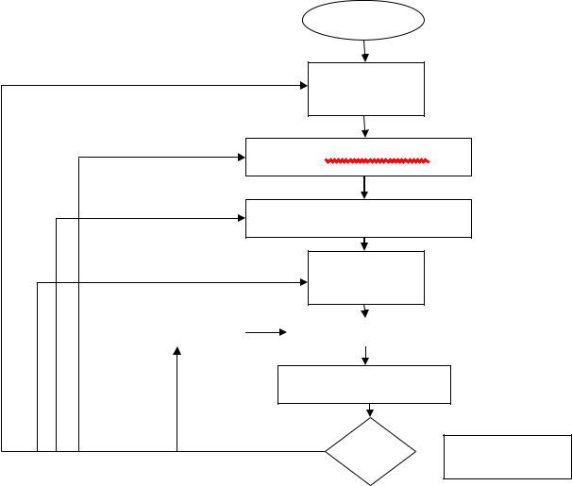

Problem

Identification

of Required

data

Data Pre-Processing

Definition of Training set

Algorithm

Selection

Parameter |  | Training

Evaluation of Test set

OK? | Classifier

Figure 2. Workflow of supervised machine learning tech-nique ^{[25]}

There are three major types or algorithm of supervised learning technique as discussed below:

- Decision Tree: Decision trees group attributes there-by sorting them based on their different values ^{[62]}. Each of this decision trees consist of nodes and branches and are mainly used for classification. A node represents attributes in a group while the branch represents a value that the node can take. An example of a decision tree is shown below.
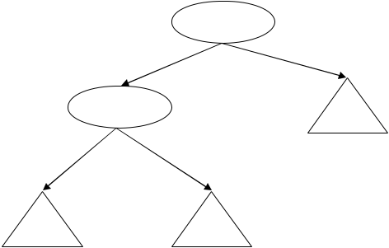

 | Age
<=30 | >30
Gender | No
Male | Female

Yes No

Figure 3. Decision Tree ^{[25]}

- Naive Bayes: This algorithm is mostly used and is a target of the text classification industry ^{[83]}. It is also used for clustering and classification purposes. Condition-al probability is the backbone of Naive bayes algorithm where it creates trees based on the probability of occur-ring. These trees can also be regarded as Bayesian Net-work. An example is shown below.
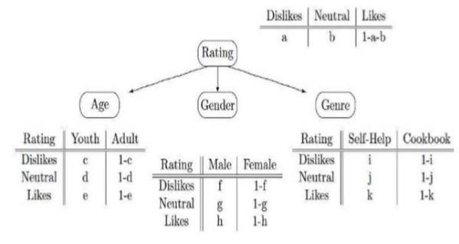

Figure 4. Bayesian Network ^{[25]}

- Support Vector Machine: This algorithm is a com-monly and widely used machine learning technique and mostly used for classification ^{[90]}. Support Vector Machine uses margin calculations where it draws margins between the classes. The distance between margins and classes is always big so as to reduce the error in classification ^{[3]}. The diagram below shows a working support vector ma-chine.
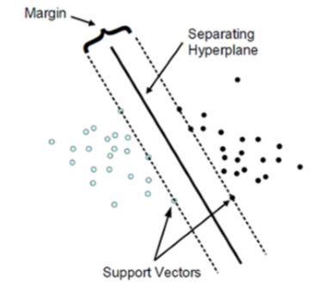

Figure 5. A working Support Vector Machine ^{[25]}

An application of the supervised learning technique is where a supervised data of the Stanford Natural Language Inference datasets is used to train and show how universal sentence representations can consistently outperform un-supervised methods ^{[22]}.

(2) UNSUPERVISED LEARNING: This technique is a

8 Distributed under creative commons license 4.0 DOI: https://doi.org/10.30564/ssid.v2i2.1931

Semiconductor Science and Information Devices | Volume 02 | Issue 02 | October 2020

bit harder than the supervised learning. This is so because we tell the computer to learn to do something that we don’t tell it how to do ^{[82]}. This learning technique does not produce classification but make decisions that maximize rewards. Some self-organized neural networks learn using the unsupervised learning technique to uncover hidden patterns in unlabelled data input ^{[89]}. The advantage of this lack of direction is that it lets the algorithm to look back for patterns that were not previously considered. The un-supervised learning technique learns few features from a set of data and then when a new data is being introduced, then it uses the learned features to recognize the class of the data ^{[70]}. Unsupervised learning technique is mainly used for clustering and feature reduction. And example is shown below.
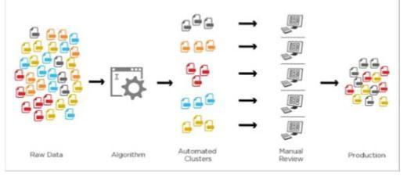

Figure 6. Example of Unsupervised Learning ^{[25]}

There are two main algorithms for supervised learning technique which are discussed below:

- K-Means Clustering: Clustering is also known as grouping which is a type of unsupervised learning tech-nique that creates group which initiated automatically ^{[87]}. It is known as K-means because it creates k-distance clus-ters where items with similar characteristics are put in the same cluster. The centre of the cluster is gotten from the mean of the values in the cluster.

- Principal Component Analysis: Here, to make the computation faster and a bit easier, the dimension of the data is reduced. For example, when principal component analysis is being applied on a 2D data, the data will then be reduced to 1D ^{[87]}.

Unsupervised learning techniques can be applied to sentences to improve embeddings ^{[72]}. Unsupervised learn-ing technique can be used to identify phases and its tran-sitions in systems, principal component analysis is used to extract the original data while clustering is used to identi-fy the phases ^{[87]}.

(3) SEMI SUPERVISED LEARNING: This technique is a technique that combines both supervised and unsu-pervised learning techniques ^{[46]}. The unlabelled data is already present while discovering the labelled data is very tasking and tedious. This technique is common in data mining field ^{[71]}. Some of the algorithms for semi-super-

vised learning technique are discussed below.

- Generative Models: This is one of the oldest semi-supervised learning technique where models like guassian mixture models is used as a mixed distribution to assume a structure ^{[48]}. The mixed component can be iden-tified within the unlabelled data.

- Self-Training: Here, the classified is trained to learn by itself by providing it with portion of labelled data where the labelled points and the predicted labels are added together in the training set, and then the process is repeated ^{[65]}.

- Transductive Support Vector Machine: This algo-rithm is an extension of the Support Vector Machine algo-rithm where both the labelled and unlabelled data is con-sidered ^{[86]}. This algorithm is used to label the unlabelled data such that the margin is large between the labelled and unlabelled data.

Odena Augustus in 2015 extended Generative adver-sarial networks to the semi-supervised learning technique of machine learning to show it can be used to create a more data-efficient classifier and higher quality samples can be generated. Semi-supervised learning is applied on graph-structured data which learns hidden layer represen-

tation that encode the graph structure and feature of nodes
[46].

- REINFORCEMENT LEARNING: In this type of technique, the positive outcome of the decisions is deter-minant or dependent on the actions to take ^{[95]}. The learner has no idea of the action to take until it is given a particu-lar situation. Depending on the actions taken by the learn-er, the future is affected in terms of the situations. Below shows a model for reinforcement learning.
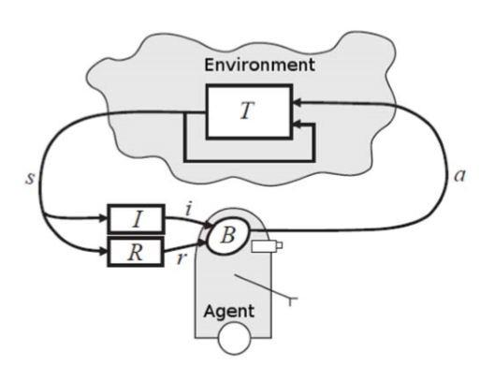

Figure 7. Reinforcement Learning Model ^{[25]}

In the above model, the input i, is being received by the agent. The agent also receives current state, s, state transition r, and input function I from the environment. With these inputs, the agent generates a behaviour B and takes an action a which generates an outcome ^{[25]}. Rein-

Distributed under creative commons license 4.0 DOI: https://doi.org/10.30564/ssid.v2i2.1931 9

Semiconductor Science and Information Devices | Volume 02 | Issue 02 | October 2020

forcement learning technique is being applied to natural language processing for dialogue creation where a model simulates dialogues between vitual agents using policy gradients for reward to conversational properties ^{[54]}.

- MULTITASK LEARNING: The algorithm remem-bers the process and procedure how a particular problem was solved and how it arrived at a certain conclusion ^{[54]}. The process and procedure is being used to proffer solution to other tasks or problem. It can also be known as transfer mechanism ^{[73]}. Sharing experience between learners helps them to learn concurrently rather than in-dividually which is much faster. Four clinical predictions benchmark is proposed using data derived from publicly available medical information database where multitask learning, deep supervision and data specific modifications is applied on the performance of neural models ^{[36]}.

- ENSEMBLE LEARNING: This technique refers to the combination of individual learners to form one learner ^{[49]}. For example, a decision tree, naive baye and neural network can be combined to form an ensemble learning. Combination of learners performs better work than indi-vidual learner. There are two algorithms under ensemble learning:

(a) Boosting: This technique collects weak learners and converts them to one strong learner ^{[92]}. It decreases bias and variance.

(b) Bagging: This technique is also known as boostrap aggregating, whenever the machine learning algorithm needs to increase accuracy and stability, bagging tech-nique is required ^{[92]}.

Machine learning models are built and proposed us-ing ensemble learning technique where large repository of malware samples and applications are gotten from an anti-virus vendor. This is in vie to reduce that malware attack on the android platform ^{[92]}

- NEURAL NETWORK LEARNING: This tech-nique is gotten from the concept of neurons which has four parts, dendrites, nucleus, Soma and Axon^{[58]}. Inter-connection of the neurons is known as neural network.

The artificial neural network behaves in the same pattern. A diagram of artificial neural network is shown below.
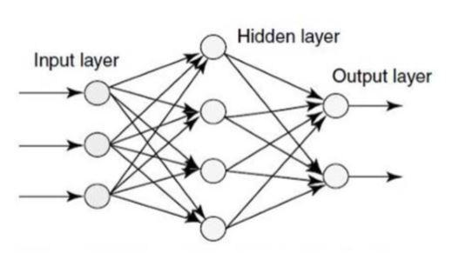

Figure 8. Artificial Neural Network ^{[25]}

The input layer takes input while the hidden layer pro-cesses the input and then the output layer sends the calcu-lated output. Artificial Neural Network can be divided into three types which are supervised, unsupervised and rein-forcement neural network. Neural networks are powerful and works well for difficult learning task like in image, speech and natural language processing ^{[95]}.

  - INSTANCE-BASED LEARNING: In this tech-nique, the learner is familiar with only one particular type of pattern where it tries to apply to newly fed data ^{[16]}. The technique is termed lazy because it waits for the test data to arrive and then act on it with training data. It gets complex as the data increases. An example of the in-stance-based learning technique is the k-nearest neighbour algorithm. In the agricultural field, the instance based learning approach is used to segment crop images where-by green texture crops are automatically discriminated from the rest of the crops ^{[2]}.

- Conclusion

This review presented a general research on machine learning, its algorithm and techniques. The paper reviews literatures on the applications of machine learning al-gorithm and techniques on various fields of life which include medical, agriculture, science and so on. Machine learning is one of the high rising technologies used re-cently for solutions to various problems. It has various algorithms which include supervised, semi-supervised, unsupervised, reinforcement algorithms and so on.

References

- Alsheikh, M. A., Lin, S., Niyato, D., Tan, H. P. Ma-chine learning in wireless sensor networks: Algo-rithms, strategies, and applications. IEEE Communi-cations Surveys & Tutorials, 2014, 16(4): 1996-2018.
- Arroyo, J., Guijarro, M., Pajares, G. An in-stance-based learning approach for thresholding in crop images under different outdoor conditions. Com-puters and Electronics in Agriculture, 2016, 127: 669-679.
- Ashfaq, R. A. R., Wang, X. Z., Huang, J. Z., Abbas, H., He, Y. L. Fuzziness based semi-supervised learn-ing approach for intrusion detection system. Informa-tion Sciences, 2017, 378: 484-497.
- Aubourg, É., Bartlett, J., Boucaud, A., Ganga, K., Giraud-Héraud, Y., Le Jeune, M., LAL, J. É. C. Prospective IN2P3 Survey Synergies with Machine Learning GT05+ GT09, 2019.
- Bakoev, S., Getmantseva, L., Kolosova, M., Kostyu-nina, O., Chartier, D., Tatarinova, T. V. PigLeg: Pre-diction of Swine Phenotype Using Machine Learn-

10 Distributed under creative commons license 4.0 DOI: https://doi.org/10.30564/ssid.v2i2.1931

Semiconductor Science and Information Devices | Volume 02 | Issue 02 | October 2020

ing, 2019.

- Balzer, L. B., Havlir, D. V., Kamya, M. R., Chamie, G., Charlebois, E. D., Clark, T. D., Kabami, J. Ma-chine learning to identify persons at high-risk of HIV acquisition in rural Kenya and Uganda. Clinical In-fectious Diseases, 2019.
- Biamonte, J., Wittek, P., Pancotti, N., Rebentrost, P., Wiebe, N., Lloyd, S. Quantum machine learning. Na-ture, 2017, 549(7671): 195-202.
- Bojanowski, P., Joulin, A. Unsupervised learning by predicting noise. In Proceedings of the 34th Interna-tional Conference on Machine Learning. JMLR. Org, 2017, 70: 517-526.
- Bostanabad, R., Bui, A. T., Xie, W., Apley, D. W., Chen, W. Stochastic microstructure characterization and reconstruction via supervised learning. Acta Ma-terialia, 2016, 103: 89-102.
- Brownlee, J. Machine learning mastery, 2014. URL: http://machinelearningmastery.com/discover-feature-en-gineering-howtoengineer-features-and-how-to-get-good-at-it
- Butler, K. T., Davies, D. W., Cartwright, H., Isayev, O., Walsh, A. Machine learning for molecular and materials science. Nature, 2018, 559(7715): 547.
- Chaker, Z., Salanne, M., Delaye, J. M., Charpentier, T. Fast and accurate predictions of NMR parameters in aluminosilicate glasses via Machine Learning, 2019.
- Chatterjee, D., Ghosh, S., Brady, P. R., Kapadia, S. J., Miller, A. L., Nissanke, S., Pannarale, F., 2019.
- Chen, D., Mak, B. K. W. Multitask learning of deep neural networks for low-resource speech recogni-tion. IEEE/ACM Transactions on Audio, Speech, and Language Processing, 2015, 23(7): 1172-1183.
- Chen, X., Gupta, A. Webly supervised learning of convolutional networks. In Proceedings of the IEEE International Conference on Computer Vision, 2015: 1431-1439.
- Cheng, M. Y., Hoang, N. D. A Swarm-Optimized Fuzzy Instance-based Learning approach for pre-dicting slope collapses in mountain roads. Knowl-edge-Based Systems, 2015, 76: 256-263.
- Cheng, Y. Semi-supervised learning for neural ma-chine translation. In Joint Training for Neural Ma-chine Translation. Springer, Singapore, 2019: 25-40.
- Chikersal, P., Poria, S., Cambria, E. SeNTU: senti-ment analysis of tweets by combining a rule-based classifier with supervised learning. In Proceedings of the 9th International Workshop on Semantic Evalua-tion (SemEval 2015), 2015: 647-651.
- Chong, B. S. A machine learning approach to detect surface features for automatic robot taping, 2019.
- Chu, S., Wagstaff, K., Bryden, G., Shvartzvald, Y.

Automatic Detection of Microlensing Events in the Galactic Bulge using Machine Learning Techniques. In Astronomical Data Analysis Software and Systems XXVII, 2019, 523: 127.
- Claussen, N., Bernevig, B. A., Regnault, N. Detec-tion of Topological Materials with Machine Learn-ing. arXiv preprint arXiv:1910.10161, 2019.
- Conneau, A., Kiela, D., Schwenk, H., Barrault, L., Bordes, A. Supervised learning of universal sentence representations from natural language inference data. arXiv preprint arXiv:1705.02364, 2017.
- Cruz, J. A., Wishart, D. S. Applications of machine learning in cancer prediction and prognosis. Cancer informatics, 2, 117693510600200030, 2006.
- Dawson, C. J., Molloy, C. L., Trim, C. M., Ganci Jr, J.

  - U.S. Patent Application No. 15/952,320, 2019.

- Dey, A. Machine learning algorithms: a review. Inter-national Journal of Computer Science and Informa-tion Technologies, 2016, 7(3): 1174-1179.
- Durai, V., Ramesh, S., Kalthireddy, D. Liver disease prediction using machine learning, 2019.
- Durand, T., Mordan, T., Thome, N., Cord, M. Wild-cat: Weakly supervised learning of deep convnets for image classification, pointwise localization and seg-mentation. In Proceedings of the IEEE conference on computer vision and pattern recognition, 2017: 642-651.
- Foerster, J., Assael, I. A., de Freitas, N., Whiteson,

  - Learning to communicate with deep multi-agent reinforcement learning. In Advances in Neural Infor-mation Processing Systems, 2016: 2137-2145.
- Forner, D., Ozcan, S., Bacon, D. Machine Learning Approach for National Innovation Performance Data Analysis, 2019.
- Fu, G. S., Levin-Schwartz, Y., Lin, Q. H., Zhang, D. Machine Learning for Medical Imaging. Journal of healthcare engineering, 2019.
- Gales, M. Introduction to machine learning, 2008.

- Gondia, A., Siam, A., El-Dakhakhni, W., Nassar, A.

  - Machine Learning Algorithms for Construction Projects Delay Risk Prediction. Journal of Construc-tion Engineering and Management, 2019, 146(1): 04019085.
- Greenberg, D. E., Kim, J., Zhan, X., Shelburne, S. A., Shelburne, S. A., Aitken, S. L., Aitken, S. L. 1831. Machine Learning Approaches to Predicting Resis-tance in Pseudomonas aeruginosa. In Open Forum Infectious Diseases. Oxford University Press, 2019, 6(Suppl 2): S42.
- Gu, S., Holly, E., Lillicrap, T., Levine, S. Deep re-inforcement learning for robotic manipulation with asynchronous off-policy updates. In 2017 IEEE in-

Distributed under creative commons license 4.0 DOI: https://doi.org/10.30564/ssid.v2i2.1931 11

Semiconductor Science and Information Devices | Volume 02 | Issue 02 | October 2020

ternational conference on robotics and automation (ICRA). IEEE, 2017: 3389-3396.
- Hamilton, I. Fraud Detection Through the Utilization of Machine Learning. 2019.
- Harutyunyan, H., Khachatrian, H., Kale, D. C., Steeg, G. V., Galstyan, A. Multitask learning and benchmarking with clinical time series data. arXiv preprint arXiv:1703.07771, 2017.
- Harwath, D., Torralba, A., Glass, J. Unsupervised learning of spoken language with visual context. In Advances in Neural Information Processing Sys-tems, 2016: 1858-1866.
- He, B., Wei, M., Watts, D. R., Donohue, K. A., Trac-ey, K. L., Shen, Y. Detect slow slip events in ocean bottom pressure data using machine learning. Thresh-old, 2019, 68: 95-5.
- Hey, T., Butler, K., Jackson, S., Thiyagalingam, J. Machine Learning and Big Scientific Data. arXiv preprint arXiv:1910.07631, 2019.
- Hong, S., You, T., Kwak, S., Han, B. Online tracking by learning discriminative saliency map with convo-lutional neural network. In International conference on machine learning, 2015: 597-606.
- Jean, N., Burke, M., Xie, M., Davis, W. M., Lobell,

  - B., Ermon, S. Combining satellite imagery and machine learning to predict poverty. Science, 2016, 353(6301): 790-794.
- Jean, N., Burke, M., Xie, M., Davis, W. M., Lobell,

  - B., Ermon, S. Combining satellite imagery and machine learning to predict poverty. Science, 2016, 353(6301): 790-794.
- Johnson, R., Zhang, T. Semi-supervised convolution-al neural networks for text categorization via region embedding. In Advances in neural information pro-cessing systems, 2015: 919-927.
- Khasawneh, K. N., Ozsoy, M., Donovick, C., Abu-Ghazaleh, N., & Ponomarev, D. Ensemble learning for low-level hardware-supported malware detection. In International Symposium on Recent Ad-vances in Intrusion Detection. Springer, Cham, 2015: 3-25.

- King, A. J., Cooper, G. F., Clermont, G., Hochheiser, H., Hauskrecht, M., Sittig, D. F., Visweswaran, S. Using Machine Learning to Selectively Highlight Pa-tient Information. Journal of Biomedical Informatics, 2019: 103327.
- Kipf, T. N., Welling, M. Semi-supervised classifica-tion with graph convolutional networks. arXiv pre-print arXiv:1609.02907, 2016.
- Kudyshev, Z. A., Kildishev, A. V., Shalaev, V. M., Boltasseva, A. Machine-Learning-Assisted Meta-surface Design for High-Efficiency Thermal Emitter

Optimization. arXiv preprint arXiv:1910.12741, 2019.
- Kuznietsov, Y., Stuckler, J., Leibe, B. Semi-super-vised deep learning for monocular depth map pre-diction. In Proceedings of the IEEE Conference on Computer Vision and Pattern Recognition, 2017: 6647-6655.
- Laradji, I. H., Alshayeb, M., Ghouti, L. Software defect prediction using ensemble learning on select-ed features. Information and Software Technolo-gy, 2015, 58: 388-402.
- Lavecchia, A. Machine-learning approaches in drug discovery: methods and applications. Drug discovery today, 2015, 20(3): 318-331.
- Law, M. T., Traboulsee, A. L., Li, D. K., Carruthers,

  - L., Freedman, M. S., Kolind, S. H., Tam, R. Ma-chine learning in secondary progressive multiple sclerosis: an improved predictive model for short-term disability progression. Multiple Sclerosis Jour-nal–Experimental, Translational and Clinical, 2019, 5(4): 2055217319885983.
- Learned-Miller, E. G. Introduction to supervised learning. I: Department of Computer Science, Uni-versity of Massachusetts, 2014.
- Lemm, S., Blankertz, B., Dickhaus, T., Müller, K.

  - Introduction to machine learning for brain imag-ing. Neuroimage, 2011, 56(2): 387-399.
- Li, J., Monroe, W., Ritter, A., Galley, M., Gao, J., Ju-rafsky, D. Deep reinforcement learning for dialogue generation. arXiv preprint arXiv:1606.01541, 2016.
- Liang, X., Liu, S., Wei, Y., Liu, L., Lin, L., Yan, S. Towards computational baby learning: A weakly-su-pervised approach for object detection. In Proceed-ings of the IEEE International Conference on Com-puter Vision, 2015: 999-1007.
- Lin, E., Tsai, S. J. Machine Learning in Neural Net-works. In Frontiers in Psychiatry. Springer, Singa-pore, 2019: 127-137.
- Lison, P. An introduction to machine learning. Lan-guage Technology Group (LTG), 2015, 1(35).
- Liu, T., Yang, Y., Huang, G. B., Yeo, Y. K., Lin, Z. Driver distraction detection using semi-supervised machine learning. IEEE transactions on intelligent transportation systems, 2015, 17(4): 1108-1120.
- Liu, Y. J., Li, J., Tong, S., Chen, C. P. Neural network control-based adaptive learning design for nonlinear systems with full-state constraints. IEEE transac-tions on neural networks and learning systems, 2016, 27(7): 1562-1571.
- Liu, Y. Y., Welch, D., England, R., Stacey, J., Har-bison, S. Forensic STR allele extraction using a machine learning paradigm. Forensic Science Inter-

12 Distributed under creative commons license 4.0 DOI: https://doi.org/10.30564/ssid.v2i2.1931

Semiconductor Science and Information Devices | Volume 02 | Issue 02 | October 2020

national: Genetics, 102194, 2019.

- Mairal, J. Incremental majorization-minimization optimization with application to large-scale machine learning. SIAM Journal on Optimization, 2015, 25(2): 829-855.
- Makantasis, K., Karantzalos, K., Doulamis, A., Dou-lamis, N. Deep supervised learning for hyperspectral data classification through convolutional neural net-works. In 2015 IEEE International Geoscience and Remote Sensing Symposium (IGARSS). IEEE, 2015: 4959-4962.
- Masood, H., Toe, C. Y., Teoh, W. Y., Sethu, V., Amal, R. Machine Learning for Accelerated Discovery of Solar Photocatalysts. ACS Catalysis, 2019.
- Mattos, D. I., Bosch, J., Olsson, H. H. Leveraging Business Transformation with Machine Learning Ex-periments. In International Conference on Software Business. Springer, Cham, 2019: 183-191.
- Misra, I., Shrivastava, A., Hebert, M. Watch and learn: Semi-supervised learning for object detectors from video. In Proceedings of the IEEE Conference on Computer Vision and Pattern Recognition, 2015: 3593-3602.
- Mnih, V., Kavukcuoglu, K., Silver, D., Rusu, A. A., Veness, J., Bellemare, M. G., Petersen, S. Hu-man-level control through deep reinforcement learn-ing. Nature, 2015, 518(7540): 529.
- Munro, R. J., Walker, C., Luger, S. K., Callahan, B. D., King, G. C., Tepper, P. A., Long, J. D. U.S. Patent Application No. 16/185,843, 2019.
- Murthy, A., Green, C., Stoleru, R., Bhunia, S., Swan-son, C., Chaspari, T. Machine Learning-based Irriga-tion Control Optimization. In Proceedings of the 6th ACM International Conference on Systems for En-ergy-Efficient Buildings, Cities, and Transportation.
ACM, 2019: 213-222.

- Narayanaswamy, S., Paige, T. B., Van de Meent, J. W., Desmaison, A., Goodman, N., Kohli, P., Torr, P. Learning disentangled representations with semi-su-pervised deep generative models. In Advances in Neural Information Processing Systems, 2017: 5925-5935.
- Noroozi, M., Favaro, P. Unsupervised learning of vi-sual representations by solving jigsaw puzzles. In Eu-ropean Conference on Computer Vision. Springer, Cham, 2016: 69-84 .
- Odena, A. Semi-supervised learning with gener-ative adversarial networks. arXiv preprint arX-iv:1606.01583, 2016.
- Pagliardini, M., Gupta, P., Jaggi, M. Unsupervised learning of sentence embeddings using composition-al n-gram features. arXiv preprint arXiv:1703.02507,

2017.

- Peng, H., Thomson, S., Smith, N. A. Deep multitask learning for semantic dependency parsing. arXiv pre-print arXiv:1704.06855, 2017.
- Pyati, V. U.S. Patent Application No. 15/949,107, 2019.
- Rezende, D. J., Eslami, S. A., Mohamed, S., Batt-aglia, P., Jaderberg, M., Heess, N. Unsupervised learning of 3d structure from images. In Advances in Neural Information Processing Systems, 2016: 4996-5004.
- Sajan, K. K., Ramachandran, G. S., Krishnamach-ari, B. Enhancing Support for Machine Learning and Edge Computing on an IoT Data Marketplace. In Proceedings of the First International Workshop on Challenges in Artificial Intelligence and Machine
Learning for Internet of Things. ACM, 2019: 19-24.

- Salamon, J., Bello, J. P. Unsupervised feature learn-ing for urban sound classification. In 2015 IEEE International Conference on Acoustics, Speech and Signal Processing (ICASSP). IEEE, 2015: 171-175.
- Sanchez-Lengeling, B., Wei, J. N., Lee, B. K., Ger-kin, R. C., Aspuru-Guzik, A., Wiltschko, A. B. Ma-chine Learning for Scent: Learning Generalizable Perceptual Representations of Small Molecules. arX-
  - preprint arXiv:1910.10685, 2019.

- Sanchez-Lengeling, B., Wei, J. N., Lee, B. K., Ger-kin, R. C., Aspuru-Guzik, A., & Wiltschko, A. B. Machine Learning for Scent: Learning Generalizable Perceptual Representations of Small Molecules. arX-
  - preprint arXiv:1910.10685, 2019.

- Schuld, M., Sinayskiy, I., Petruccione, F. An intro-duction to quantum machine learning. Contemporary Physics, 2015, 56(2): 172-185.
- Shen, W. U.S. Patent No. 10,467,339. Washington,

DC: U.S. Patent and Trademark Office, 2019.

- Srivastava, N., Mansimov, E., Salakhudinov, R. Un-supervised learning of video representations using lstms. In International conference on machine learn-ing, 2015: 843-852.
- Stoudenmire, E., Schwab, D. J. Supervised learning with tensor networks. In Advances in Neural Infor-mation Processing Systems, 2016: 4799-4807.
- Sun, Y., Tang, K., Minku, L. L., Wang, S., Yao, X. Online ensemble learning of data streams with grad-ually evolved classes. IEEE Transactions on Knowl-edge and Data Engineering, 2016, 28(6): 1532-1545.
- Tandia, A., Onbasli, M. C., Mauro, J. C. Machine Learning for Glass Modeling. In Springer Handbook of Glass. Springer, Cham, 2019: 1157-1192.
- Tu, Y., Lin, Y., Wang, J., Kim, J. U. Semi-supervised learning with generative adversarial networks on dig-

Distributed under creative commons license 4.0 DOI: https://doi.org/10.30564/ssid.v2i2.1931 13

Semiconductor Science and Information Devices | Volume 02 | Issue 02 | October 2020

ital signal modulation classification. Comput. Mater.

Continua, 2018, 55(2): 243-254.

- Wang, L.Discovering phase transitions with unsu-pervised learning. Physical Review B, 2016, 94(19): 195105.
- Wang, S., Yin, Y., Cao, G., Wei, B., Zheng, Y., Yang,

  - Hierarchical retinal blood vessel segmentation based on feature and ensemble learning. Neurocom-puting, 2015, 149: 708-717.
- Wang, X., Gupta, A. Unsupervised learning of visual representations using videos. In Proceedings of the IEEE International Conference on Computer Vision, 2015: 2794-2802.
- Yao, X., Han, J., Cheng, G., Qian, X., Guo, L. Yang,

  - F., Lin, K., Chen, C. S. Supervised learning of se-mantics-preserving hash via deep convolutional neu-ral networks. IEEE transactions on pattern analysis and machine intelligence, 2017, 40(2): 437-451.
- Yerima, S. Y., Sezer, S., Muttik, I. High accuracy android malware detection using ensemble learn-

ing. IET Information Security, 2015, 9(6): 313-320.

- Zhang, F., Du, B., Zhang, L., Xu, M. Weakly super-vised learning based on coupled convolutional neural networks for aircraft detection. IEEE Transactions on Geoscience and Remote Sensing, 2016, 54(9): 5553-5563
- Zhao, M., Chow, T. W., Zhang, Z., Li, B. Automatic image annotation via compact graph based semi-su-pervised learning. Knowledge-Based Systems, 2015, 76: 148-165.
- Zhao, Y., Li, J., Yu, L. A deep learning ensemble approach for crude oil price forecasting. Energy Eco-nomics, 2017, 66: 9-16.
- Zoph, B., Le, Q. V. Neural architecture search with reinforcement learning. arXiv preprint arX-iv:1611.01578,2016.
- Ren, Z., Yan, J., Ni, B., Liu, B., Yang, X., Zha, H.

Unsupervised deep learning for optical flow estima-tion. In Thirty-First AAAI Conference on Artificial Intelligence, 2017.

14 Distributed under creative commons license 4.0 DOI: https://doi.org/10.30564/ssid.v2i2.1931

