IBM Naan Mudhalvan - Artificial Intelligence

|  |  |
| --- | --- |
| **Date** | **10-10-2023** |
| **Team ID** | **Proj_223470_Team_2** |
| **Project Name** | **Market Basket Analysis** |

**Table of Contents**

|  |  |
| --- | --- |
| 1 | Introduction |
| 2 | Problem Statement |
| 3 | Design and Innovation Strategies |
| 3.1 | Data Collection and Feature Engineering |
| 3.2 | Data Pre-processing |
| 3.3 | Model Selection and Training |
| 3.4 | Geographic Analysis |
| 3.5 | Market Sentiment Analysis |
| 3.6 | Explainable AI (XAI) |
| 3.7 | Continuous Learning |
| 4 | Conclusion |

**1. Introduction**

Market Basket Analysis (MBA) is a vital tool in the arsenal of businesses seeking to understand and leverage customer purchasing patterns. MBA focuses on uncovering associations and relationships between products frequently bought together by customers. By mining transactional data, MBA provides valuable intelligence, enabling businesses to optimize product placement, enhance cross-selling strategies, and offer personalized recommendations. In essence, MBA empowers retailers and e-commerce platforms to make informed decisions, boost sales, and create a more tailored and appealing shopping experience for their customers. In this introduction, we'll explore the fundamentals of Market Basket Analysis and its pivotal role in modern retail analytics.

**2. Problem Statement**

Unveiling Customer Behaviour through Association Analysis: Utilize market basket analysis on the provided dataset to uncover hidden patterns and associations between products, aiming to understand customer purchasing behaviour and identify potential cross-selling opportunities for the retail business.

**3. Design and Innovation Strategies**

**3.1. Data Collection and Feature Engineering**

Data collection: Collect data on customer transactions, such as the items purchased in each transaction, the time and date of the transaction, and any other relevant information.

One-hot encoding: One-hot encode categorical features, such as product categories or customer demographics. This will convert each categorical feature into a set of binary features, where each feature represents a possible value of the categorical feature.

Feature aggregation: Aggregate features to create new features that capture more information about the data. For example, you could create a feature that represents the total number of items purchased in each transaction.

Feature selection: Select the features that are most relevant to the market basket analysis task. This can be done using a variety of techniques, such as correlation analysis or mutual information.

**3.2. Data Pre-processing**

Clean and preprocess the data, removing any irrelevant information, handling missing values, and converting the data into a suitable format for analysis. This may involve converting the data to a binary format, where each item in a transaction is represented as a 1 or 0.

**3.3. Model Selection and Training**

Choose a model. There are a variety of machine learning models that can be used for market basket analysis, such as the Apriori algorithm, FP-growth algorithm, and association rule mining. The best model to use will depend on the specific dataset and the desired results.

Prepare the data. The data should be cleaned and pre-processed to ensure that it is in a format suitable for analysis. This may involve removing duplicate transactions, correcting errors in the data, and converting the data to a binary format.

Train the model. Once the data is prepared, the model can be trained on the dataset. This involves feeding the model the data and allowing it to learn the patterns and associations between products.

Evaluate the model. Once the model is trained, it should be evaluated on a holdout dataset to assess its performance. This can be done by calculating the accuracy, precision, recall, and F1 score of the model.

Deploy the model. Once the model is evaluated and found to be performing well, it can be deployed to production. This may involve integrating the model into a retail business's existing systems or developing a new application.

**3.4. Geographic Analysis**

Segment the customer base by geographical location. This can be done using customer addresses, postal codes, or other geospatial data.

Perform market basket analysis on each customer segment. This will identify the most frequently purchased items and item sets in each geographical location.

Compare the market basket analysis results across geographical locations. This will identify any regional differences in customer purchasing behaviour.

Use the market basket analysis results to develop targeted marketing campaigns and promotions for each geographical location.

For example, a retailer may find that customers in a particular region are more likely to purchase milk and bread together than customers in other regions. The retailer could then target this region with a promotion on milk and bread.

**3.5. Market Sentiment Analysis**

Market sentiment analysis can be used to understand customer purchasing behaviour and identify potential cross-selling opportunities by uncovering hidden patterns and associations between products. This can be done by using market basket analysis to identify the most frequently purchased items and item sets, as well as the rules that govern how items are purchased together. Once the association rules have been identified, they can be used to identify potential cross-selling opportunities.

**3.6. Explainable AI (XAI)**

Visualizations: XAI can be used to create visualizations that show how products are purchased together. This can help to identify patterns and relationships that would be difficult to see in the raw data.

Rule explanations: XAI can be used to generate explanations for the association rules that are identified. This can help to understand why certain products are purchased together and how this information can be used to improve the business.

Counterfactual reasoning: XAI can be used to perform counterfactual reasoning to explore how the association rules would change if certain conditions were different. This can help to identify the key factors that drive the associations.

**3.7. Continuous Learning**

Collect and analyze new data on a regular basis to identify emerging patterns and associations between products.

Use machine learning algorithms to develop predictive models that can forecast customer demand and identify potential cross-selling opportunities.

Update their product placement, promotions, and inventory management strategies based on the latest insights from market basket analysis.

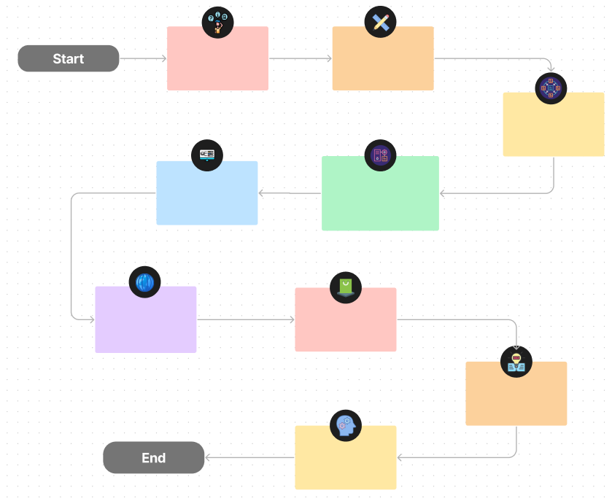Note: In the diagram below, we've depicted the key components and interactions described in sections 3.1 to 3.7, offering a clear and concise overview of our solution architecture. This visualization simplifies the complex concepts and relationships discussed in those sections, making it easier for the reader to grasp the overall design and innovation strategies briefly.

Improvement & Case Study

Explainable AI

Market Sentimental Analysis

Geographical Analysis

Continuous Learning

Model Training

Data Pre-processing

Feature Engineering

Data collection

**4. Conclusion**

Market basket analysis is a valuable tool for retailers to understand customer purchasing behavior and identify potential cross-selling opportunities. By uncovering hidden patterns and associations between products, retailers can make informed decisions about product placement, promotions, and inventory management.

This can lead to a number of benefits, including:

Increased sales: By cross-selling complementary products, retailers can encourage customers to spend more money.

Improved customer satisfaction: By providing customers with the products, they are most likely to want, retailers can improve their overall customer satisfaction.

Reduced costs: By better understanding customer demand, retailers can reduce their inventory costs and avoid overstocking.

Overall, market basket analysis is a powerful technique that can help retailers to improve their bottom line.