1. Home Page Report of the Dashboard

1. Best/Worst Sellers Page Report of the Dashboard

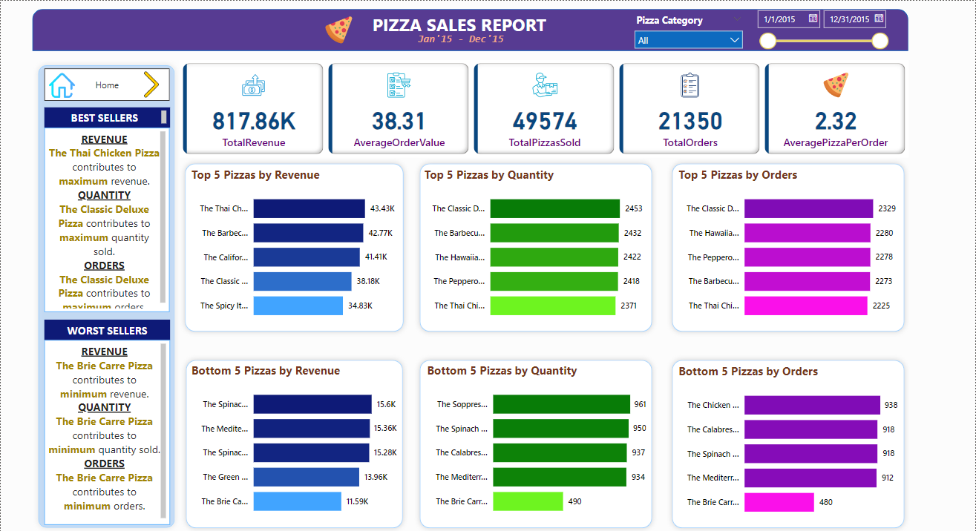

1. Home Page Report of the Dashboard filtered by Pizza Category and Order Date

1. Best/Worst Sellers Page Report of the Dashboard filtered by Pizza Category and Order Date

