**LAB ASSIGMENT : 1**

**PROGRAM: B.TECH/CSE**

**SPECIALIZATION : AIML**

**COURSE TITLE : AI ASSISTANT CODING**

**SEMESTER : 3RD**

**NAME OF THE STUDENT: SRIYA**

**ENROLLMENT NO: 2403A51350**

**BATCH NO:01**

**Task Description#2**

**>>use copilot to generate a is_prime() python function**

**Expected output#2**

**>>function to check primality with correct input**

**PROMPT:**

**>>Develop a python program to check a number prime or not**

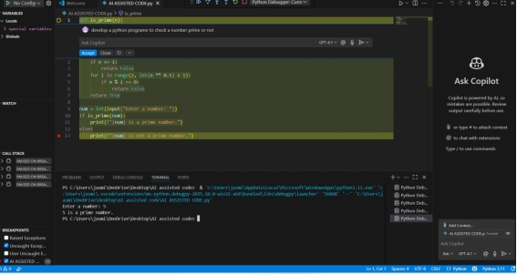

**Task Description#3**

**>>write a comment like#function to reverse a string and use copilot to generate a function**

**Expected output#3**

**auto completed function**

**PROMPT:**

**Develop a python code to generate a comment like#function to reverse a string**

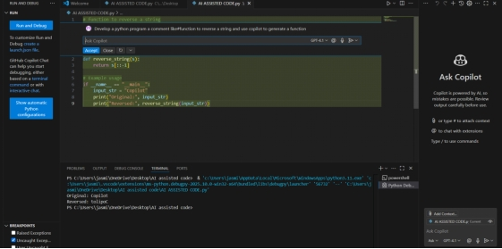

**Task Description#4**

**>>Generate both recursive and iterative versions of a factorial functions using comments**

**Expected output#4**

**>>two working factorial implementation**

**PROMPT:**

**develop a python program to generate both recursive and iterative versions of a factorial functions using functions**

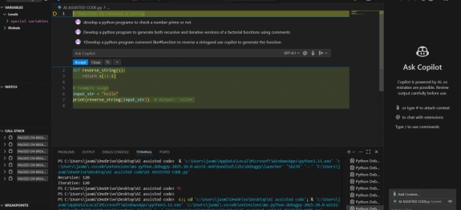

**Task Description#5**

**>>use copilot to find the largest number in a list**

**assess code quality and efficiency**

**Expected output#5**

**a valid function with your review**

**PROMPT:**

**>>Develop a python program to find largest number in a list assess code quality and efficiency**

