PROGRAM: B.TECH

SPECIALIZATION: CSE - AIML

COURSE TITLE: AI CODING

SEMESTER : 3RD SEM

NAME OF STUDENT: SRIYA

ENROLLMENT NO: 2403A51350

BATCH NO: 01

ASSIGNMENT 12.3:

Task Description #1 – Linear Search implementation  
Task: Write python code for linear_search() function to search a value  
in a list and extract it’s index

PROMPT:

Write python code for linear_search() function to search a value in a list and extract it’s index with user given input

CODE:

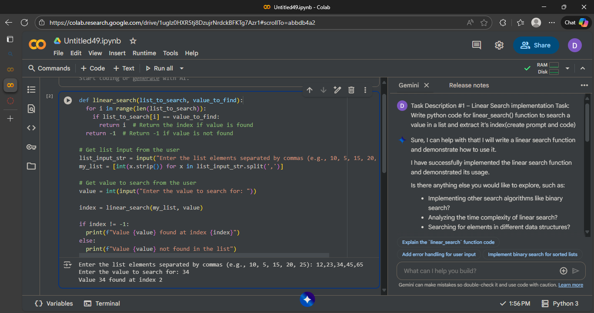

OBSERVATION :

Based on the execution of the code:

1. The user was prompted to enter a list of elements separated by commas and entered "12,23,34,45,65". This input was successfully parsed into a Python list [12, 23, 34, 45, 65].
2. The user was then prompted to enter the value to search for and entered "34".
3. The linear_search function was called with the list [12, 23, 34, 45, 65] and the value 34.
4. The function iterated through the list and found the value 34 at index 2.
5. The function returned the index 2.
6. The code then printed the message "Value 34 found at index 2".

Task Description #2 – Sorting Algorithms  
Task: Ask AI to implement Bubble Sort and check sorted output

PROMPT:

Write a python code on bubble sort with user given input.

CODE:

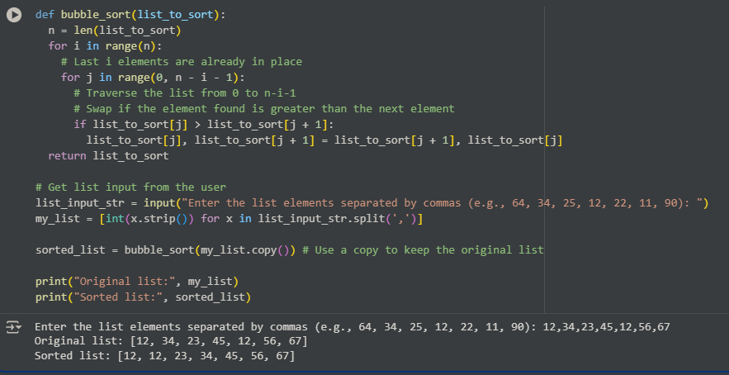

OBSERVATION:

1. The code takes a comma-separated list as user input.
2. The bubble_sort function sorts the list by repeatedly swapping adjacent elements.
3. A copy of the original list is sorted to preserve the original.
4. The original and the correctly sorted lists are then printed.

Task Description #3 – Optimization  
Task: Write python code to solve below case study using linear  
optimization

PROMPT:

Write python code to solve below case study using linear  
optimization

CODE:

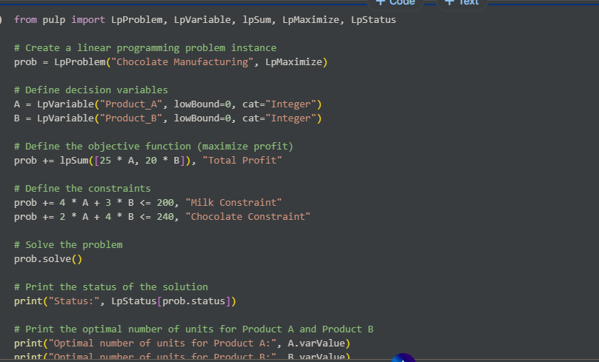

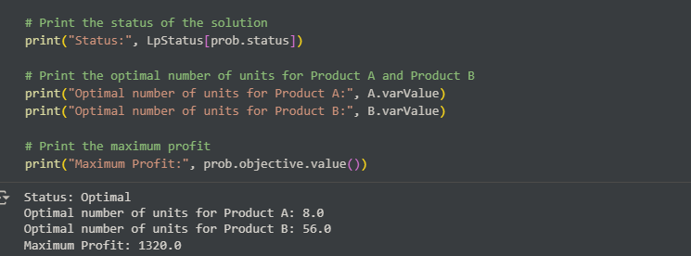

OBSERVATION:

Data Analysis Key Findings

* The linear programming problem for chocolate manufacturing was successfully set up with the objective of maximizing profit.
* The constraints on milk and chocolate availability were incorporated into the model (4*Product_A + 3*Product_B <= 200 for milk and 2*Product_A + 4*Product_B <= 240 for chocolate).
* The solver found an optimal integer solution for the production quantities.
* The optimal production plan is to produce 8 units of Product A and 56 units of Product B.
* Following this production plan yields a maximum profit of $1320.0.

Task Description #4 – Gradient Descent Optimization  
Task: Write python code to find value of x at which the function  
f(x)=2X3+4x+5 will be minimum

PROMPT:

Write python code to find value of x at which the function  
f(x)=2X3+4x+5 will be minimum

CODE:

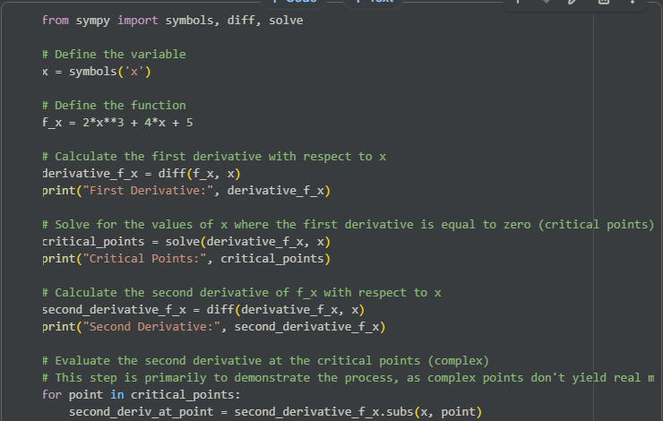

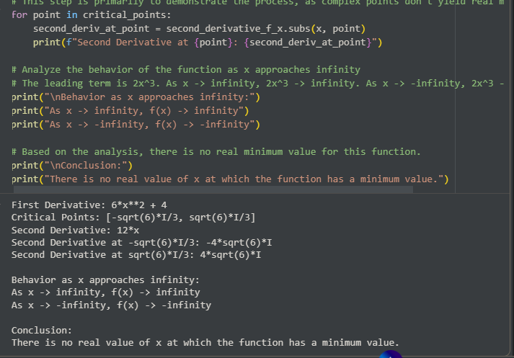

OBSERVATION:

1. The first derivative of f(x) was calculated as 6*x**2 + 4.
2. Setting the first derivative to zero and solving for x yielded complex critical points [-sqrt(6)*I/3, sqrt(6)*I/3].
3. The second derivative was calculated as 12*x.
4. Evaluating the second derivative at the complex critical points resulted in complex values.
5. Analysis of the function's behavior as x approaches infinity and negative infinity showed that f(x) approaches infinity and negative infinity, respectively.
6. The conclusion is that there is no real value of x at which the function has a minimum value.