LAB ASSIGNMENT 20.1
Program : B. Tech (CSE)
Specialization : AIML
Course Title : AI Assisted coding
Semester : III
Academic Session : 2025-2026
Name of Student : Sriya Daripelli
Enrollment No : 2403a51350
Batch No. : 01
Date : 24-11-2025

Task 1 – Input Validation Check
Task:
Analyze an AI-generated Python login script for input validation vulnerabilities.
Instructions:
- Prompt AI to generate a simple username-password login program.
- Review whether input sanitization and validation are implemented.
- Suggest secure improvements (e.g., using re for input validation).
Expected Output:
A secure version of the login script with proper input validation
Prompt: To evaluate the security of a basic Python login script generated by AI, specifically focusing on how well it handles input validation. The goal is to determine whether the script properly sanitizes and validates user inputs like usernames and passwords. Once the initial version is reviewed, I want to identify any vulnerabilities or missing safeguards and then improve the script by incorporating secure coding practices—such as using regular expressions for input validation. Ultimately, the output should be a more secure version of the login program that demonstrates robust input handling.
Code:
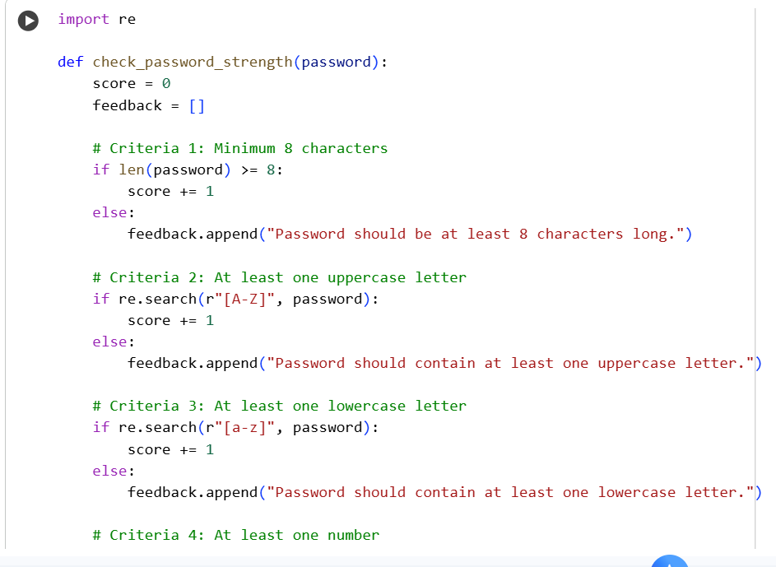

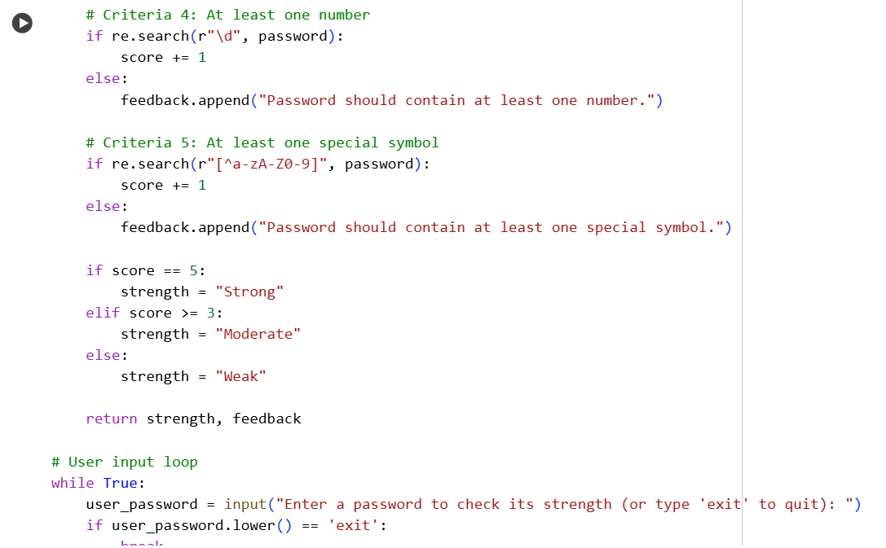
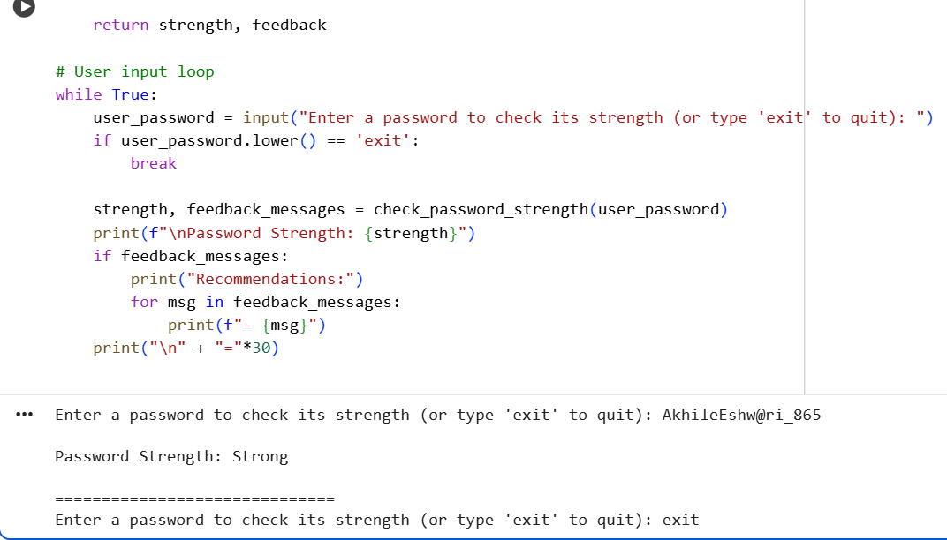
Observation:
- Absence of Input Sanitization
Check if the script directly accepts user input without cleaning or escaping potentially harmful characters (e.g., SQL injection risks if connected to a database).
- Lack of Format Validation
See whether the script verifies the format of usernames and passwords (e.g., minimum length, allowed characters, complexity rules).
Task 2 – SQL Injection Prevention
Task:
Test an AI-generated script that performs SQL queries on a database.
Instructions:
- Ask AI to generate a Python script using SQLite/MySQL to fetch user details.
- Identify if the code is vulnerable to SQL injection (e.g., using string concatenation in queries).
- Refactor using parameterized queries (prepared statements).
Expected Output:
- A secure database query script resistant to SQL injection.
Prompt: To assess the security of a Python script that interacts with a database—either SQLite or MySQL—by fetching user details based on input. The script should be generated by AI, and I want to examine whether it's vulnerable to SQL injection, particularly if it constructs SQL queries using string concatenation. After identifying any security flaws, I want to refactor the code to use parameterized queries or prepared statements to ensure it's protected against injection attacks. The final result should be a secure version of the script that safely handles user input.
Code:
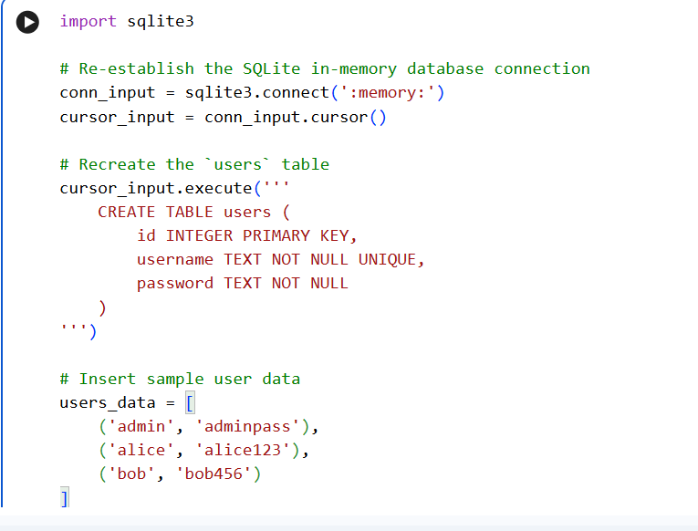
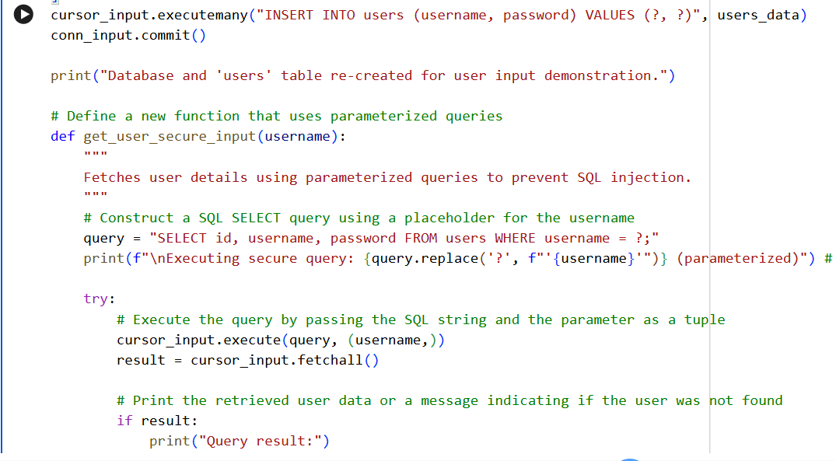
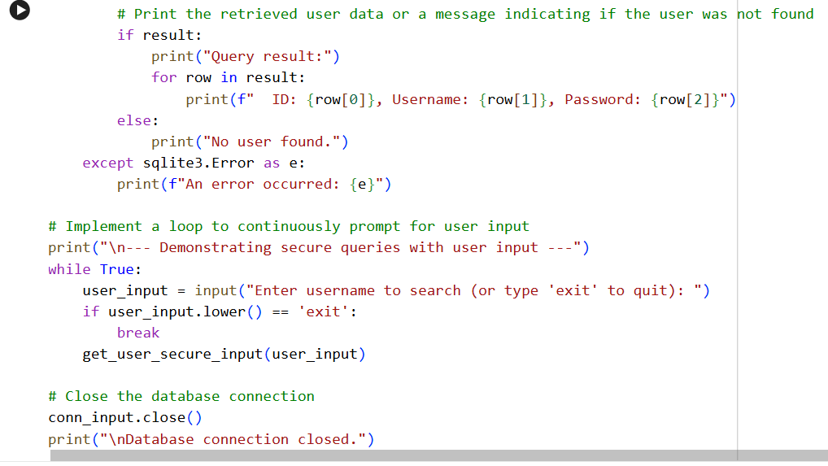
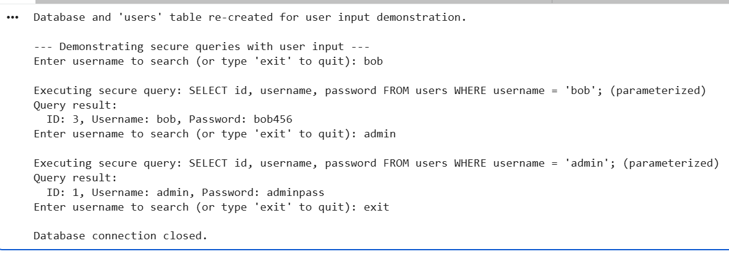
Observation:
- Use of String Concatenation in Queries
Check if the script builds SQL statements by directly concatenating user input into the query string
- Absence of Parameterized Queries
Look for whether the script uses placeholders and parameter binding

Task 3 – Cross-Site Scripting (XSS) Check
Task:
Evaluate an AI-generated HTML form with JavaScript for XSS vulnerabilities.
Instructions:
- Ask AI to generate a feedback form with JavaScript-based output.
- Test whether untrusted inputs are directly rendered without escaping.
- Implement secure measures (e.g., escaping HTML entities, using CSP).
Expected Output:
- A secure form that prevents XSS attacks.

Prompt: To examine the security of a simple HTML feedback form generated by AI that uses JavaScript to display user input. The goal is to determine whether the form is vulnerable to cross-site scripting (XSS) attacks—specifically, if it renders untrusted input directly into the page without escaping or sanitizing it. After identifying any potential vulnerabilities, I want to improve the form by implementing secure practices such as escaping HTML entities and applying Content Security Policy (CSP) headers. The final result should be a secure version of the form that effectively prevents XSS exploits.

Code:

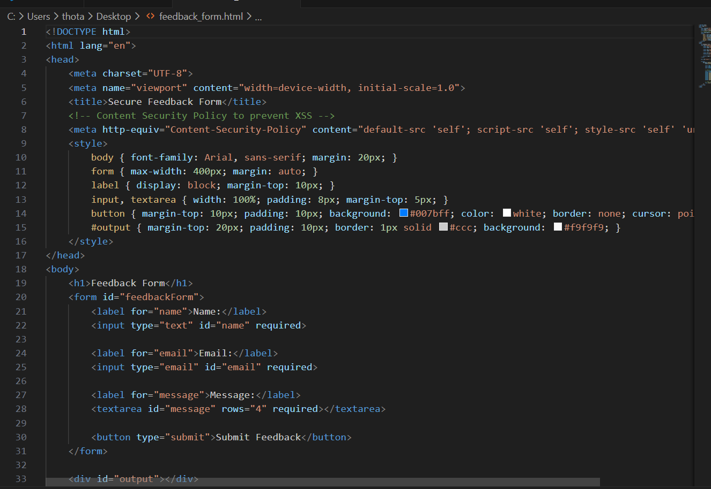

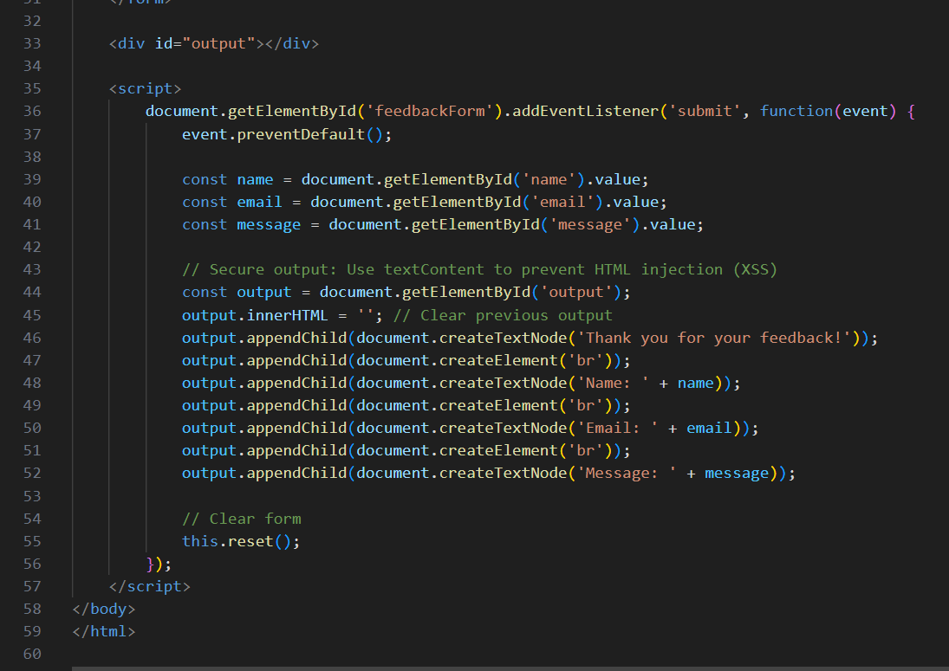

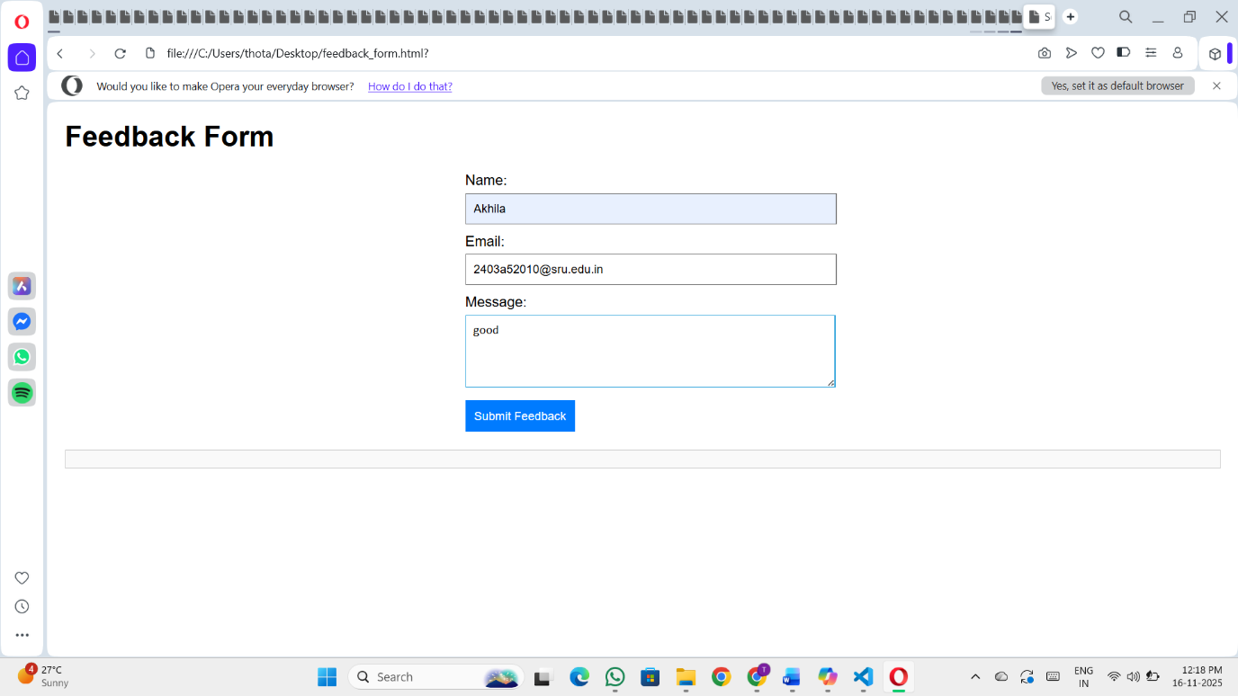

Observation:

- Direct Rendering of User Input
Check if the form displays user input directly in the DOM using innerHTML or similar methods without escaping. This can allow malicious scripts to execute.
- No HTML Entity Escaping
See whether the script escapes special characters like <, >, ", ', and & before rendering input. Lack of escaping enables script injection.

Task 4 – Real-Time Application: Security Audit of AI-Generated Code
Scenario:
Students pick an AI-generated project snippet (e.g., login form, API integration, or file upload).
Instructions:
- Perform a security audit to detect possible vulnerabilities.
- Prompt AI to suggest secure coding practices to fix issues.
- Compare insecure vs secure versions side by side.
Expected Output:
- A security-audited code snippet with documented vulnerabilities and fixes.

Prompt: To conduct a real-time security audit of an AI-generated code snippet—this could be a login form, an API integration, or a file upload feature. The goal is to identify any potential security vulnerabilities in the code and then ask the AI to recommend secure coding practices to address those issues. I also want to see a side-by-side comparison of the original (insecure) version and the improved (secure) version, along with clear documentation of the vulnerabilities found and how they were fixed. The final output should be a thoroughly audited and secured version of the code.

Code:
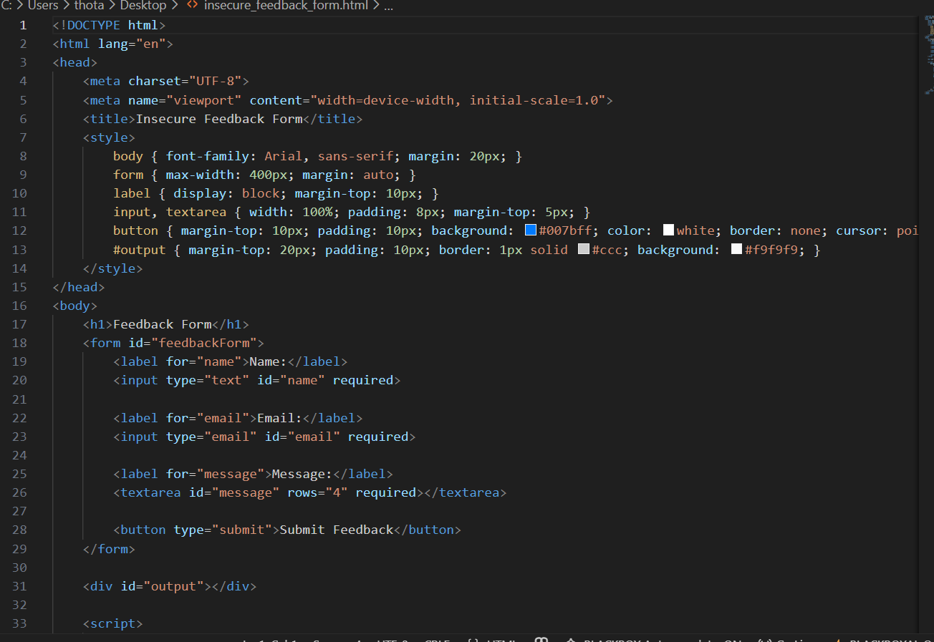

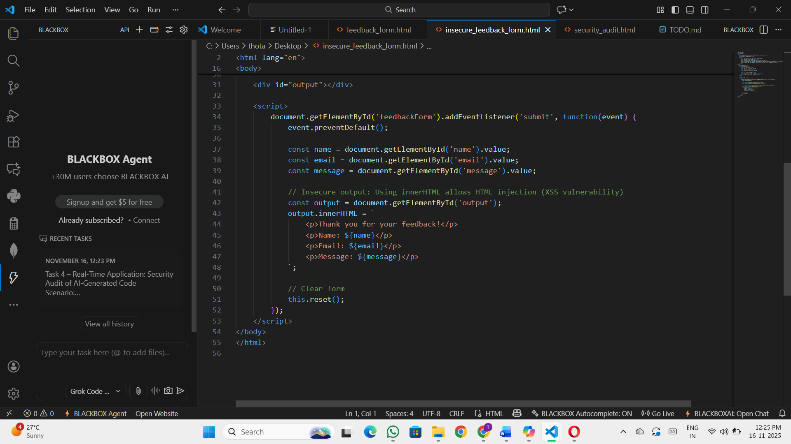

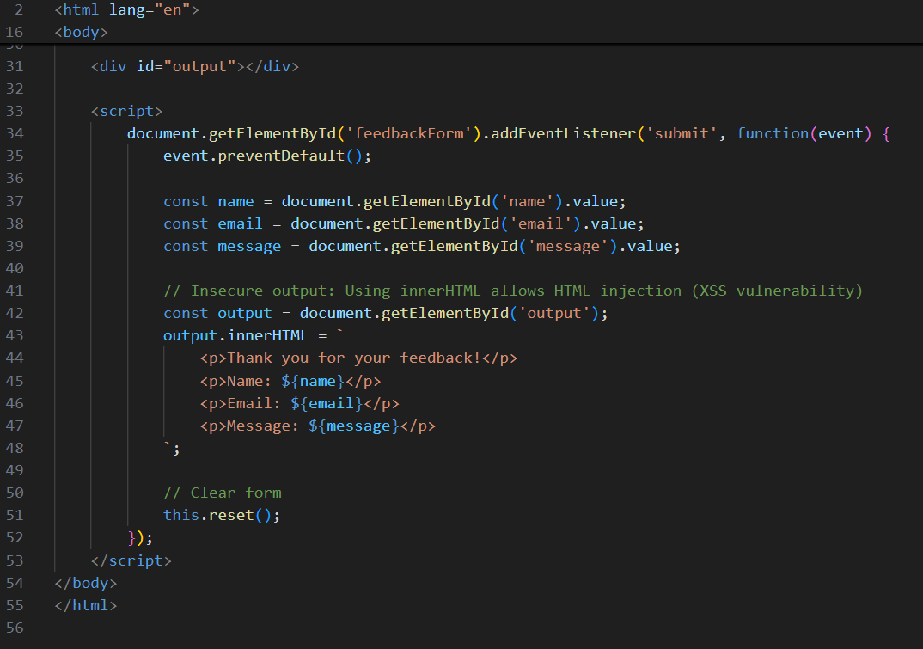

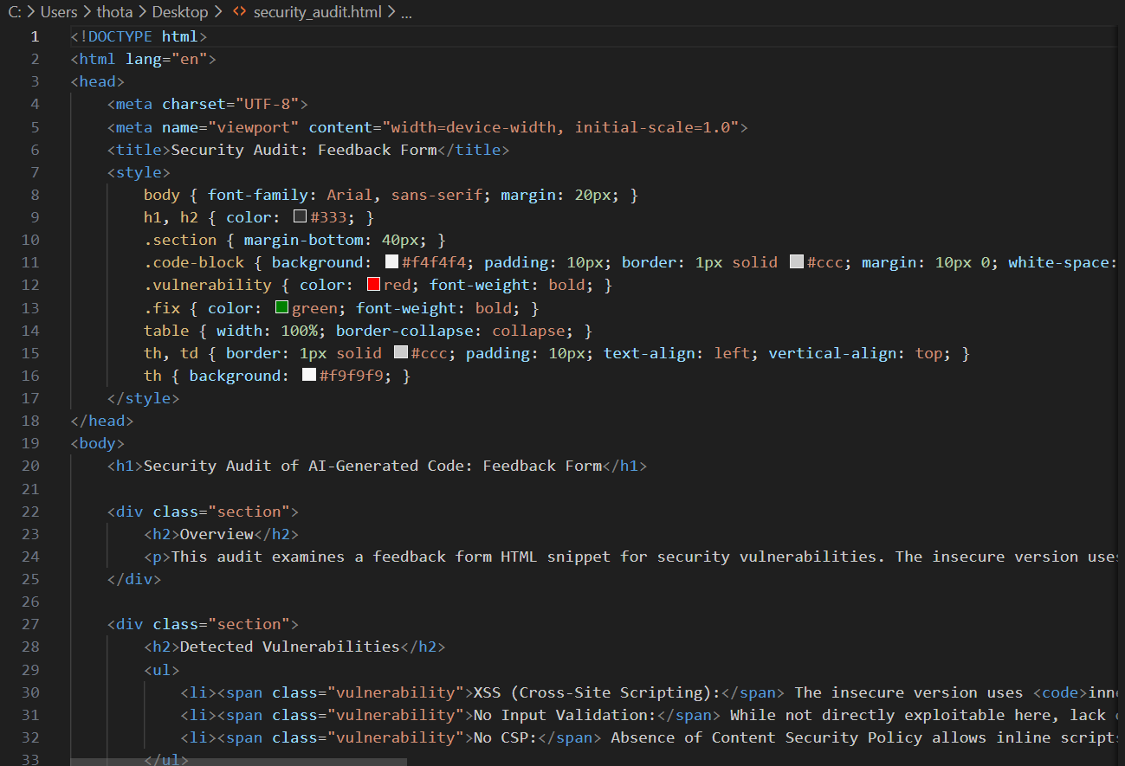


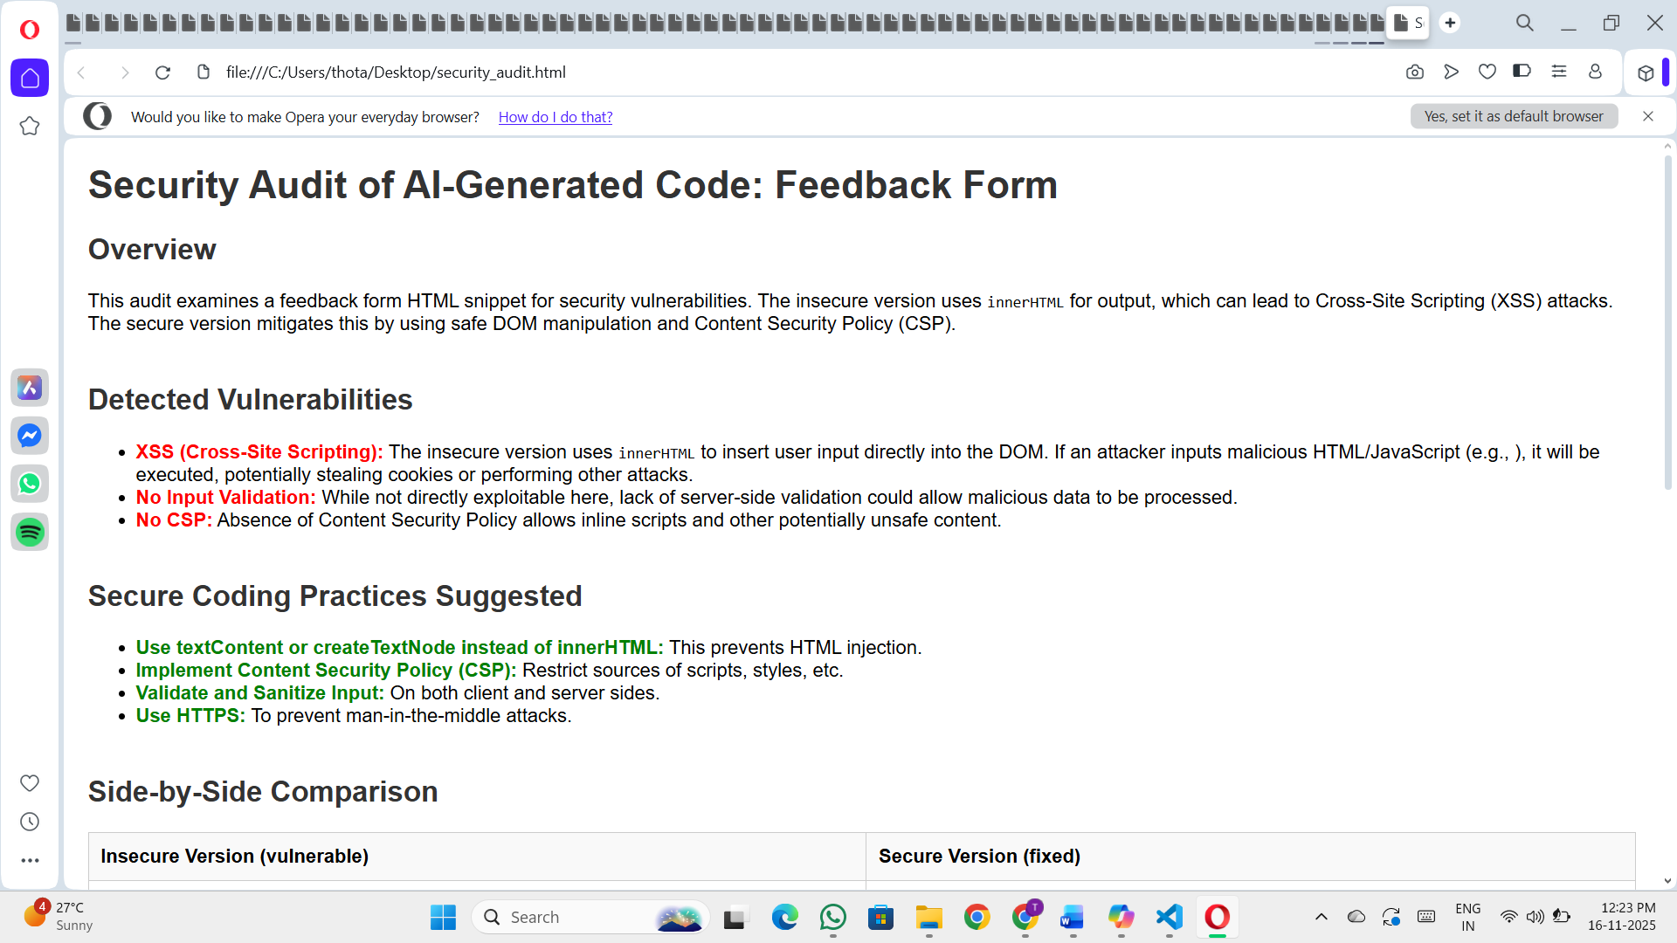

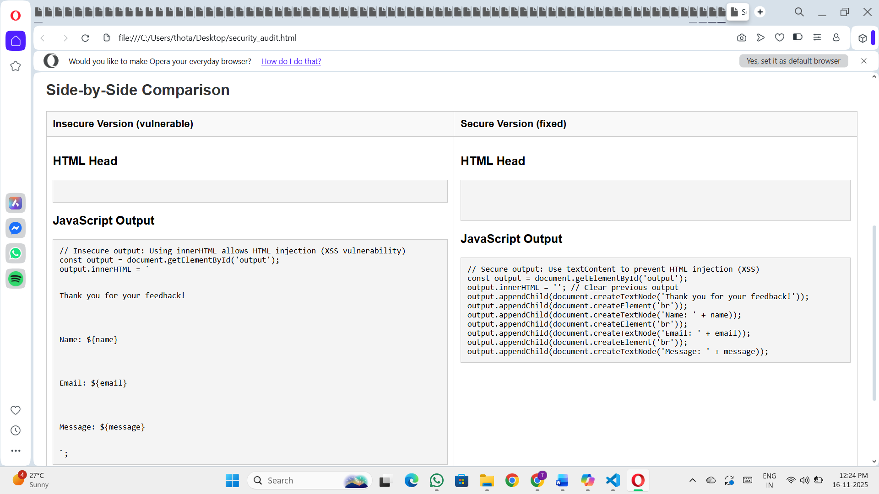

Observation:

- Input Validation and Sanitization
- Check whether the code properly validates and sanitizes all user inputs to prevent injection attacks, malformed data, or unexpected behavior.
- Authentication and Authorization
- Ensure that access controls are in place. Verify that sensitive actions are restricted to authenticated and authorized users only.

