
Program :B.tech(CSE)
Specialization :AIML
Course Title :AI Assisted Coding
Course Code :24CS002PC215
Semester :3rd semester
Academic Session :2025-2026
Name of Student :SRIYA DARIPELLI
Enrollment No. :2403A51350
Batch No. :01
Date :24/11/2025
#LAB ASSIGNMENT-19.2
#TASK DESCRIPTION-1:
Sorting Algorithm Translation
You are part of a multinational development team. The backend is written in
Java, but a new module requires a Python implementation of the same
algorithm for integration with a data science pipeline.
• Task 1: Use AI-assisted coding to translate a given Java bubble sort
program into Python. Verify that the translated code works correctly.
• Task 2: Introduce errors in the Python version to check if the input list
is empty or contains non-numeric values.
#PROMPT:
Write a Python program that translates a Java Bubble Sort program into Python. The program should include the original Java code, the correctly translated Python version, and a modified version with error handling that checks if the input list is empty or contains non-numeric values. Display sample outputs for both successful and error cases. Keep the code clean, simple, well-commented, and easy to understand.
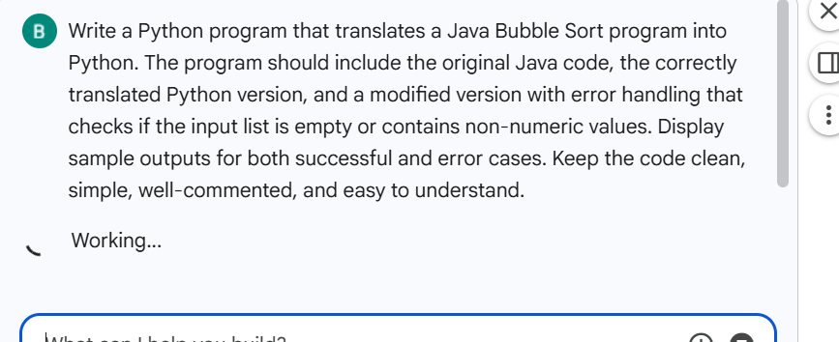
#CODE:
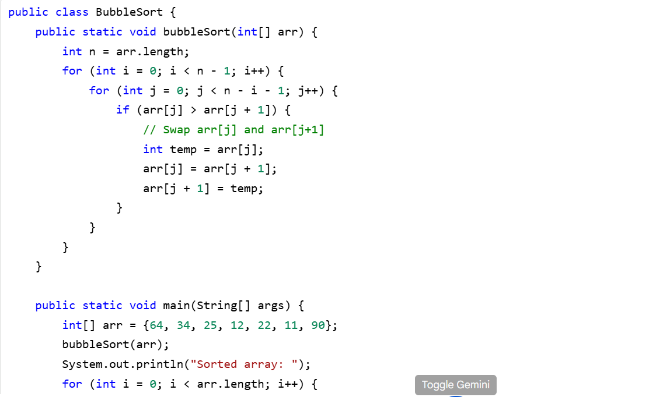
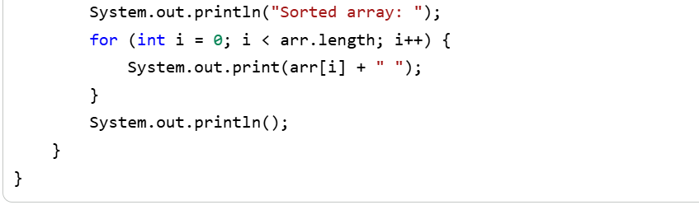
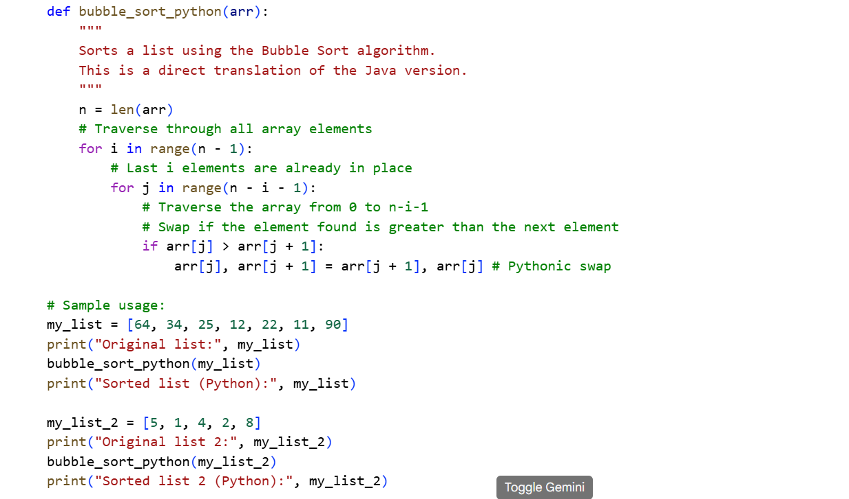
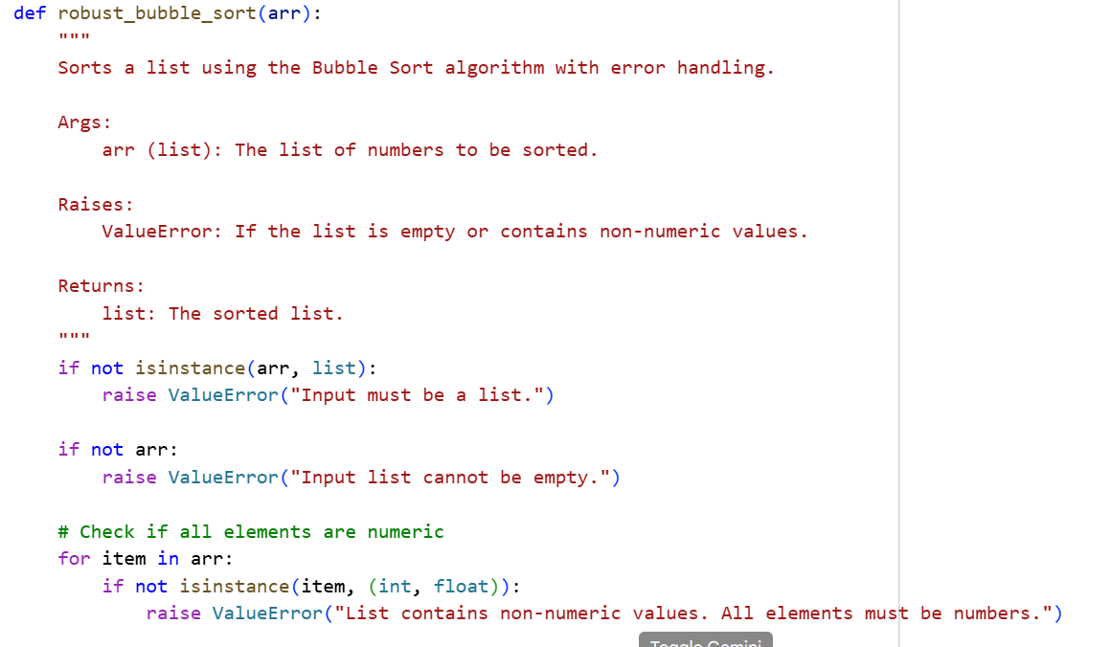
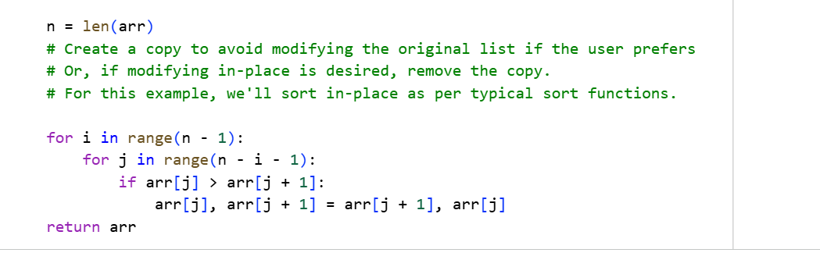
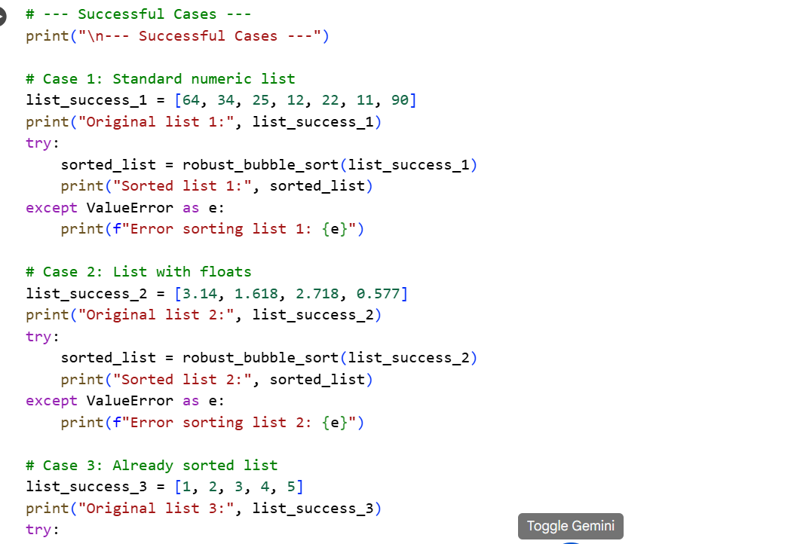
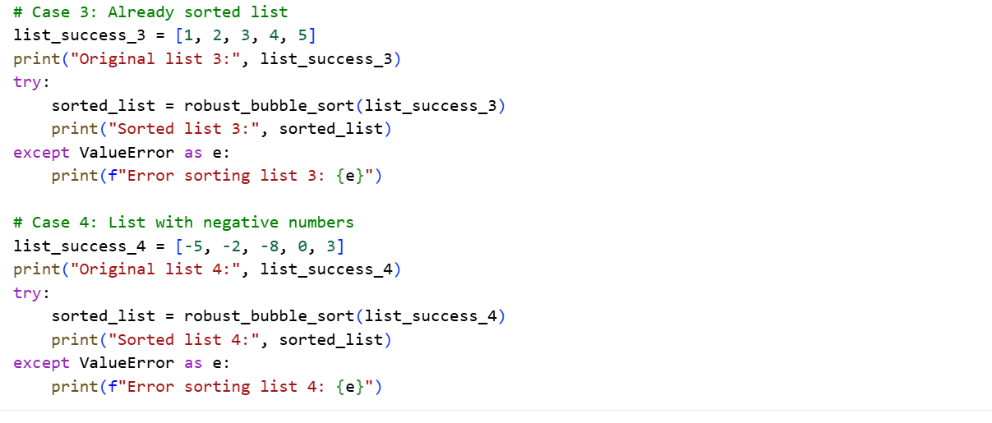
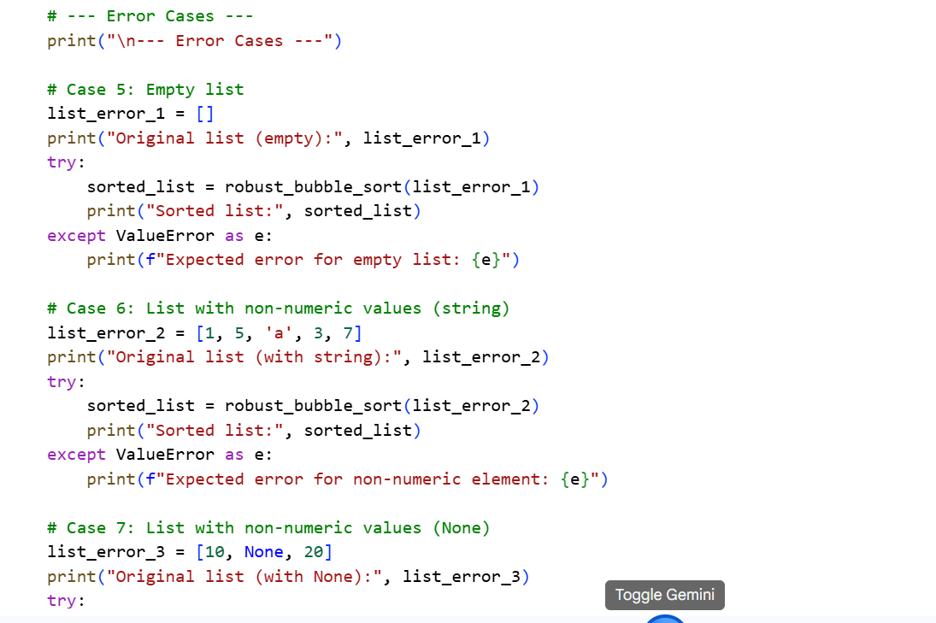
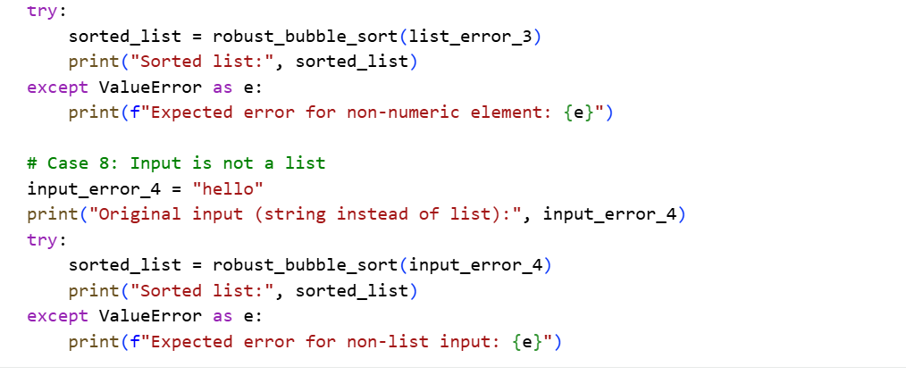
# OUTPUT:
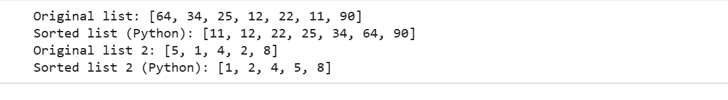
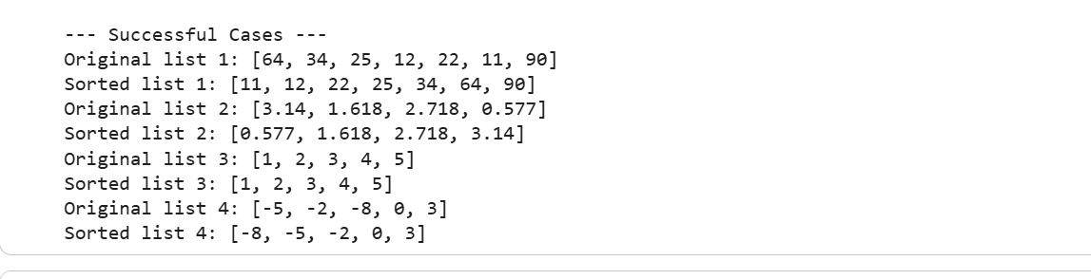
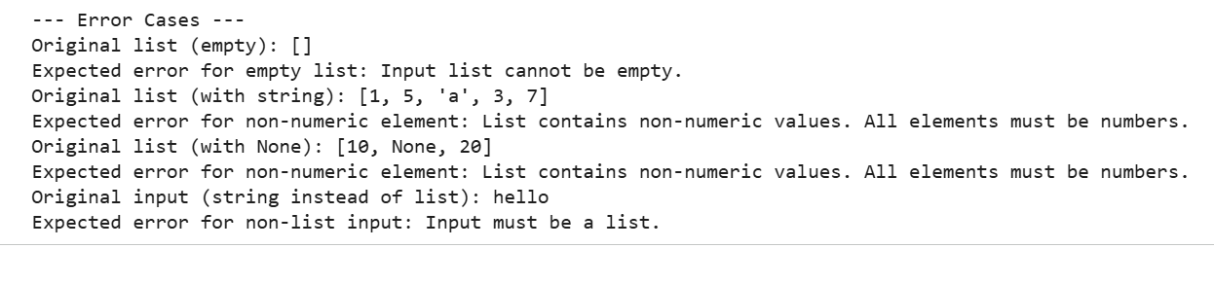

#TASK DESCRIPTION-2:
File Handling Translation
A company’s legacy codebases stores and processes files in C++, but the
analytics team needs an equivalent program in JavaScript (Node.js) for
integration with a web dashboard.
• Task 1: Translate a given C++ file read-and-write program into
JavaScript using AI assistance. Ensure the script reads a text file and
writes processed output to a new file.
• Task 2: Add error handling in the JavaScript version to gracefully handle
missing files or permission errors.
#PROMPT:
Write a JavaScript (Node.js) program that translates a given C++ file read-and-write program. The script should read a text file, process its content, and write the output to a new file. Then, modify the JavaScript version to include error handling that gracefully handles missing files or permission errors. Keep the code clean, simple, well-commented, and easy to understand, and include sample inputs and outputs to demonstrate both normal execution and error cases.
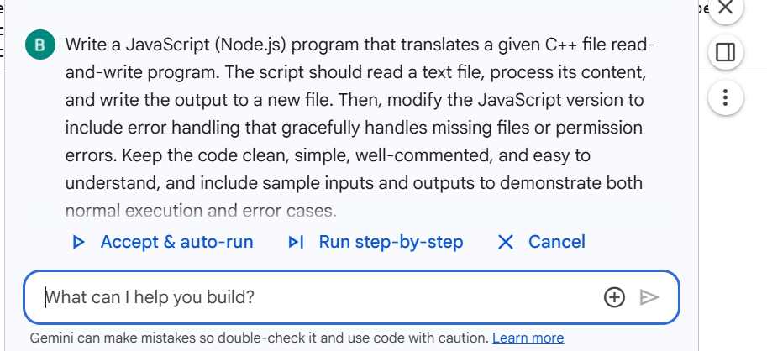
#CODE:
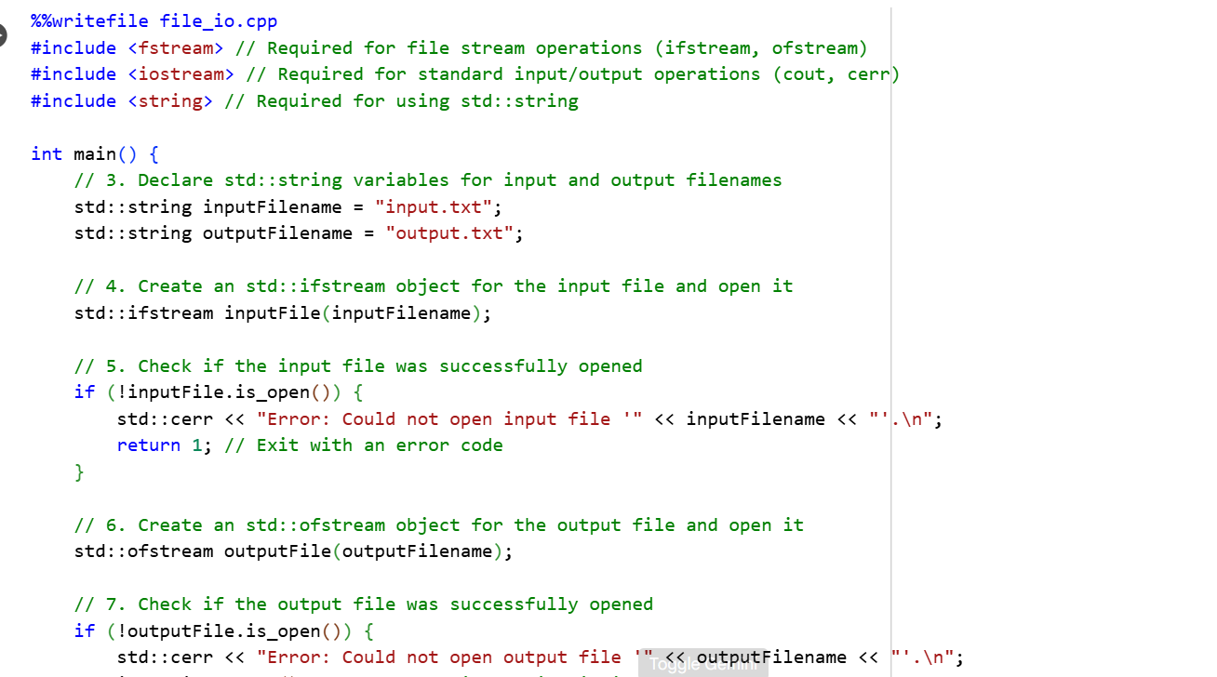
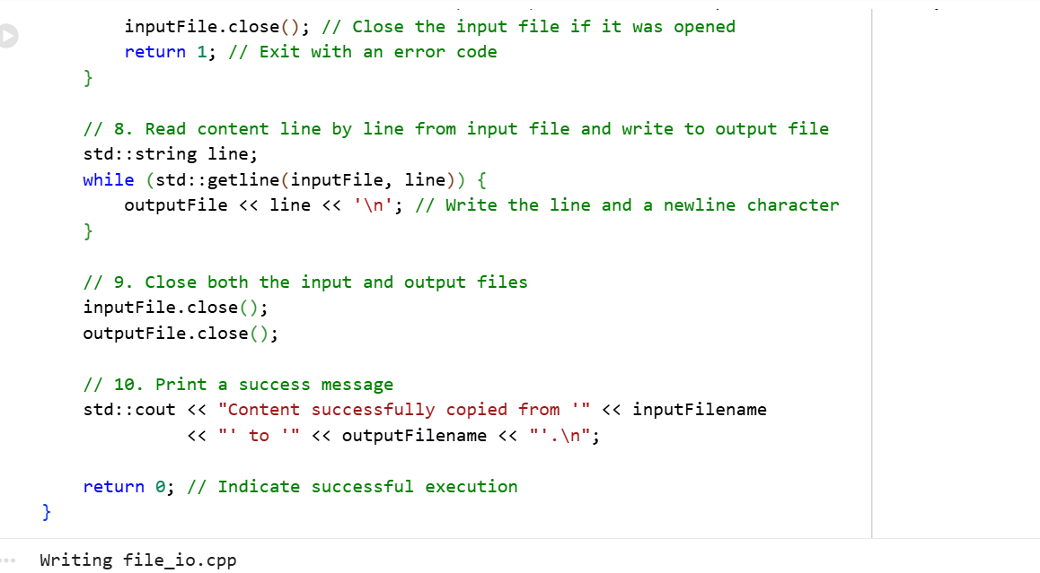
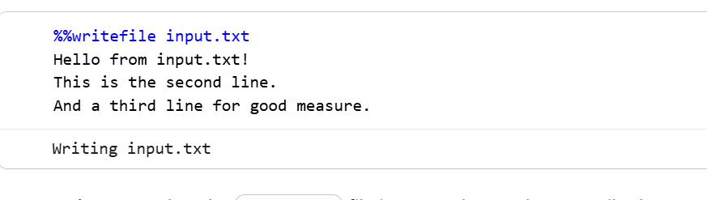
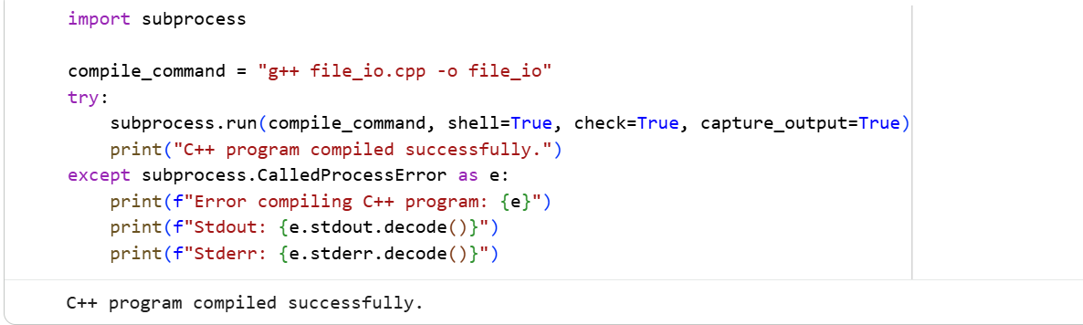
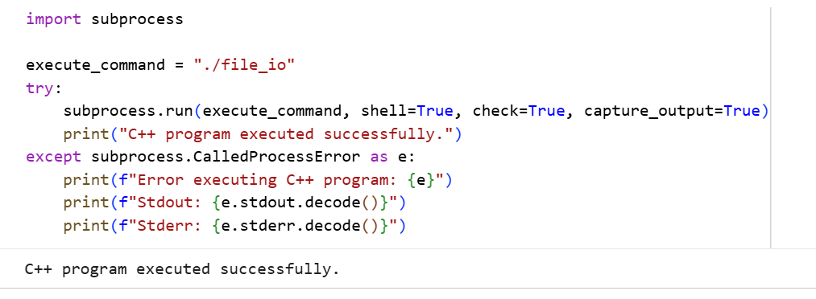
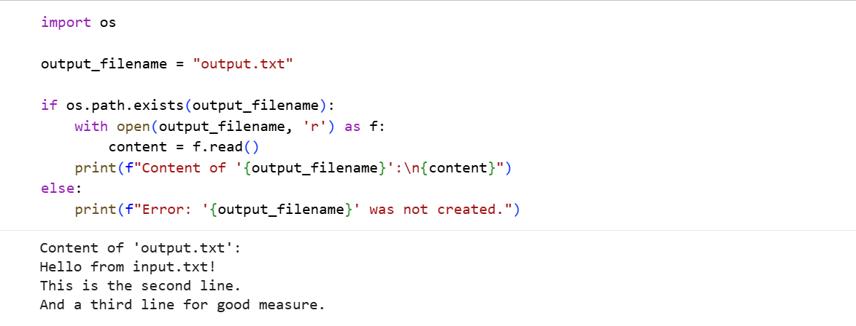
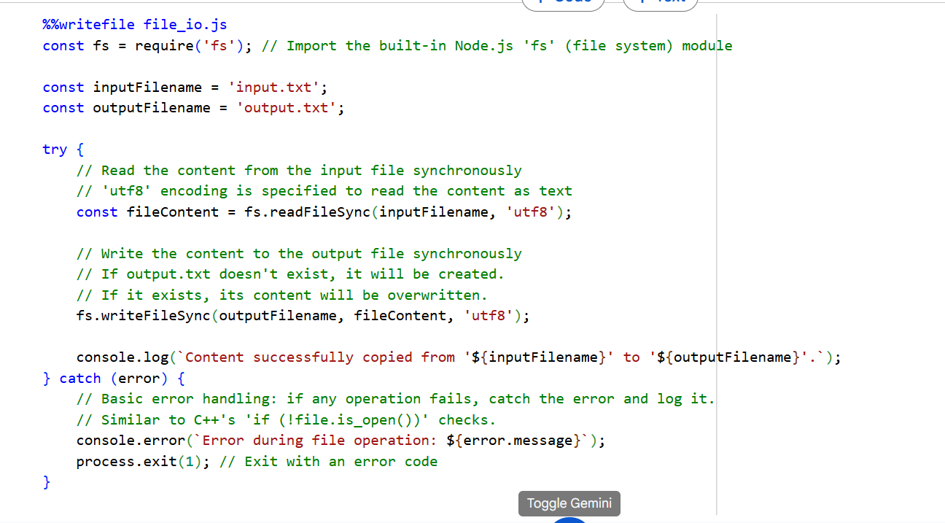
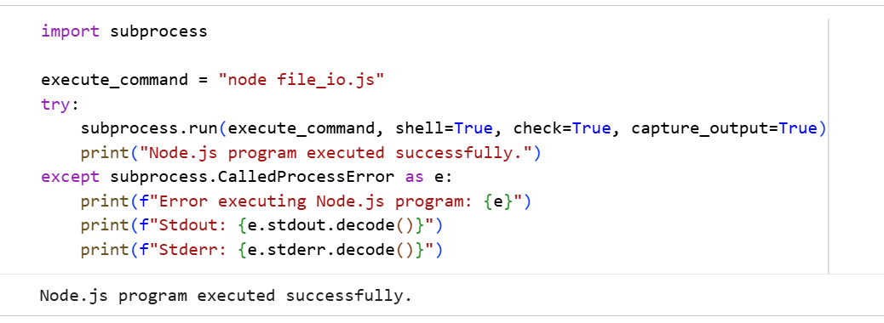
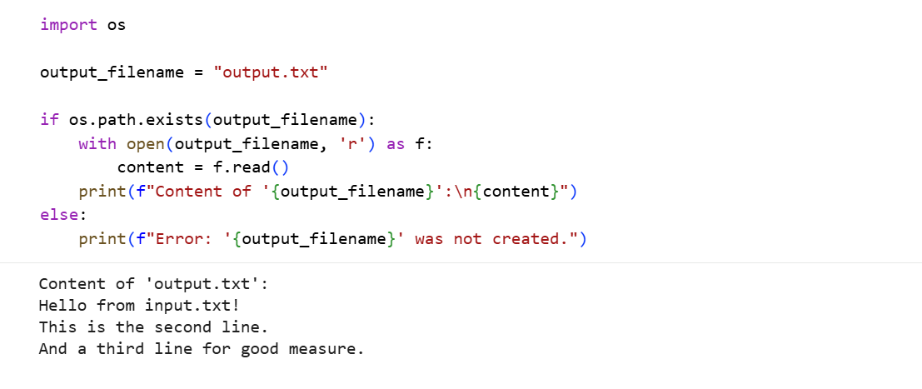
#OUTPUT:
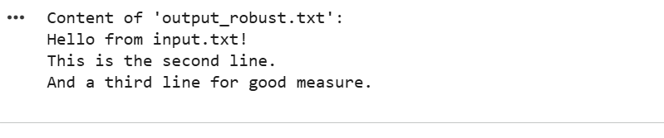

#TASK DESCRIPTION-3:
API Call Translation
Your team developed a prototype in Python to fetch weather data from an API,
but the production environment only supports Java.
• Task 1: Translate the Python script (that makes an API call and prints
the response) into Java using AI-assisted coding. Ensure equivalent
functionality.
• Task 2: Add proper error handling in the Java version for cases such as
invalid API key, request timeout, or no internet connection.

#PROMPT:
Write a Java program that translates a given Python script which fetches weather data from an API and prints the response. Ensure the Java version has equivalent functionality. Then, enhance the Java program to include proper error handling for cases such as an invalid API key, request timeout, or no internet connection. Keep the code clean, simple, well-commented, and easy to understand, and include sample outputs demonstrating both successful API calls and error scenarios.
#CODE:
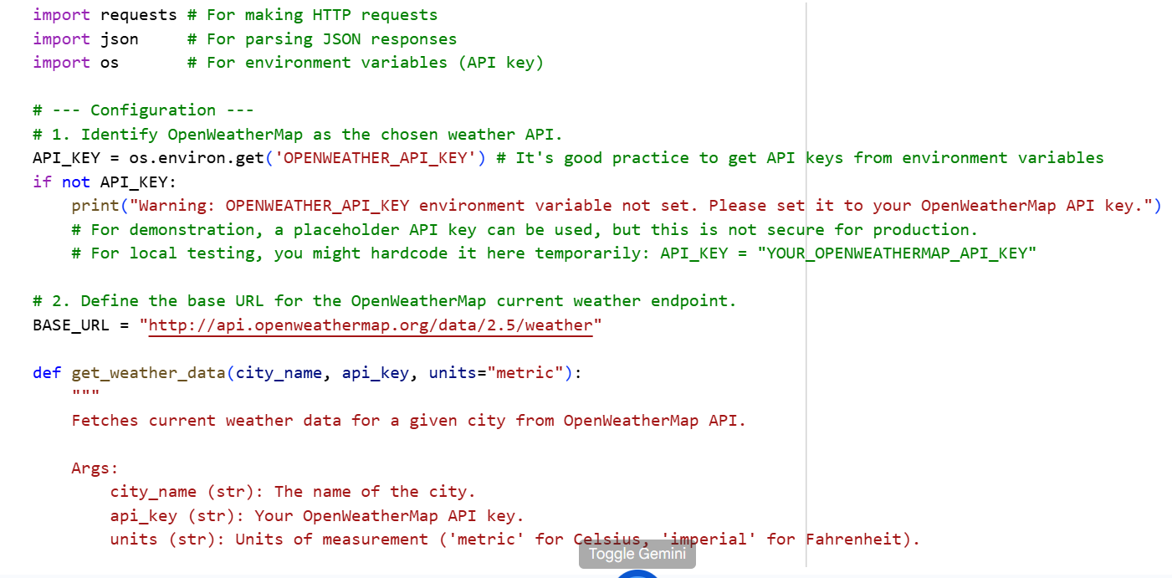
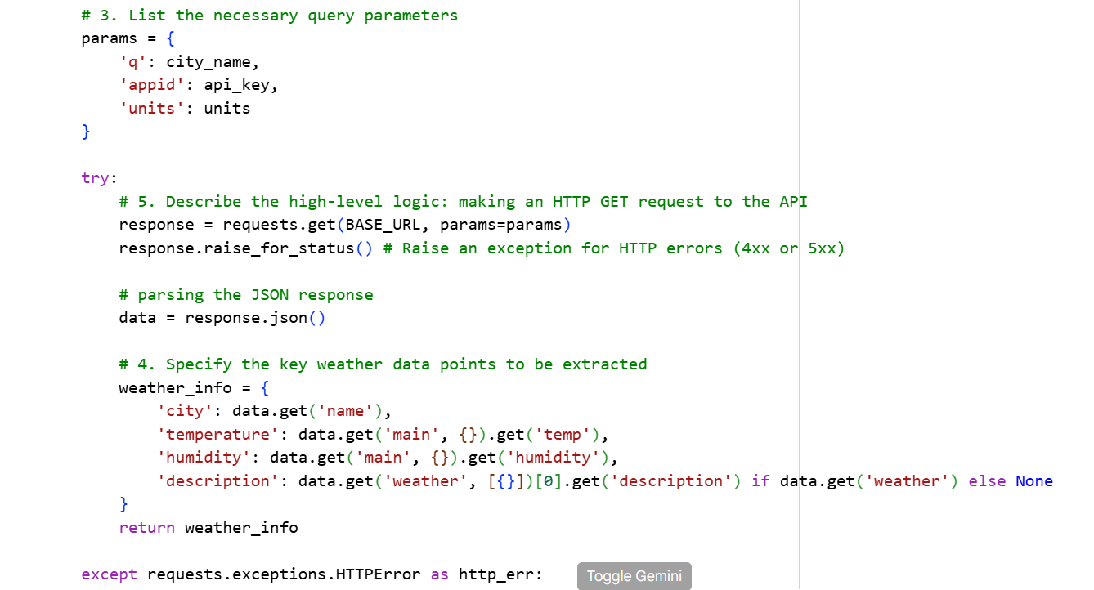
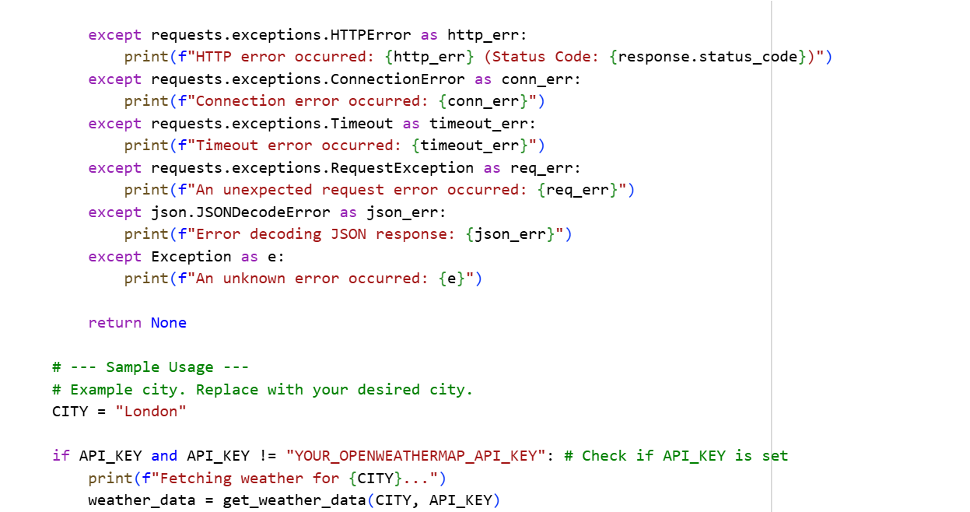
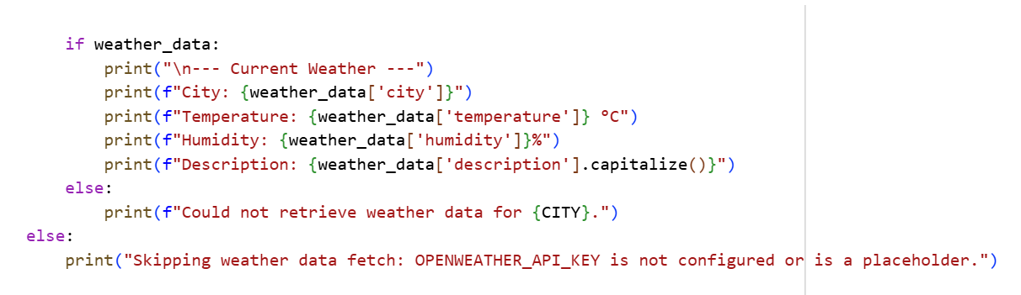
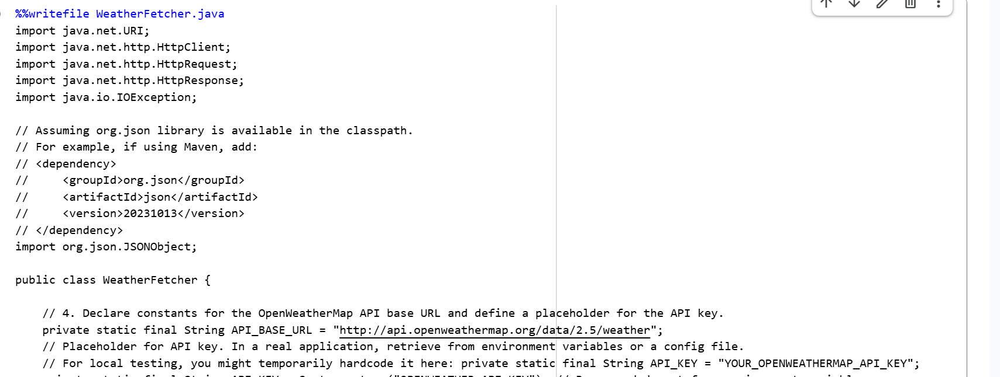
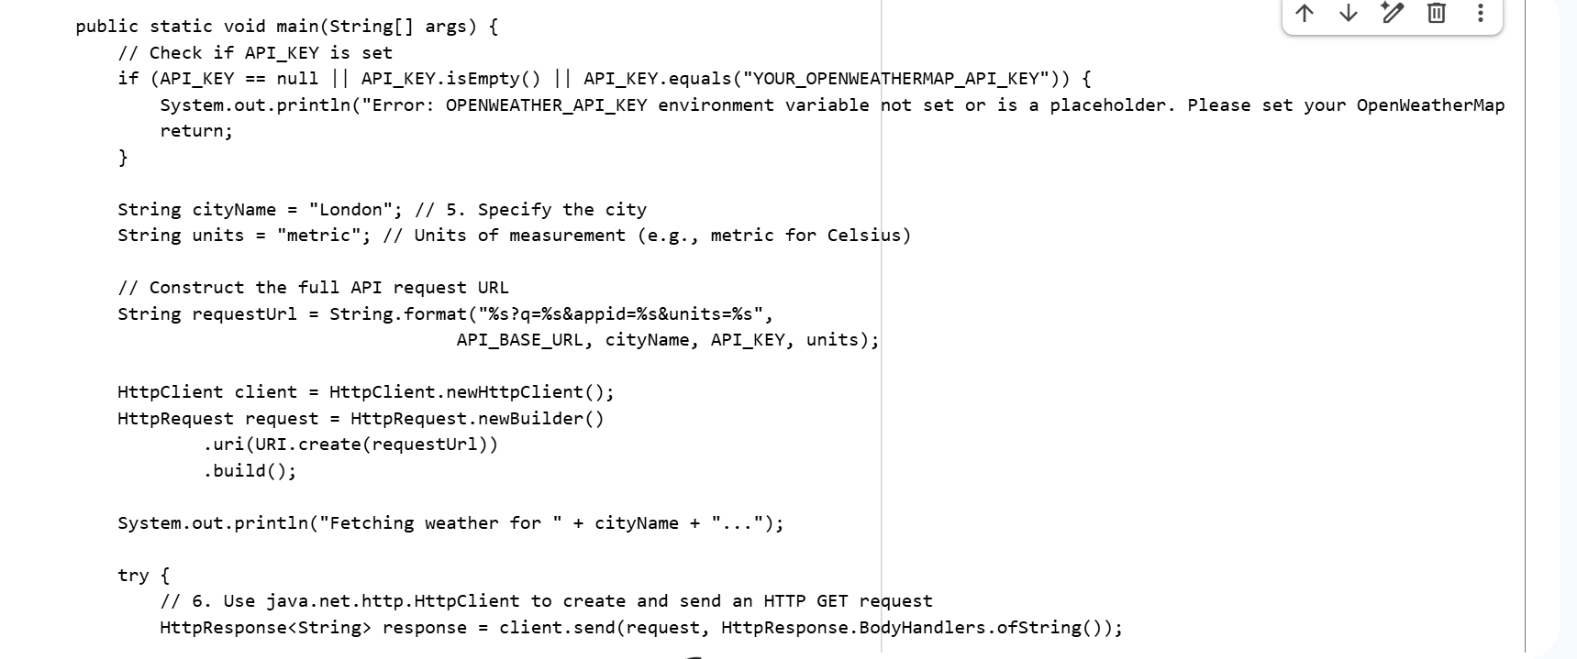

#OUTPUT:
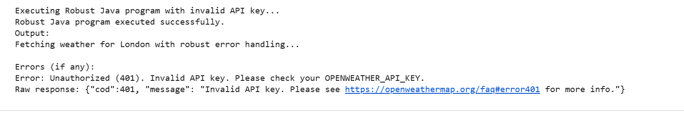
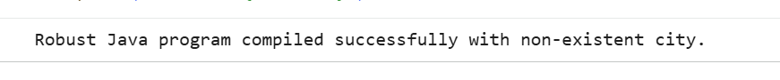
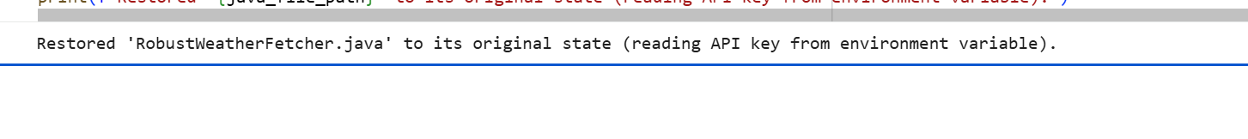

-------- Thank You-------

