ASSIGNMENT- 17

NAME: SRIYA DARIPELLI

H.NO:2403A51350

SUBJECT:AI ASSISTANT CODING

Task 1 – Social Media Data Cleaning
Task: Clean raw social media posts dataset.
Instructions:
- Remove stopwords, punctuation, and special symbols from post text.
- Handle missing values in likes and shares columns.
- Convert timestamp to datetime and extract features (hour, weekday).
- Detect and remove spam/duplicate posts.
Expected Output: A cleaned dataset with structured features for sentiment/engagement analysis
Prompt:
Generate Social Media Data Cleaning Task: Clean raw social media posts dataset.
Instructions:
- Remove stopwords, punctuation, and special symbols from post text.
- Handle missing values in likes and shares columns.
- Convert timestamp to datetime and extract features (hour, weekday). - Detect and remove spam/duplicate posts
Code:
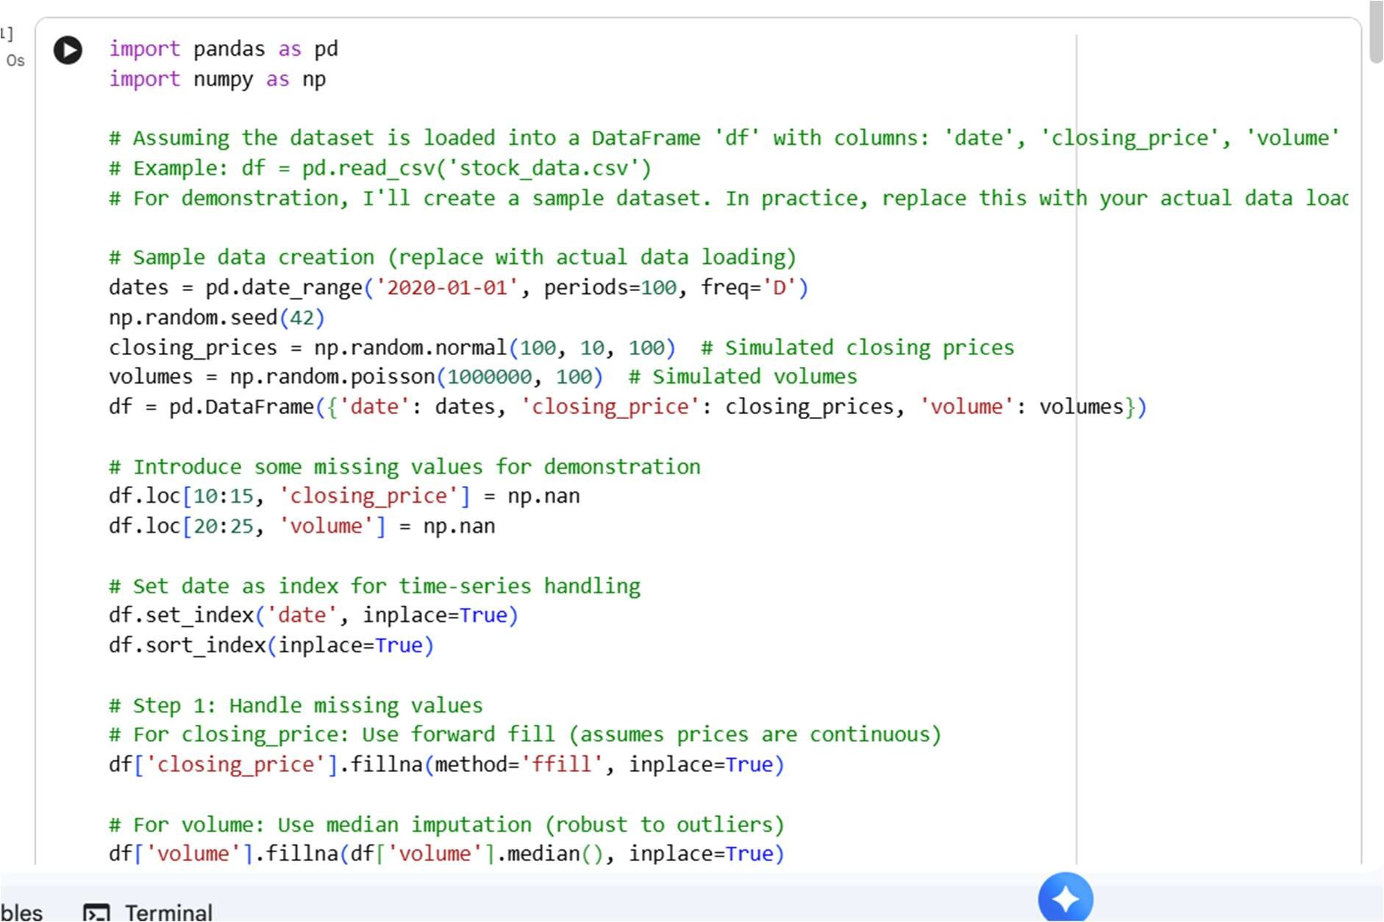

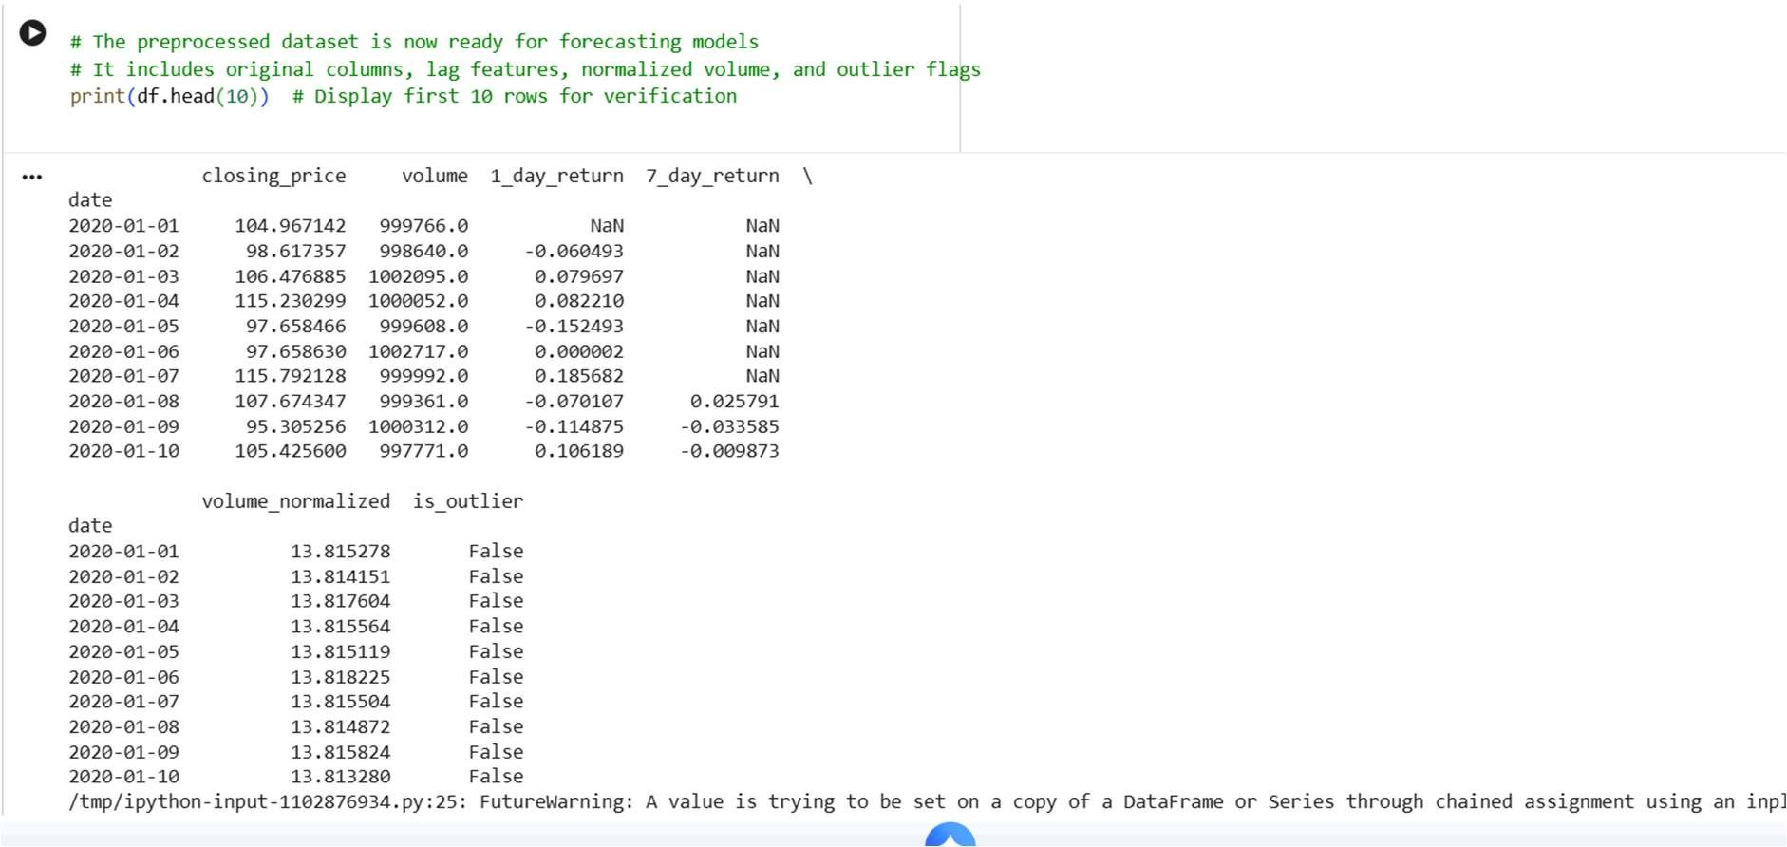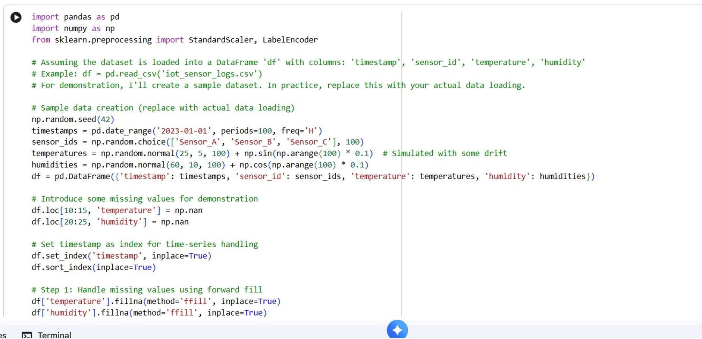

OBSERVATION:
It is observed that the code is super easy to understand and implement.

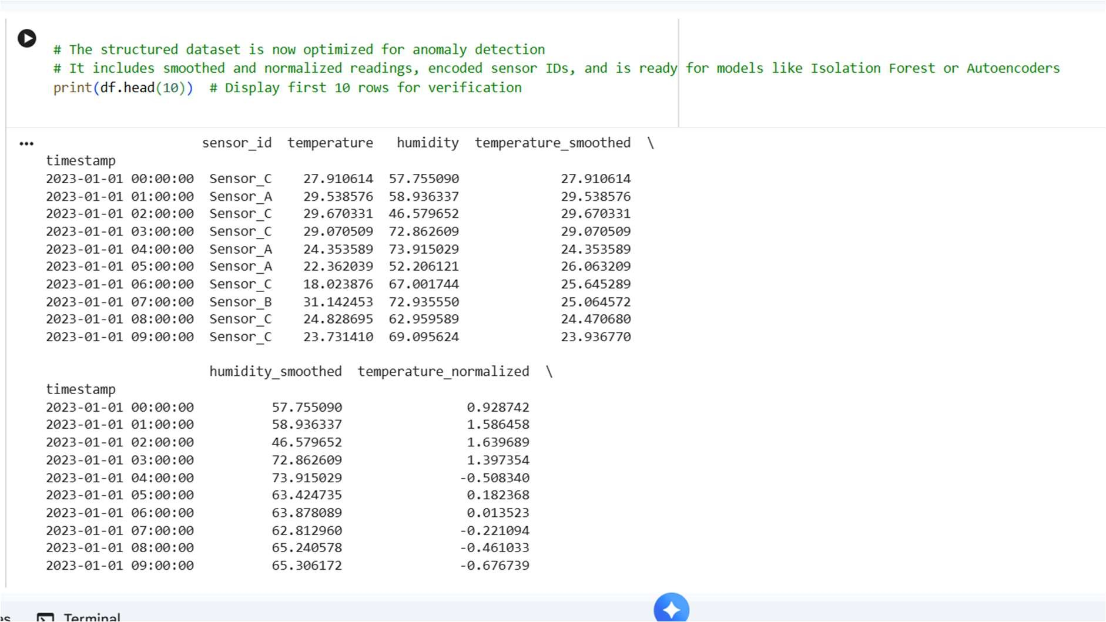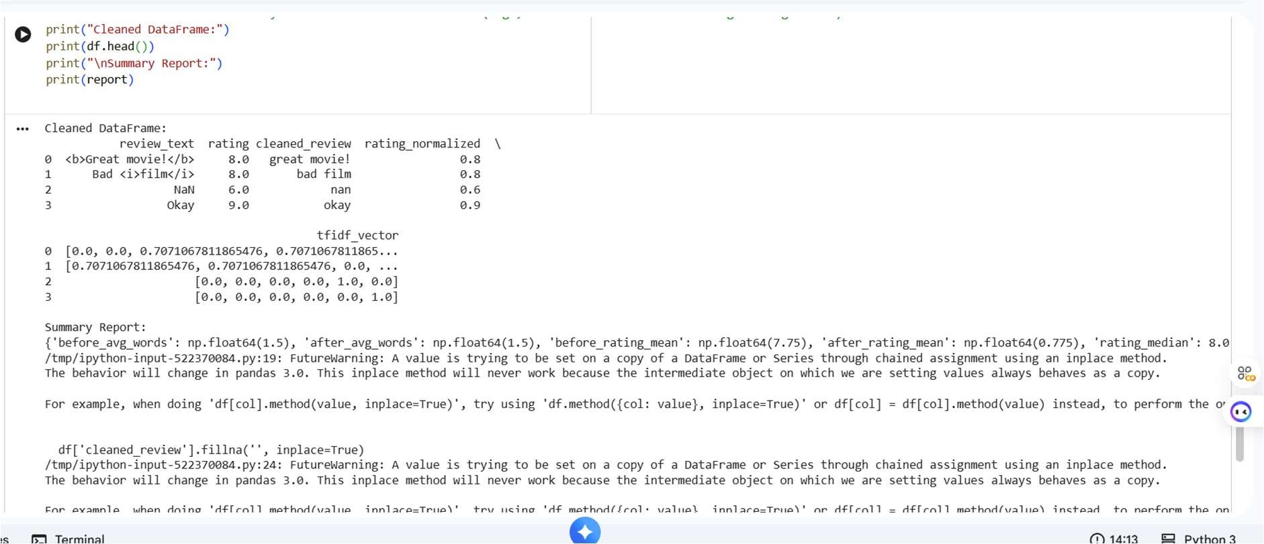
Task 2 – Financial Data Preprocessing
Task: Preprocess a stock market dataset.
Instructions:
- Handle missing values in closing_price and volume.
- Create lag features (1-day, 7-day returns).
- Normalize volume column using log-scaling.
- Detect outliers in closing_price using IQR method.
Expected Output: A time-series dataset ready for forecasting models
Prompt:
Generate a code for Financial Data Preprocessing Task: Preprocess a stock market dataset. Instructions:
- Handle missing values in closing_price and volume.
- Create lag features (1-day, 7-day returns).
- Normalize volume column using log-scaling. - Detect outliers in closing_price using IQR method
Code:
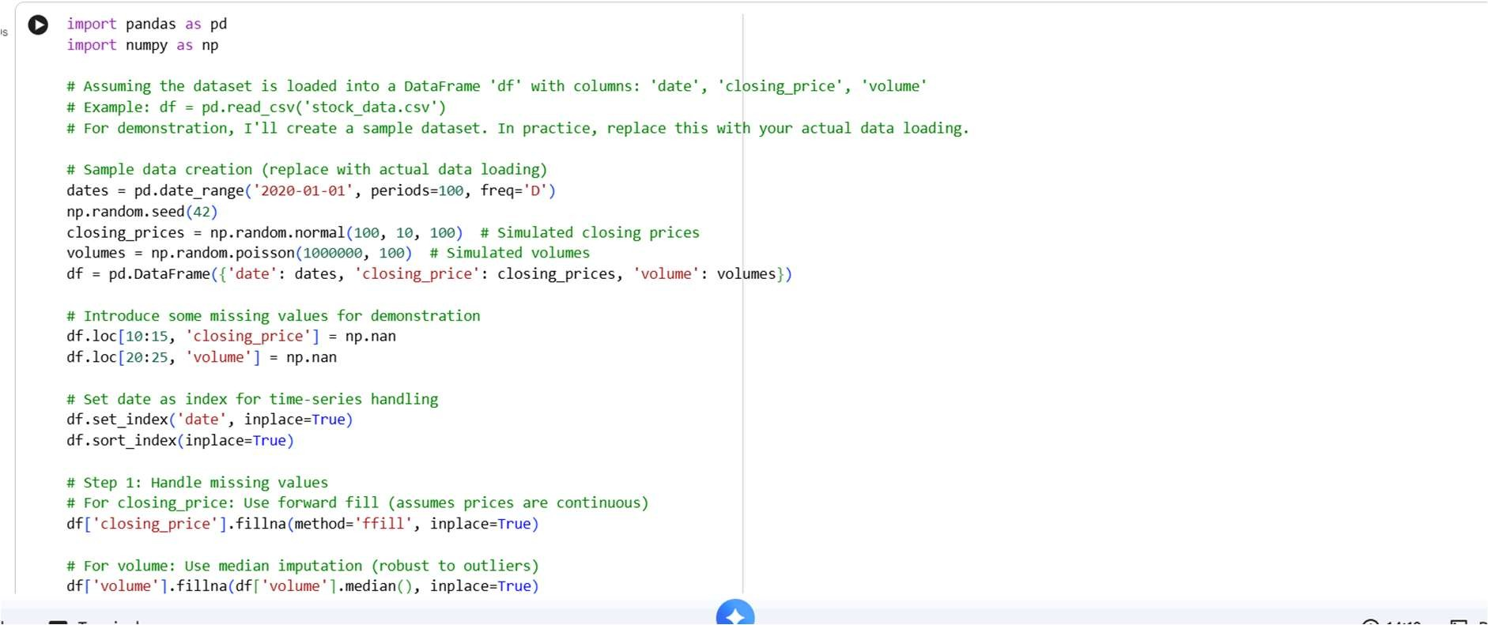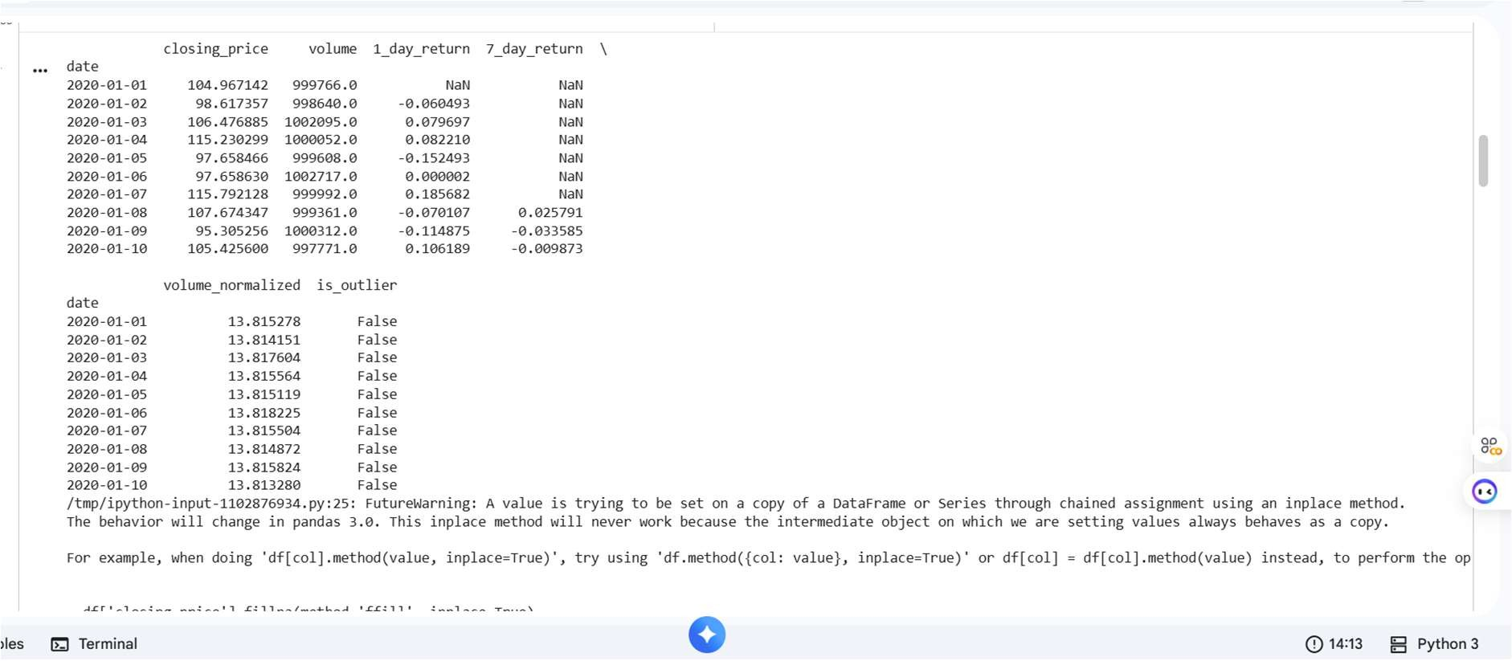

OBSERVATION:
It is observed that the code is super easy to understand and implement.

Task 3 – IoT Sensor Data Preparation
Task: Clean and preprocess IoT temperature and humidity logs.
Instructions:
- Handle missing values using forward fill.
- Remove sensor drift (apply rolling mean).
- Normalize readings using standard scaling. - Encode categorical sensor IDs.
Expected Output: A structured dataset optimized for anomaly
detection

Prompt:
Generate a python code for IoT Sensor Data Preparation Task: Clean and preprocess IoT temperature and humidity logs.
Instructions:
- Handle missing values using forward fill.
- Remove sensor drift (apply rolling mean).
- Normalize readings using standard scaling. - Encode categorical sensor ID
Code:
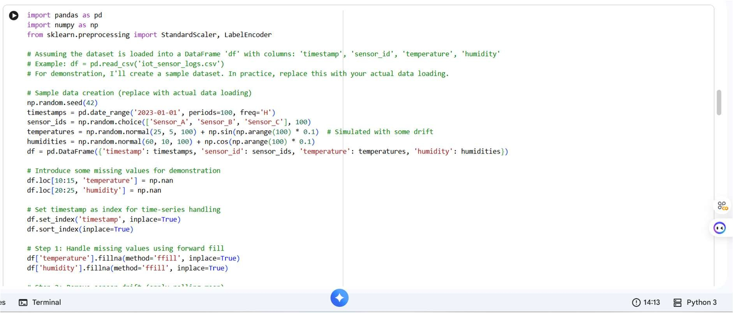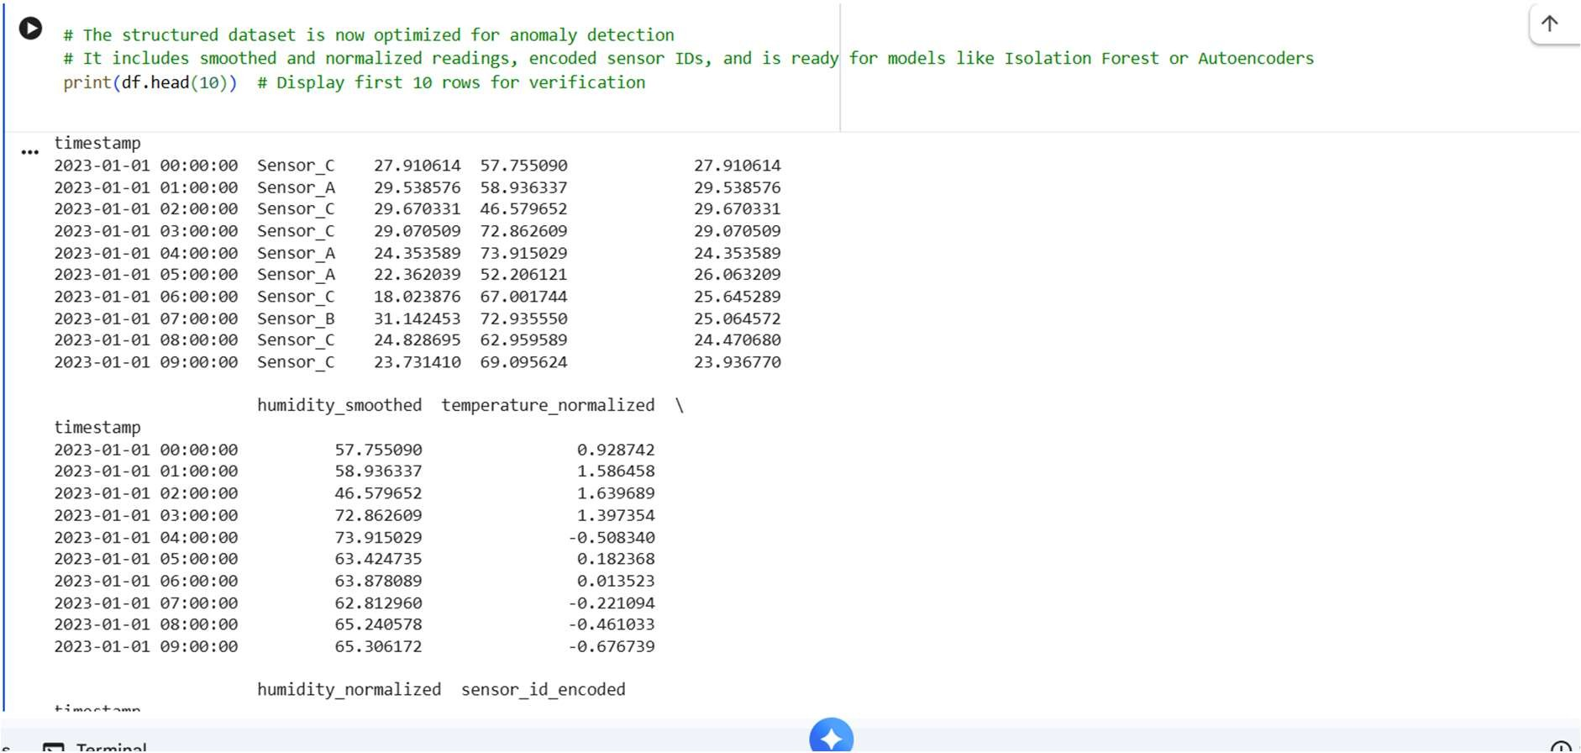

OBSERVATION:
It is observed that the code is super easy to understand and implement.

Task 4 – Real-Time Application: Movie Reviews Data Cleaning Task: A streaming platform wants to analyze customer reviews. Instructions:
Standardize text (lowercase, remove HTML tags).
- Tokenize and encode reviews using AI-assisted methods (TF-IDF or embeddings).
- Handle missing ratings (fill with median).
- Normalize ratings (0–10 → 0–1 scale).
- Generate a before vs after summary report.
Expected Output: A cleaned dataset ready for sentiment classification.
Deliverables (For All Tasks)
- AI-generated prompts for code and test case generation.
- At least 3 assert test cases for each task.
- AI-generated initial code and execution screenshots.
- Analysis of whether code passes all tests.
- Improved final version with inline comments and explanations.
- Compiled report (Word/PDF) with prompts, test cases, assertions, code, and output.
Prompt:
Generate A streaming platform wants to analyze customer reviews. Instructions:
Standardize text (lowercase, remove HTML tags).
- Tokenize and encode reviews using AI-assisted methods (TF-IDF or embeddings).
- Handle missing ratings (fill with median).
- Normalize ratings (0–10 → 0–1 scale).
- Generate a before vs after summary report.
Code:
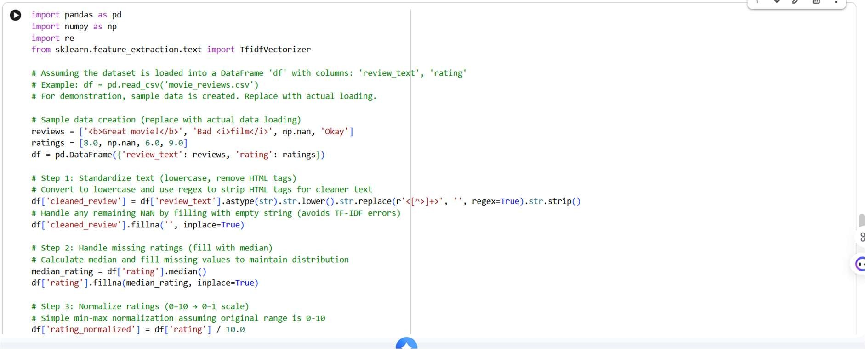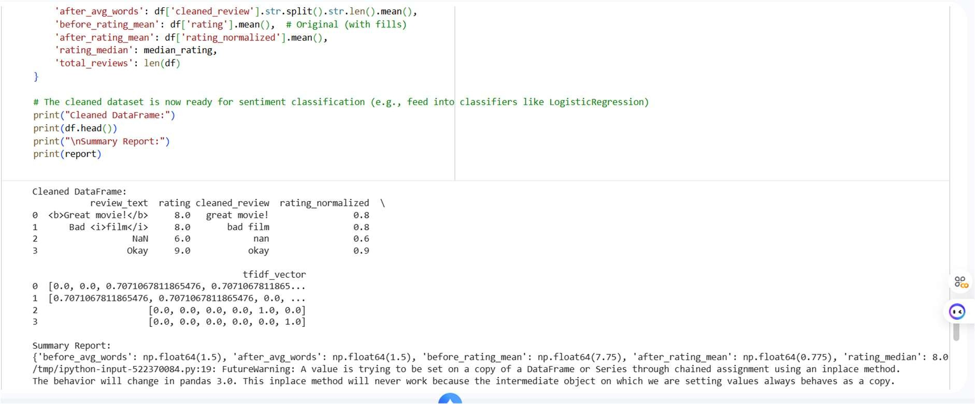

OBSERVATION:
It is observed that the code is super easy to understand and implement.

