AI ASSISTED CODING -22
NAME: SRIYA DARIPELLI
ENROLLMENT NO: 2403A51350
COURSE: AI ASSISTED CODING
SPECILIZATION: CSE-AIML
DATE :24-11-2025

Task 1 – Project Proposal
- Students choose a real-world problem to solve with an AI-assisted application (e.g., ecommerce billing system, health monitoring dashboard, student attendance tracker).
- Prepare a project proposal including: o Objective
  - Features
  - Tools/technologies to be used
PROMPT: Develop a code to generate a python code Project Proposal • Students choose a real-world problem to solve with an AI-assisted application (e.g., ecommerce billing system, health monitoring dashboard, student attendance tracker). • Prepare a project proposal include
Expected output:
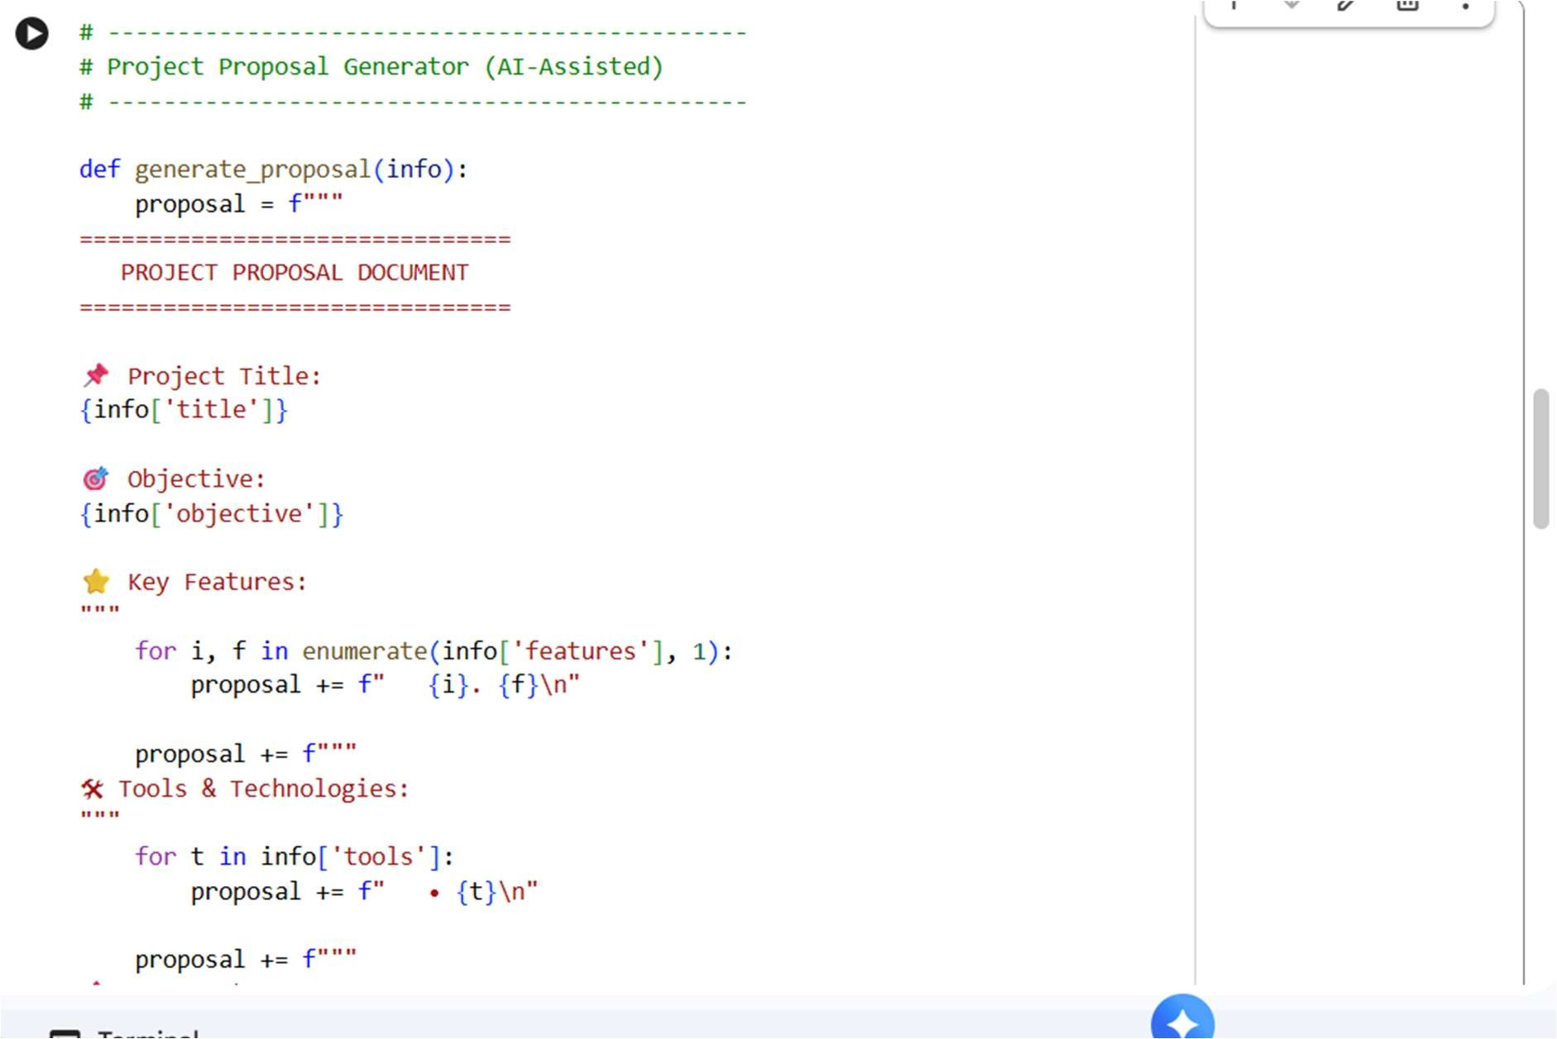
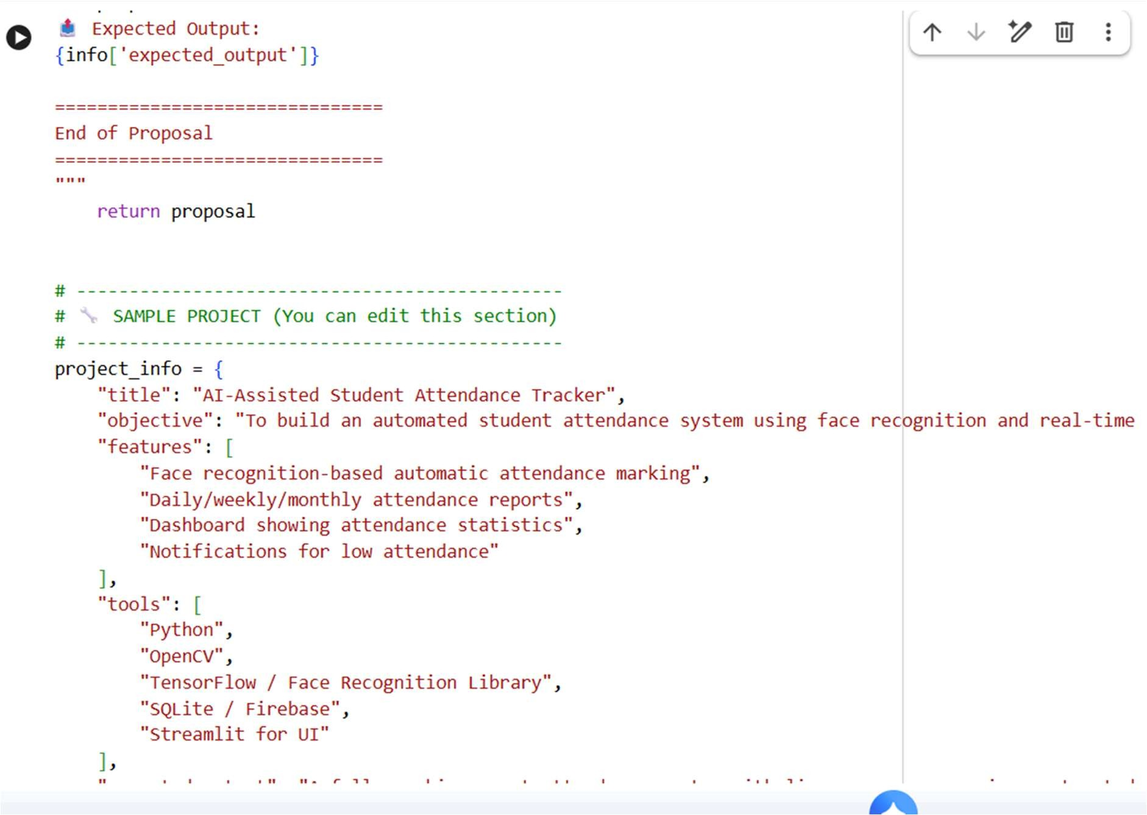
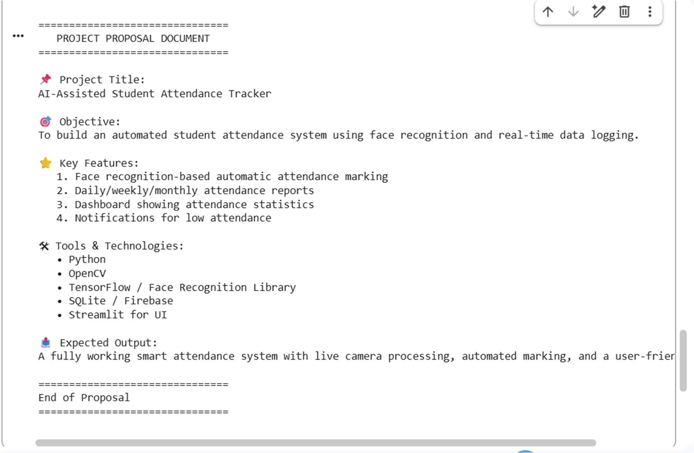
Task 2 – Application Design • Use AI tools to assist in: o Designing system architecture diagrams. o Defining database schema (if needed).
Creating wireframes/UI mockups for frontend design PROMPT:
Generate a python code to develop an Application DesignUse AI tools to assist in: o Designing system architecture diagrams. o Defining database schema (if needed). o Creating wireframes/UI mockups for frontend design Expected output:
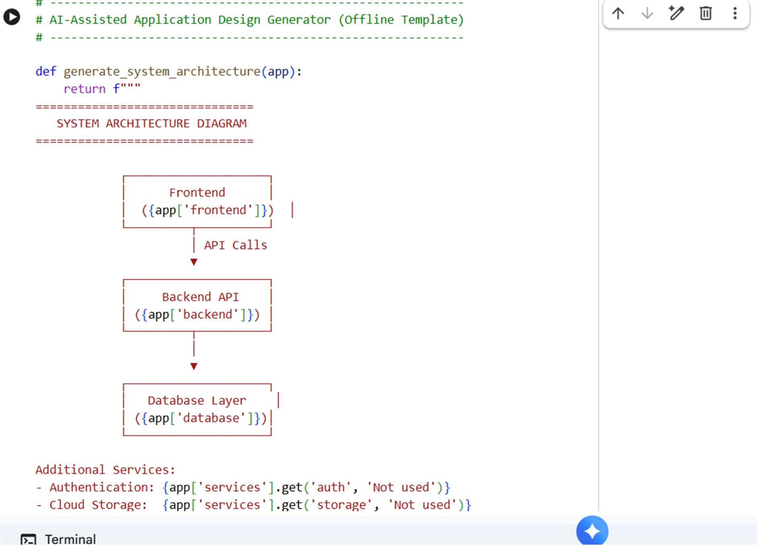
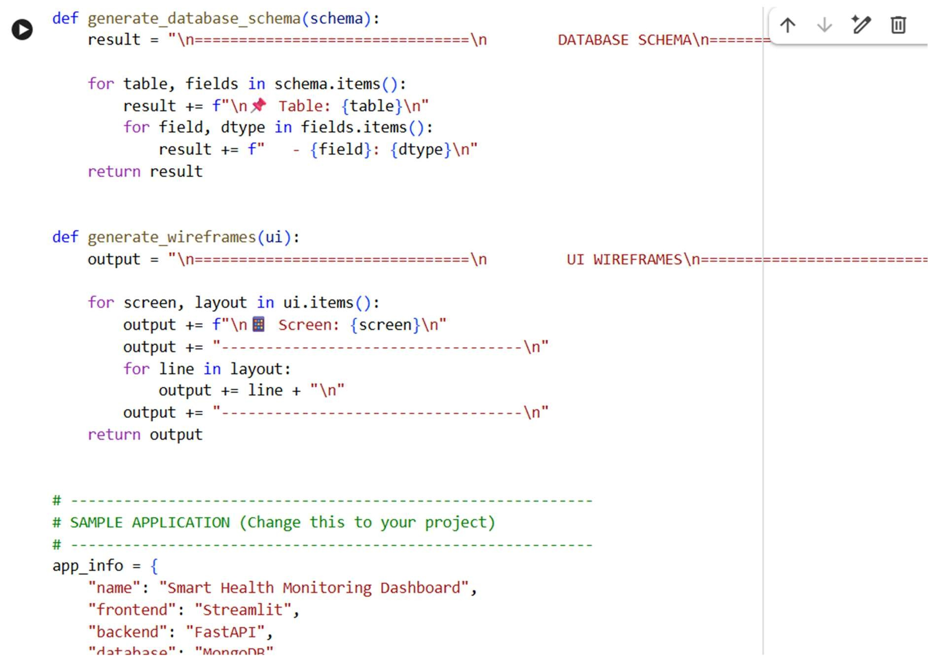
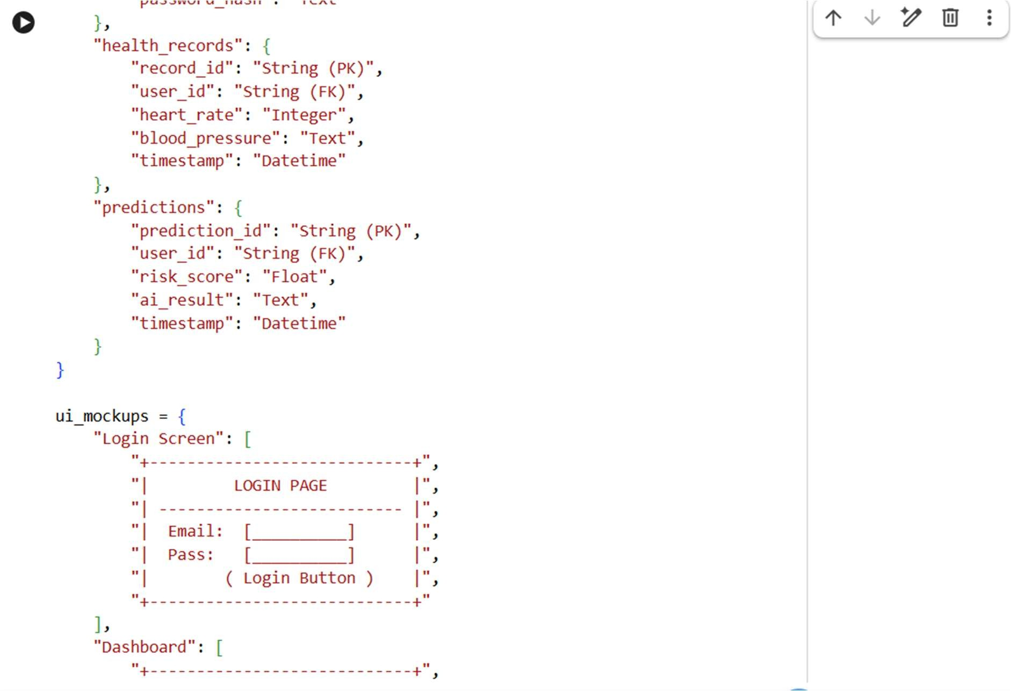
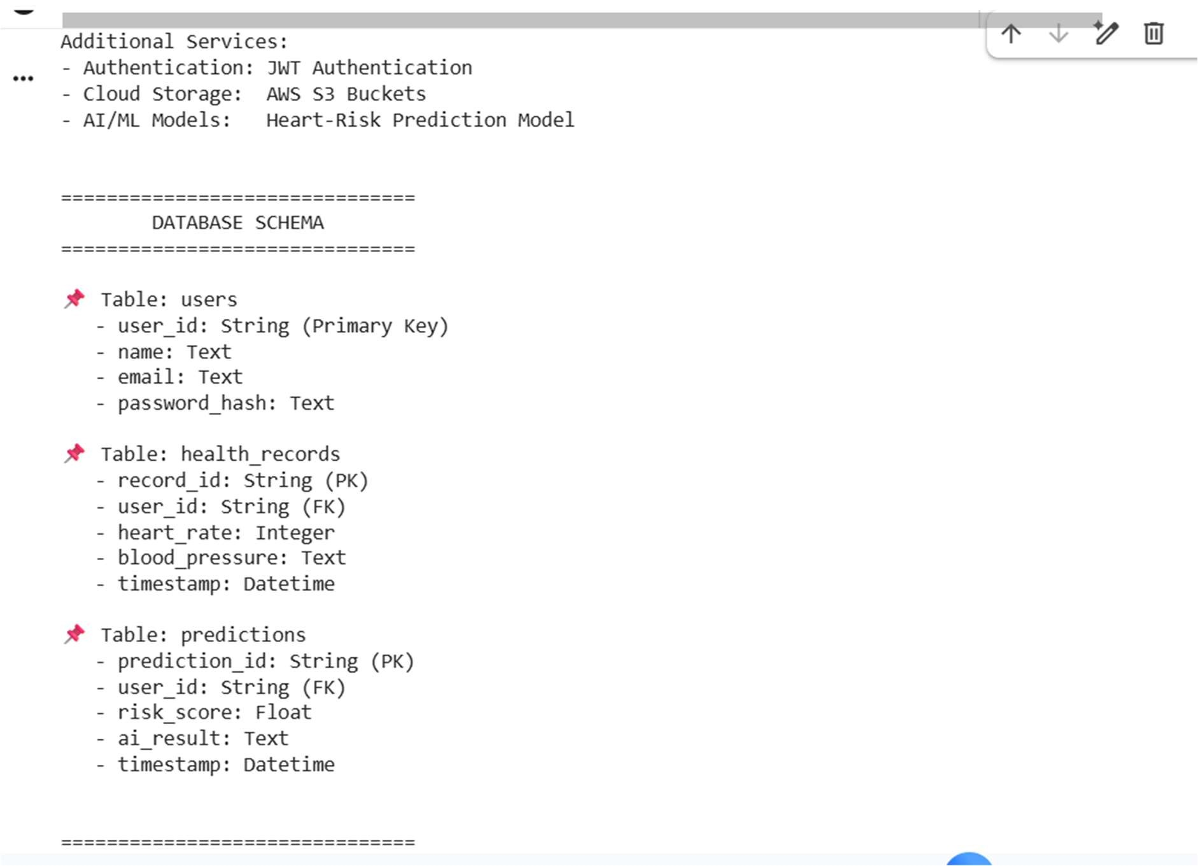

Task 3 – AI-Assisted Code Development
• Implement the application in phases:
- Frontend: Web/mobile UI with HTML/CSS/JS (or framework).
- Backend: RESTful APIs or server logic.
- Database: Schema design, SQL queries.
Integration: API calls, authentication, error handling PROMPT:
Develop a code generate a python code AI-Assisted Code Development • Implement the application in phases: o
Frontend: Web/mobile UI with
HTML/CSS/JS (or framework). o Backend: RESTful APIs or server logic. o Database: Schema design, SQL queries. o Integration: API calls, authentication, error handling
Expected output:
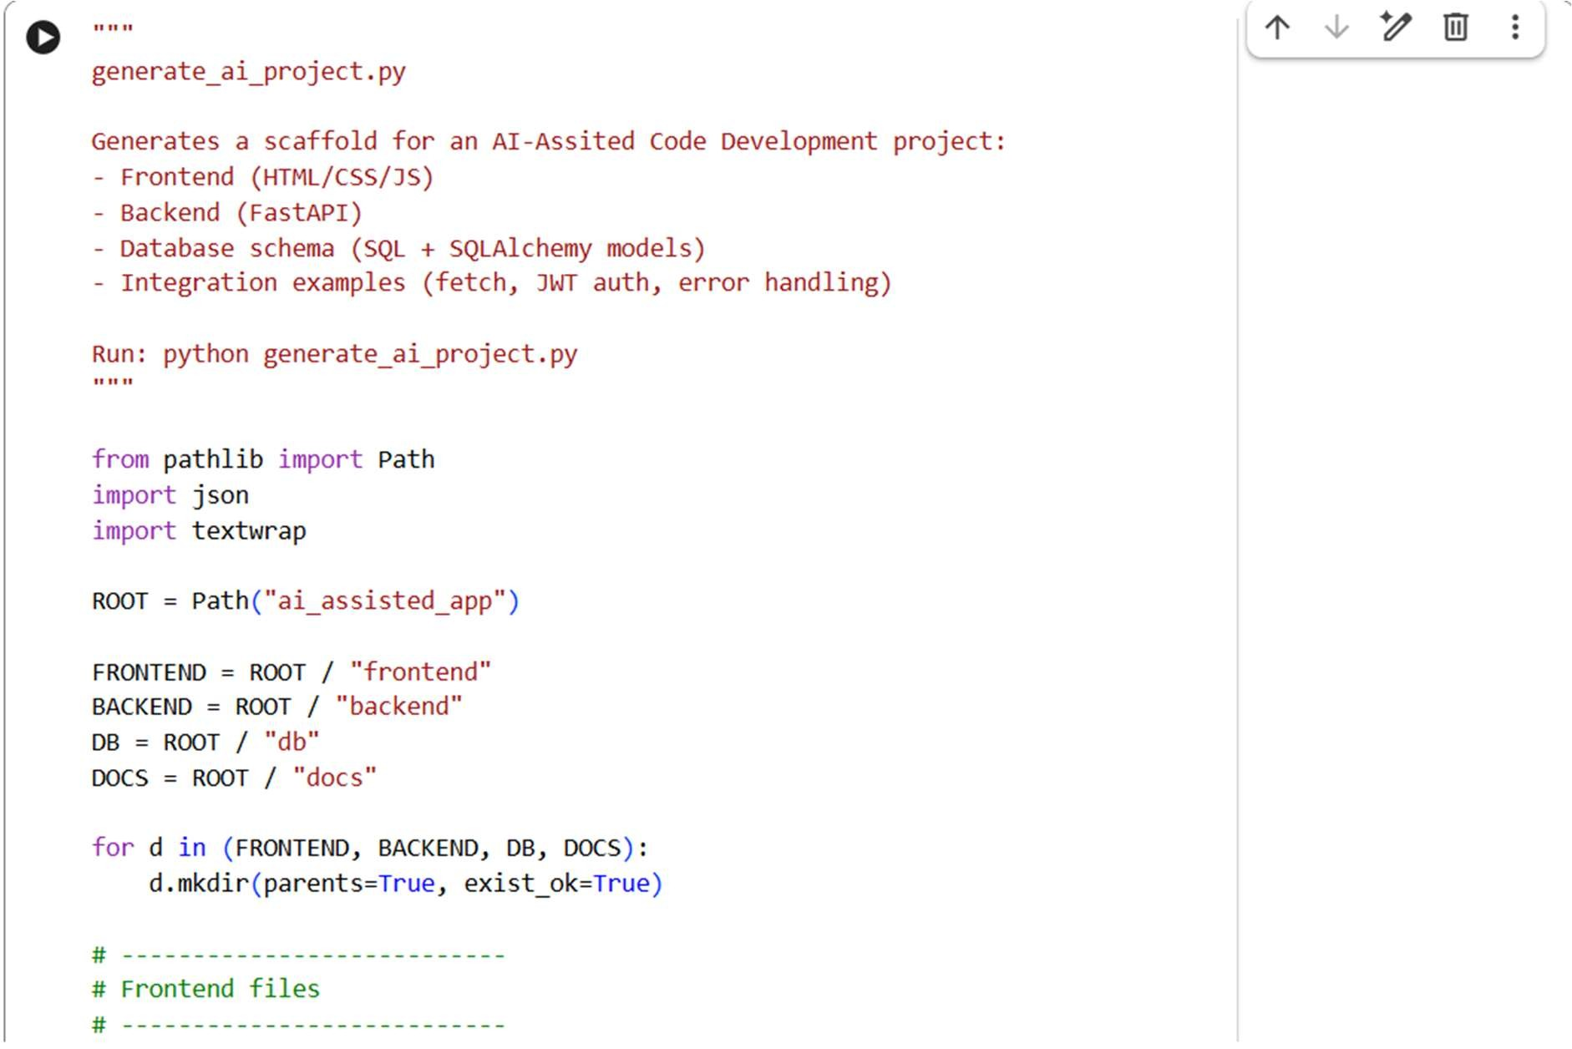
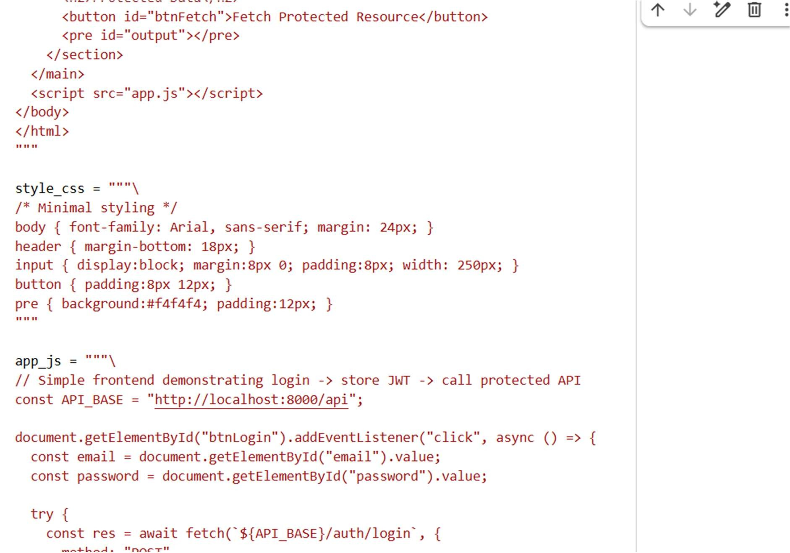
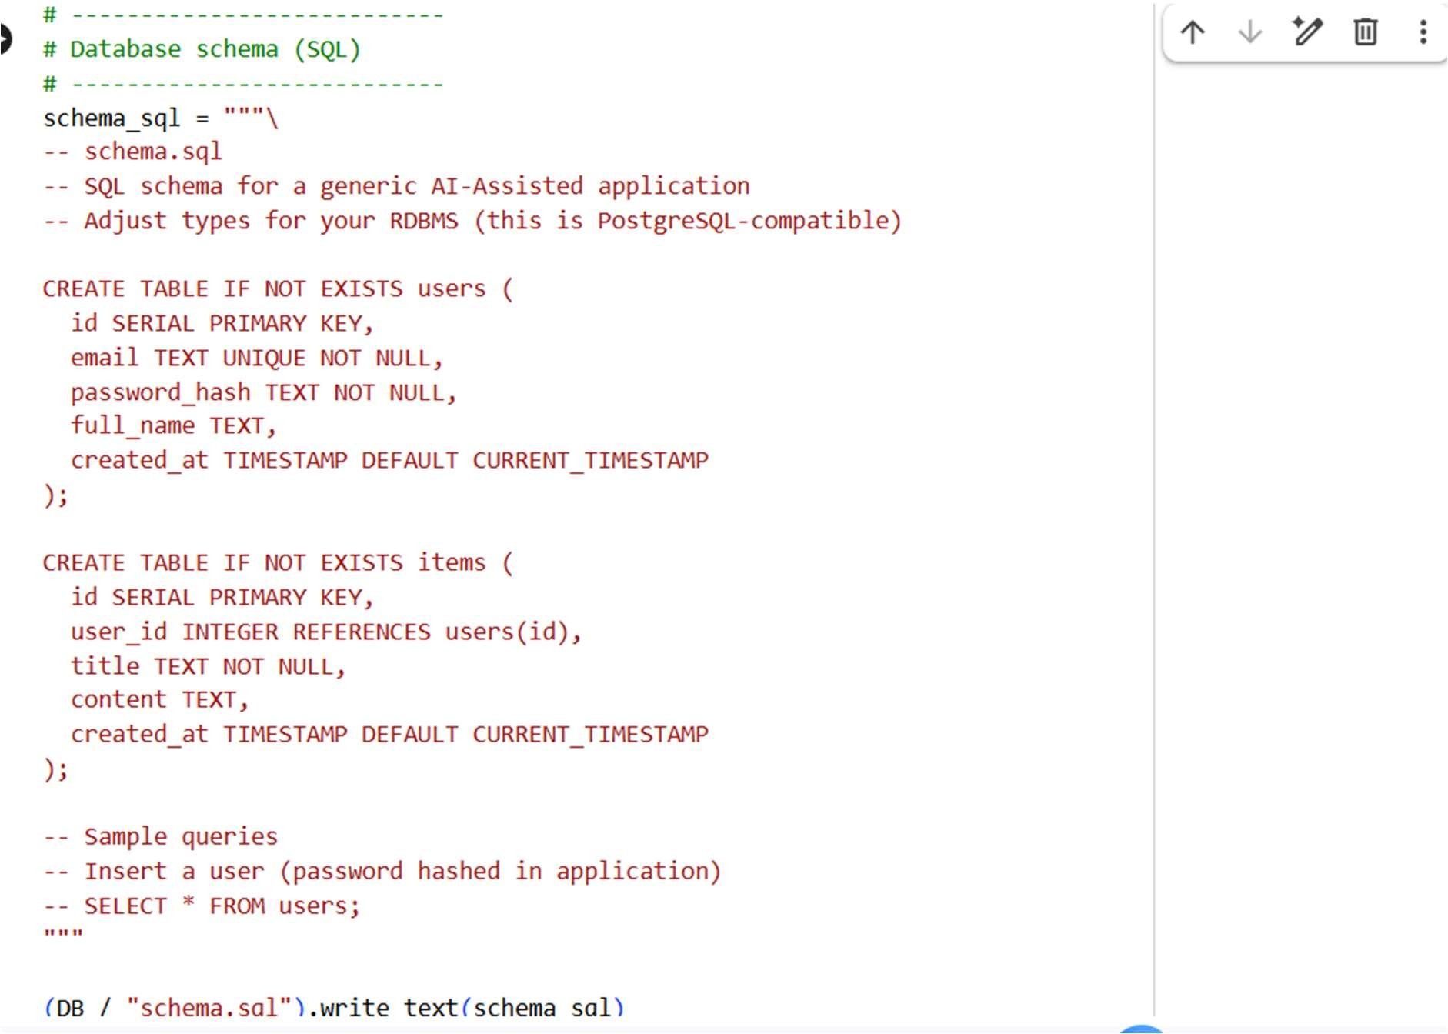
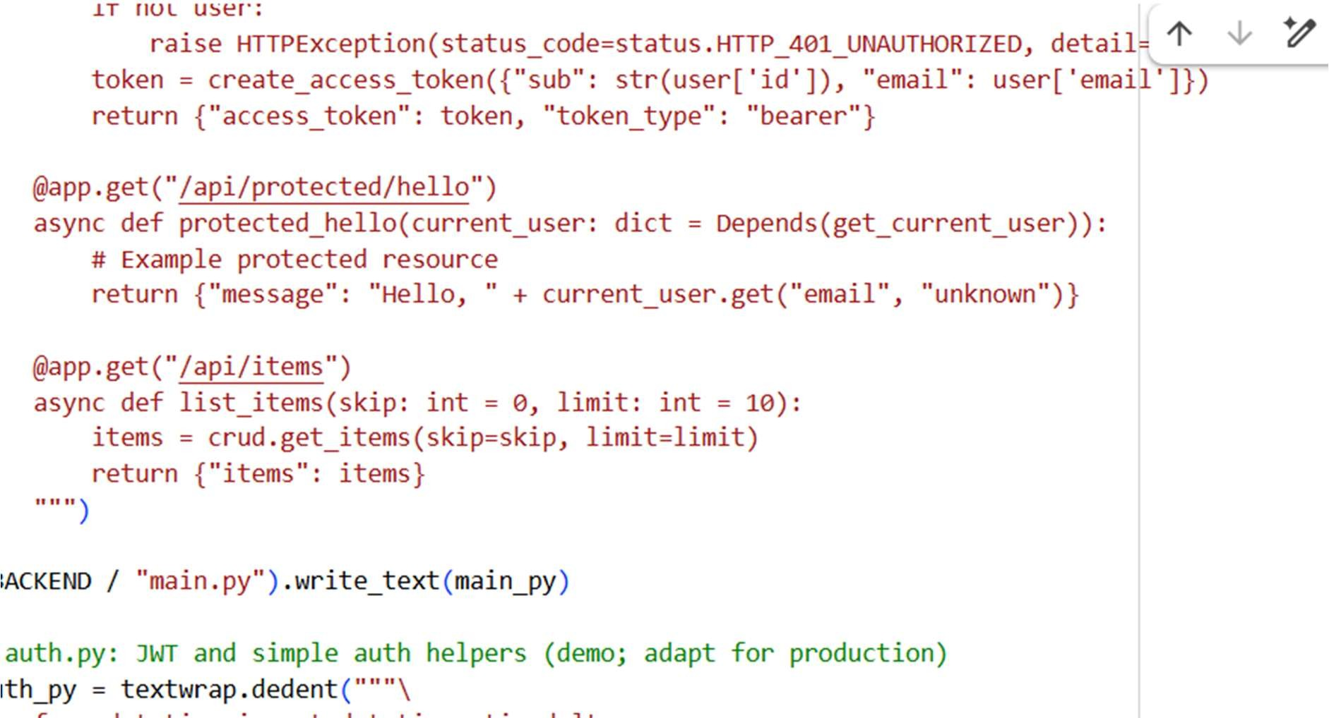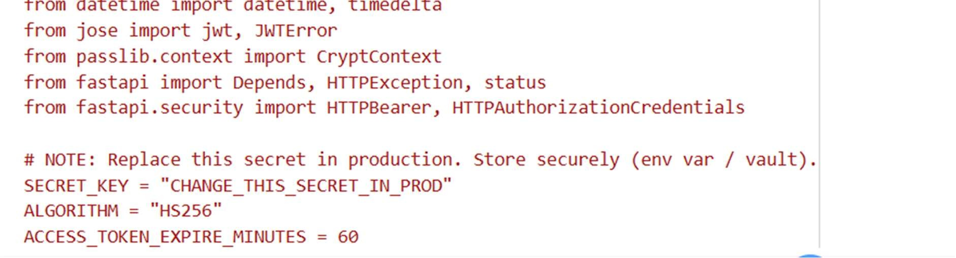
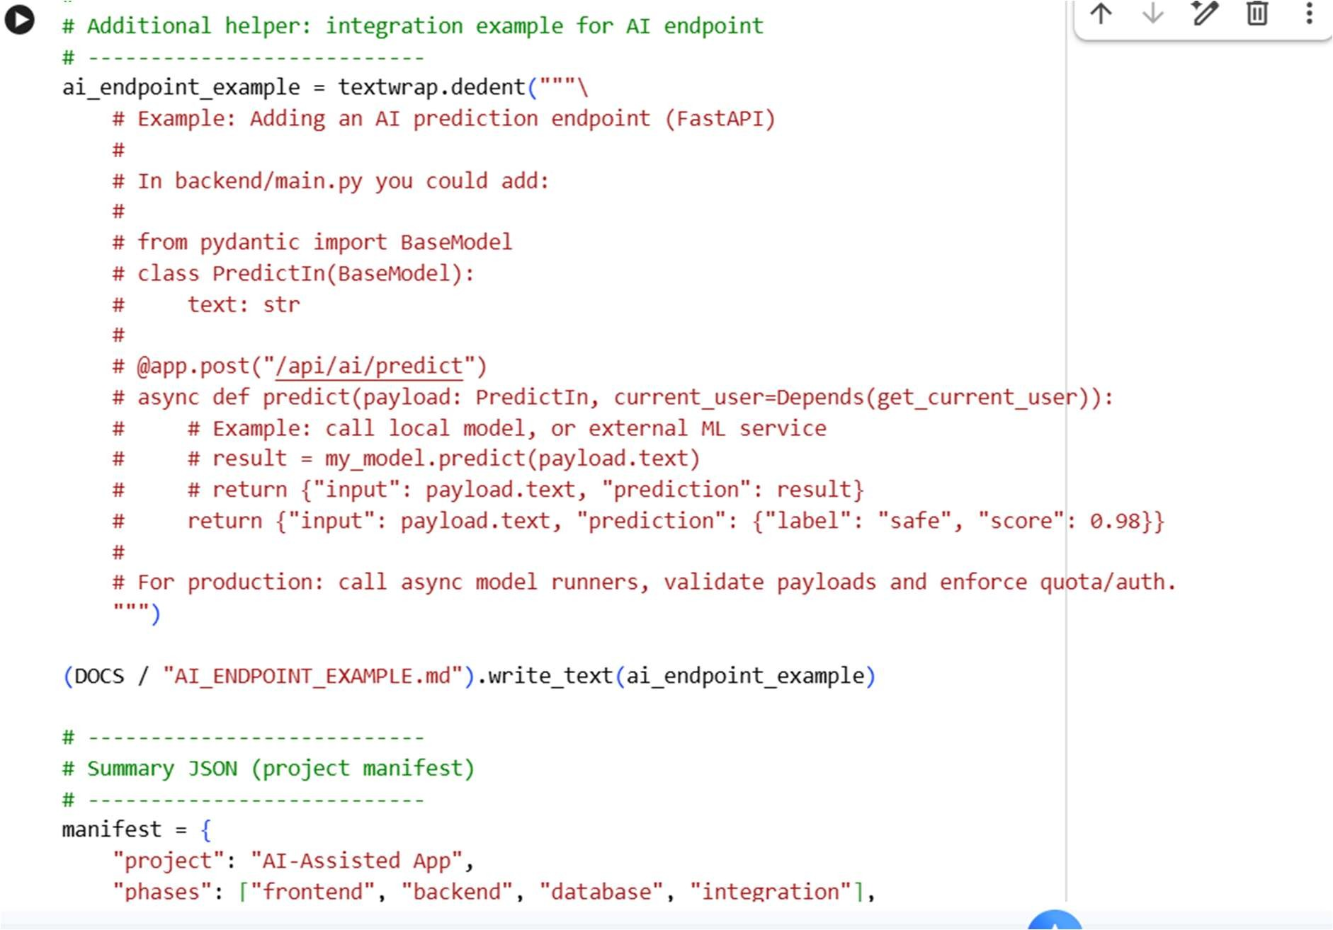
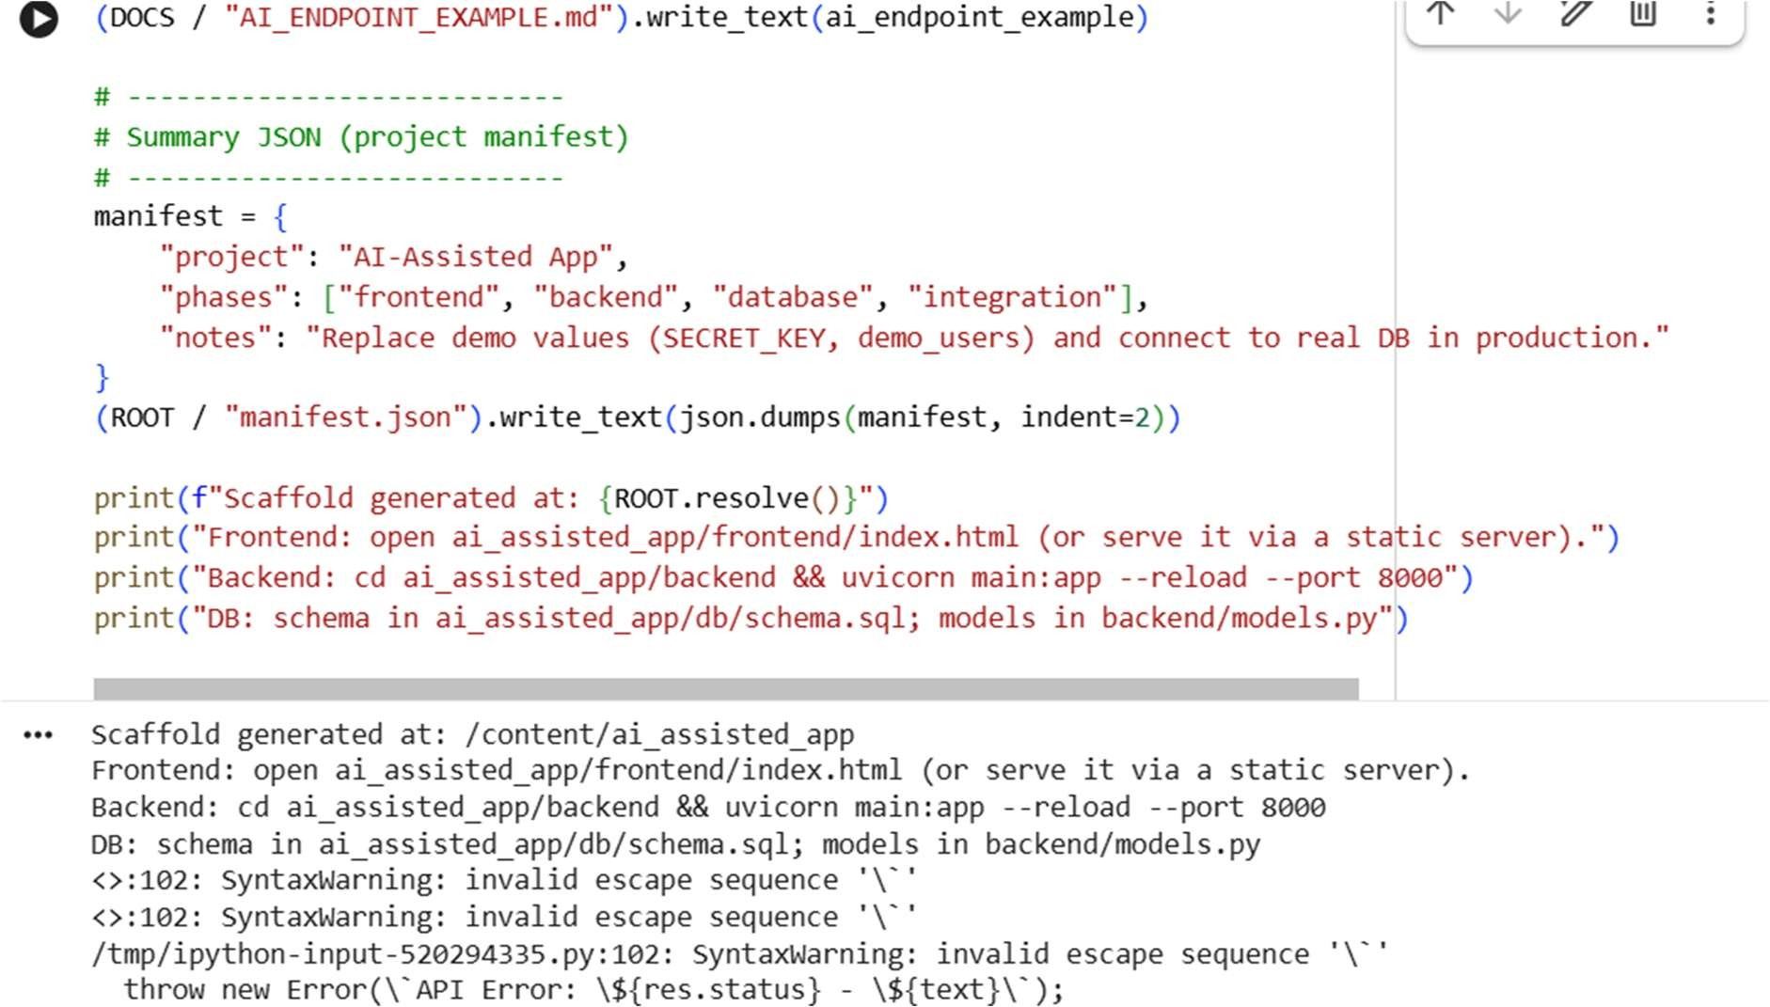
Task 5 – Testing & Debugging • Use AI to: o Generate unit tests. o Identify vulnerabilities/security flaws. o Suggest optimizations for performance PROMPT:
Develop a python code to generate Use AI to: o Generate unit tests. o Identify vulnerabilities/security flaws. o Suggest optimizations for performance Expected output:
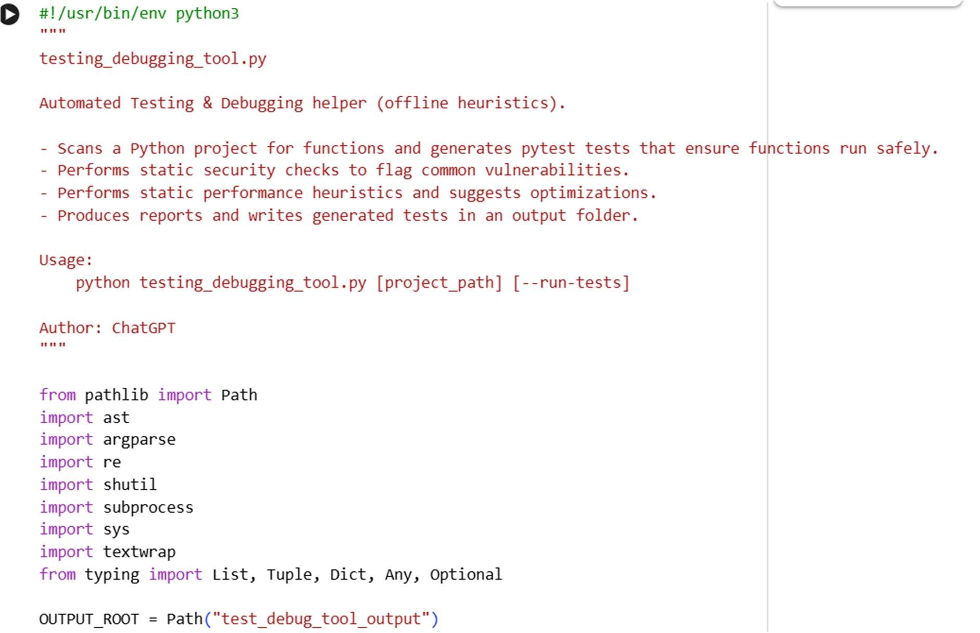
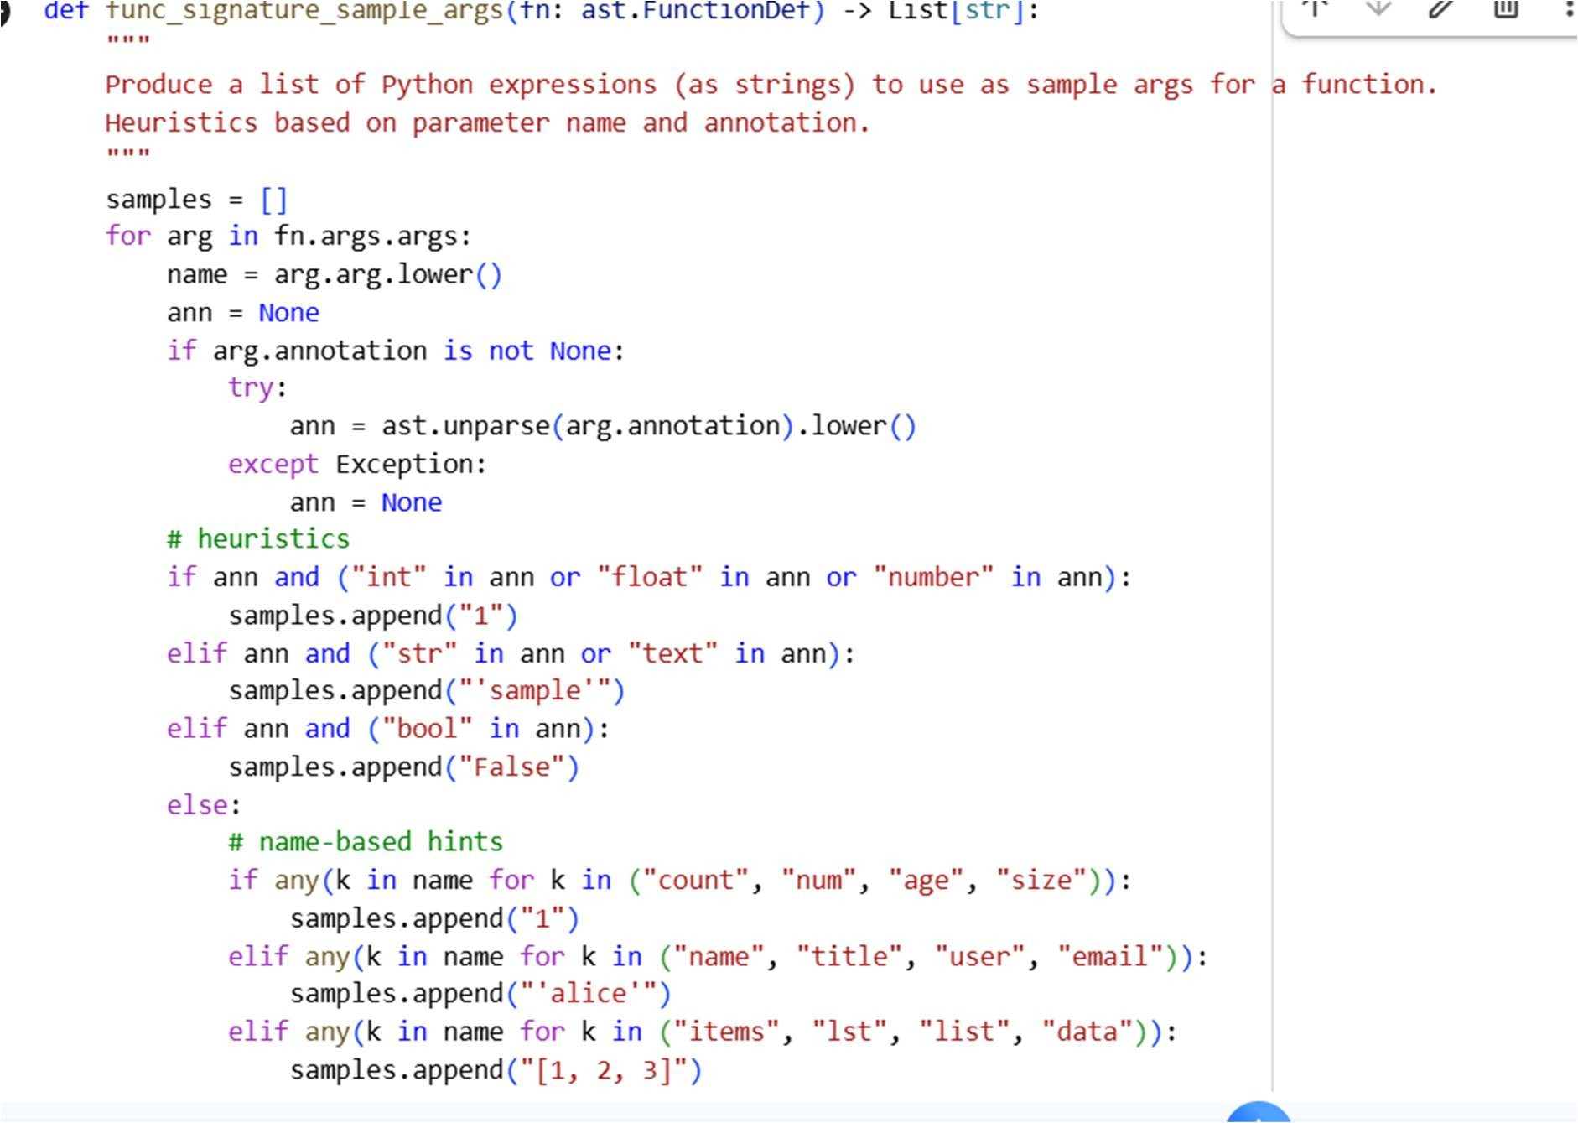
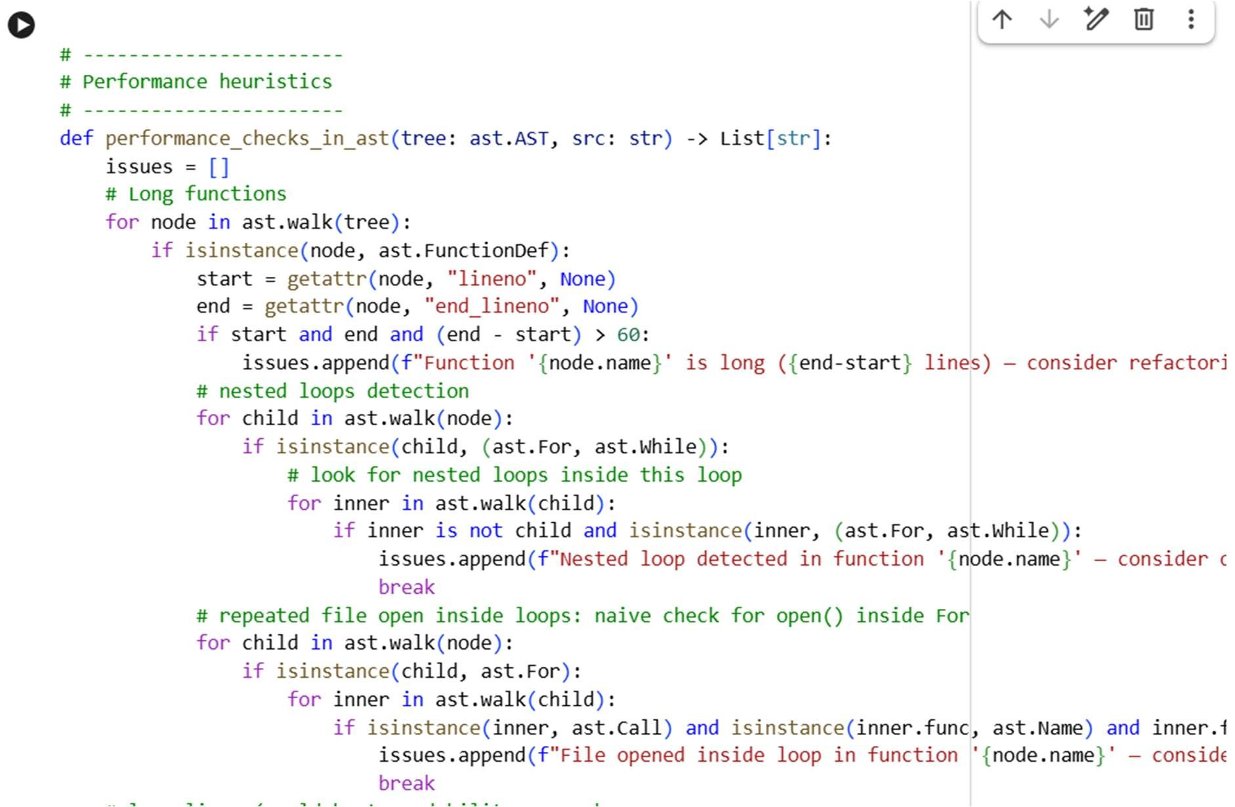
Task 6 – Deployment & Presentation
- Deploy application on a cloud/free hosting platform (Heroku, GitHub Pages, Firebase, etc.).
- Prepare a final presentation including: o Problem statement
  - Solution architecture
  - Live demo
  - Reflection on AI assistance and
limitations

Expected Outcomes:
- A complete, deployable software application.
- Students gain experience in end-toend development with AI tools.
- Improved skills in teamwork, documentation, and ethical AI usage.

脥 Deliverables (For All Tasks)
- AI-generated prompts for code and test case generation.
- At least 3 assert test cases for each task.
- AI-generated initial code and execution screenshots.
- Analysis of whether code passes all tests.
- Improved final version with inline comments and explanation.
- Compiled report (Word/PDF) with prompts, test cases, assertions, code, and output.

PROMPT:
generate a python code to develop an Deployment & Presentation • Deploy application on a cloud/free hosting platform (Heroku, GitHub Pages, Firebase, etc.). • Prepare a final presentation including: o Problem statement o Solution architecture o Live demo o Reflection on AI assistance and limitations
Expected output:
