`Detection of Fake Online Reviews using Semi-Supervised and Supervised Learning

In this paper author is using supervised and semi-supervised algorithms to predict fake reviews as all users depend on internet to know quality of any product and by reading reviews about that product can make decision and some malicious users may take this as advantage and can report fake reviews about any product to degrade of grade it quality and to predict such fake reviews author applying Semi-Supervised algorithms such as Expected Maximization with SVM and Expected Maximization with Naïve Bayes and then applying supervised algorithms such as SVM and Naïve Bayes and comparing accuracy performance between Supervised and Semi-Supervised and among both algorithms Supervised is giving better performance.

Expected Maximization: The Expectation-Maximization (EM) algorithm is a way to find maximum-likelihood estimates for model parameters when your data is incomplete, has missing data points, or has unobserved (hidden) latent variables. It is an iterative way to approximate the maximum likelihood function

**SVM Algorithm**: Machine learning involves predicting and classifying data and to do so we employ various machine learning algorithms according to the dataset. SVM or Support Vector Machine is a linear model for classification and regression problems. It can solve linear and non-linear problems and work well for many practical problems. The idea of SVM is simple: The algorithm creates a line or a hyperplane which separates the data into classes. In machine learning, the radial basis function kernel, or RBF kernel, is a popular kernel function used in various kernelized learning algorithms. In particular, it is commonly used in support vector machine classification. As a simple example, for a classification task with only two features (like the image above), you can think of a hyperplane as a line that linearly separates and classifies a set of data.

Intuitively, the further from the hyperplane our data points lie, the more confident we are that they have been correctly classified. We therefore want our data points to be as far away from the hyperplane as possible, while still being on the correct side of it.

So when new testing data is added, whatever side of the hyperplane it lands will decide the class that we assign to it.

Naïve Bayes: Naïve Bayes algorithm is a supervised learning algorithm, which is based on Bayes theorem and used for solving classification problems. ... Naïve Bayes Classifier is one of the simple and most effective Classification algorithms which helps in building the fast machine learning models that can make quick predictions.

To implement this project we have used ‘Gold Standard’ Dataset which contains 1600 reviews from which 800 are genuine reviews and 800 are fake reviews and to train both supervised and semi supervised we have used this dataset and this dataset saved inside ‘Dataset’ folder and below screen shots showing dataset details



In above screen we have two columns such as Review and Label where Review column contains user review and label column contains values as 0 or 1 where 0 means FAKE review and 1 means genuine review. After training algorithm with above dataset then we can apply test review on trained model to predict it class as FAKE or GENUINE.

To implement this project we have designed following modules

1. Upload Gold Standard Reviews Dataset: using this module we will upload dataset to application
2. Preprocess Dataset: using this module we will read all reviews and then tokenize it and then remove stop words and special symbols and then make clean text. Clean text will be converted to numeric vector called TF-IDF (Term Frequency – Inverse Document Frequency) vector. This vector contains count of each word divide by its number of occurrence in all reviews
3. Run EM-SVM Algorithm: TF-IDF vector will be applied on EM-SVM algorithm to trained model and then calculate its prediction accuracy. To trained model we have used 80% of dataset and to test algorithm we have used 20% dataset.
4. Run EM-Naive Bayes Algorithm: Trained dataset with EM-Naïve Bayes algorithm
5. Run SVM Algorithm: Trained dataset with supervised SVM algorithm
6. Run Naive Bayes Algorithm: Trained dataset with supervised Naïve Bayes algorithm
7. Comparison Graph: This graph show accuracy comparison between all algorithms
8. Upload Test Review & Predict Fake & Sentiments: Using this module we can upload test data and then application will predict its sentiment, fake and genuine review class.

SCREEN SHOTS

To run project double click on ‘run.bat’ file to get below screen

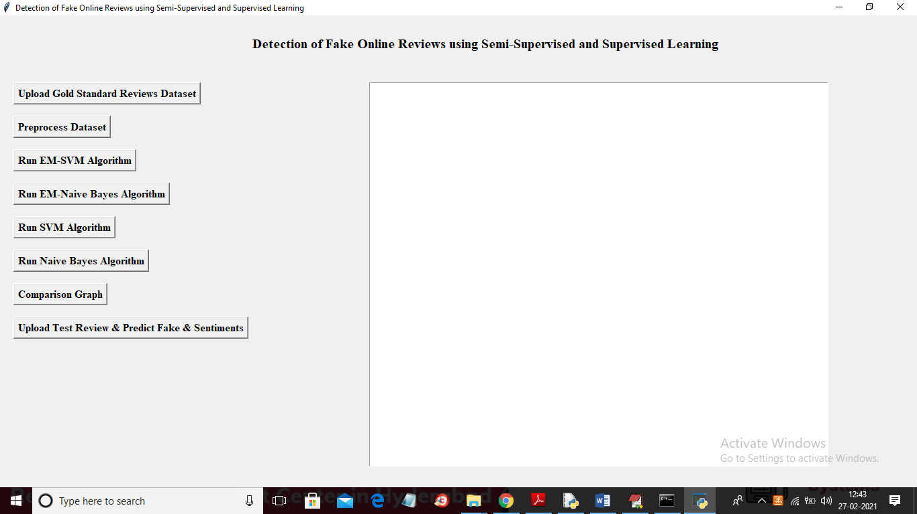

In above screen click on ‘Upload Gold Standard Reviews Dataset’ button to upload dataset

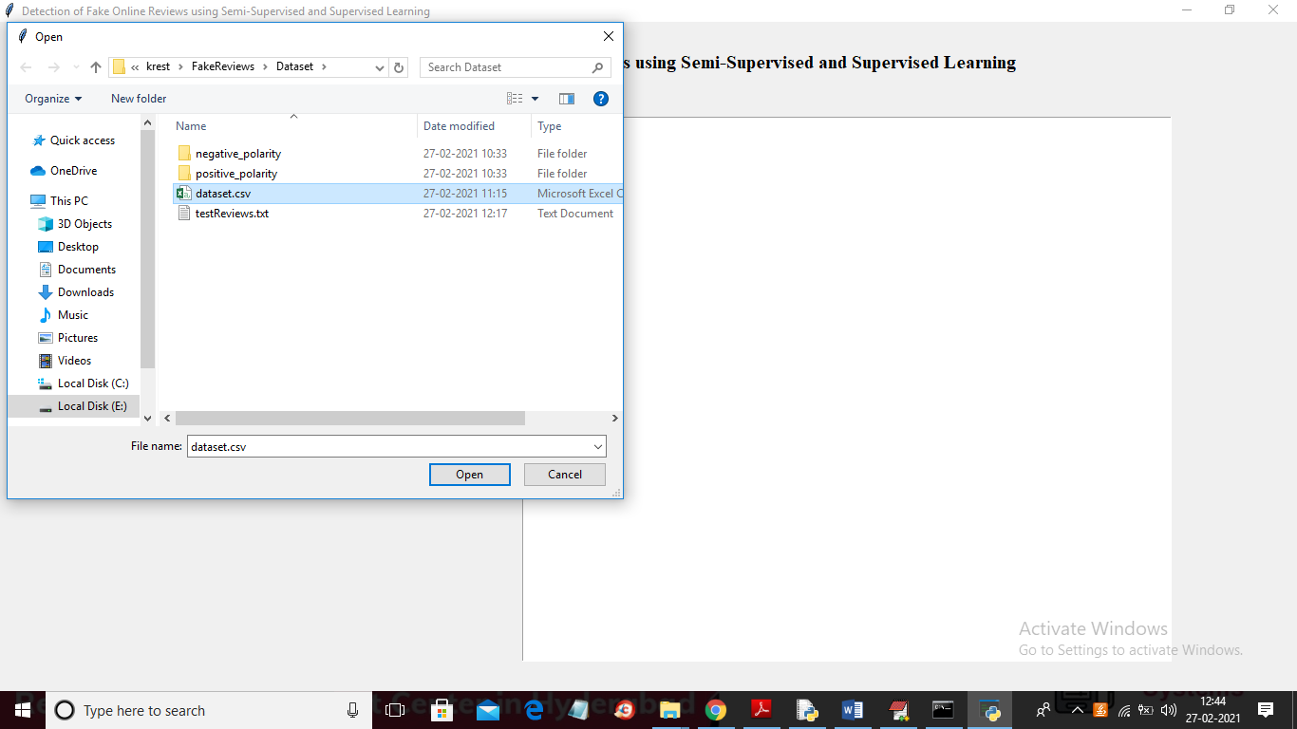

In above screen selecting and uploading ‘dataset.csv’ file and then click on ‘Open’ button to load dataset and to get below screen

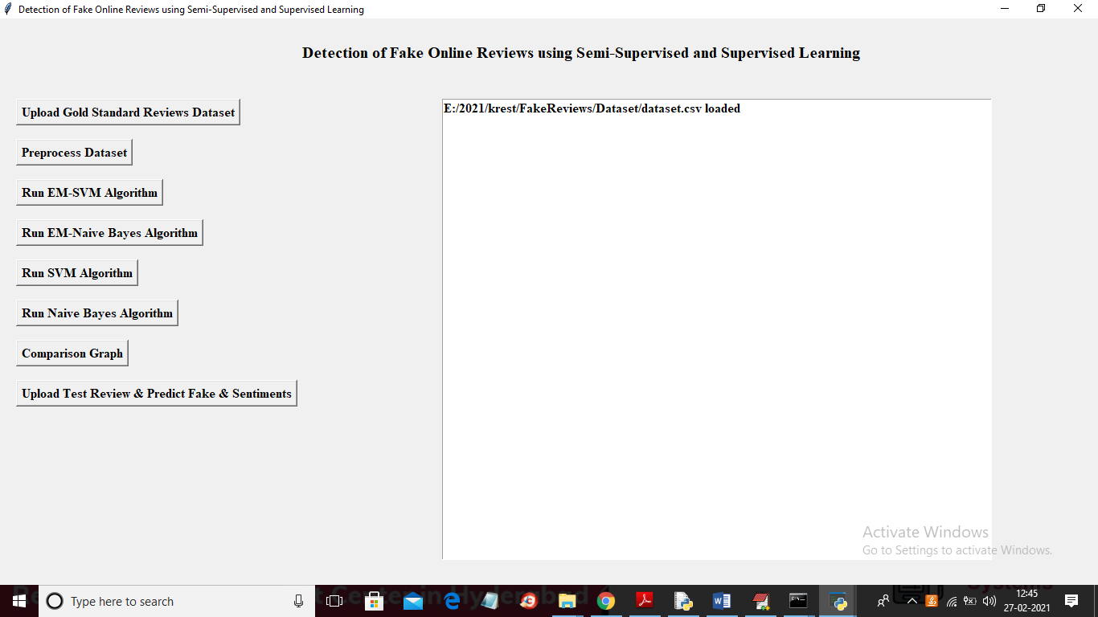

In above screen dataset loaded and now click on ‘Preprocess Dataset’ button to read and process dataset and to get below screen

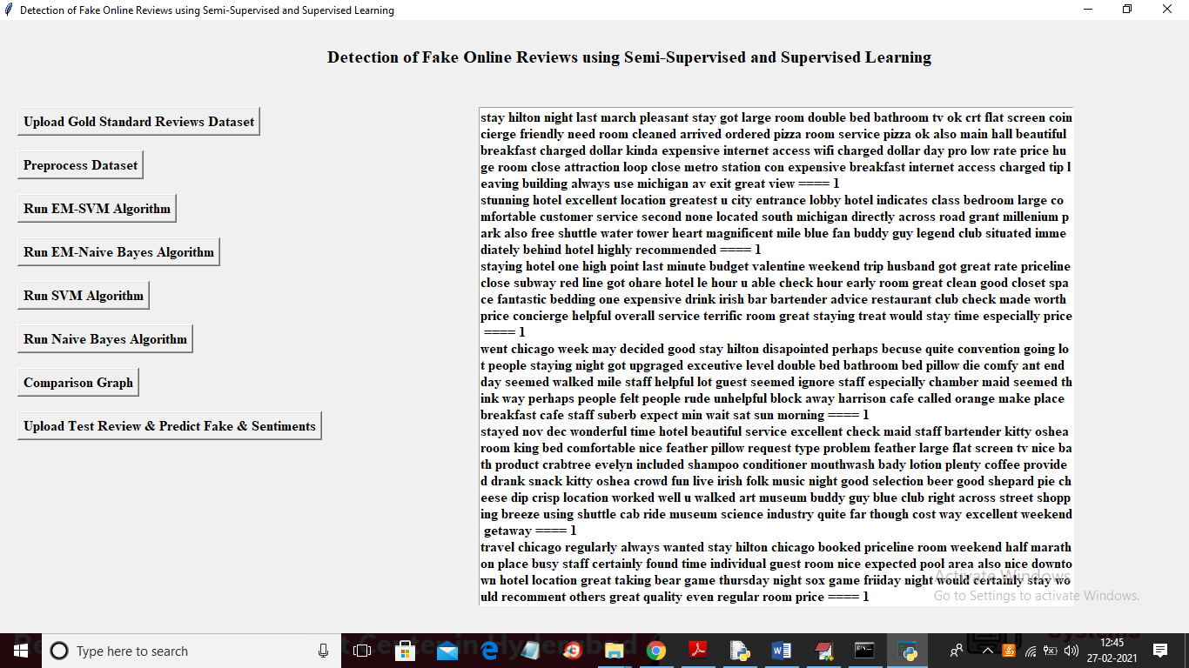

In above screen from all reviews we removed stop words and after === symbol we can see it label as 0 or 1 and now scroll down above screen to bottom to see TF-IDF vector. You can see below screen

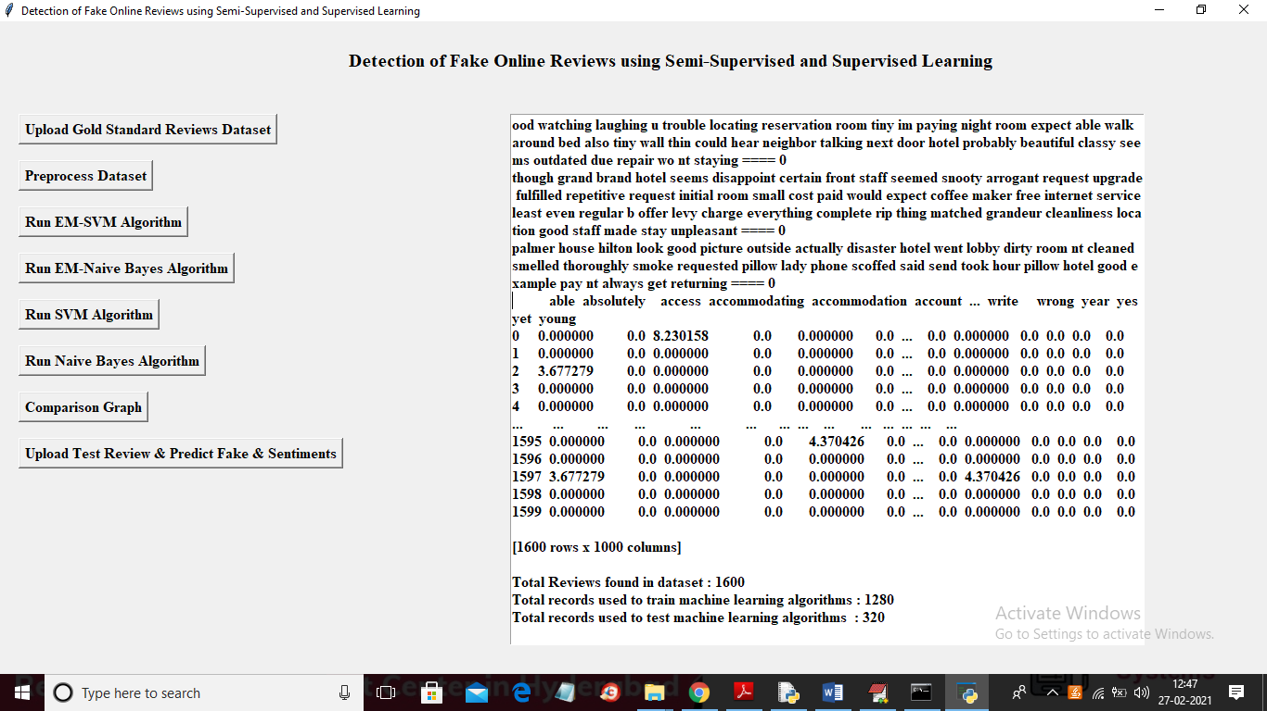

In above screen in top row we can see all words separated by TAB and in below top row we can see its numeric value calculated using TF-IDF. In above screen in bottom we can see dataset contains total 1600 reviews and then application using 1280 reviews for training and 320 reviews for testing. Now train and test data is ready and now click on ‘Run EM-SVM Algorithm’ button to train it

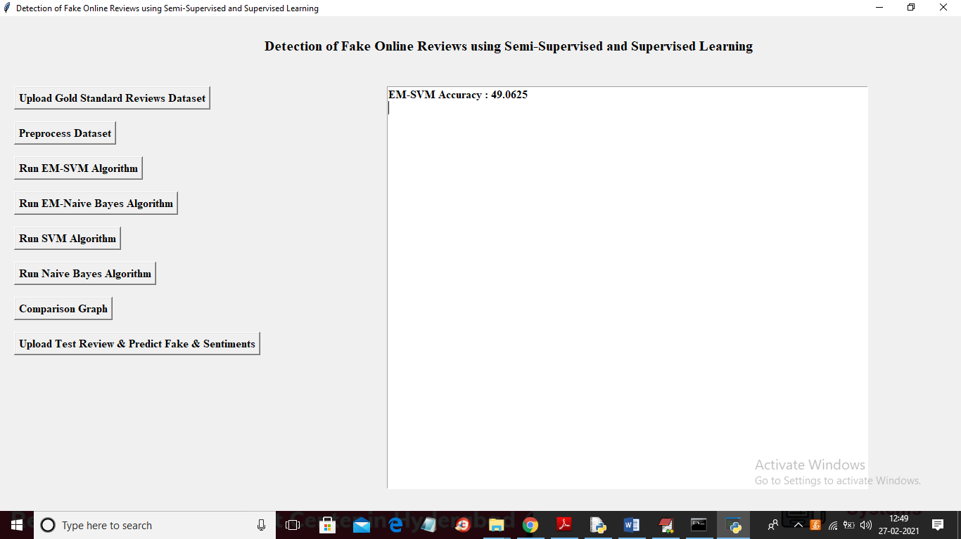

In above screen EM-SVM got 49% accuracy and similarly click next 3 buttons to train all algorithms

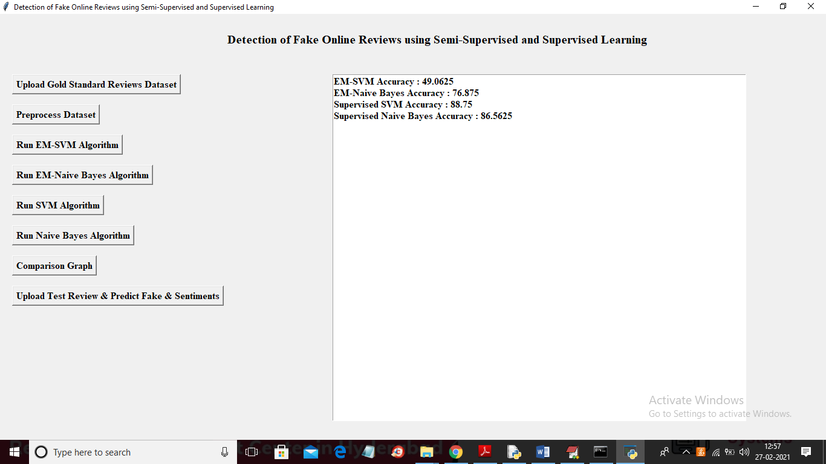

In above screen we can see EM algorithms are not working well but supervise algorithms are giving better accuracy and now click on ‘Comparison Graph’ button to get below graph

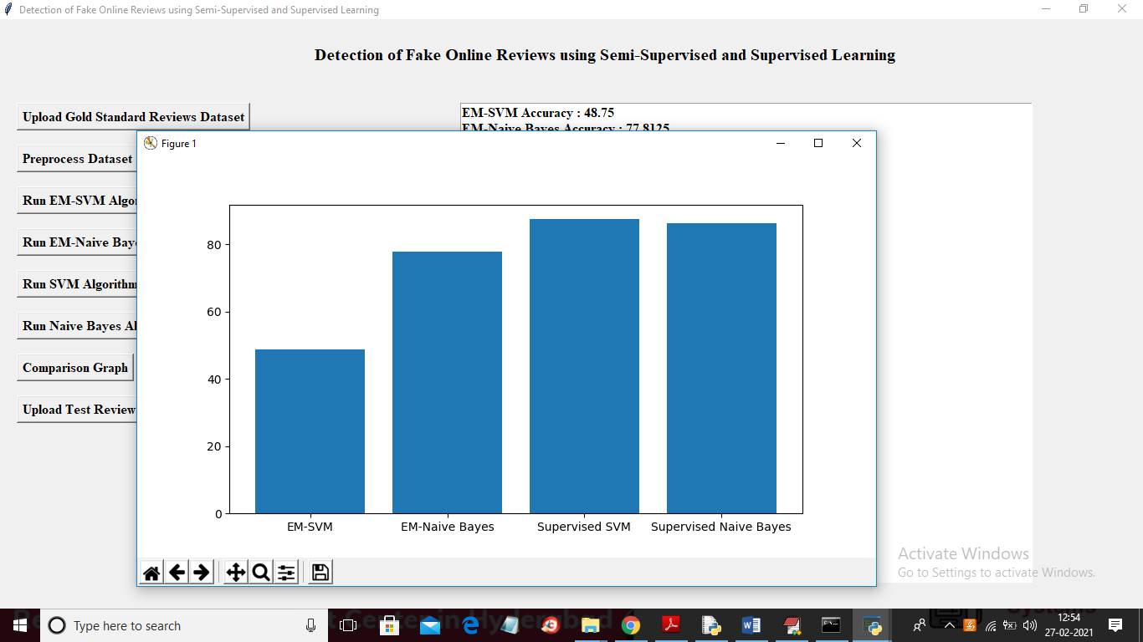

In above screen x-axis represents algorithm name and y-axis represents accuracy of those algorithms and from above graph we can say supervised algorithms are better than EM. Now click on ‘Upload Test Review & Predict Fake & Sentiments’ button to upload test review and to get below output for each review

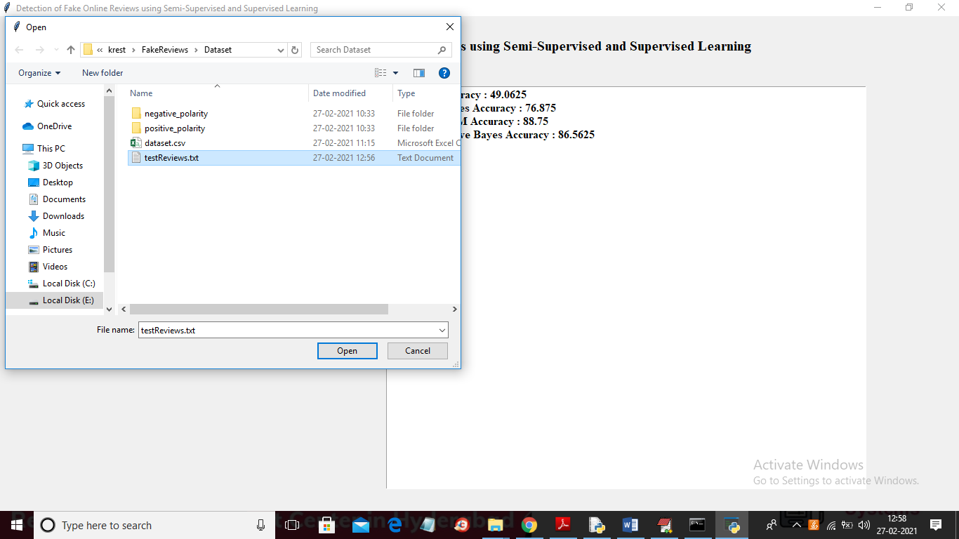

In above screen selecting and uploading ‘testReviews’ and then click on ‘Open’ button to get below result

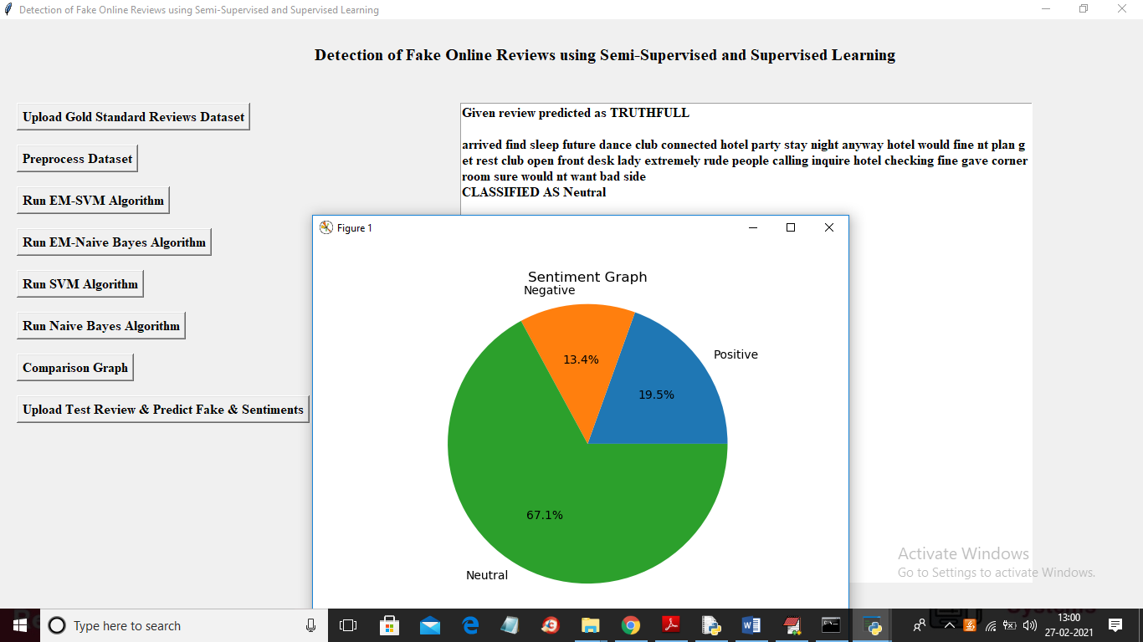

In above screen we can see review detected as TRUTHFULL and its sentiment predicted as NEUTRAL