**Introduction to Biology**

**Assignment 1**



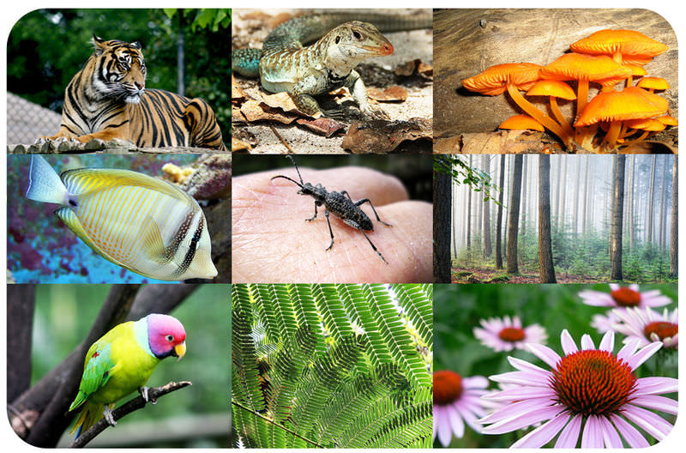

**Name**  **:**  Srejon Ahamed Joy

**Id**  **:**  21301354

**Section :** 2

**Date :** 22 - 02 -2023

**Submitted to :** Md Asaduzzaman Khan

Biodiversity

**What is Biodiversity?**

Biodiversity means the difference of life forms on Earth, such as plants, wildlife, bacteria, genes, genetic material, and the ecosystems they generate. This term includes the diversity of genetic makeup, the variation of ecosystems, and the number of different species present within a given area, biome, or the entire planet.

**Types of Biodiversity:**

**Genetic diversity:** The diversity of genes found in all living beings, particularly trees, humans, insects, and microbes, is referred to as genetic diversity. This variety exists not just within one species, but also between them.

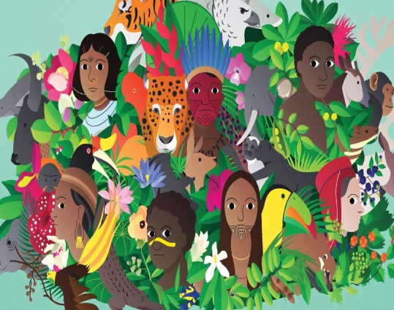**Species diversity:** Species variety includes all of the variations found among and within groups of a single species, as well as differences that exist across species. The ecological processes that take place, as well as the variation within individual ecosystems.

**Ecosystem diversity:** Ecosystem diversity describes the variety of habitat, biological species, and ecosystem dynamics that exist, as well as variation within certain ecosystems.

**Importance of Biodiversity:**

The variety of habitats, biotic communities, and ecological processes that comprise the biosphere, biodiversity is critical to the survival of life on Earth. It greatly adds to the aesthetic value of the natural environment as well as having utilitarian benefits by supplying diverse resources such as food, fodder, fuel, lumber, and pharmaceuticals that contributes to our material well-being. Because species rely on biodiversity for the oxygen they inhale, the foodstuff they consume, and the freshwater they drinks, biodiversity acts as a vital life supporting system. Waterways, for example, act as natural filters that remove contaminants from the water, while the plants and trees store carbon, which helps to prevent global warming.

**Threats to Biodiversity:**

**Habitat Fragmentation:**

Habitat fragmentation occurs when ecosystems are degraded or converted, leading to a loss of natural habitats. The loss of habitats due to exploitation of resources, agriculture, and urbanization is the primary cause of the decline in biodiversity. The fragmentation of habitats creates small, isolated patches of land that cannot sustain species populations in the long term.

**Exotic Species Introductions:**

The introduction of exotic species, intentionally or unintentionally, is another significant threat to ecosystems in British Columbia. This invasion of alien species often results in significant changes in the structure and function of ecosystems, making it challenging for native species to compete.

**Pollution:**

Pollution from atmospheric and hydrologic sources also negatively affects biodiversity. Burning fossil fuels produces pollutants that can remain in the atmosphere or fall as acid rain, which can cause acidification of lakes and damage to forest growth. Chemical pollutants like pesticides and herbicides can also leach into soils and watersheds, affecting the health of many species, including salmonids.

**Global Climate Change:**

Global climate change resulting from the release of greenhouse gasses, primarily carbon dioxide, from burning fossil fuels, deforestation, and agricultural practices also has negative effects on biodiversity. Increased temperatures, air pollution, changes in weather patterns, and shifts in vegetation distribution will make it difficult for many species to adapt, leading to possible extinction.

**Solutions:**

1. One possible solution to these threats is the corridor concept, which proposes that connecting refuges via corridors can promote gene flow, prevent inbreeding, and offset extinction. This way, maintaining landscape connectivity can help to mitigate the negative impacts on biodiversity.
2. The government has the authority to regulate activities within their country's habitats. Laws that prohibit the use of natural resources, development, and other forms of human exploitation in order to protect natural habitats have a significant influence on preserving biodiversity.
3. In addition, it is important for people to seek advice from ecologists familiar with the region before introducing new species of animals or plants.
4. In case an area is affected by human activities, efforts should be made to restore it to its natural condition, including reintroducing its indigenous plant and animal species.
5. To reduce the impact of climate change, it is necessary to shift from non-renewable to renewable energy sources and sustainable products.
6. Education is a crucial component of achieving success in most environmental issues. Educating people about the significance of preserving biodiversity raises public awareness and involvement, which eventually influences government officials to enforce stricter environmental protection measures.

**Reference:**

1. U.S, Rawat & Agarwal, N.. (2015). Biodiversity: Concept, Threats and Conservation. Environment Conservation Journal. 16. 19-28. 10.36953/ECJ.2015.16303.
2. https://www.environment.nsw.gov.au/resources/nature/landholderNotes15WildlifeCorridors.pdf