**LAB 2**

**c) Design an attractive advertisement using Adobe Photoshop**

**INTRODUCTION**

Creating an eye-catching advertisement with Adobe Photoshop involves a blend of creativity and technical skills. Start by conceptualizing your design with a clear idea of the message and target audience. Sketch a rough layout to organize your thoughts. Set up your canvas in Photoshop with the desired dimensions and resolution, considering the ad’s display medium (print, web, social media). Choose high-quality images relevant to your product or message, sourced from stock image sites or your own photography. Typography is crucial; select legible fonts that convey the right tone, and use contrasting fonts for headings and body text to create visual interest. Pick a color palette that aligns with your brand and evokes the desired emotions, ensuring good contrast between text and background for readability.

**PROCEDURE**

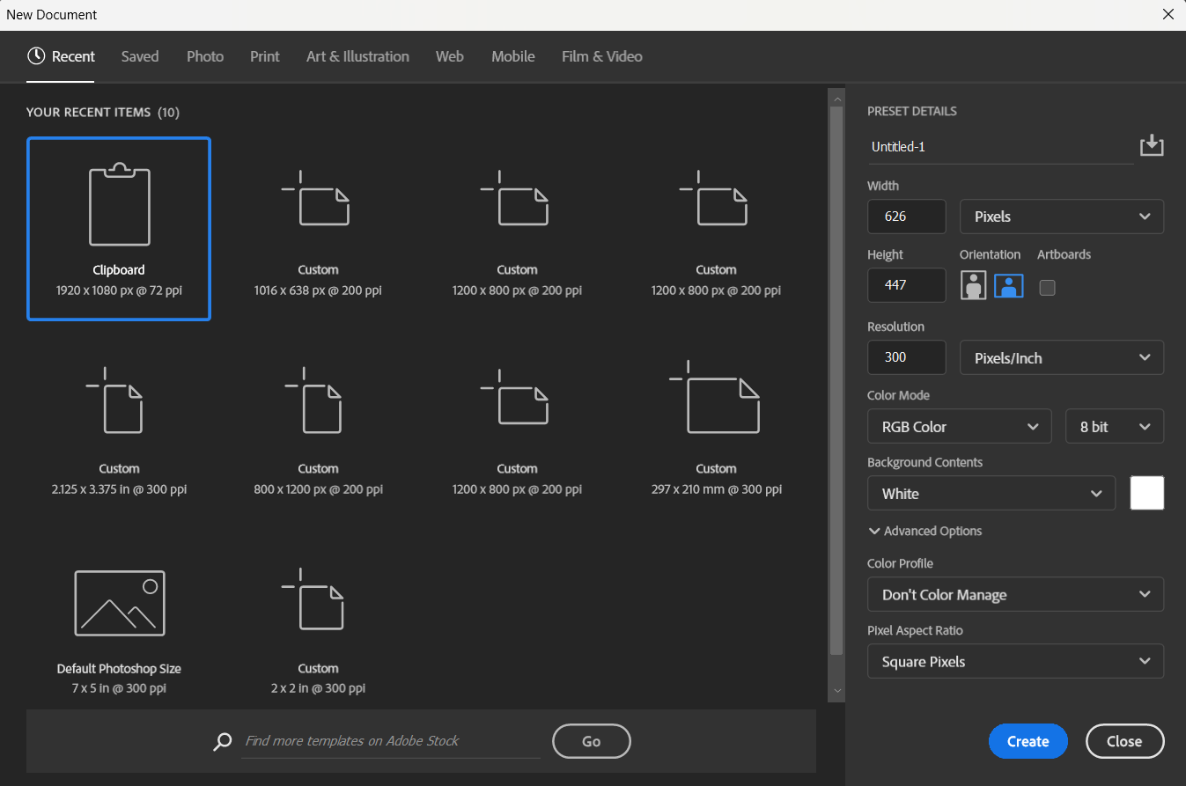**Step 1: Open Adobe Photoshop and adjust the dimensions (height, width and resolution) according to the background image properly.**

**Step 2: Now, import the background image.**

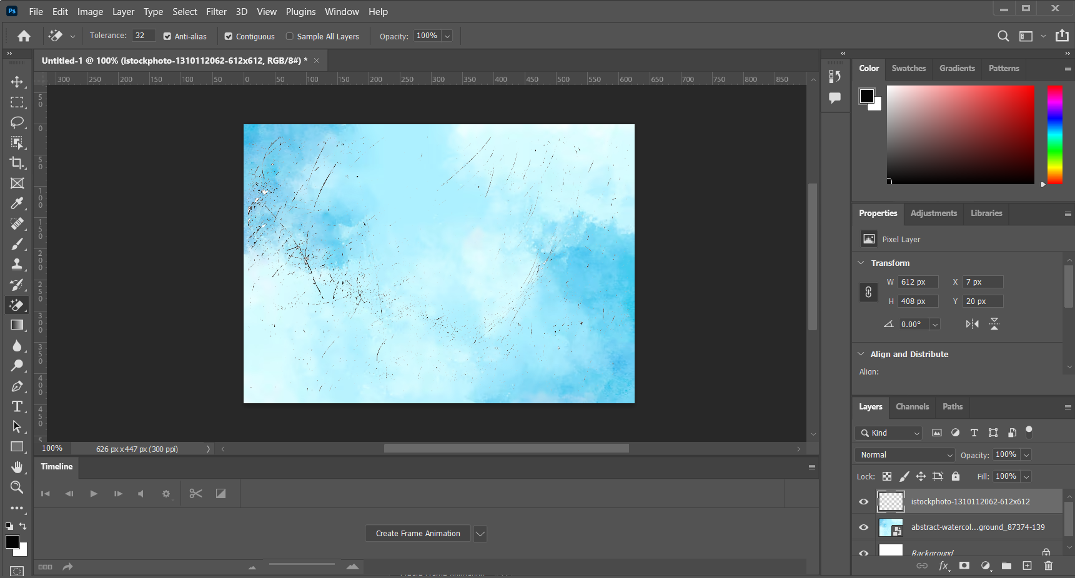

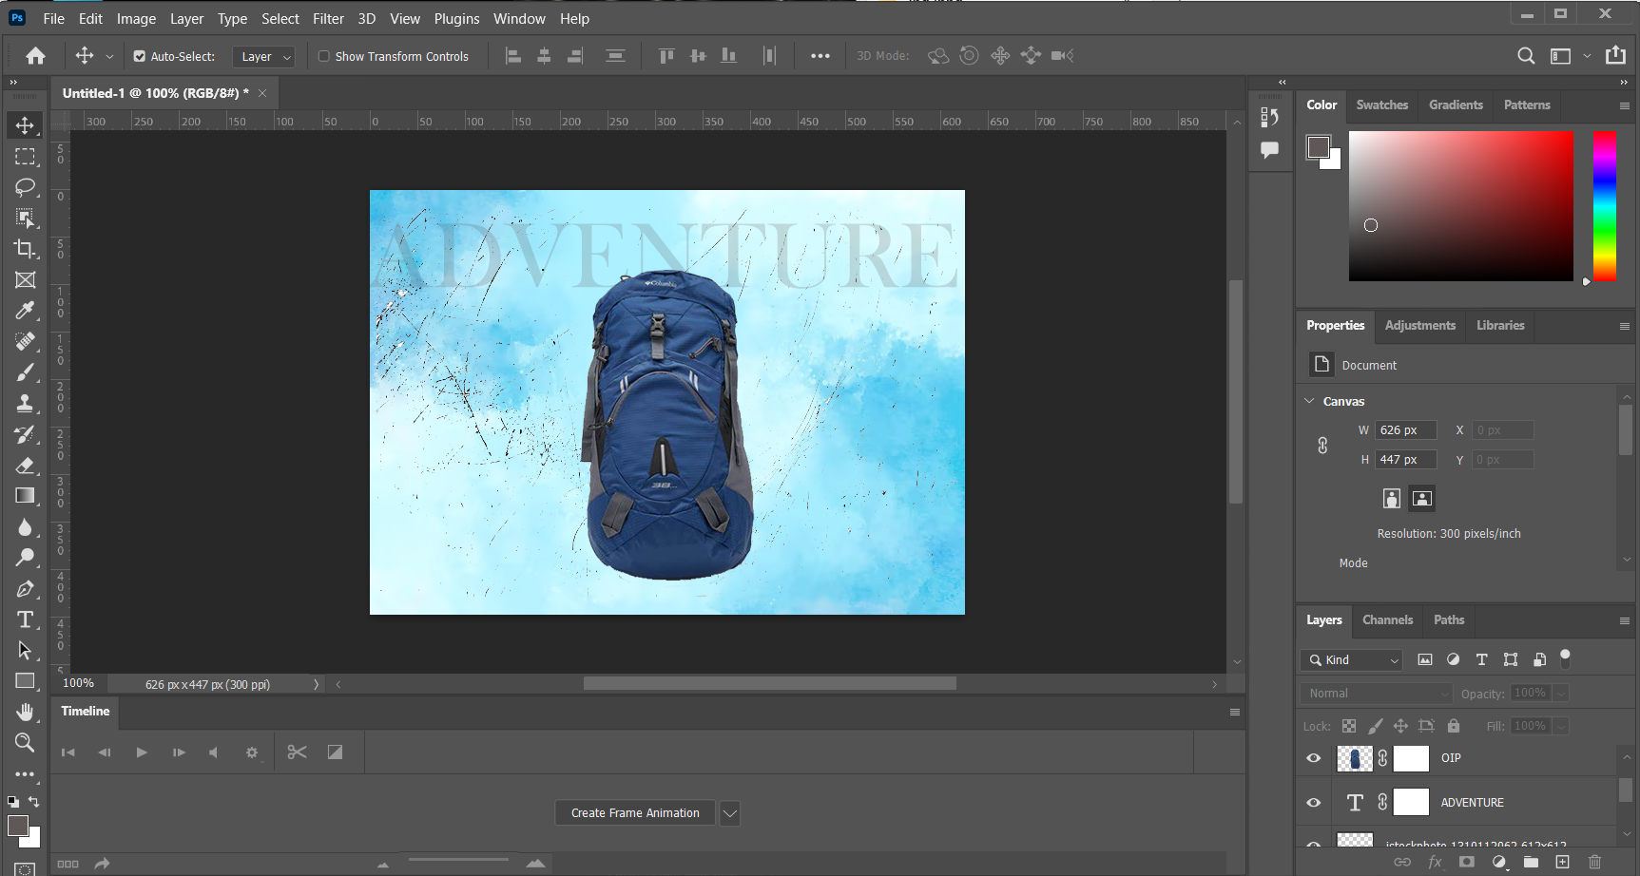**Step 3: Then, insert the necessary image and text.**

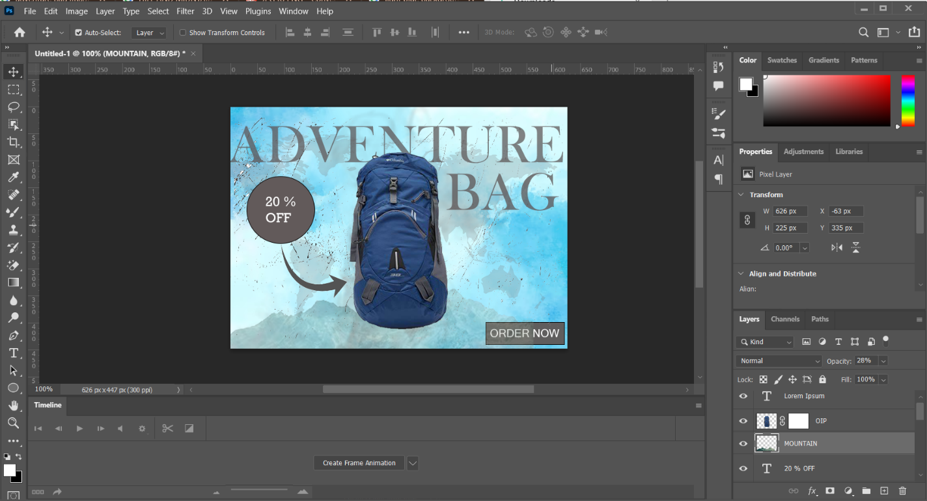**Step 4: Add required polygons and adjust the design as needed.**

**OUTPUT**

**CONCLUSION**

In this way, we can create an attractive advertisement using Adobe Photoshop.