# LAB 1

**a) Creating a Logo Using Macromedia Freehand**

# CONCEPT

The objective of this lab is to design a simple, professional logo using Macromedia Freehand. The logo should be visually appealing, memorable, and representative of my college named "Academia International College". The design should incorporate modern design elements, using clean lines and a minimalist approach.

# PROCEDURE

**Step 1: Create a new file and draw a circle from tools bar.**

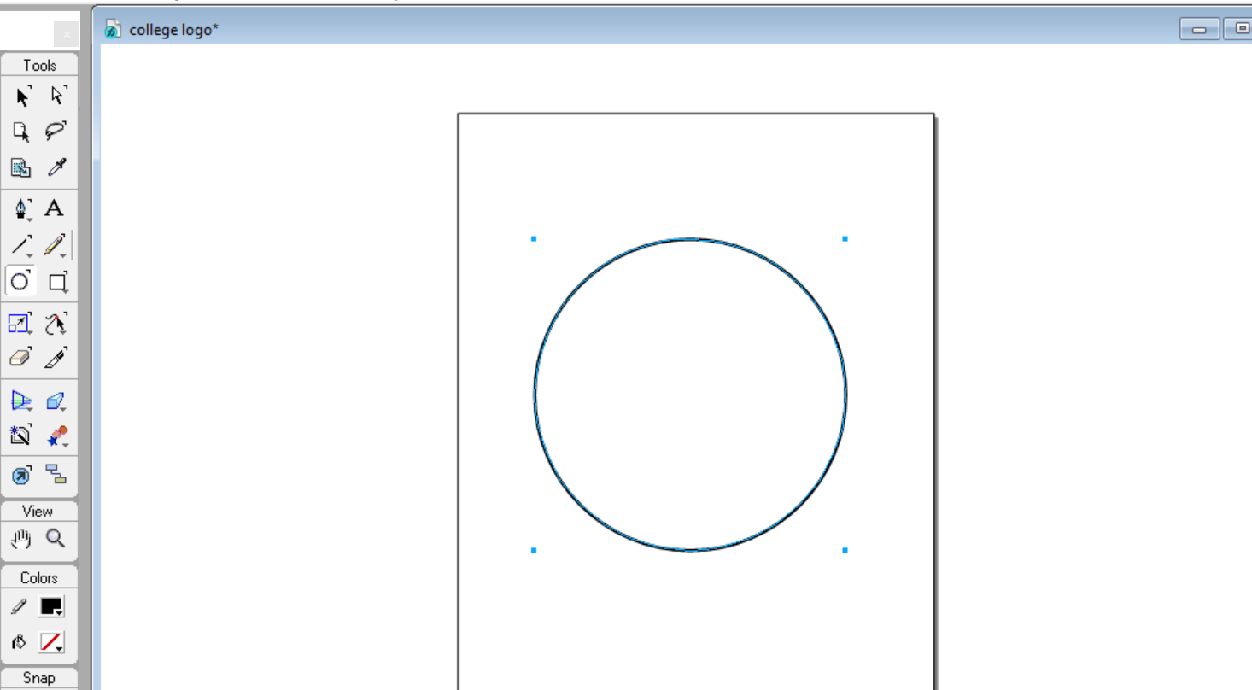

**Step 2: Create another smaller circle in the middle.**

(Tip: Select both circles and CTRL+shift+A to align right in the center)

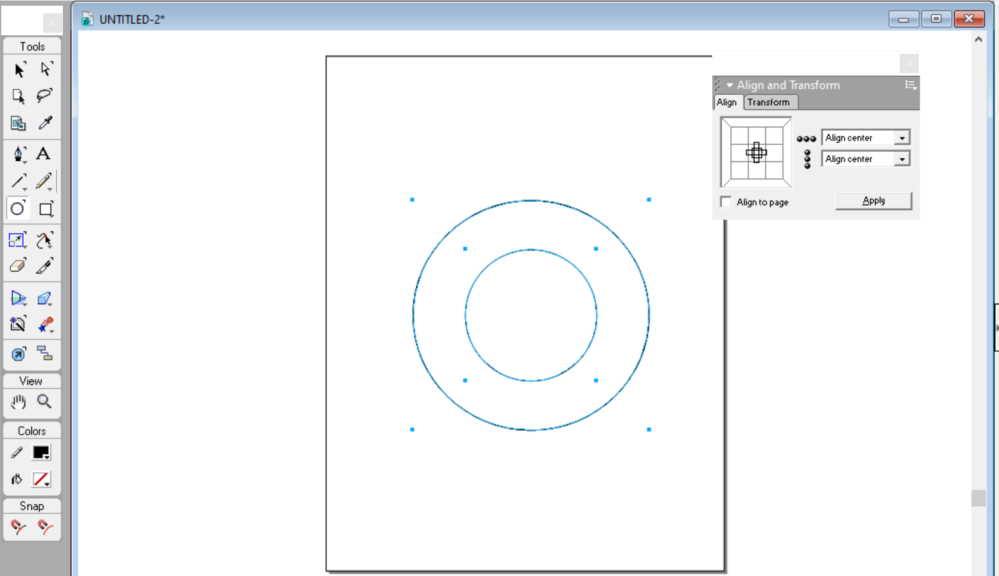

**Step 3: (Click and hold the rectangle tool to switch to polygon tool then double click to adjust no. of sides for triangle.)**

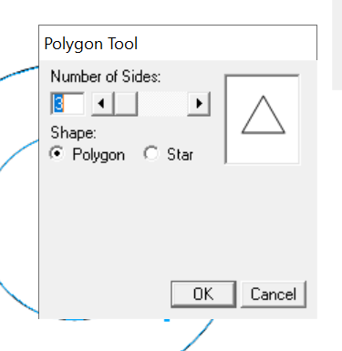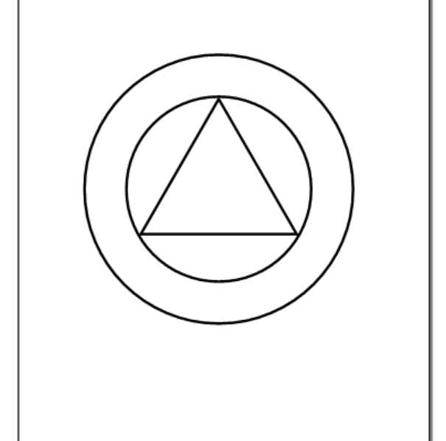

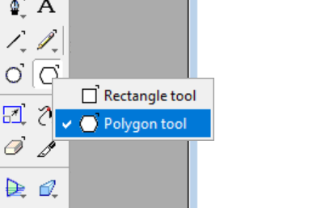

**Step 4: Duplicate the triangle (CTRL+Shift+D) and click on scale tool then choose rotate option and set the angle to 180 to rotate the duplicated.**

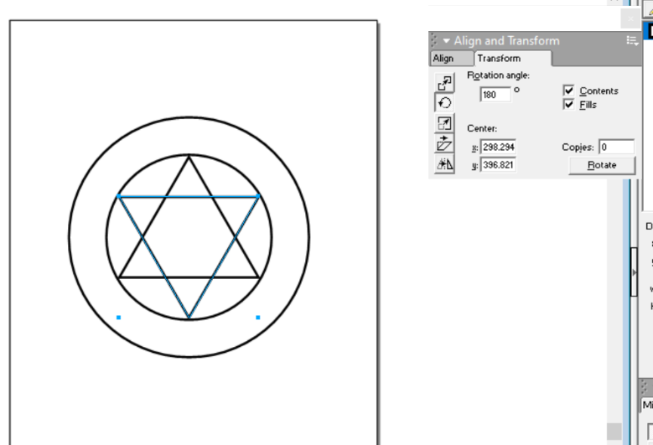



**Step 5:Click on the inner circle then press CTRL+shift+Y to add text on the borders of the circle.**

# 

**Step 6: Add the star shape through polygon tool and the select star on shape. \**

**Import the book icon from menu.**

# 

# 

# FINAL OUTPUT

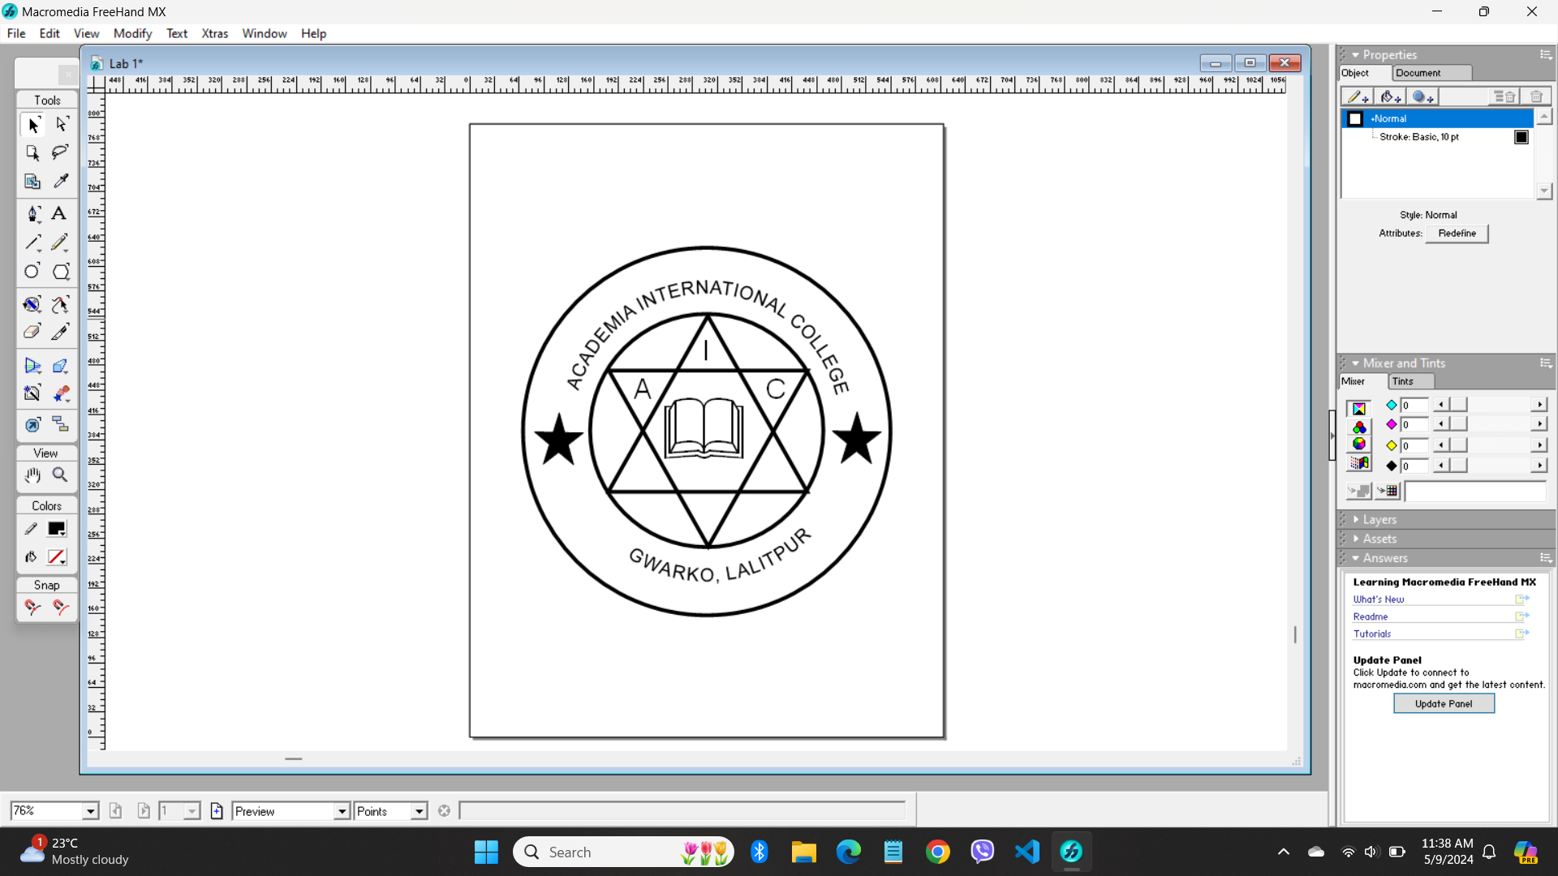

**CONCLUSION**

In this lab, we successfully designed a college logo using Macromedia Freehand. The process involved creating basic shapes, adding text, incorporating symbolic elements, and applying color and styling to achieve a professional look. This exercise demonstrated the versatility of vector graphics in logo design and the importance of each design step to create a cohesive and representative logo.

**b) Creating a professional design of my choice.**

# CONCEPT

In this project, through Multimedia Freehand software I designed the logo of Target, using a variety of tools.

The design process involved the following steps:

**Step 1:** Draw 3 circles. (The color fill is set to red for the outer and inner circles.)



**Step 2:** Add the text.

