# LAB 2

# Using Adobe Photoshop - Dithering Technique

# CONCEPT

Dithering is a technique used in digital graphics to simulate the appearance of color depth in images with limited color palettes. It works by creating a pattern of pixels to approximate colors that are not available in the palette. This method is commonly used to avoid banding and to give a more natural look to images when reducing the number of colors.

# PROCEDURE

**Step 1: Go to Image >> Mode>>Grayscale.**

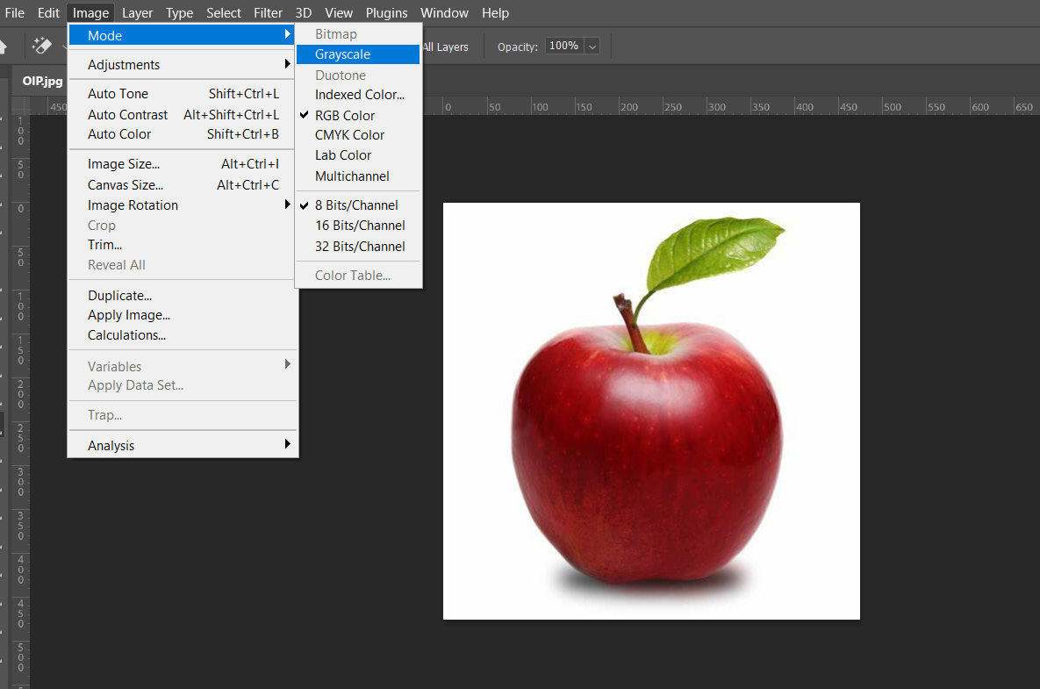

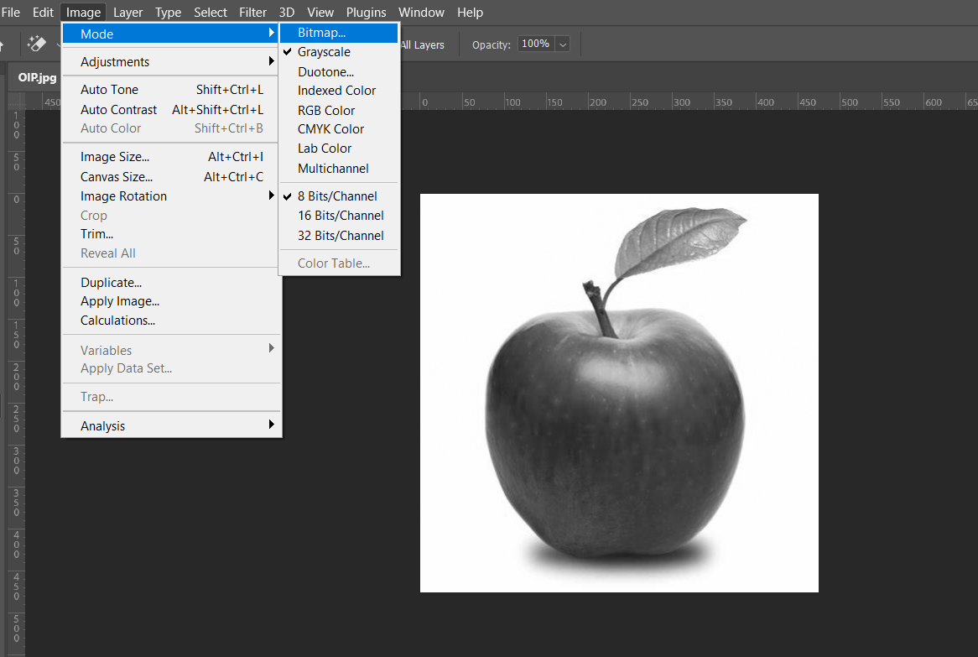**Step 2: Again, go to Image>>Mode>> and then Bitmap.**

**Step 4: Select the appropriate resolution and method.**

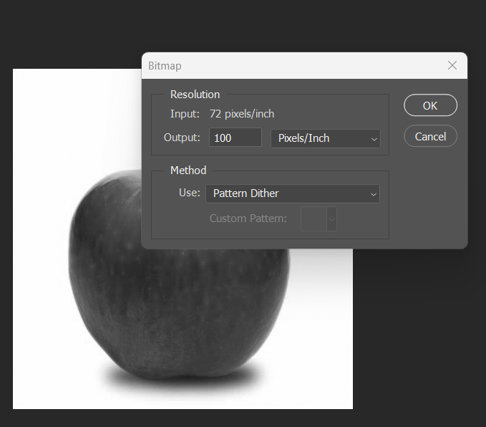

**Step 5: Finally, we’ll get the dither effect. (zoom for pixel comparison)**

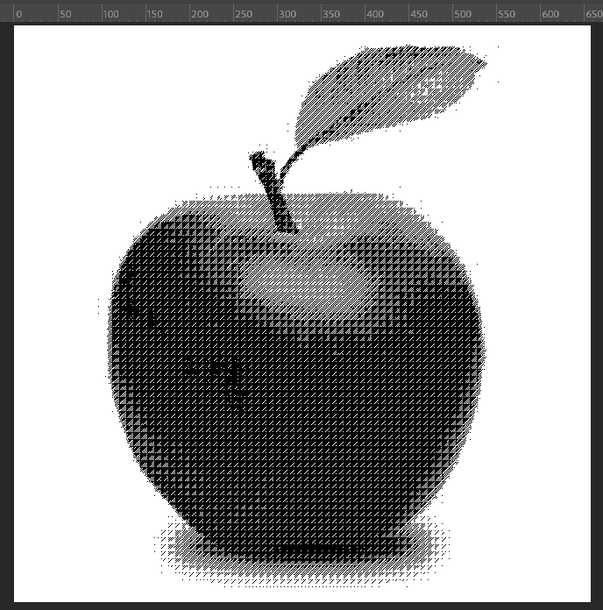

# FINAL OUTPUT:

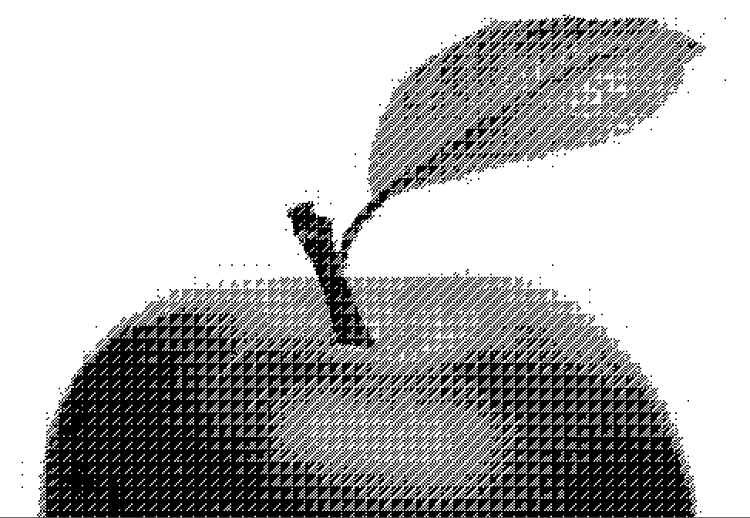

**CONCLUSION**

Dithering is an effective technique to simulate more colors and smoother gradients in images with a limited color palette. By strategically placing pixels of different colors next to each other, dithering reduces the visual artifacts of color quantization. In this lab, we successfully applied dithering to an image using Adobe Photoshop, demonstrating how this method can enhance the visual quality of digital graphics with restricted color usage. The final output shows a visually pleasing image with minimized banding effects, confirming the utility of dithering in practical scenarios.

**b) CREATING GIFs**

# CONCEPT

A GIF (Graphics Interchange Format) is a bitmap image format that supports both static and animated images, commonly used on the web for simple graphics, short animations, and looping videos due to its wide compatibility and small file size. GIFs are widely used on the internet due to their ability to support both static and animated images, making them ideal for simple graphics, logos, icons, and short animations or looping video clips. They are particularly popular for their small file size, lossless compression, and wide compatibility with different web browsers and platforms.

**PROCEDURE**

Step 1: Make layers of each frame to be converted into a gif in a sequence.

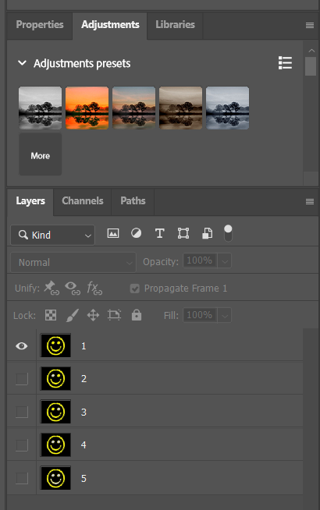

Step 2: Go to Window>>Timeline and Select Create Frame Animation.

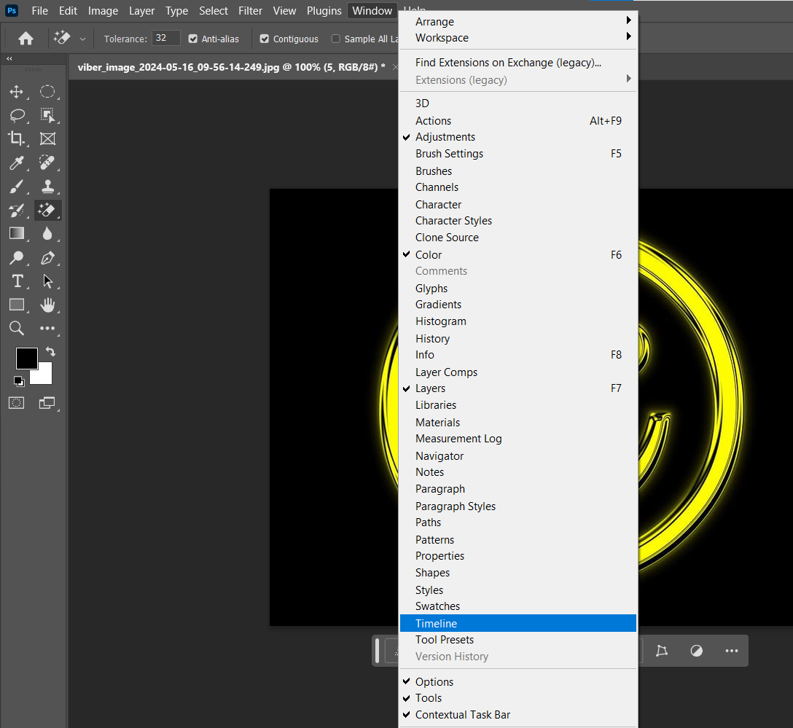

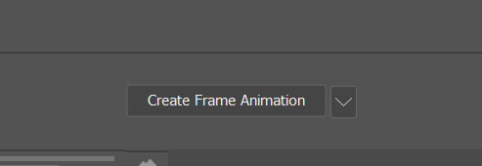

Step 4: Go to the new window and select Make Frames from layers.

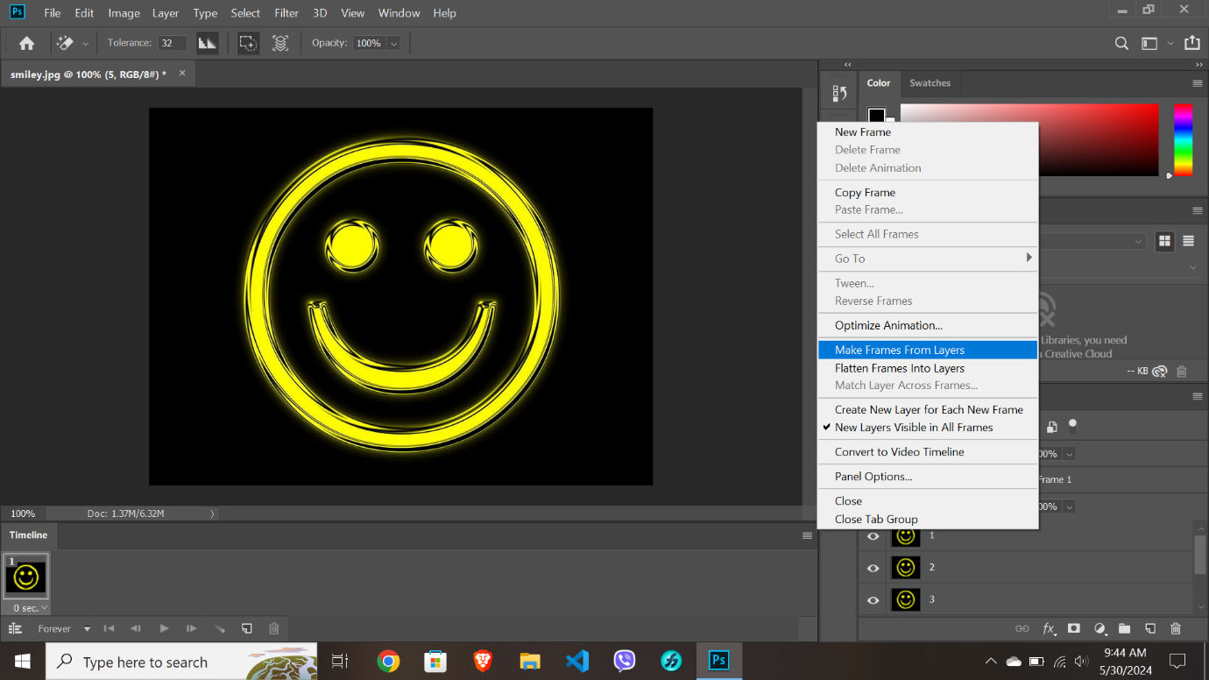

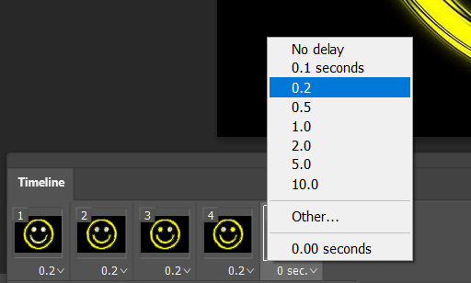Step 5: On each frame select the appropriate time of transition.

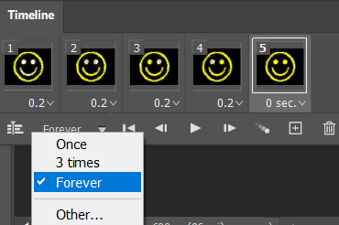

**OUTPUT**

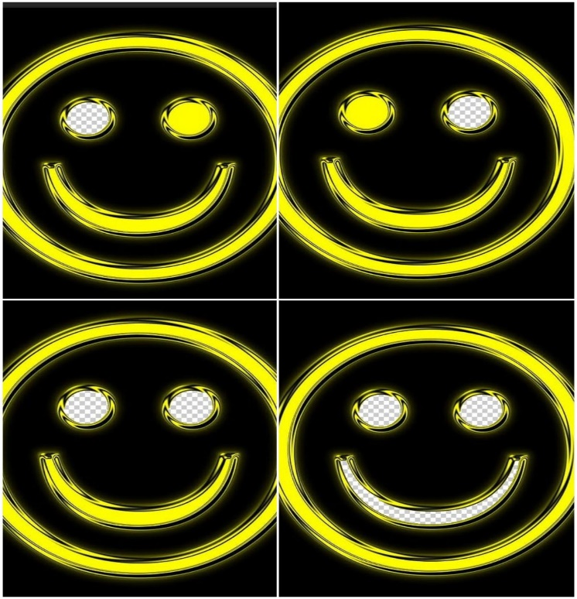

**CONCLUSION**

Creating a GIF in Adobe Photoshop involves a series of well-defined steps starting from setting up the project, creating individual frames, to compiling them into an animated sequence. By following these steps, you can produce high-quality GIFs suitable for a variety of applications. The process is straightforward, and with practice, it can be done efficiently to create engaging animations.