PROJECT: CREATE EBS SNAPSHOTS AND RESTORE AN EC2 INSTANCE

Objective
The objective of this project is to create an Amazon EBS snapshot of a volume attached to an EC2 instance and restore the data by creating a new volume from the snapshot. This demonstrates how backups and recovery can be performed using EBS snapshots in AWS.

Procedure:
To make the creation of instances and ebs attachment initially, I used terraform to create the infrastructure
I created the following files.

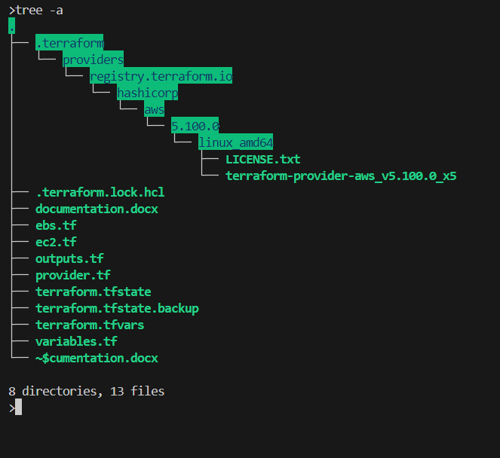

provider.tf
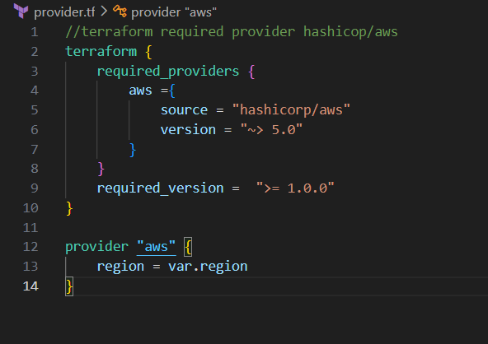

variables.tf
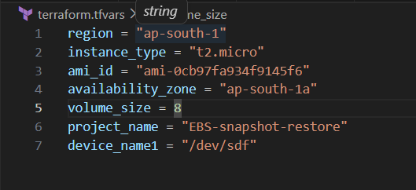
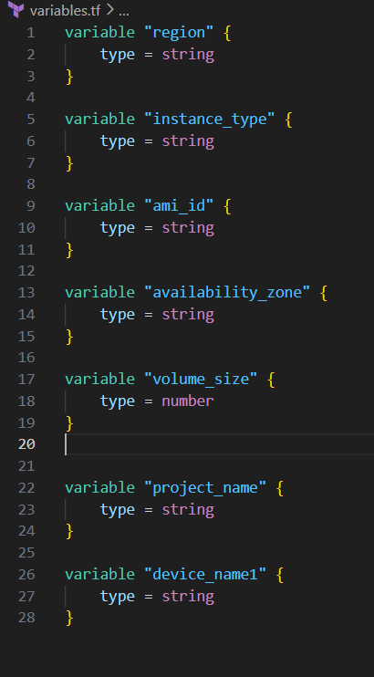

terraform.tfvars

ec2.tf
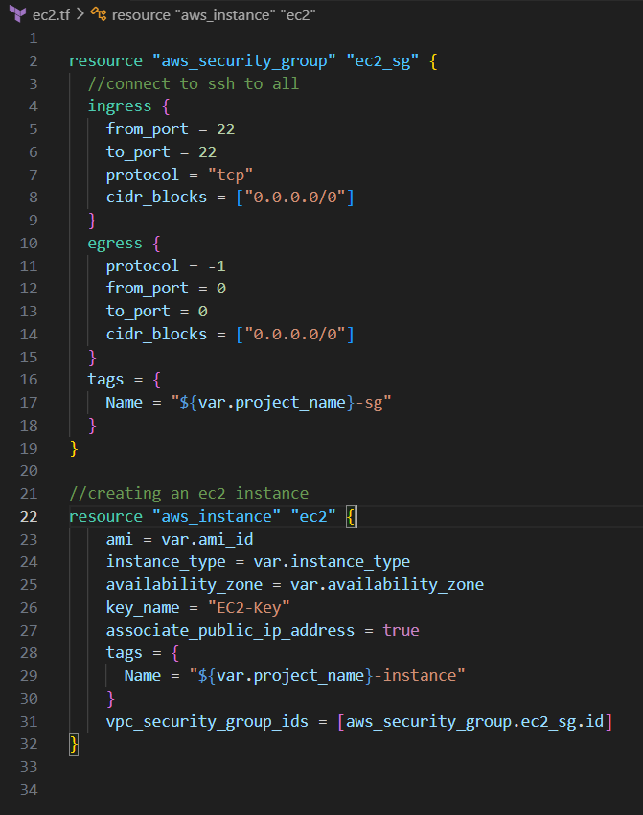

ebs.tf
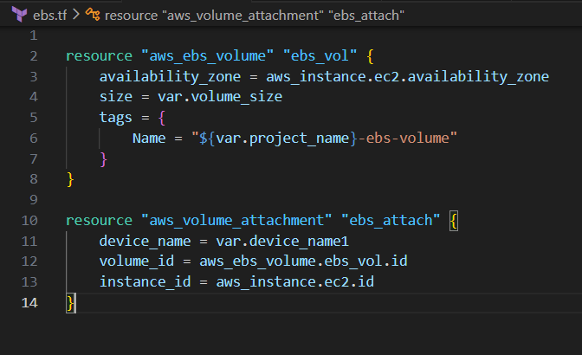

outputs.tf
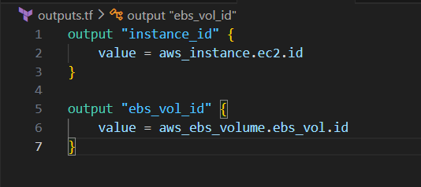

After creating these files I ran the following commands
- terraform init
- terraform validate
- terraform plan
- terraform apply

then I ssh-ed into the instance using the following command
ssh -I EC2-Key.pem ubuntu@3.110.162.26
command format is
ssh -I <the key here> ubuntu@<public ip of the instance>

then ran the following command
lsblk
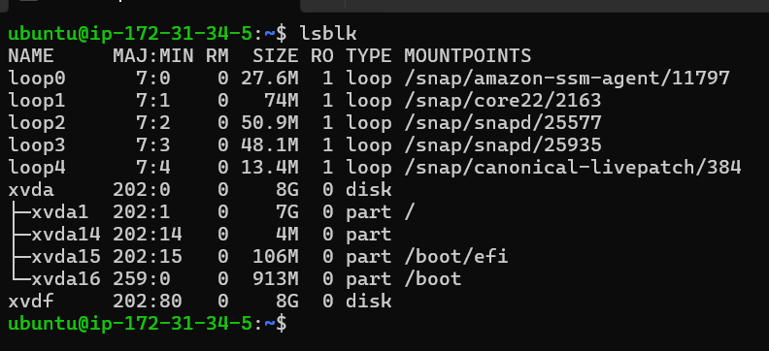

Here the /dev/xvdf is our current attached ebs vol
Created a filesystem in the ebs of type ext4
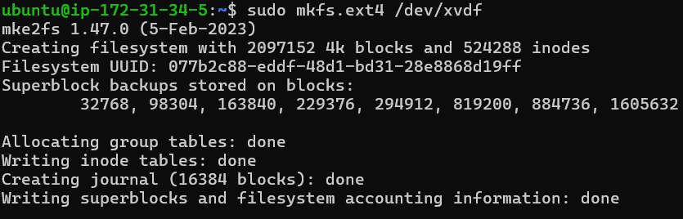
We make a directory /data using the following command
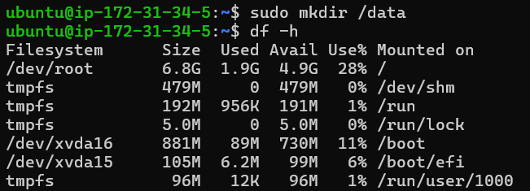
Now we mount the directory to the /dev/xvdf
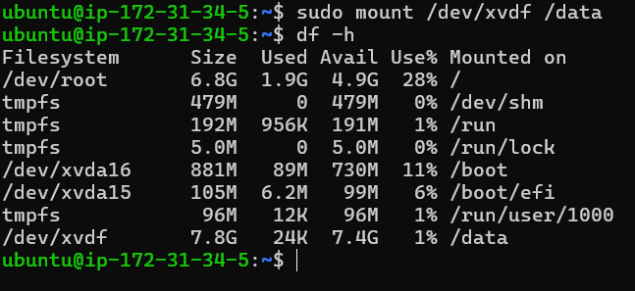
We create a txt file in it
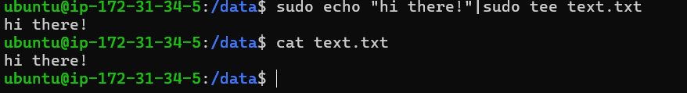

Now we take a snapshot of the modified ebs vol
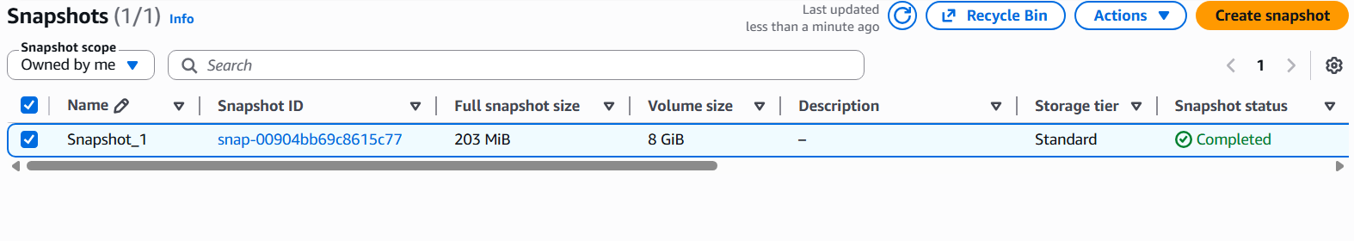

Now we will use this snapshot to create a volume using it
Now we will attach this with the ec2 instead of the original one
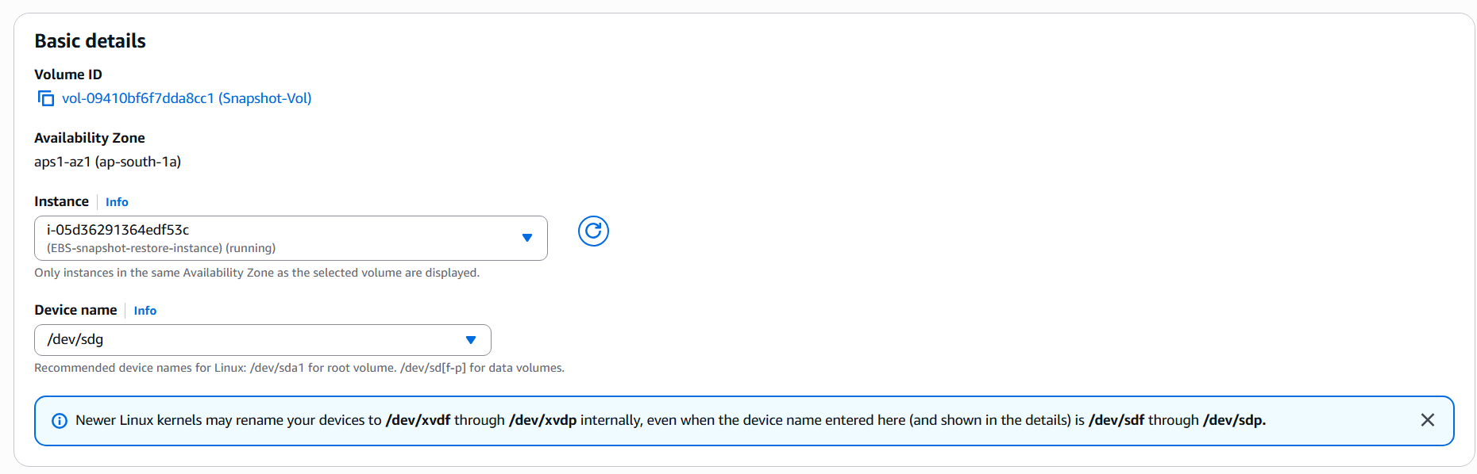

We will detach the previous ebs vol
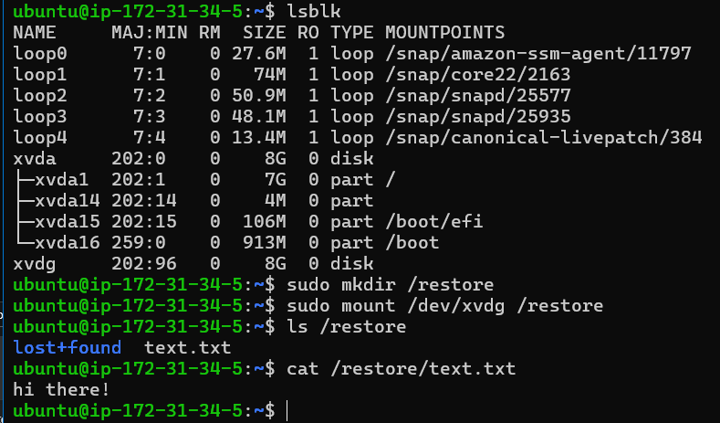

The /restore was created as a mount point so linux has a directory where the restored data can appear in the fs.

Cleanup
After verification, the created resources can be removed to avoid unnecessary costs.
Command:
- terraform destroy
This removes the EC2 instance and related infrastructure created during the project.

Expected Outcome
A snapshot of the EBS volume is successfully created and used to restore a new EBS volume containing the same data. This demonstrates the use of EBS snapshots for backup and data recovery in AWS.

