**1. User Interface**

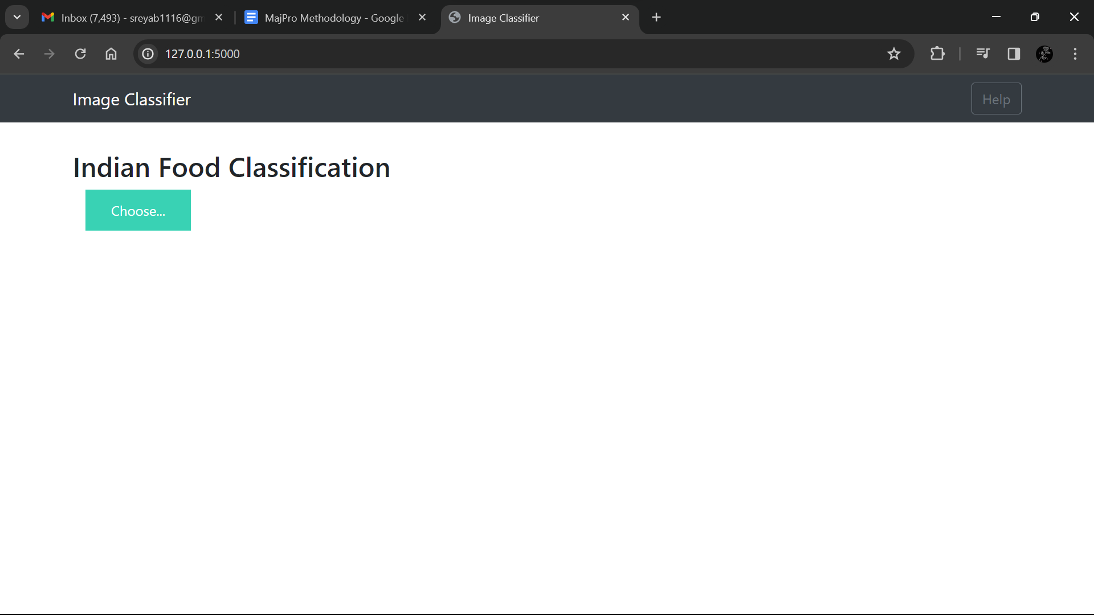

Fig. 1 User Interface

**2. Food Recognition and Recipe Generation-1**

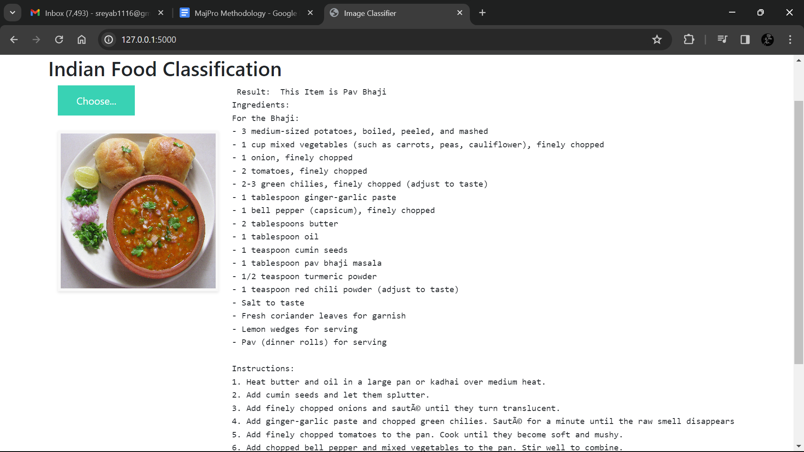

Fig. 2 Predicted Food Recipe-Pav Bhaji

**3. Food Recognition and Recipe Generation-2**

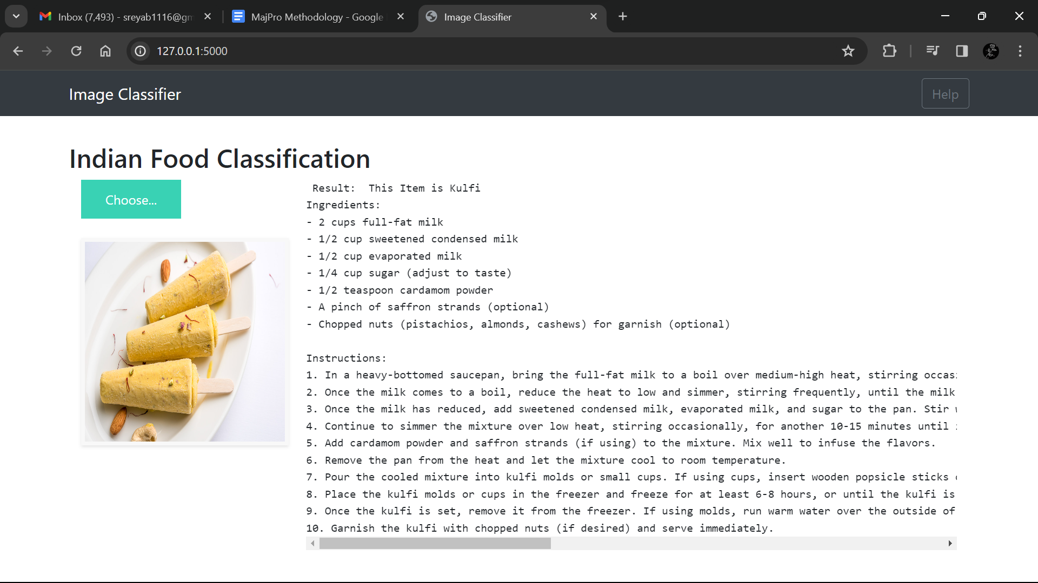

Fig. 3 Predicted Food Recipe-Kulfi

**4. Food Recognition and Recipe Generation-3**

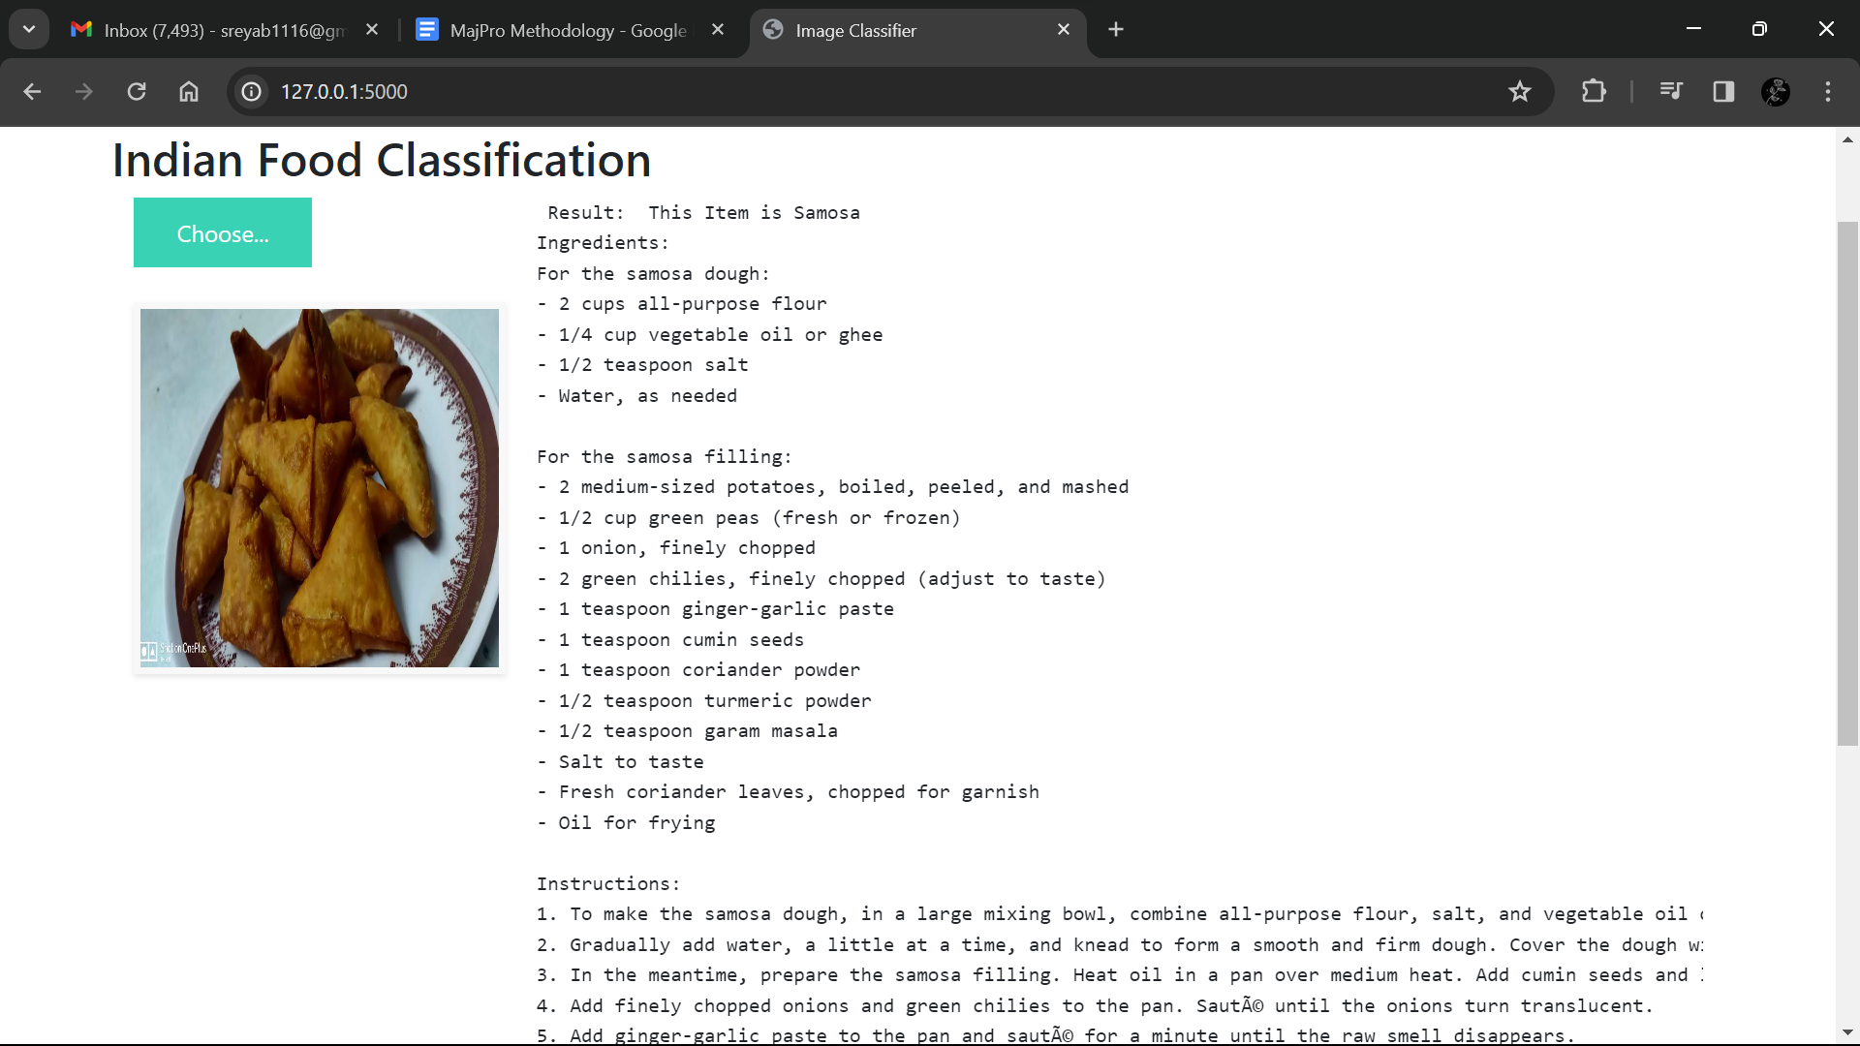

Fig. 4 Predicted Food Recipe-Samosa

**5. Food Recognition and Recipe Generation-4**

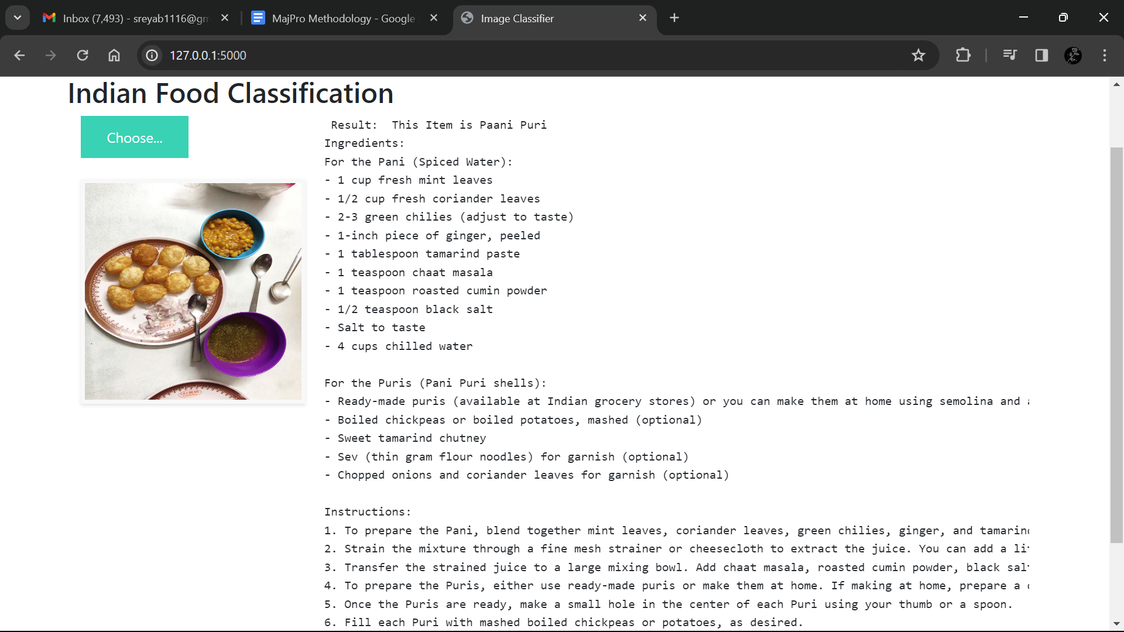

Fig. 5 Predicted Food Recipe-Paani Puri