CUSTOMER SHOPPING BEHAVIOUR ANALYSIS

- Project Overview
This project analyzes customer shopping behavior to identify revenue drivers, customer segments, and operational risks such as discount dependency.
The objective is to translate raw data into actionable business insights that improve customer retention, increase revenue, and optimize pricing strategies.

- Dataset Summary
- Rows: 3,900
- Columns: 18
- Key Features:
- Customer demographics (Age, Gender, Location, Subscription Status)
- Purchase details (Item Purchased, Category, Purchase Amount, Season, Size, Color)
- Shopping behavior (Discount Applied, Promo Code Used, Previous Purchases,
Frequency of Purchases, Review Rating, Shipping Type)
- Missing Data: 37 values in Review Rating column

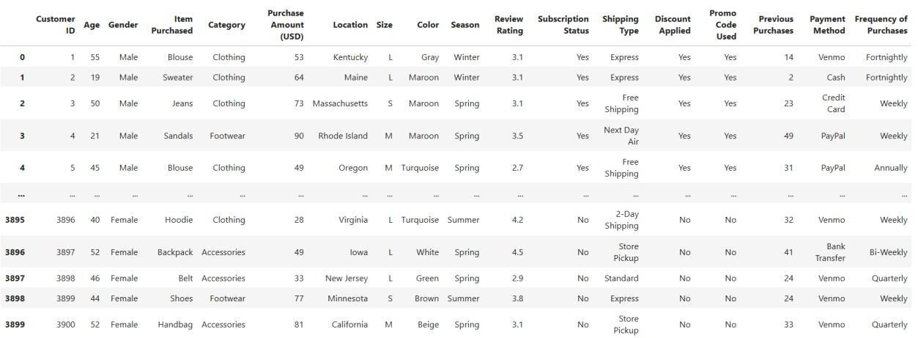

3. Exploratory Data Analysis using Python
We began with data preparation and cleaning in Python:
- Data Loading:
Imported the dataset using pandas.
- Initial Exploration:
Used df.info() to check structure and .describe() for summary statistics

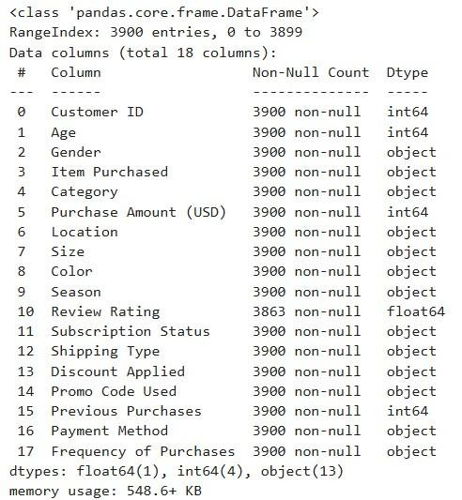

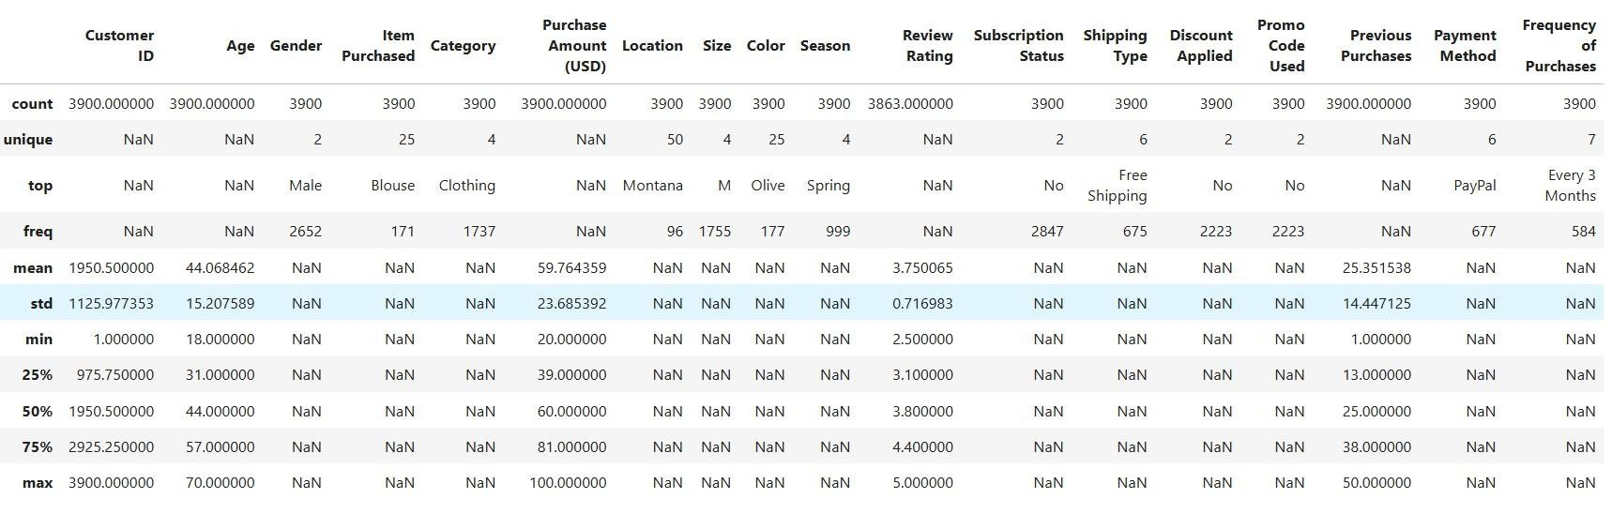
- Missing Data Handling:
Checked for null values and imputed missing values in the Review Rating column using the median rating of each product category.
- Column Standardization:
Renamed columns to snake case for better readability and documentation.
- Feature Engineering:
○ Created age_group column by binning customer ages.
○ Created purchase_frequency_days column from purchase data.
- Data Consistency Check:
Verified if discount_applied and promo_code_used were redundant; dropped promo_code_used.
- Database Integration:
Connected Python script to MYSQL WORKBENCH and loaded the cleaned DataFrame into the database for SQL analysis.

4. Data Analysis using SQL (Business Transactions)
We performed structured analysis in MYSQL WORKBENCH to answer key business questions:
- Revenue by Gender
Compared total revenue generated by male vs. female customers.
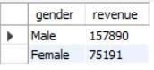

- High-Spending Discount Users
Identified customers who used discounts but still spent above the average purchase amount
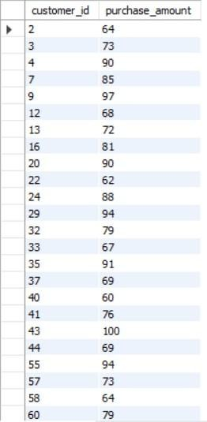

- Top 5 Products by Rating
Found products with the highest average review ratings.
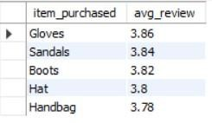
- Shipping Type Comparison
Compared average purchase amounts between Standard and Express shipping.
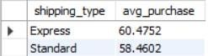

- Subscribers vs. Non-Subscribers
Compared average spend and total revenue across subscription status
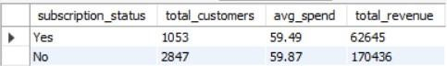

- Discount-Dependent Products
Identified 5 products with the highest percentage of discounted purchases.
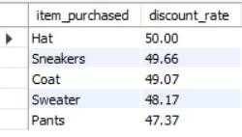
- Customer Segmentation
Classified customers into New, Returning, and Loyal segments based on purchase history.
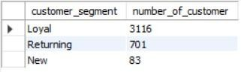

- Top 3 Products per Category
Listed the most purchased products within each category
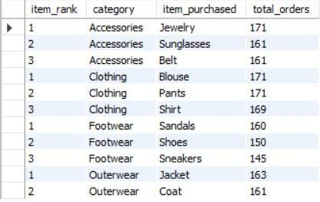

- Repeat Buyers & Subscriptions
Checked whether customers with >5 purchases are more likely to subscribe.
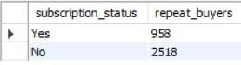
- Revenue by Age Group
Calculated total revenue contribution of each age group.
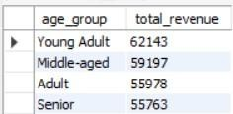

Key Business Insights

- Loyal customers contribute the majority of total revenue, highlighting strong retention value
- Subscriber base is relatively low (~24%), indicating significant growth potential
- Approximately 40% of orders involve discounts, suggesting dependency on promotions and potential margin risk
- Express shipping customers show higher purchase value, indicating preference for premium services

Dashboard in Power BI
Finally, we built an interactive dashboard in Power BI to present insights visually and support data-driven decision-making for stakeholders.
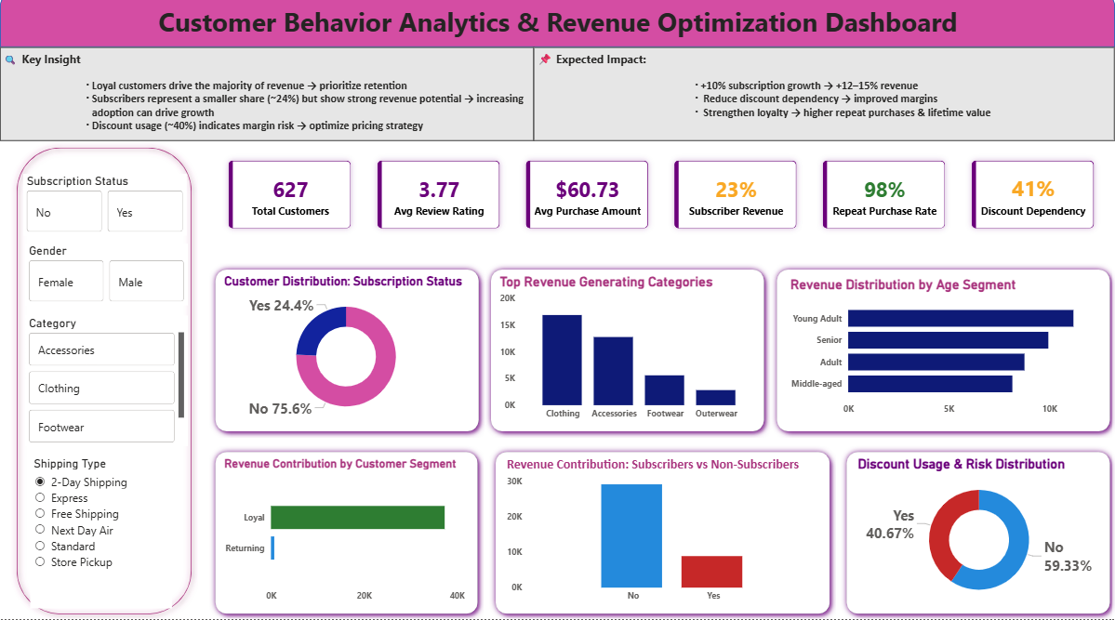

Business Recommendations
- Boost Subscription Adoption
Promote exclusive perks such as early access, special discounts, and faster delivery to convert regular customers into subscribers.
- Strengthen Customer Loyalty Programs
Introduce reward points, cashback, or tier-based benefits to encourage repeat purchases and transition customers into the “loyal” segment.
- Optimize Discount Strategy
Evaluate the effectiveness of discounts and promo codes to ensure they drive sales without significantly impacting profit margins.
- Enhance Product Positioning
Prioritize top-rated and high-performing products in marketing campaigns to increase visibility and conversions.
- Implement Targeted Marketing
Focus campaigns on high-revenue customer segments, such as specific age groups and frequent express-shipping users, for better ROI.

Business Impact

• Increasing subscription adoption by 10% can drive approximately 12–15% revenue growth
• Reducing discount dependency can improve overall profit margins
• Strengthening loyalty programs can increase repeat purchase rates and customer lifetime value

