**Front-End UI/UX Mini Project**

# 1. Title Page

* **Project Title**: Truffles Restaurant Website
* **Submitted By**:  o *Shreya Ann Binoy- 2462073- sreya.ann@btech.christuniversity.in*

o *Girikshith G Bhat- 2462073-girikshith.g@btech.christuniversity.in*

o *Joseph T Manu – 2462090-* *joseph.t@btech.christuniversity.in*

* **Course**:  *UI/UX Design Fundamentals*
* **Instructor Name**:  *Ms Nagaveena*
* **Institution**:  *Christ University* *Kengeri Campus*
* **Date of Submission**: *13/08/2025*

# 2. Abstract

This project involves the design and development of a responsive restaurant website for *Truffles*, a dining destination offering a variety of dishes across starters, mains, and desserts. The site was created entirely using **HTML5** and **CSS3**, with **Font Awesome** icons to enhance visual appeal. The main goal was to provide customers with an easy way to explore the menu, learn about the restaurant, and view contact details, all within a visually appealing, mobile-friendly interface. The final product features a categorized menu, an engaging “About Us” section, and integrated social media links, ensuring a seamless and user-friendly experience across devices.

**3. Objectives**

* **Design a visually appealing and user-friendly restaurant website**
* **Develop a fully responsive layout using only HTML and CSS**
* **Organize the menu into clearly defined categories**
* **Incorporate contact details and social media links**
* **Ensure accessibility and readability on multiple devices**

# 4. Scope of the Project

* Focuses solely on front-end design
* No JavaScript or backend integration
* Optimized for desktop, tablet, and mobile devices
* Uses only open-source tools and resources

# 5. Tools & Technologies Used

|  |  |
| --- | --- |
| **Tool/Technology** | **Purpose** |
| **HTML5** | Markup and content structure |
| **CSS3** | Styling and layout management |
| **VS Code** | Code editor |
| **Chrome DevTools** | Testing and debugging |

# 6. HTML Structure Overview

* Used semantic tags: <header>, <nav>, <section>, <footer>
* Website structured into key sections: Hero image, Menu, About Us, Contact, Footer
* Navigation menu created using <ul> and anchor links to scroll to sections

# 7. CSS Styling Strategy

* Used an external CSS file (style.css) for styling and layout organization
* Techniques applied:
  + Flexbox for alignment and layout
  + Media Queries for mobile responsiveness
  + Hover effects for interactive elements
  + Consistent typography and branding-focused color scheme

# 8. Key Features

|  |  |
| --- | --- |
| **Feature** | **Description** |
| **Responsive Design** | Adapts seamlessly to all screen sizes |
| **Categorized Menu** | Separate sections for Starters, Mains, and Desserts |
| About Section | Highlights the restaurant’s story and values |
| **Social Media Integration** | Links to Facebook, Instagram, and Twitter |
| Contact Information | Displays location, phone and operation hours |

# 9. Challenges Faced & Solutions

|  |  |
| --- | --- |
| **Challenge** | **Solution** |
| **Ensuring mobile responsiveness** | Implemented media queries and tested on various devices |
| Aligning icons with text | Used Flexbox alignment and padding adjustments |
| Maintaining design consistency | Applied a fixed color palette and font style throughout the site |

# 10. Outcome

The *Truffles* website effectively provides a visually appealing, functional, and mobile-responsive platform for customers to explore the restaurant’s offerings. It ensures ease of navigation and reflects the brand’s identity through consistent design, layout, and typography.

# 11. Future Enhancements

* Add JavaScript for dynamic menu filtering and animations
* Integrate an online reservation system
* Include a photo gallery of dishes and interiors
* Add light/dark mode toggle for improved accessibility

1. **Sample Code** 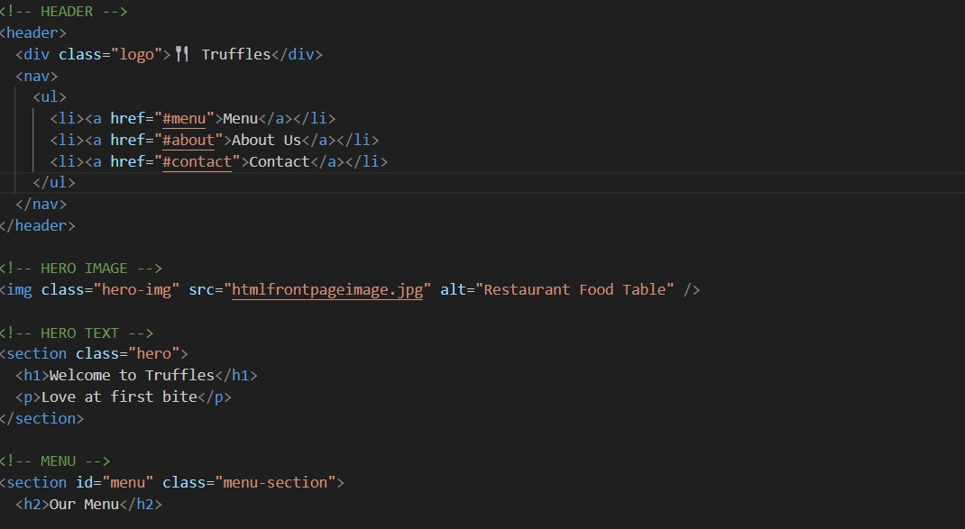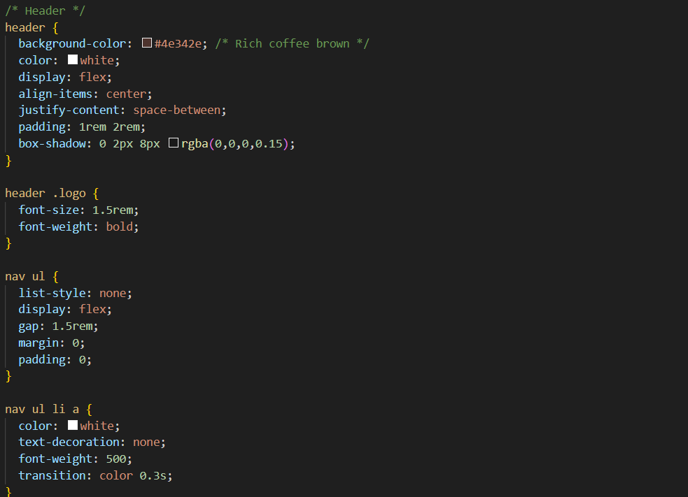

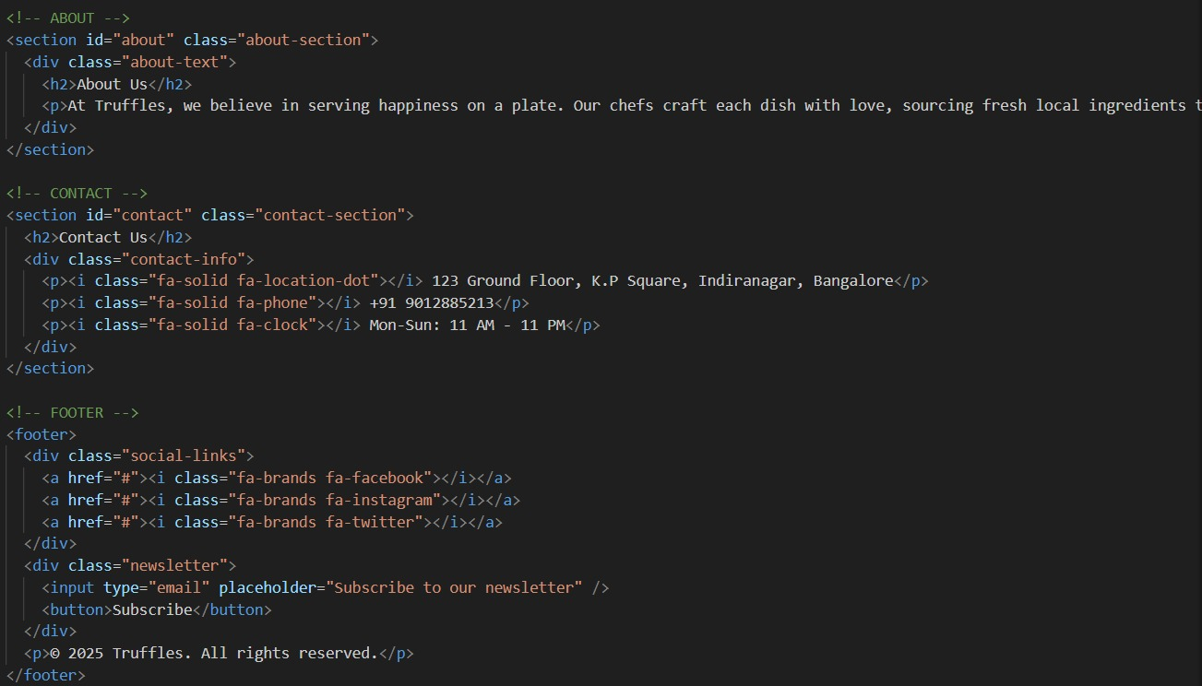

1. **Screenshots of Final Output**

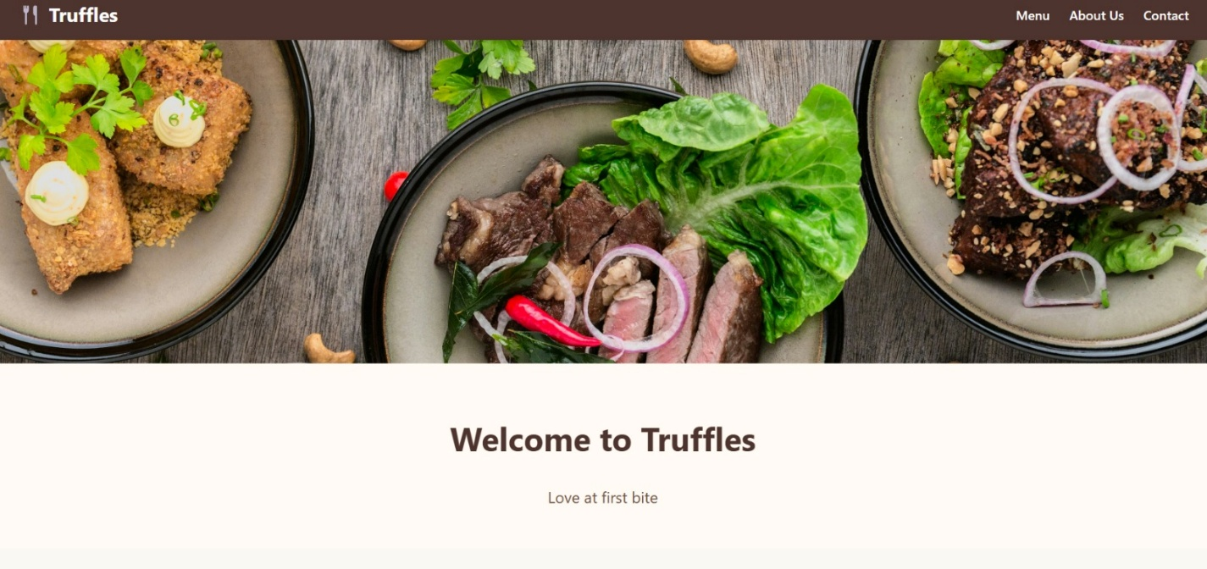

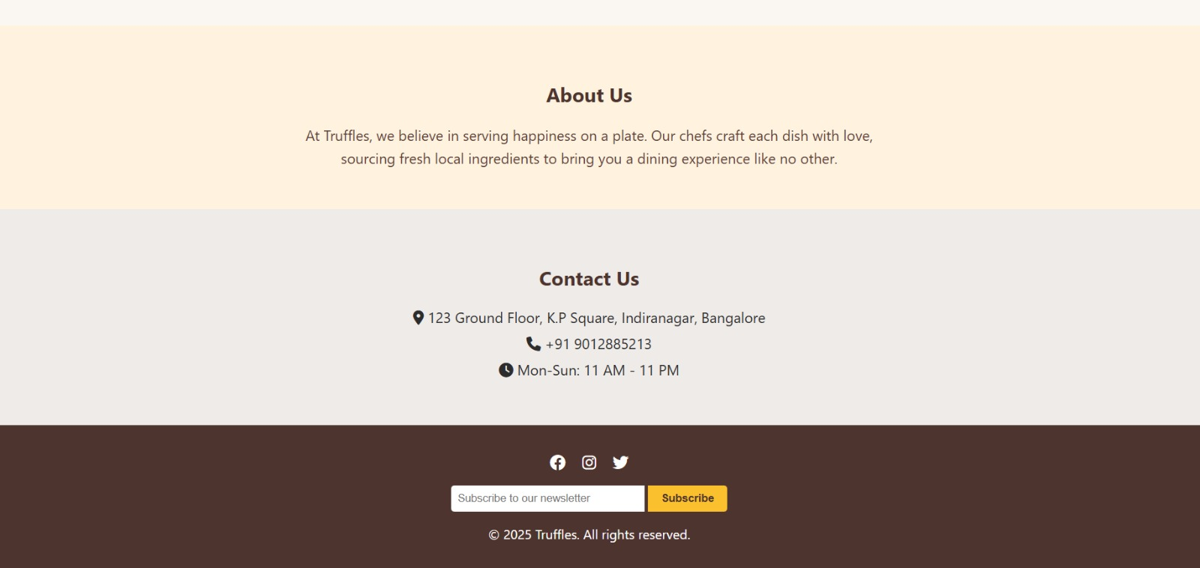

# 14. Conclusion

This restaurant website project demonstrates the effective use of HTML and CSS in creating a responsive, user-friendly, and aesthetically pleasing online presence. It strengthened skills in UI/UX design, responsive layouts, and semantic structuring, showcasing how well-structured front-end development can enhance brand engagement

# 15. References

- L&T LMS : https://learn.lntedutech.com/Landing/MyCourse

- W3Schools – HTML/CSS Documentation

- MDN Web Docs

- CSS Tricks

- Unsplash Image Repository