**Front-End UI/UX Mini Project**

# 1. Title Page

* **Project Title**: HopeForAll NGO website
* **Submitted By**:  o *Shreya Ann Binoy- 2462073- sreya.ann@btech.christuniversity.in*

o *Girikshith G Bhat- 2462073-girikshith.g@btech.christuniversity.in*

o *Joseph T Manu – 2462090-* *joseph.t@btech.christuniversity.in*

* **Course**:  *UI/UX Design Fundamentals*
* **Instructor Name**:  *Ms Nagaveena*
* **Institution**:  *Christ University* *Kengeri Campus*
* **Date of Submission**: *13/08/2025*

# 2. Abstract

This project involves the design and development of a responsive NGO website for HopeForAll, a non-profit organization dedicated to eradicating poverty, improving access to education, and providing healthcare to underserved communities. The website was created entirely using HTML5 and CSS3, focusing on clean UI design, responsive layouts, and accessibility. The goal was to showcase the NGO’s mission, programs, and calls-to-action while ensuring an engaging user experience on desktop and mobile devices. The final output is a visually appealing, functional, and responsive platform that can help increase outreach, attract volunteers, and enable donations.

# 3. Objectives

- Design a user-friendly interface using modern UI principles

- Develop a fully responsive layout using only HTML and CSS

- Implement structured HTML5 semantic elements

- Apply CSS styling for branding, layout, and responsive behavior

- Ensure accessibility and readability across devices

# 4. Scope of the Project

- Focused on front-end design only

- No JavaScript or server-side integration

- Intended for desktop, tablet, and mobile viewports

- Used only open-source tools and pure code (no libraries)

# 5. Tools & Technologies Used

|  |  |
| --- | --- |
| **Tool/Technology** | **Purpose** |
| **HTML5** | Markup and content structure |
| **CSS3** | Styling and layout management |
| **VS Code** | Code editor |
| **Chrome DevTools** | Testing and debugging |

# 6. HTML Structure Overview

Used semantic tags: <header>, <nav>, <main>, <section>, <footer>  
Structured into reusable sections: Home, About, Programs, Get Involved, Contact  
Navigation menu built using <ul> and anchor links for smooth scrolling

# 7. CSS Styling Strategy

Used an external CSS file (style.css) organized with comments and sections.  
Techniques used:  
 o Flexbox and Grid for layout  
 o Media Queries for responsiveness  
 o Hover effects and transitions for interactive elements  
 o Mobile-first design approach  
 o Consistent color scheme (blue for trust, yellow for warmth, white for clarity)

# 8. Key Features

|  |  |
| --- | --- |
| **Feature** | **Description** |
| **Responsive Design** | Adapts seamlessly to all screen sizes |
| **Smooth Navigation** | Sticky top navigation with anchor links |
| **Project Cards** | Grid-based layout for highlighting NGO programs |
| Prominent Call-to-Action Buttons | Encourage donations and volunteering |
| **Accessible Fonts & Colors** | High contrast and readable typography |

# 9. Challenges Faced & Solutions

|  |  |
| --- | --- |
| **Challenge** | **Solution** |
| **Overlapping elements on small screens** | Used media queries to stack elements |
| **Difficulty aligning items using float** | Shifted to Flexbox and Grid |
| **Typography scaling issue** | Used relative units (em/rem) instead of px |

# 10. Outcome

The HopeForAll website successfully delivers a clean, responsive, and visually engaging platform. Visitors can easily access information about the NGO, view its programs, and take action through donations or volunteering. The project enhanced our understanding of responsive design, semantic HTML, and user-focused UI/UX principles.

# 11. Future Enhancements

- Add JavaScript for interactivity (form validation, dynamic content)

- Integrate animations or transitions

- Backend integration for donation and volunteer form submissions

- Theme toggler (light/dark mode)

1. **Sample Code**

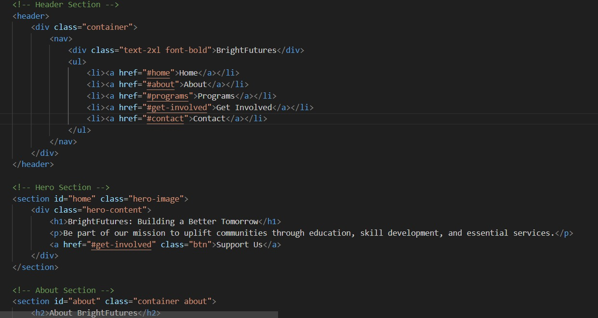

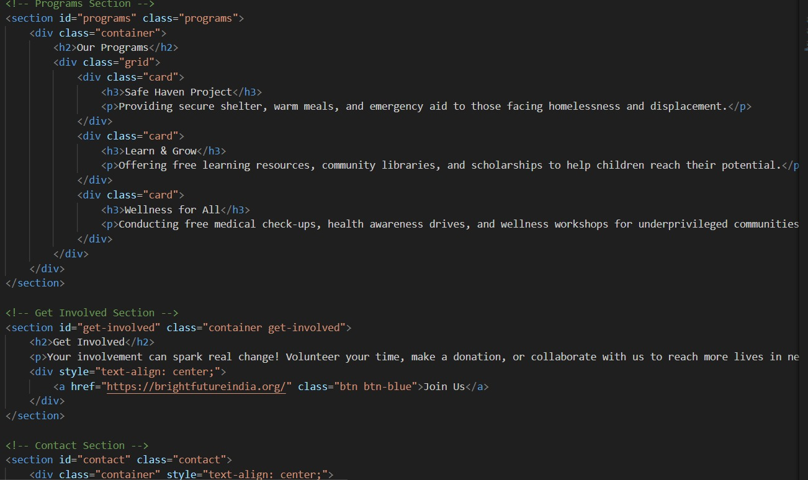

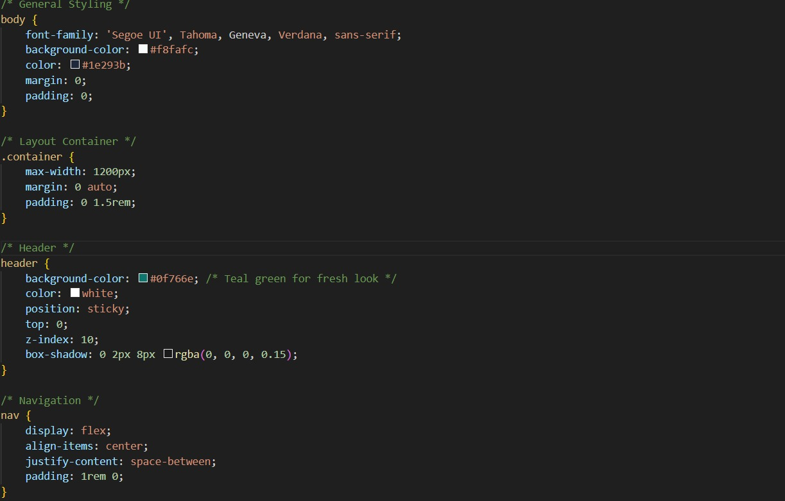

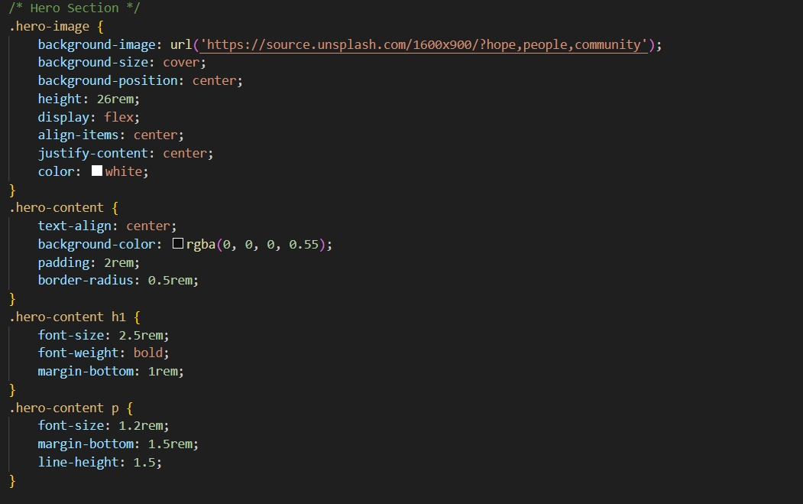

1. **Screenshots of Final Output**

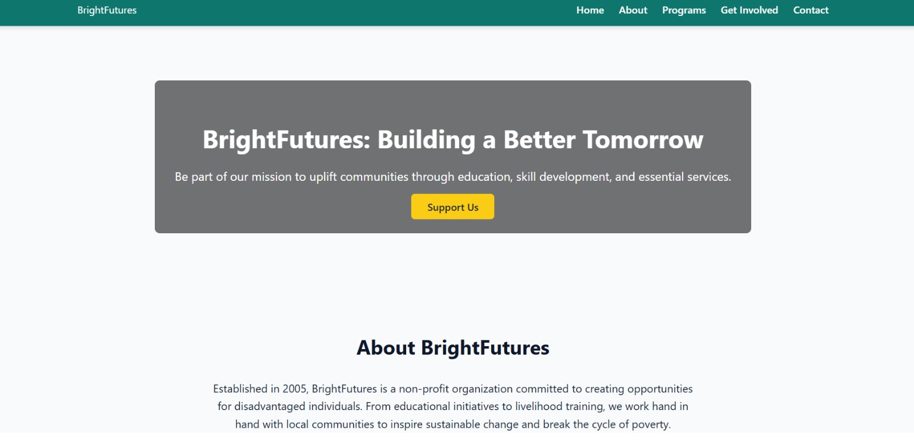

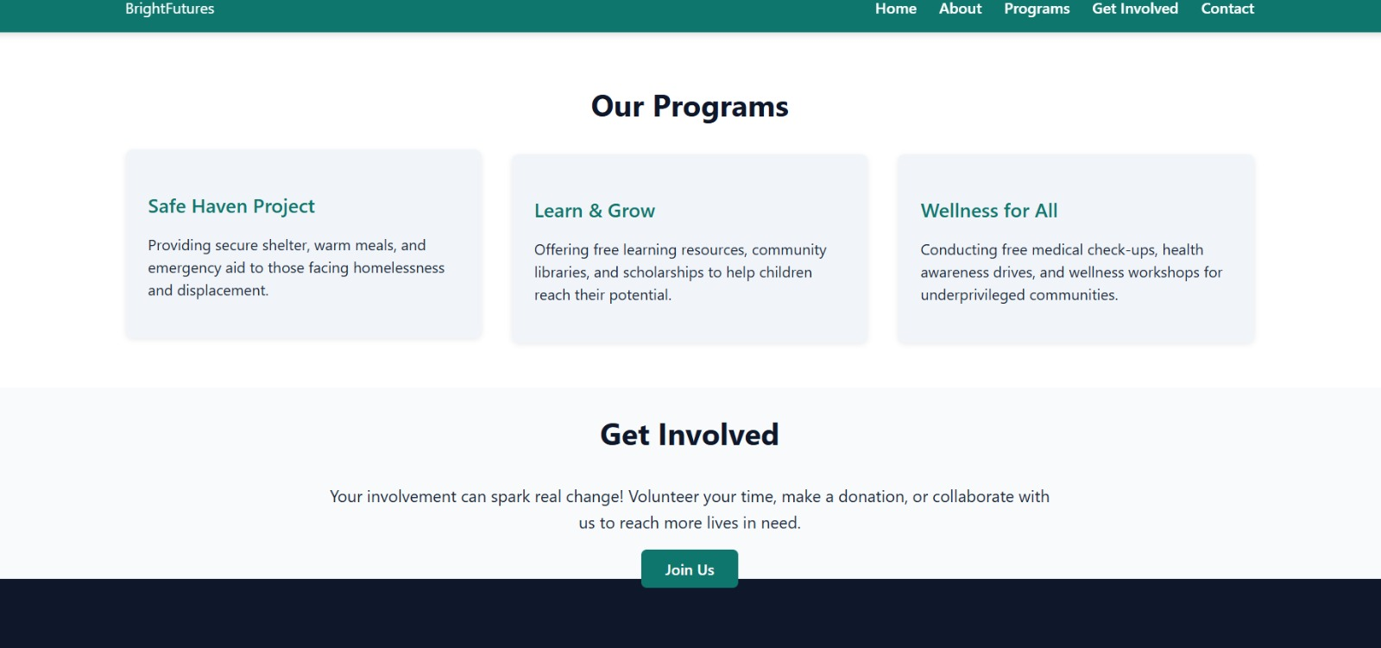

# 14. Conclusion

This front-end UI/UX mini project applied core design principles to develop a fully responsive NGO website using HTML and CSS. It strengthened our practical knowledge of layout structuring, visual hierarchy, and accessibility. The project demonstrates how clean, user-friendly design can enhance outreach and engagement for non-profit organizations.

# 15. References

- L&T LMS : https://learn.lntedutech.com/Landing/MyCourse

- W3Schools – HTML/CSS Documentation

- MDN Web Docs

- CSS Tricks

- Unsplash Image Repository