**A REPORT**

**ON**

**Graph Data Digest Document Format (GDF)**

BY

Vipin Baswan 2017A7PS0429P

Suyash Raj 2017A7PS0191P

Yashdeep Gupta 2017A7PS0114P

Abhinava Arsada 2017A7PS0028P

Sreyas Ravichandrana 2017A7PSP

AT

**Homi Bhabha Centre for Science Education (HBCSE)**

A Practice School-1 station of



Birla Institute of Technology & Science, Pilani

(June 2019)

**A REPORT**

**ON**

**Graph Data Digest Document Format (GDF)**

BY

Vipin Baswan 2017A7PS0429P Computer Science

Suyash Raj 2017A7PS0191P Computer Science

Yashdeep Gupta 2017A7PS0114P Computer Science

Abhinava Arsada 2017A7PS0028P Computer Science

Sreyas Ravichandrana 2017A7PSP Computer Science

Prepared in the partial fulfilment of the

Practice School-I (BITS F221)

AT

**Homi Bhabha Centre for Science Education (HBCSE)**

A Practice School-1 station of



Birla Institute of Technology & Science, Pilani

(June 2019)

**ACKNOWLEDGEMENTS**

We’d like to thank Dr K Subramaniam, Director, Homi Bhabha Centre for Science Education for providing this opportunity to us, the students of BITS Pilani to work with the organization towards the fulfilment of its purpose of promoting science education throughout the country. We’d also like to thank Nagarjuna G. to allow us the chance to work on this project under his able guidance. We also extend our thanks to Prof. Mukesh Kumar Rohil, our Practice School Coordinator for his constant support and guidance. Additionally, we express our heartfelt gratitude to Mr. J. B. Waghmare for his constant support at the PS station in non-academic matters.

Finally, our humblest apologies to others who helped us but whose names were not mentioned in the list.

**Birla Institute of Technology and Science**

**Pilani (Rajasthan)**

**Practice School Division**

**Station:** Homi Bhabha Centre for Science Education

**Duration:** 21 days

**Date of Start:** 21st May, 2019

**Date of Submission:** 10th June, 2019

**Title of Project:** Graph Data Digest Document Format (GDF)

**Submitted By:**

Vipin Baswan 2017A7PS0429P Computer Science

Suyash Raj 2017A7PS0191P Computer Science

Yashdeep Gupta 2017A7PS0114P Computer Science

Abhinava Arsada 2017A7PS0028P Computer Science

Sreyas Ravichandrana 2017A7PSP Computer Science

**Under:**

Nagarjuna G., Faculty at Homi Bhabha Centre for Science Education

**Submitted to:**

Prof. Mukesh Kumar Rohil, our PS1 faculty

**Key Words:** Graph Databases, RDF, GraphQL, Data Digest Format

**Project Areas:** Graph Databases

**Abstract:**

Graph databases have always been a promising tool in increasing the querying efficiency on datasets. Hence, the prospect of data digest document format such as GDF seems very promising in today’s world where datasets interact in a complex manner and quick information retrieval is of prime import.

Our project deals with developing a format called GDF and the method to convert any document format into GDF. This will assist us in quick merging of different files as graphs can be merged easily.

**TABLE OF CONTENTS**

1. Acknowledgements
2. Abstract
3. Introduction
4. Main Text
   1. Background
   2. 7-Column Format
   3. Meta-Data Format
   4. Components of the Project
   5. Our Progress
   6. To be completed
5. Conclusion
6. Appendix
7. References
8. Glossary

**INTRODUCTION**

The aim of our project is to develop a Data Digest Format which can be used to convert and represent information from any format. The format is graph based, hence the name.

The scope of our project is to:

1. Decide the format of GDF
2. Write methods to convert a text file into GDF
3. Create meta-data in the GDF format from the meta-data in the text format
4. Develop a query language (based on SPARQL) for information retrieval

Currently, we have completed aims (a) and (b). We will use the 7-column format for GDF. The relevant details will be provided in the main text.

We are currently working on (c) and (d). We hope to complete objective (c) by 15th May, 2019. Also, some of our members are also concurrently working on objective (d).

Since the idea of GDF is pretty innovative and unique in itself (Credit: Nagarjuna G.), not much literature is available to us for this exact format. But a similar data format called Resource Description Format (RDF) already exists. It is also graph based data format. Hence, we have gone through the literatures regarding RDF (links of the online resources have been given in the References section). Also, we have generated the sample data (for testing our code) ourselves using a python code but later we will collect more data from DBPedia (an online platform to get 3-column formatted data for various Wikipedia pages). Also, the query language for our format is basically SPARQL. We are referring to the official literature available on SPARQL (link for the same has been provided in References Section) for building our querying engine.

We wanted to limit the dependency of our code on various platforms. Hence, we have used BASH Scripting to write our code.

Due to time constraints, we will not be able to create our own renderer but we will be using already existing ___________ renderer.

This report gives an outline of our project and the path we are expected to follow to complete the project on time. We also explain whatever we have completed till now and also introduce what we will be doing in the coming days. This report is like a comprehensive summary of our whole project.

**MAIN TEXT**

1. **BACKGROUND**

This data format can be said to be loosely inspired from the RDF format, additionally making use of the seven-column format, which has been described below. In both of these formats, data is stored in the form of graphs i.e. nodes as well as edges for easier and more efficient querying of data. We also decided to additionally generate unique IDs for each one of the tuples generated as well as each entity uniquely specified by the edges and nodes. The last addition to this data format is that we shall implement a constantly self-updating metadata section of our data which cannot be accessed by the users and contains information about the type of entities stored in our data which reduces our query time to a very large extent despite requiring a very large amount of storage space.

1. **7-COLUMN FORMAT**

Each tuple in the input file (can be in any format) can be viewed as an entity with a Subject, Object and a Predicate. For instance, in “*Yashdeep likes to eat ice-cream*”, ‘Yashdeep’ is the Subject, ‘ice-cream’ is the Object and ‘likes to eat’ is the Predicate.

Let’s see the graph given below:



*Fig.1: A graph representing the sentence “Yashdeep like to eat ice-cream”*

Here are the observations:

1. Both subject and object are represented by the nodes of the graph
2. Predicate is represented by the edge of the graph
3. Both nodes and edges have some text associated with them (like ‘Yashdeep’ and ‘Ice-cream’ associated with nodes and ‘Likes to eat’ associated with edge)
4. The edge originates from Subject and terminates at Object
5. Thus, the graph we get is always a directed graph
6. Subject, Objects and Predicates can also have ‘qualifiers’ associated with them. For example, in above graph, Subject Qualifier can be ‘Person’, Object Qualifier can be ‘Dessert’ and Predicate Qualifier can be ‘Preferences’. In short, a qualifier gives more information about the entity.

The above graph corresponds to a single tuple of the GDF file. This graph is represented by a 7-column format in our GDF File. The format is:

UID | Subject | Subject_Qualifier | Predicate | Predicate_Qualifier | Object | Object_Qualifier

Hence, above graph will be represented by the following tuple in our GDF File:

1242353353|Yashdeep|Person|LikesToEat|Preferences|Ice-cream|Dessert

Thus, for each tuple in the input file, a tuple is generated in the GDF file. Finally, the output will contain a file with .gdf extension.

The code for the conversion of text into GDF file is attached in the appendices section along with the ReadMe file for the code. Also, the sample data file along with the python code has also been attached in the appendices section.

1. **META-DATA FORMAT**

Along with the GDF file a meta-data GDF file is also created. For creating this file, the user has to give the meta-data text file as the input. The meta-data file will also have a Graph based file format. For instance, see the graph below:

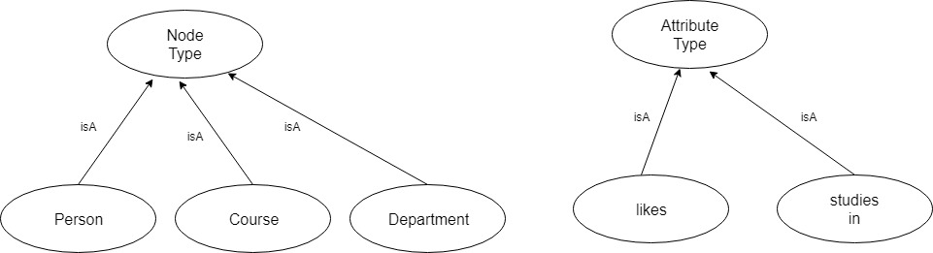

*Fig. 2: An example Node and Attribute types for meta-data.gdf file*

The meta-data contains two basic entities: Node type and Attribute/Predicate type. This is used to define the nodes and edges within the graph.

In the example discussed previously, “*Yashdeep likes to eat ice-cream*”, Yashdeep is a Person and hence Yashdeep is a Member of Person Node type. This information can also be conveyed through the 7-column format:

Subject | Subject_Qualifier | memberOf | | Node_Type

Predicate | Predicate_Qualifier | memberOf | | Attribute_Type

Object | Object_Qualifier | memberOf | | Node_Type

In our example,

Yashdeep | | memberOf | | Person

Ice-cream | | memberOf | | Food-items

Likes to eat | | memberOf | | likes

Hence, for each subject/object/predicate, our meta-data.gdf file will contain a tuple in it.

1. **COMPONENTS OF THE PROJECT**

The conversion of input text file into Graph database can be represented by the following graph:

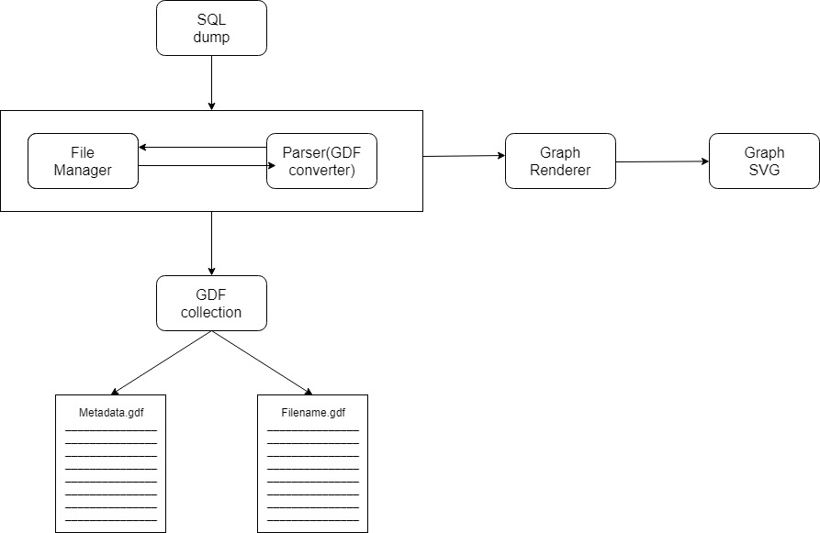

*Fig. 3: Processing of input file to get an interactive Graph SVG*

The steps are as follows:

1. We will receive input from the user in the form of a table (called SQL Dump in the above chart). Mostly, user will also provide the corresponding meta-data file as another input file.
2. The parser will parse the input file and generate the GDF file along with the meta-data.GDF file. The availability of meta-data.GDF rests upon the availability of meta-data file as the input from user.
3. The, we need to convert the GDF file into the JSON objects and then render these JSON objects in the form of Graph SVGs. This will be done by the Graph Renderer.