**How to Create an App with Vue CLI**

Before creating a project, need to install Vue CLI first:

*npm install –g @vue/cli*

Steps to create a project with Vue CLI:

1. Run *vue create <directory name>*



1. There are 2 choices: the default (which enables *babel* and *eslint*) or select *Manually select features.* But now we choose *Manually select features*

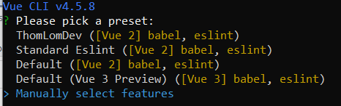

1. Select *Linter/Formatter*

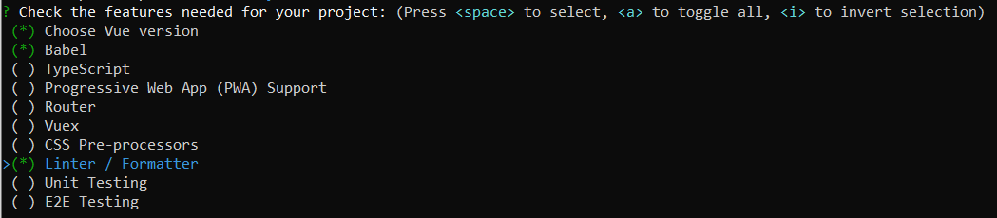

1. Select *ESLint with error prevention only*

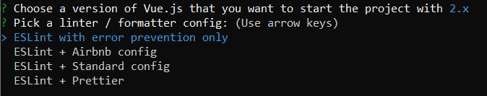

1. Select *Lint on save*



1. Select *In dedicated config files* for Babel, PostCSS, ESLint, etc.

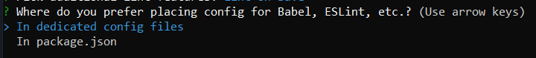

1. Then go to that directory, and run *npm run serve*

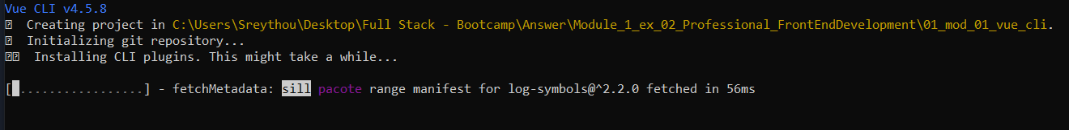

1. Lastly, open the browser and visit *http://localhost:8080*

