**Mongo DB Installation and Practice**

**Steps to install Mongo DB:**

Step 1: Go to this URL: <https://www.mongodb.com/try/download/community>

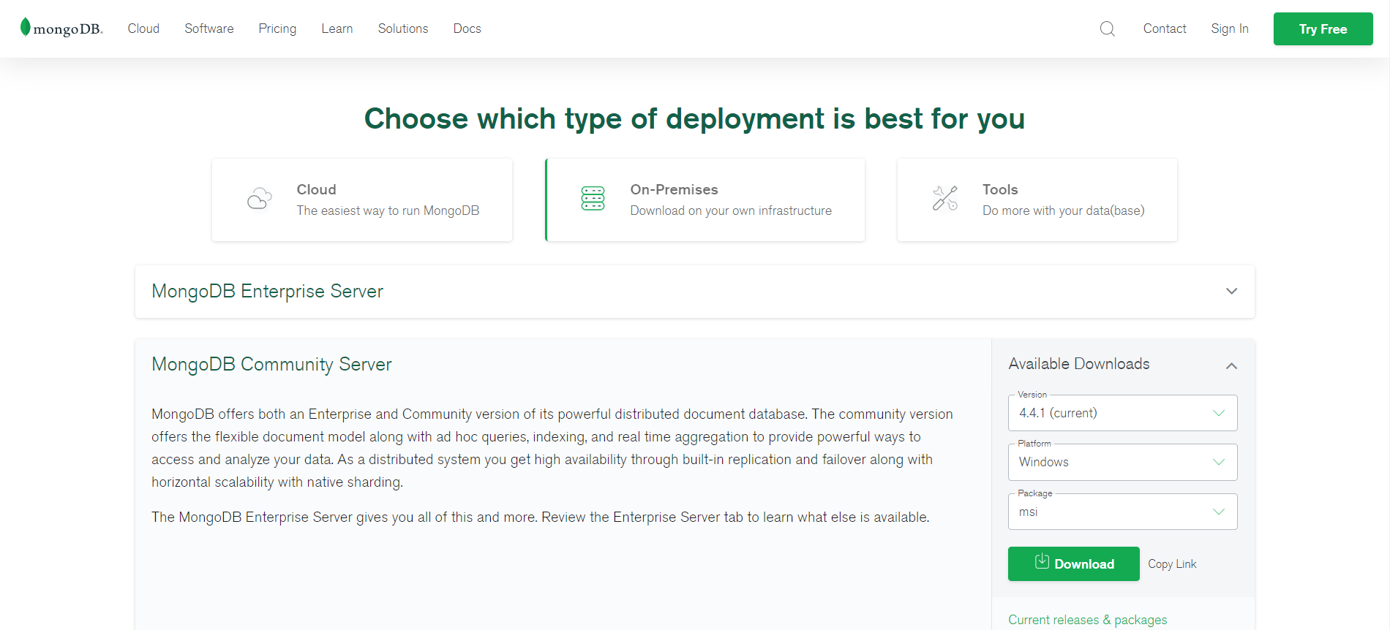

Step 2: Click on *Download* button in *MongoDB Community Server*

Step 3: Install the file below

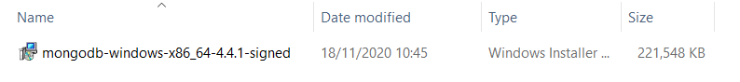

Step 4: After installation that file, Mongo DB Compass will start like below:

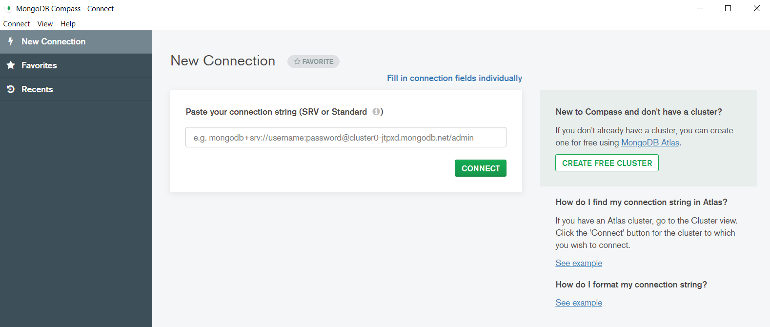

**Establish Connection to MongoDB Server**

Step 1: Open *command prompt* and go to directory path: *C:\Program Files\MongoDB\Server\4.4\bin*

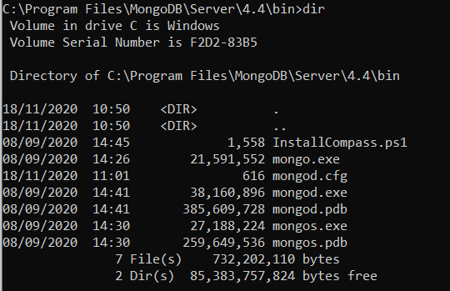

Step 2: Go to *Task Manager* and find *MongoDB* in *Service tab.* If the status is *Stopped,* right click and click on *Start*

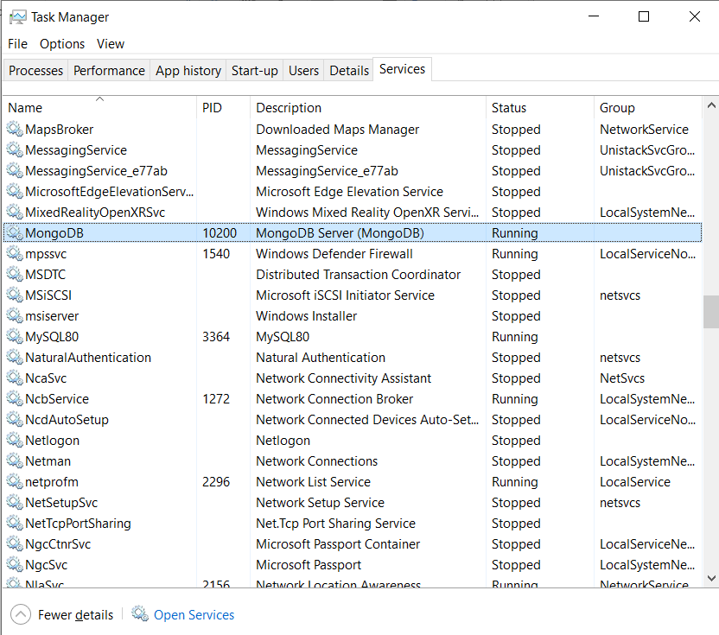

Step 3: Go to *Command Prompt,* and run *mongo*

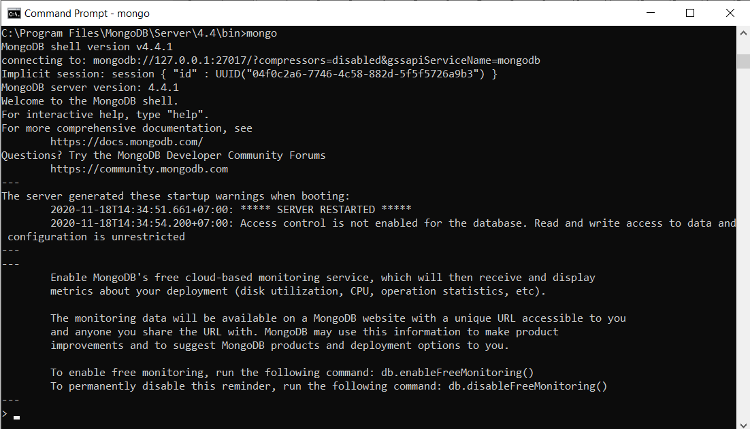

**Practice: Create, Display and Delete Database**

Create three database **“Student”**, **“Teacher”** and **“School”**

*use <Database-name>* command is used to create database. The command will create a new database if it doesn't exist, otherwise it will return the existing database.

Your created database (mydb) is not present in list. To display database, you need to insert at least one document into it.

*db.COLLECTION_NAME.insert(<document>)* command is used to insert data into MongoDB collection.

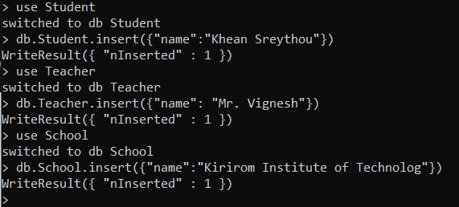

**Display the names of all the available databases**

*show dbs* command is used to list down all the existing database.

In MongoDB default database is test. If you didn't create any database, then collections will be stored in test database.

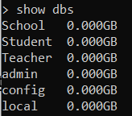

**Delete the databases one by one**

*db.dropDatabase()* command is used to drop a existing database. This will delete the selected database. If you have not selected any database, then it will delete default 'test' database.

