**MongoDB Read and Sort**

**Requirements**

* Read and display all the records from the **“records”** collection of the **“employee”** database as a single operation using command prompt.
* Sort and display the records in ascending order of the **“id”** property.
* Sort and display the records in descending order of the **“id”** property.
* Display the records in a proper format.

**sort()**

* To sort documents in MongoDB
* The method accepts a document containing a list of fields along with sorting order.
* To specify sorting order 1 and -1 are used.
* 1 is used for ascending order.
* -1 is used for descending order.
* Syntax: *db.COLLECTION_NAME.find().sort({KEY:1})*

**Normal Display (without sorting)**

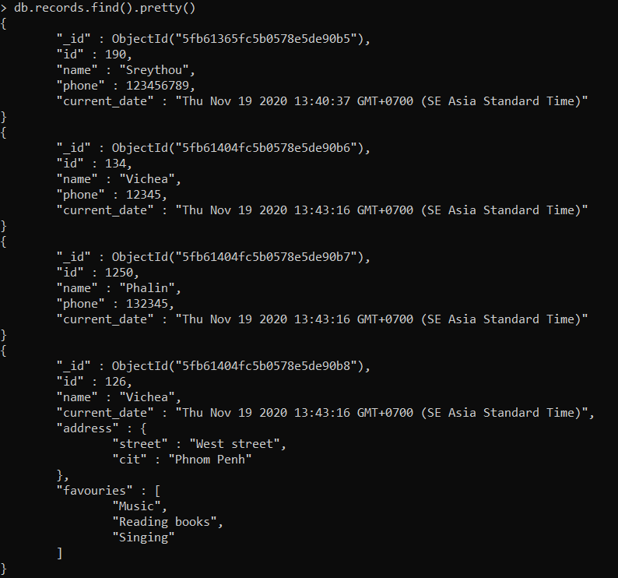

**Sort Display (Ascending order base on “id”)**

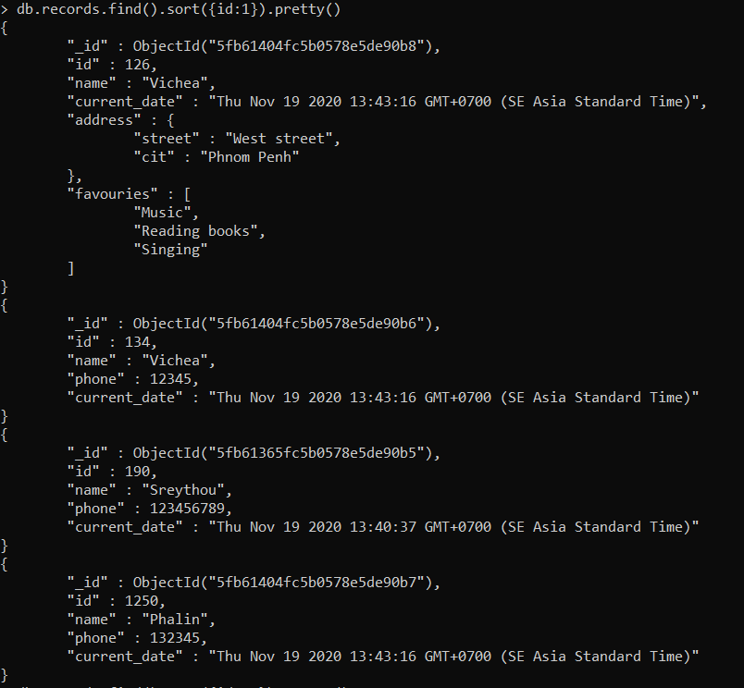

**Sort Display (Descending order base on “id”)**

