**MongoDB Read a Record**

**Requirements**

* Update the existing records with the “**name”** property with the value **“Phalin”** in the **“records”** collection of the **“employee”** database as a single operation using command prompt.
* Assume below is the current set of values of the row:

{

**id: 1250**

**name: “Phalin”**

**phone: 132345**

**current_date: <Current Date>**

}

* The value to be updated mentioned below.

{

**id: 19990**

**name: “Chan Phalin”**

}

* Note. If the record/records not found then create a new record. The extra columns (phone and current_date) apart from the new set of values must be removed from the document.
* Display the updated records in a proper format after update.

**update()**

* To update values in the exisiting document.
* Syntax: *db.COLLECTION_NAME.update(SELECTION_CRITERIA, UPDATED_DATA)*
* **$set**: is an operator used for update the value of fields.

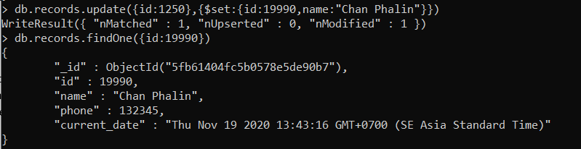

* **$unset**: is an operator used for delete the fields.

