**MongoDB Update Records Increment**

**Requirements**

* Assume there are three records already available in the collection **“records”** of the **“employee”** database as mentioned below.

**id: 134**

**name: “Vichea”**

**phone: 12345**

**salary: 10000**

**current_date: <Current Date>**

**id: 1250**

**name: “Phalin”**

**phone: 132345**

**salary: 11000**

**current_date: <Current Date>**

**id: 126**

**name: “Vichea”**

**current_date: <Current Date>**

**address: { street: “West street”, city : “Phnom Penh” }**

**salary: 20000**

**favourites: [“Music”, “Reading books”, “Singing”]**

* Update the existing records and increment **“salary” by 1000** for the records whose **“name”** is **“Phalin”**.

**id: 134**

**name: “Vichea”**

**phone: 12345**

**salary: 10000**

**current_date: <Current Date>**

**id: 1250**

**name: “Phalin”**

**phone: 132345**

**salary: 12000**

**current_date: <Current Date>**

**id: 126**

**name: “Vichea”**

**current_date: <Current Date>**

**address: { street: “West street”, city : “Phnom Penh” }**

**salary: 20000**

**favourites: [“Music”, “Reading books”, “Singing”]**

* Display all the records in a proper format after update.

Existing records in the **records** collection

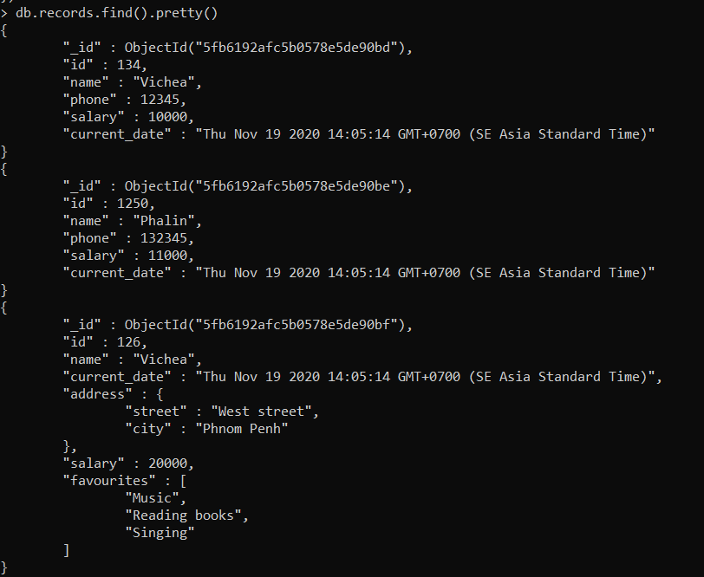

* We used update() method to update the data.
* **$inc**: is an incremental operator, used to increase the fields value.

