**MongoDB Rename Property**

**Requirements**

* Update the name of the **“phone”** property in the **“records”** collection of the **“employee”** database into **“mobile”**. Let’s assume the current record in the collection looks like below.

**id: 134**

**name: “Vichea”**

**phone: 12345**

**current_date: <Current Date>**

* After updating the property should look like below.

**id: 134**

**name: “Vichea”**

**mobile: 12345**

**current_date: <Current Date>**

* Display the updated records in a proper format after update to check if the property name is changed.

Current record in the collection

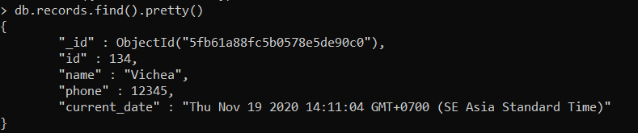

* We used the update() to update the records.
* **$rename**:**{<old-name>:<new-name>}** used to rename the field by putting the old name and new name field in the curly brace.

