**MongoDB Delete Records**

**Requirements**

* Remove an existing record/records with the “**name”** property with the value **“Vichea”** in the **“records”** collection of the **“employee”** database as a single operation using command prompt.
* Display the latest records in a proper format after deleting.

Current records

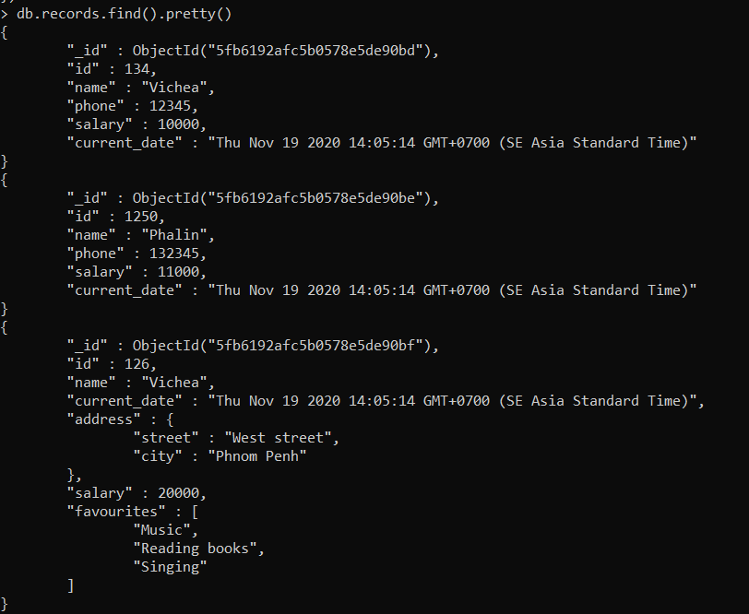

**remove()**

* To remove the documents in the collection base on the condition.
* If we do not specify the condition, remove() function will remove all the documents in the collection.

