**MongoDB Adding Sub Documents**

**Requirements**

* Create the two records with the below properties and values into the **“records”** collection of the **“employee”** database.

**id: 134**

**name: “Vichea”**

**phone: 12345**

**salary: 10000**

**current_date: <Current Date>**

**id: 1250**

**name: “Phalin”**

**phone: 132345**

**salary: 11000**

**current_date: <Current Date>**

* After creating the above records now add **subdocument** named **“reviews”** to each record mentioned above. The **“reviews”** sub document must have three properties named **reviewer_name, message_body and current_date.** The review for each record is mentioned below.

Reviews for the record of **“Vichea”:**

reviews: [{

reviewer_name: “Arun”,

message_body: “He is a good Employee”,

current_date: <Date>

},

{

reviewer_name: “Reak”,

message_body: “His performance is good”,

current_date: <Date>

}]

Reviews for the record of **“Phalin”:**

reviews: [{

reviewer_name: “Vandate”,

message_body: “His coding skills are very good”,

current_date: <Date>

}]

* We used **update()** method to update the existing document.
* **$push** use to add the sub document to existing document.
* Syntax of **$push** operator: *<$push: {<field>:{<modifier>:<value>,…}*

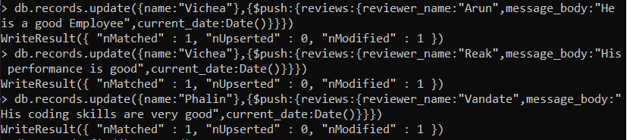

Display the documents

