**MongoDB Add index Perform Text Search**

**Requirements**

* Insert the below records to the **“records”** collection of the **“employee”** database.

**id: 134**

**name: “Vichea”**

**phone: 12345**

**salary: 10000**

**current_date: <Current Date>**

**id: 1250**

**name: “Phalin”**

**phone: 132345**

**salary: 11000**

**current_date: <Current Date>**

**id: 1505**

**name: “Veasna”**

**phone: 100307**

**current_date: <Current Date>**

* Now add indexing to the **“name”** property of the **“records”** collection. Perform a **text search** and find the records with the name that starts with “V” and ends with “a”.

Current **records**

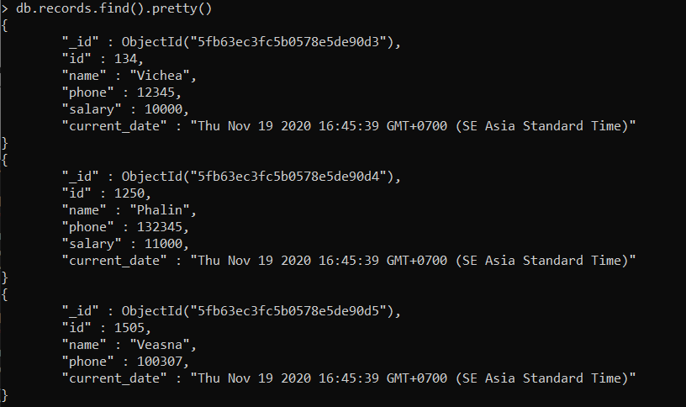

**Text Search**

* MongoDB supports query operations that perform a text search of string content. To perform text search, MongoDB uses a text index and the $text operator.
* **Text index**
  + To support text search queries on string content
  + Include any field whose value is a stirng or an array of string elements.
  + Need **text index** on the collection.
  + A collection can only have one text search index, but the index can cover multiple fields.
  + Syntax: *db.COLLECTION-NAME.createIndex({name:”text”})*

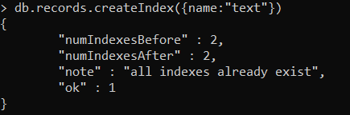

* **$text operator**
  + To perform text searches on a collection with a text index.
  + It will tokenize the search string using whitespace and most punctuation as delimiters, and perform a logical OR of all such todens in the search string.
  + Term exclusion: to exclude a word, you can prepend a “-“ character.

