**MongoDB Comparison**

**Requirements**

* Insert the below records to the **“records”** collection of the **“employee”** database.

**id: 134**

**name: “Vichea”**

**phone: 12345**

**salary: 5000**

**current_date: <Current Date>**

**id: 1250**

**name: “Phalin”**

**phone: 132345**

**salary: 11000**

**current_date: <Current Date>**

**id: 1505**

**name: “Veasna”**

**phone: 10307**

**current_date: <Current Date>**

* Find and display the records where salary is greater than 5000
* Find and display the records where salary is less than or equal to 9000
* Find and display the records where salary is between 8000 and 11000

**Comparison Operators:** we can use this comparison operator in the find() to put the condition.

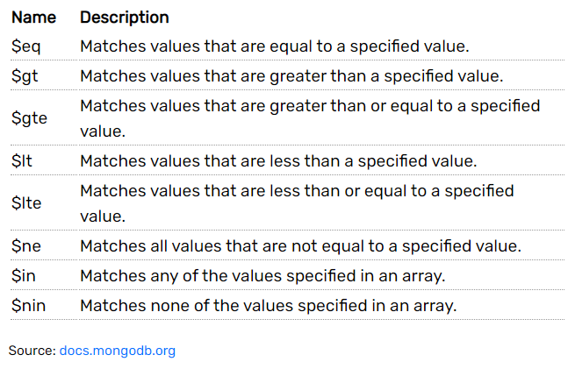

**records** collection:

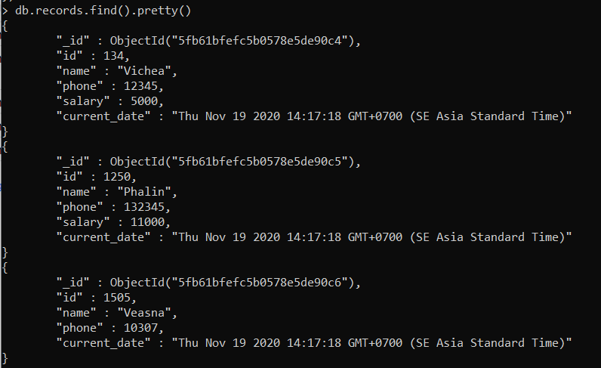

Find and display the records where salary is greater than 5000

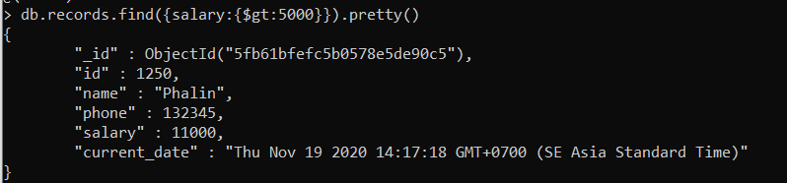

Find and display the records where salary is less than or equal to 9000

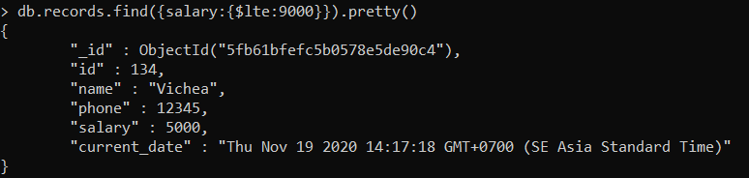

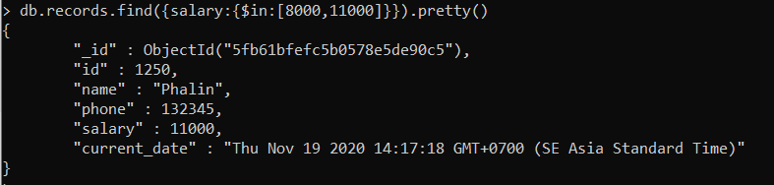Find and display the records where salary is between 8000 and 11000