**EYE DISEASE DETECTION USING DEEP LEARNING**

**AN INTERNSHIP PROJECT REPORT**



**Department of Computer Science and Engineering**

## **GAYATRI VIDYA PARISHAD COLLEGE OF ENGINEERING FOR WOMEN**



**INTERNSHIP DURATION :** January 2025 - April 2025

**Submitted By Submitted To**

Simhadri Sridevi Smart Bridge

Hyderabad

### 

**TABLE OF CONTENTS**

#### TOPICS PAGENO.

|  |  |
| --- | --- |
| **Abstract** | **i** |

|  |  |  |
| --- | --- | --- |
| **1.** | **INTRODUCTION** | **1-2** |
|  | 1.1 Problem Statement |  |
| **2.** | **RELATED WORK** | **3** |
| **3.** | **SYSTEM ANALYSIS** | **4** |
|  | 3.1 Software Requirement Specification |  |
|  | 3.2 System requirements |  |
|  | 3.2.1 Minimum Software requirements |  |
|  | 3.2.2 Minimum Hardware requirements |  |
| **4.** | **SYSTEM DESIGN** | **5-9** |
|  | 4.1 Introduction |  |
|  | 4.2 UML Diagrams |  |
|  | 4.2.1 Use case diagram |  |
|  | 4.2.2 Class diagram |  |
|  | 4.2.3 Sequence diagram |  |
|  | 4.2.4 Activity diagram |  |
| **5.** | **METHODOLOGY** | **10-11** |
|  | 5.1 Modules |  |
|  | 5.2 Packages, Libraries, Datasets Used |  |
|  | 5.3 Techniques/Algorithms Used |  |
| **6.** | **IMPLEMENTATION** | **12-14** |
| **7.** | **RESULTS** | **15-19** |
|  | 7.1 Output Screens |  |
| **8.** | **CONCLUSION** | **20** |
| **9.** | **FUTURE SCOPE** | **21** |
| **10.** | **REFERENCES** | **22** |

**ABSTRACT**

Eye diseases such as cataracts, diabetic retinopathy, and glaucoma are major causes of visual impairment and blindness worldwide. Early detection is crucial for preventing severe vision loss and enabling timely medical intervention. This project presents an AI-powered eye disease detection system that employs deep learning techniques to classify retinal images into four categories: cataracts, diabetic retinopathy, glaucoma, and normal. The system utilizes the VGG19 model, a pre-trained convolutional neural network, for feature extraction and classification, ensuring high accuracy and efficiency. The model is trained using a carefully curated dataset, incorporating image preprocessing and augmentation techniques to enhance its performance and generalization capabilities.

To improve accessibility, a web-based interface developed with Flask enables users to upload retinal images for real-time disease prediction. This allows both medical professionals and non-specialists to utilize AI for preliminary diagnoses, making eye disease screening more efficient, especially in regions with limited healthcare infrastructure. By automating the initial screening process, this system has the potential to support ophthalmologists, reduce the burden on healthcare systems, and improve patient outcomes through early intervention.

1. **Introduction**

The increasing prevalence of eye diseases poses a significant challenge to global healthcare. Millions of individuals suffer from vision impairment due to conditions such as cataracts, diabetic retinopathy, and glaucoma. Traditional diagnostic methods require specialized ophthalmic equipment and trained professionals, which can be expensive and inaccessible, particularly in rural or underdeveloped regions. Delays in detection often result in severe vision loss, highlighting the need for innovative solutions that can facilitate early diagnosis and timely medical intervention.

This project introduces an AI-based system designed to detect common eye diseases, including cataracts, diabetic retinopathy, and glaucoma, along with normal eye conditions. The deep learning model is built using the VGG19 architecture, a pre-trained convolutional neural network known for its accuracy and efficiency in image classification tasks. The dataset used for training and validation is carefully curated, incorporating image preprocessing and augmentation techniques to improve model generalization and performance. The trained model is then integrated into a web-based interface developed using Flask, allowing users to upload retinal images for real-time disease prediction.

By automating the screening process, this AI-powered system provides an accessible and scalable solution for early detection of eye diseases. It not only aids ophthalmologists by reducing their workload but also empowers individuals in remote areas to seek medical attention before their conditions worsen. Through the seamless integration of deep learning and web technologies, this project aims to bridge the gap between advanced diagnostics and widespread accessibility, ultimately contributing to improved eye healthcare and reduced cases of preventable blindness.

**1.1 Problem Statement**

Eye diseases such as cataracts, diabetic retinopathy, and glaucoma are leading causes of blindness worldwide. The current diagnostic methods rely heavily on manual examination by ophthalmologists, which can be time-consuming, costly, and inaccessible to people in remote or underserved areas. The lack of early detection often leads to irreversible vision loss, emphasizing the need for an efficient, automated solution.

This project aims to develop an AI-powered eye disease detection system that utilizes deep learning to analyze retinal images and classify them into distinct disease categories. By implementing a pre-trained VGG19 model and a user-friendly web interface using Flask, the system provides an accessible and efficient tool for preliminary disease diagnosis. The goal is to bridge the gap between healthcare accessibility and advanced diagnostics, enabling early detection and timely medical intervention to prevent vision impairment. Additionally, the system aims to reduce the burden on healthcare professionals by assisting in preliminary screenings, thereby allowing specialists to focus on critical cases requiring immediate attention. By integrating AI-driven diagnostics with a scalable web platform, this project presents a step towards making quality eye care more inclusive and widely available.

.

1. **Related Work**

Several studies have explored the application of artificial intelligence and deep learning in medical imaging for disease detection. Convolutional Neural Networks (CNNs) have demonstrated remarkable accuracy in classifying medical images, particularly in ophthalmology. Researchers have used architectures such as ResNet, InceptionV3, and VGG19 to diagnose conditions like diabetic retinopathy and glaucoma from retinal fundus images. These models leverage large-scale datasets and image augmentation techniques to enhance predictive accuracy. Moreover, some studies have integrated attention mechanisms and ensemble learning to further refine classification performance, making AI-driven eye disease detection a viable alternative to traditional diagnostic methods.

In addition to model development, web-based and mobile applications have been deployed to make AI-assisted diagnosis more accessible. Several telemedicine platforms now incorporate AI-powered screening tools that allow patients to upload retinal images for instant analysis. Existing works have also emphasized the importance of explainability and trust in AI-based healthcare solutions, advocating for interpretable models that provide insights into prediction results. Despite significant advancements, challenges remain in ensuring model robustness across diverse datasets, addressing biases in training data, and gaining regulatory approval for clinical use. This project builds upon these developments by leveraging the VGG19 model in an AI-powered web application for real-time eye disease detection, aiming to improve accessibility and efficiency in ophthalmic care.

1. **System Analysis**

**3.1 Software Requirement Specification**

The software requirement specification defines the key technical and performance criteria necessary for the AI-powered eye disease detection system. It outlines the essential software tools, libraries, and frameworks required for implementing deep learning models, image processing, and web-based deployment. The system relies on Python-based frameworks such as TensorFlow and Keras for model training and inference, while Flask is used to create a lightweight and interactive web application. Additionally, image preprocessing libraries like OpenCV and PIL enhance the quality of retinal images before analysis. The system is designed to ensure seamless integration between the deep learning model and the web interface, enabling users to upload retinal images and receive predictions in real-time. By focusing on accuracy, efficiency, and user accessibility, the specification aims to create a scalable and robust solution for early eye disease detection.

**3.2 System requirements**

**3.2.1 Minimum Software requirements**

* Operating System: Windows 10 / Linux (Ubuntu 18.04+)
* Programming Language: Python 3.x
* Frameworks: TensorFlow, Keras, Flask
* Web Technologies: HTML, CSS, JavaScript
* Database: SQLite / MySQL (optional for user data storage)
* Image Processing Libraries: OpenCV, PIL
* Browser: Google Chrome / Mozilla Firefox (for web interface)

**3.2.2 Minimum Hardware requirements**

* Processor: Intel Core i5 or higher
* RAM: 8GB (Recommended: 16GB for faster processing)
* GPU: NVIDIA GTX 1050 or higher (Recommended: RTX 2060+ for deep learning acceleration)
* Storage: 50GB free space (for dataset and model storage)
* Internet Connection: Required for model training and web application hosting

1. **System Design**

**4.1 Introduction**

System design defines the architecture, components, and data flow of the AI-based eye disease detection system. This phase ensures that the software structure is well-organized, modular, and scalable, allowing for efficient implementation and future improvements. The system is designed to integrate deep learning models with a user-friendly web interface, facilitating easy interaction for both medical professionals and non-specialist users.

The architecture consists of three primary components: the deep learning model, the web-based interface, and the backend processing unit. The deep learning model is responsible for analyzing retinal images and predicting diseases. The web interface provides an intuitive platform for users to upload images and receive diagnostic results, while the backend handles data processing, model inference, and result generation. The design also accounts for security, ensuring that user data is handled safely and efficiently. By structuring the system with modularity and efficiency in mind, this design phase lays the foundation for a high-performance, scalable, and accessible AI-powered diagnostic tool.

**4.2 UML Diagrams**

**4.2.1 Use Case Diagram**

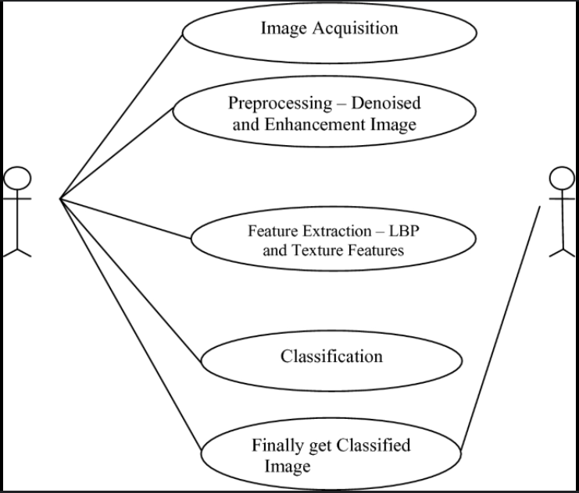

**Fig 4.2.1: Use case Diagram**

**4.2.2 Class Diagram**

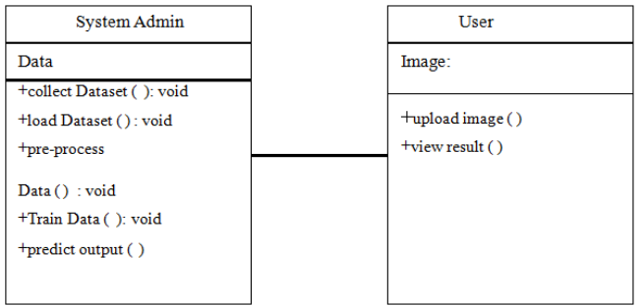

**Fig 4.2.2: Class Diagram**

**4.2.3 Sequence diagram**

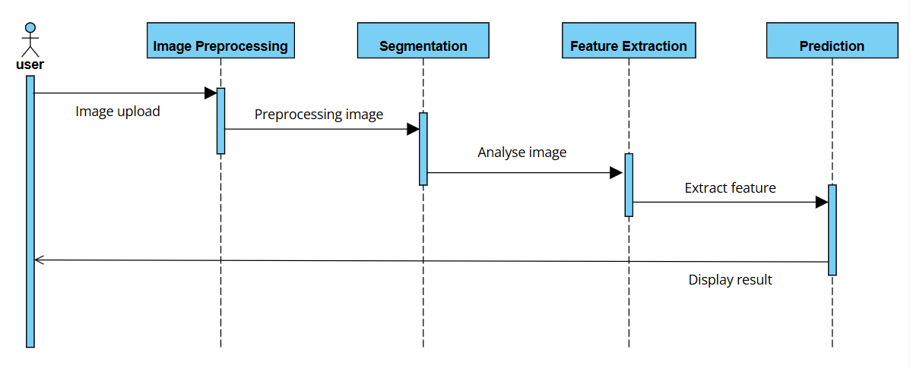

**Fig 4.2.3: Sequence Diagram**

**4.2.4 Activity diagram**

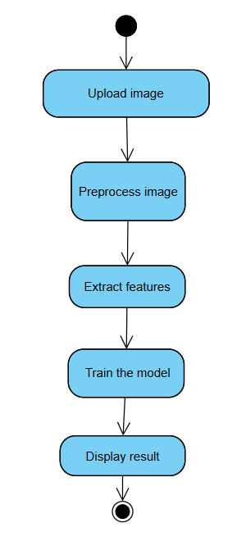

**Fig 4.2.4: Activity Diagram**

1. **Methodology**

#### ****5.1 Modules****

* **Dataset Preparation and Splitting**
* The dataset consists of retinal images categorized into **cataract, diabetic retinopathy, glaucoma, and normal eyes**.
* Using splitfolders.ratio(), the dataset is split into:
* **Training set (80%)** – for model learning.
* **Validation set (20%)** – for performance evaluation.
* **Data Preprocessing and Augmentation**
* Images are resized to **224×224 pixels** to match the VGG19 model input size.
* ImageDataGenerator() is applied for augmentation, including:
* **Rescaling** (normalizing pixel values between [0,1]).
* **Shear, zoom, and horizontal flipping** to improve model robustness.
* To handle corrupted images, ImageFile.LOAD_TRUNCATED_IMAGES=True is used.
* **Model Selection and Architecture**
* **VGG19 (Pre-trained on ImageNet)** is used as the backbone.
* The convolutional layers are **frozen** (layer.trainable=False) to retain learned features.
* A **Flatten layer** is added to convert feature maps into a 1D vector.
* A **Dense layer with Softmax activation (4 classes)** is appended for classification.
* The model is **compiled with categorical cross-entropy loss and Adam optimizer**.
* **Model Training and Optimization**
* The training is conducted using:
* **Batch size:** 64
* **Epochs:** 50
* **Steps per epoch:** Length of training set
* **Validation steps:** Length of validation set
* The model performance is monitored through accuracy and loss metrics.
* **Model Evaluation and Deployment**
* The trained model is **saved as** evgg.h5 for future use.
* A **test image is loaded, resized, and preprocessed** before prediction.
* The trained model **predicts the disease class**, mapping it to ['cataract', 'diabetic_retinopathy', 'glaucoma', 'normal']
* The system can be deployed via **Flask**, enabling a **web-based AI screening tool**.

#### ****5.2 Packages, Libraries, and Datasets Used****

* **Programming Language:** Python 3.x
* **Core Libraries:**
* **Deep Learning:** TensorFlow, Keras
* **Image Processing:** OpenCV, PIL
* **Data Handling:** NumPy
* **Visualization:** Matplotlib
* **Web Development (for deployment):** Flask
* **Dataset:**
* A curated retinal image dataset categorized into **four eye conditions named cataract, glaucoma, diabetic_retinopathy, and normal.**

#### ****5.3 Techniques/Algorithms Used****

* **Image Processing Techniques:**
* Image resizing, rescaling (1/255), and augmentation (shear, zoom, flip).
* **Deep Learning Algorithm:**
* **VGG19 (Transfer Learning Approach)**:
* Pre-trained on **ImageNet** for effective feature extraction.
* Fine-tuned with **Flatten + Dense layers** for classification.
* **Loss Function:** Categorical Cross-Entropy (multi-class classification).
* **Optimizer:** Adam (adaptive learning for fast convergence).
* **Model Training Strategy:**
* **Data split:** 8**0% training, 20% validation**.
* **Hyperparameters:** **50 epochs, batch size = 64**.
* **Prediction Pipeline:**
* Loads the saved model (evgg.h5).
* Preprocesses an uploaded image.
* Outputs the **predicted disease category**.

1. **Implementation**

**MODEL BUILDING**

import splitfolders

splitfolders.ratio('dataset', output="output", seed=1337, ratio=(.8, 0.2))

print("Dataset splitting completed!")

from tensorflow.keras.preprocessing.image import ImageDataGenerator

from PIL import ImageFile

ImageFile.LOAD_TRUNCATED_IMAGES=True

from tensorflow.keras.applications.vgg19 import VGG19, preprocess_input

from tensorflow.keras.layers import Flatten, Dense

from tensorflow.keras.models import Model

from tensorflow.keras.models import load_model

from tensorflow.keras.preprocessing import image

import numpy as np

import matplotlib.pyplot as plt

import matplotlib.image as mpimg

%matplotlib inline  
train_datagen = ImageDataGenerator(rescale=1./255,

shear_range=0.2, zoom_range=0.2, horizontal_flip=True)

test_datagen = ImageDataGenerator(rescale=1./255)

training_set=train_datagen.flow_from_directory('output/train',

target_size=(224,224),

batch_size=64,

class_mode='categorical')

test_set=test_datagen.flow_from_directory('output/val',

target_size=(224,224),

batch_size=64,

class_mode='categorical')

IMAGE_SIZE=[224, 224]

VGG19 = VGG19(input_shape=IMAGE_SIZE+[3], weights='imagenet', include_top=False)

for layer in VGG19.layers:

layer.trainable=False

x=Flatten()(VGG19.output)

prediction=Dense(4,activation='softmax')(x)

model = Model(inputs=VGG19.input, outputs=prediction)

model.summary()

model.compile(loss='categorical_crossentropy', optimizer='adam', metrics=['accuracy'])

from PIL import Image

r = model.fit(

training_set,

validation_data=test_set,

epochs=50,

steps_per_epoch=len(training_set),

validation_steps=len(test_set)

)

model.save('evgg.h5')

from tensorflow.keras.models import load_model

from tensorflow.keras.preprocessing import image

import numpy as np

model=load_model("evgg.h5")

img=image.load_img(r"C:\Users\91934\OneDrive\Desktop\SmartBridge\output\val\normal\ 2567_left.jpg",target_size=(224,224))

x=image.img_to_array(img)

x=np.expand_dims(x,axis=0)

preds=model.predict(x)

pred=np.argmax(preds,axis=1)

index=['cataract','diabetic_retinopathy','glaucoma','normal']

result=str(index[pred[0]])

result

**APP.PY**

import os

import numpy as np

from flask import Flask, request, render_template

from tensorflow.keras.models import load_model

from tensorflow.keras.preprocessing import image

from tensorflow.keras.applications.resnet_v2 import preprocess_input

# Initialize Flask app

app = Flask(__name__)

# Ensure 'static/uploads' directory exists

UPLOAD_FOLDER = os.path.join('static', 'uploads')

os.makedirs(UPLOAD_FOLDER, exist_ok=True)

app.config['UPLOAD_FOLDER'] = UPLOAD_FOLDER

# Load trained model

model = load_model("evgg.h5")

# Define disease categories

disease_classes = ['Cataract', 'Diabetic Retinopathy', 'Glaucoma', 'Normal']

# Define routes

@app.route('/')

def index():

    return render_template('index.html')  # Home page

@app.route('/home')

def home():

    return render_template("index.html")  # Redirect to home

@app.route('/about')

def about():

    return render_template('about.html')

@app.route('/inp')

def inp():

    return render_template("predict.html")  # Image upload page

@app.route('/predict', methods=['GET', 'POST'])

def predict():

    if request.method == 'GET':

        return render_template('predict.html')  # Show upload page

    if 'image' not in request.files:

        return render_template('predict.html', prediction="No file uploaded.", image_path=None)

    file = request.files['image']

    if file.filename == '':

        return render_template('predict.html', prediction="No file selected.", image_path=None)

    # Save the uploaded file to 'static/uploads'

    file_path = os.path.join(app.config['UPLOAD_FOLDER'], file.filename)

    file.save(file_path)

    # Load and preprocess image

    img = image.load_img(file_path, target_size=(224, 224))

    img_array = image.img_to_array(img)

    img_array = np.expand_dims(img_array, axis=0)

    img_array = preprocess_input(img_array)

    # Predict

    prediction = np.argmax(model.predict(img_array), axis=1)[0]

    result = disease_classes[prediction]

    return render_template('predict.html', prediction=result, image_path=file.filename)

# Run Flask app

if __name__ == '__main__':

    app.run(debug=True)

**7. Results**

**7.1 Output Screens**

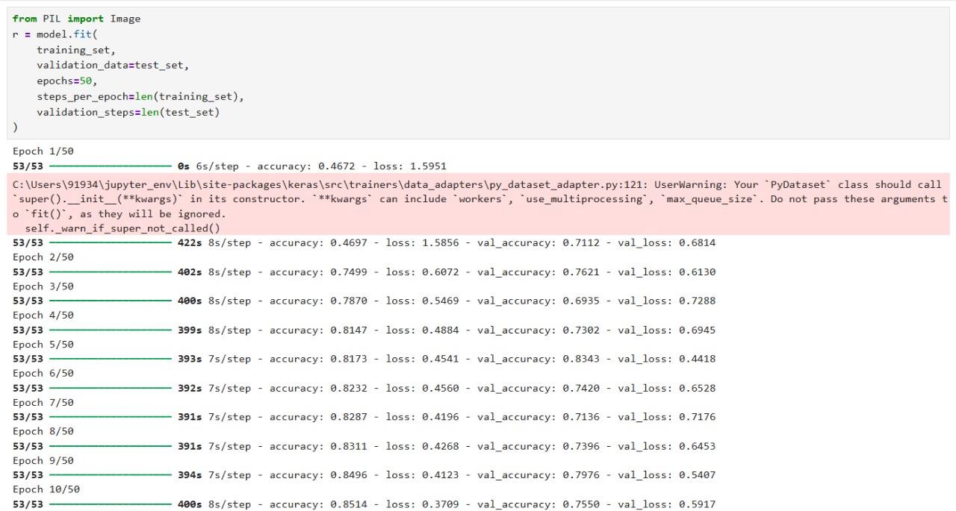

Fig 7.1: Output Screen 1

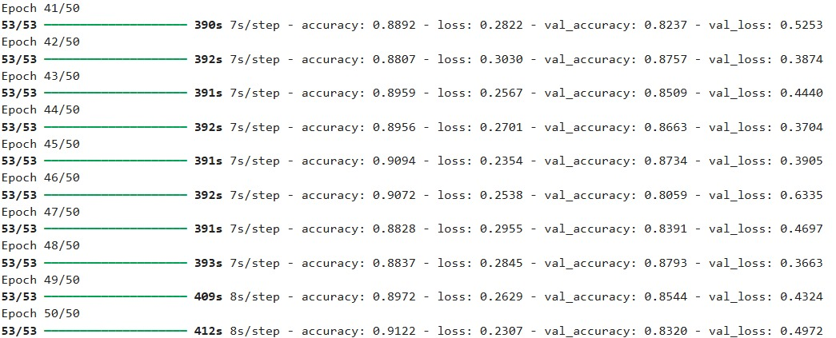

Fig 7.2: Output Screen 2

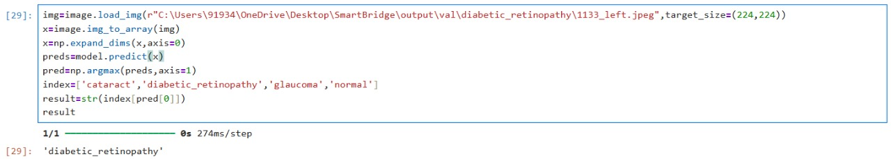

Fig 7.3: Output Screen 3

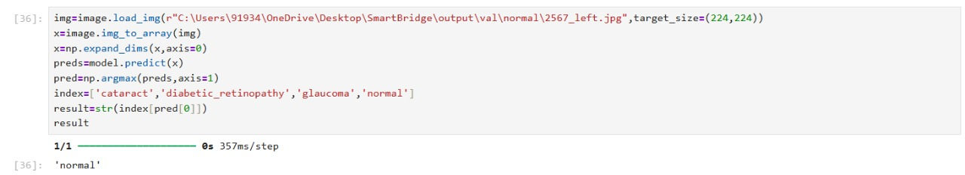

Fig 7.4: Output Screen 4

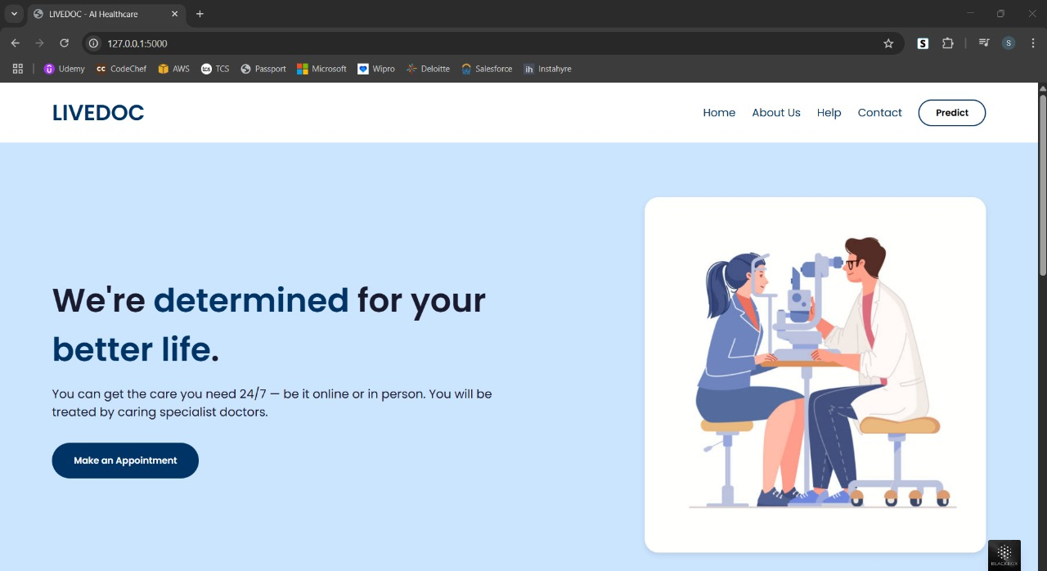

Fig 7.5: Output Screen 5



Fig 7.6: Output Screen 6

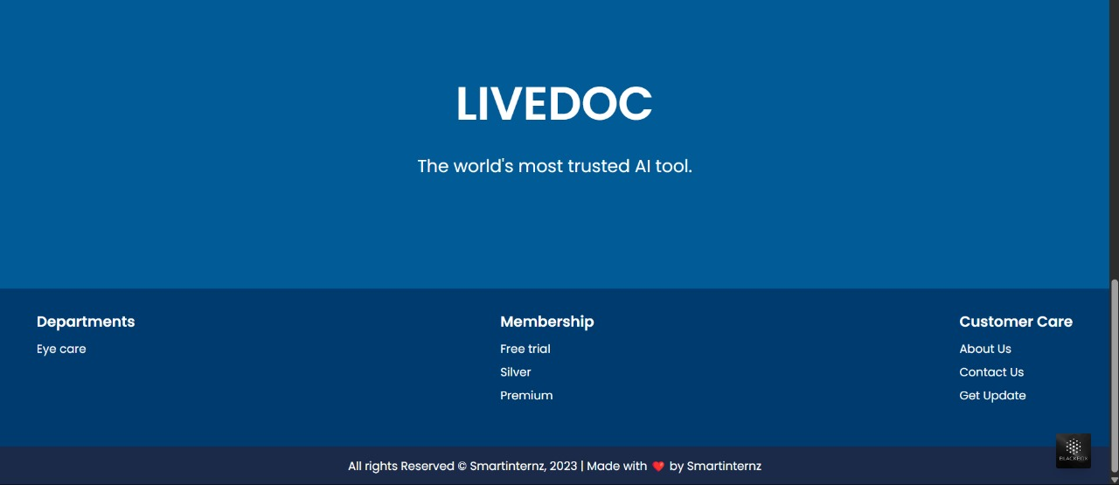

Fig 7.7: Output Screen 7

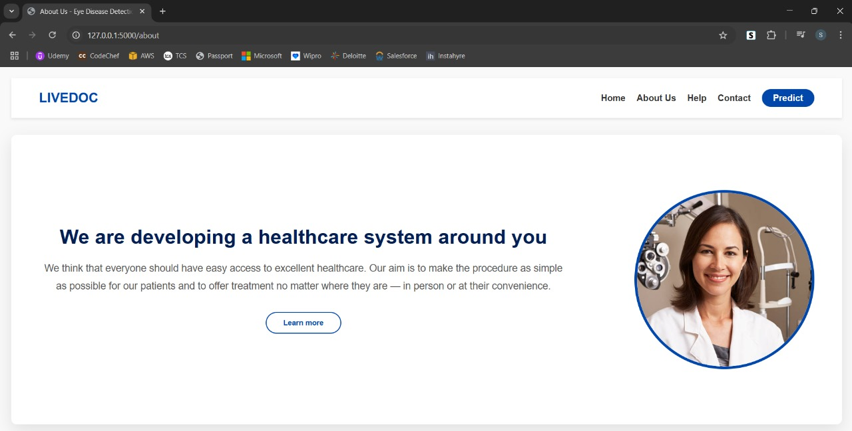

Fig 7.8: Output Screen 8

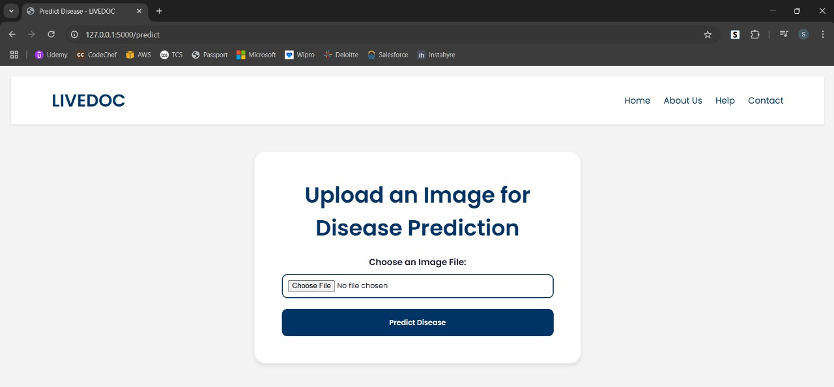

Fig 7.9: Output Screen 9

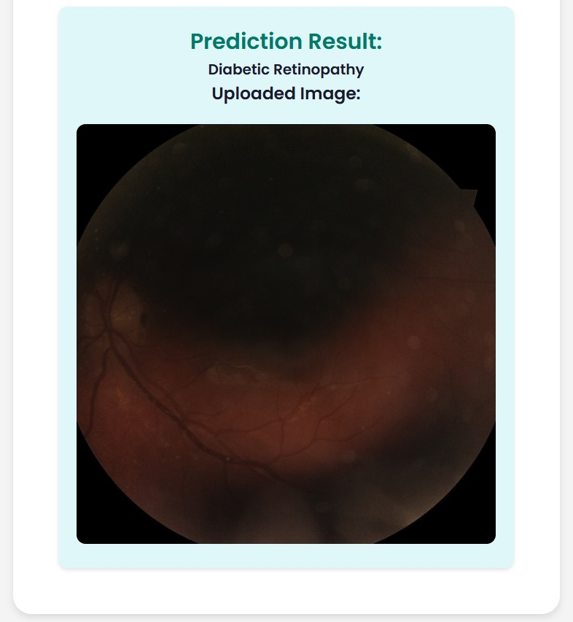

Fig 7.10: Output Screen 10

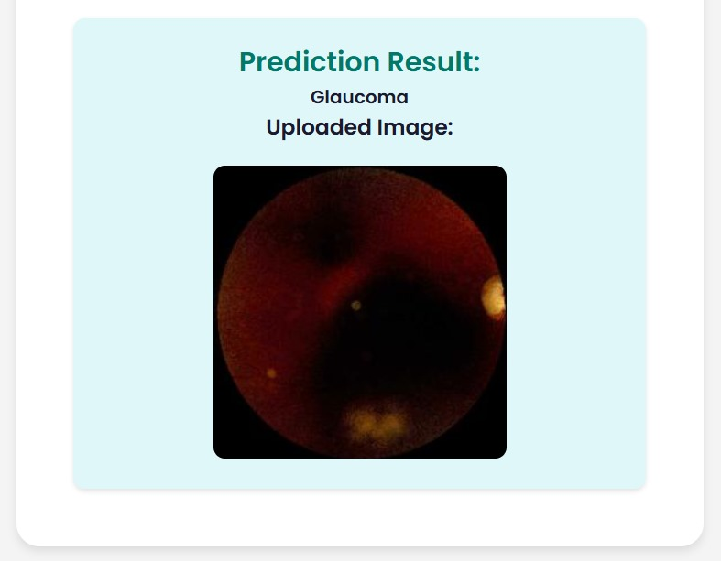

Fig 7.11: Output Screen 11

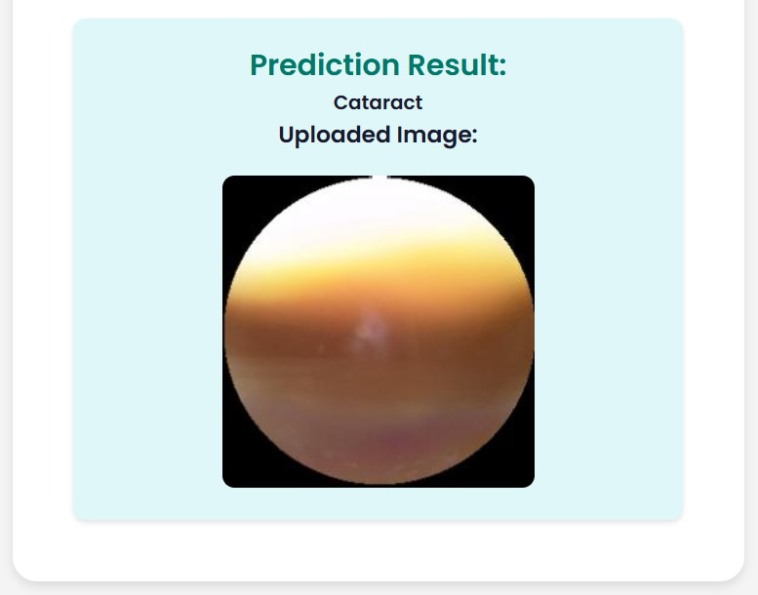

Fig 7.12: Output Screen 12

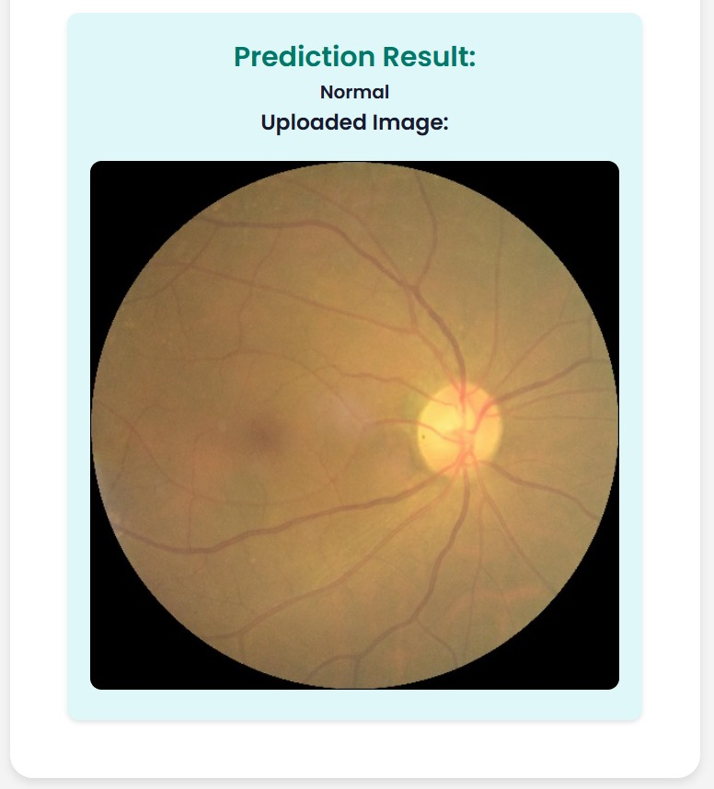

Fig 7.13: Output Screen 13

**8. Conclusion**

The AI-powered eye disease detection system developed in this project demonstrates the potential of deep learning in ophthalmic diagnostics. By leveraging the VGG19 model and a web-based interface, the system effectively classifies retinal images into normal and diseased categories, including cataracts, diabetic retinopathy, and glaucoma. The integration of deep learning techniques ensures high accuracy in prediction, while the web application enhances accessibility, enabling users to receive real-time disease assessments. This approach significantly reduces the dependency on traditional diagnostic methods and provides a scalable solution for early eye disease detection.

The project aims to bridge the gap between advanced medical diagnostics and accessibility, particularly in resource-limited areas. By automating the initial screening process, the system supports healthcare professionals in prioritizing critical cases while empowering individuals to seek medical attention at an early stage. Future enhancements could include expanding the dataset for improved model generalization, incorporating explainable AI techniques for better interpretability, and integrating the system with mobile applications for wider adoption. This project is a step towards revolutionizing ophthalmic care through AI-driven innovation, ultimately contributing to the reduction of preventable blindness worldwide.

1. **FUTURE SCOPE**

The Eye Disease Detection system using deep learning holds immense potential for future advancements and innovations. One of the primary areas for improvement is expanding the model’s capabilities to detect a broader range of eye diseases beyond cataract, diabetic retinopathy, and glaucoma, such as macular degeneration and retinal detachment. Integrating the system with advanced medical imaging devices and hospital management software can enable real-time diagnosis and seamless data sharing between patients and healthcare providers. Additionally, developing a mobile application would allow users to upload eye images directly from their smartphones, offering instant preliminary diagnoses and suggesting further medical consultations.

To enhance transparency and build trust among medical professionals, implementing Explainable AI (XAI) techniques can help make the model's predictions more interpretable. The system can also benefit from continuous model training through federated learning, allowing updates with new data from various hospitals while preserving patient privacy. Hosting the application on cloud platforms can further improve scalability, supporting larger datasets and enabling remote access to the tool.

Moreover, incorporating multimodal data analysis by combining medical images with patient history, genetic information, and lifestyle data could significantly boost diagnostic accuracy. For better accessibility, adding voice-enabled AI assistance would guide visually impaired users through the process of capturing images and interpreting results. Collaborating with hospitals and research centers for clinical trials would validate the model’s performance, ensuring its reliability for real-world medical applications. Lastly, implementing multi-language support for the web interface can make the system more inclusive, catering to diverse patient populations.

With these future enhancements, the Eye Disease Detection system has the potential to become a powerful, reliable, and user-friendly tool, contributing to early diagnosis and treatment of eye conditions on a global scale.

**10. References**

* Simonyan, K., & Zisserman, A. (2014). Very deep convolutional networks for large-scale image recognition. arXiv preprint arXiv:1409.1556.
* Gulshan, V., Peng, L., Coram, M., Stumpe, M. C., Wu, D., Narayanaswamy, A., ... & Webster, D. R. (2016). Development and validation of a deep learning algorithm for detection of diabetic retinopathy in retinal fundus photographs. JAMA, 316(22), 2402-2410.
* Liu, X., Fu, Y., Wang, Y., & Liu, M. (2020). Deep learning-based automatic detection of glaucoma using retinal fundus images: A review. Neural Computing and Applications, 32(4), 1115-1132.
* Lin, D., Wu, C., Zhang, G., Huang, Y., & Kang, X. (2019). Deep learning algorithm for automatic detection of diabetic retinopathy in fundus photographs. BMC Bioinformatics, 20(1), 253.
* Tan, J. H., Bhandary, S. V., Sivaprasad, S., & Hagiwara, Y. (2018). Age-related macular degeneration detection using deep convolutional neural network. Future Generation Computer Systems, 87, 127-135.