SMART PARKING

Phase 2

Innovation

Smart parking is a technological approach to improve the parking process and the cars’ positioning in a city with a shortage of space.

The basic goals of smart parking systems:

* to unload city roads from a growing number of vehicles,
* to reduce oil use and its negative impact on the atmosphere when drivers look for a parking lot, and
* to save the time and patience of city drivers who want to leave their cars closer to the destination point.

Any smart parking initiative implies the use of additional smart devices starting from a regular smartphone to special sensors and cameras in the parking areas. Also, AI takes its place among smart parking solutions. In other words, smart parking is a highly diverse branch using the latest tech advancements.

IoT systems for smart parking is a constantly evolving trend. Starting from underground sensors to AI robots – drivers get a variety of options. We may expect this trend to grow because it also provides benefits to business owners, city authorities, and finally, the environmental situation in the area. oT systems for smart parking is a constantly evolving trend. Starting from underground sensors to AI robots – drivers get a variety of options. We may expect this trend to grow because it also provides benefits to business owners, city authorities, and finally, the environmental situation in the area.

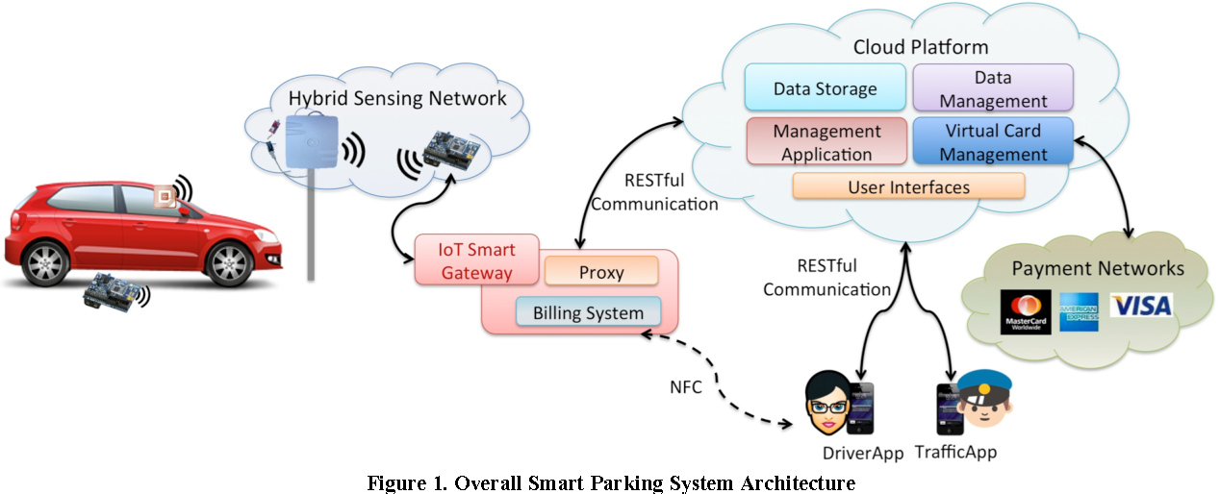

1. **Intelligent Parking Reservations**:

Develop an advanced reservation system that not only reserves a parking space but also dynamically adjusts based on real-time demand and user preferences.

1. **Augmented Reality (AR) Parking Guidance:**

Implement an AR-based navigation system in the mobile app, overlaying directions and parking space availability indicators onto the user's real-world view.

1. **Blockchain-Based Parking Payments:**

Utilize blockchain technology for secure, transparent, and decentralized parking payments, reducing transaction costs and enhancing trust.

1. **Dynamic Pricing Models:**

Introduce dynamic pricing based on factors like demand, time of day, and special events to optimize parking space utilization and incentivize off-peak usage.

1. **Automated Valet Parking:**

Explore the concept of automated valet parking, where users drop off their vehicles at a designated point, and automated systems park the cars efficiently.

1. **Solar-Powered Charging Stations**:

Integrate solar panels into parking structures to provide renewable energy for electric vehicle charging stations, promoting sustainability.

1. **Gamification for Parking Rewards**:

Implement a gamified system where users earn rewards or discounts for using smart parking features, encouraging positive user behavior and engagement.

1. **Predictive Analytics for Parking Demand**:

Use machine learning algorithms to predict parking space demand based on historical data, events, and trends, optimizing resource allocation.

1. **Smart Parking for Autonomous Vehicles**:

Develop a smart parking system tailored for autonomous vehicles, enabling them to navigate to and from parking spaces autonomously.

1. **Biometric Access for Premium Parking:**

Introduce biometric access control for premium or secure parking spaces, providing an additional layer of security and exclusivity.

1. **Environmental Impact Dashboard:**

Include a dashboard in the mobile app that showcases the environmental impact of using smart parking, such as reduced emissions and fuel consumption.

Voice-Activated Parking Assistance:

Integrate voice-activated commands in the mobile app for hands-free navigation, parking reservations, and real-time updates.

1. **Crowdsourced Parking Data:**

Implement a crowdsourcing feature where users can share real-time parking availability data with the community, enhancing the accuracy of the system.

1. **Smart Parking API Ecosystem**:

Create an open API ecosystem that allows third-party developers to build innovative applications and services on top of the smart parking platform.

1. **Responsive Urban Planning Insights**:

Provide city planners with insights derived from smart parking data to optimize urban planning, infrastructure development, and traffic flow.

1. **Flexible parking fees**

 RFID Card Based (Wireless)Wireless Parking Fee Management System - is widely used i... In this RFID card based Parking FEE Management System no wires are used between Entry & Exit Gates. Multiple Entry and exit Gates can be controlled by one software.