ROUND-2

Easy Level:
- Which code reverses the number n=1234 ? [Answer: B ]
A. 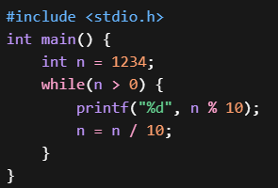
B. 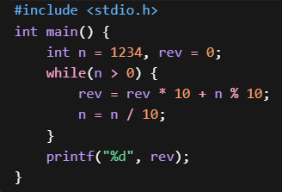
C. 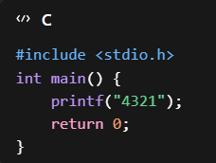
D. 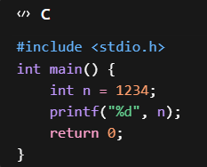
- Which of the following program swaps two numbers without using third variable? [Answer = D]
- 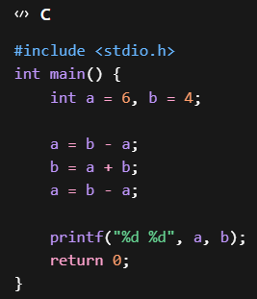
- 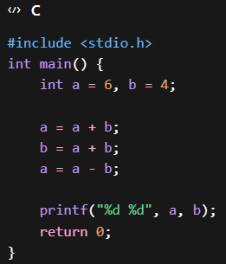
- 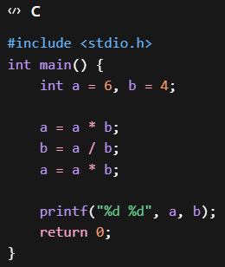
- 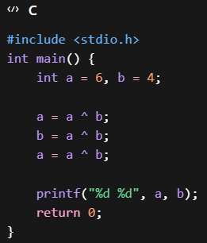
- What will be the output of the following C program? [Answer: B]
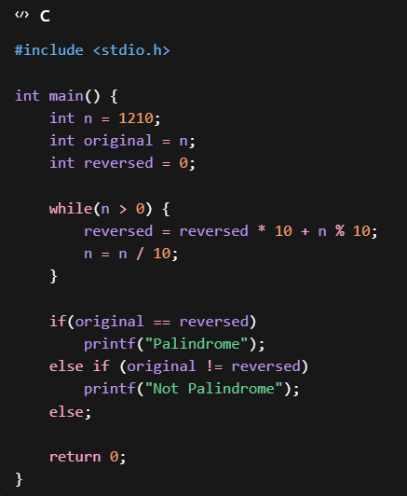
A) 1210
B) -1
C) Compilation Error
D) No Output
- What is the output of the following C program? [Answer: A]
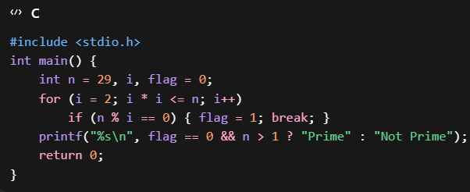
A) Prime
B) Not Prime
C) Compilation Error
D) Infinite Loop
- Which of the following programs correctly checks whether a number is Even or Odd without using the % operator? [Answer: B]
- 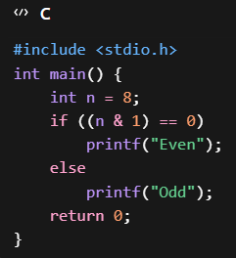
- 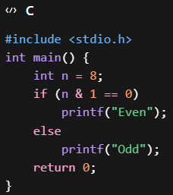
- 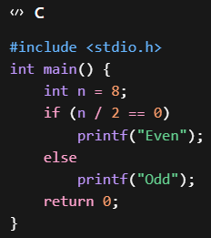
- 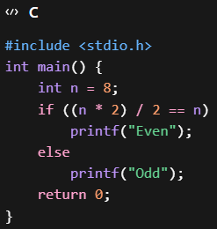
- What is the output of this code? [Answer: C]
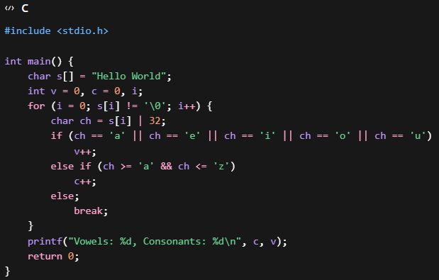
- Vowels: 3, Consonants: 7
- Vowels: 0, Consonants: 1
- Vowels: 1, Consonants: 0
- Vowels: 7, Consonants: 10

Medium Level
- Which of the following C code snippets correctly determines whether a given year is a Leap Year? [Answer: B]
- 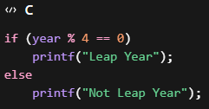
- 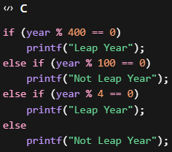
- 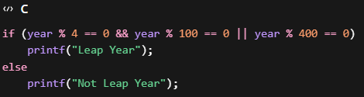
- 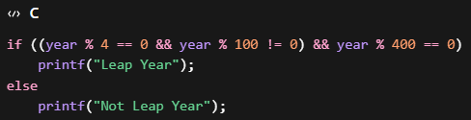
- Which of the following recursive functions correctly returns the nth Fibonacci number? [Answer: C]
- 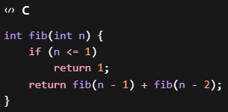
- 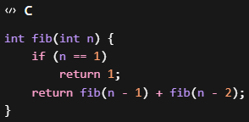
- 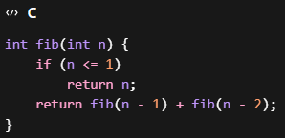
- 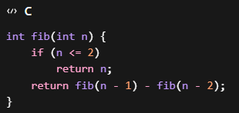
- What is the output of the following C program? [Answer: C]
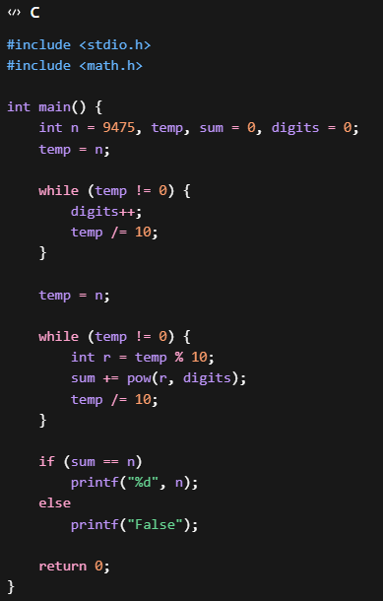
A) 9474
B) 9475
C) False
D) Compilation Error
- What is the output of the following C program? [Annswer: B]
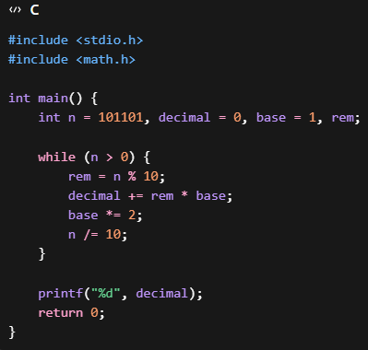
A) 101101
B) 45
C) 44
D) Compilation Error
- Which of the following C programs correctly finds the missing number from an array containing distinct integers from 1 to N, where exactly one number is missing? [Answer= B]
- 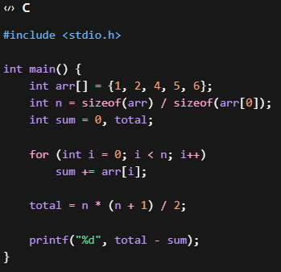
- 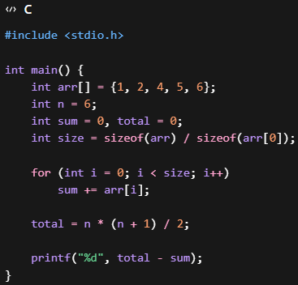
- 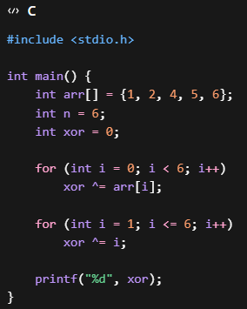
- 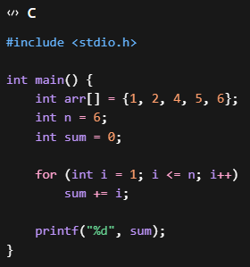
- Which of the following C program gives the following output:
7 9 8
12 3 6
5 14 11
[Answer: B]

- 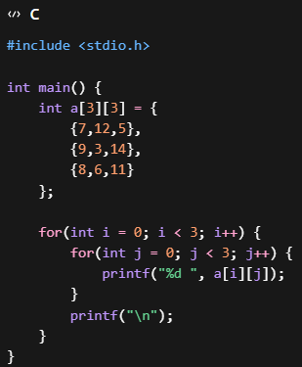
- 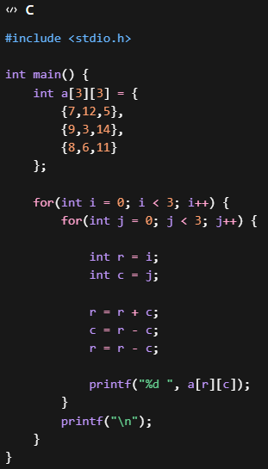
- 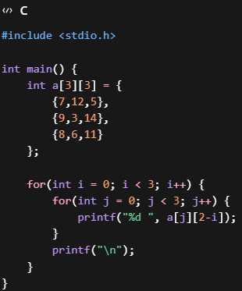
- 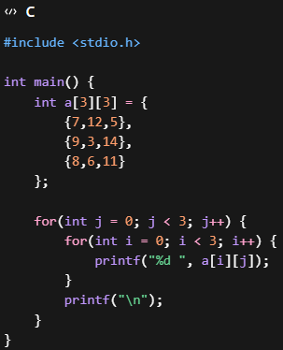

Hard Level
- Which program correctly prints the first 5 rows of:
1
1 1
1 2 1
1 3 3 1
1 4 6 4 1
[Answer: A]
- 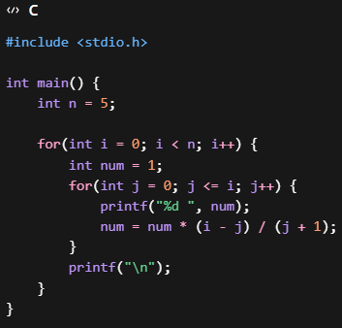
- 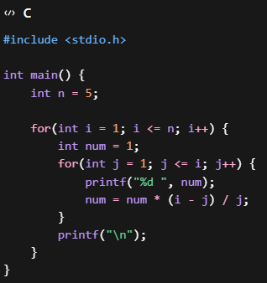
- 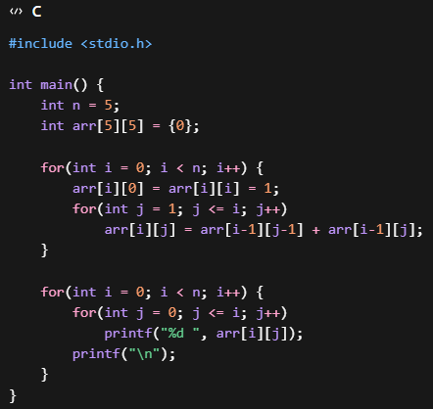
- 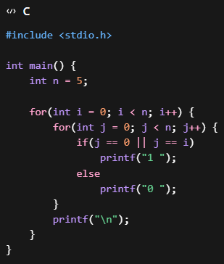
- What is the output of the below code: [Answer: C]
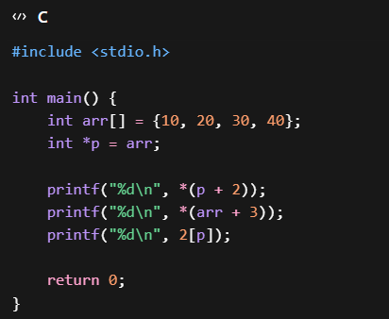
- 30
40
20
- 20
40
30
- 30
40
30
- Compilation Error
- What is the output of the below code: [Answer: C]
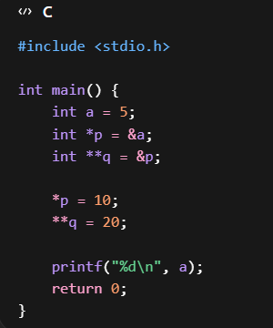
- 5
B) 10
C) 20
D) 0
- Which code correctly prints this pattern? {Answer: A]

 