Customer Purchase Insights using Power BI

Name: Vedantam Venkata Sri Bharathi

Date: July 2025

# Introduction

This project demonstrates the end-to-end process of analyzing customer purchase behavior using real-world datasets. It involves data cleaning, integration, and visualization to gain insights into customer demographics, product sales, and geographical trends. The final output is presented in the form of an interactive Power BI dashboard.

# Tools & Technologies Used

* SQLite (for structured database setup)
* Python (for data cleaning and transformation using pandas)
* Power BI Desktop (for data visualization and dashboard building)
* Visual Studio Code (as code editor)

# Data Collection & Processing

The project uses three datasets: customers.csv, products.csv, and sales.csv. These were merged and cleaned using Python and loaded into SQLite. The cleaned dataset was then exported as cleaned_sales.csv for use in Power BI. A new calculated column 'TotalSales' was created to compute sales value.

# Dashboard Design

The Power BI report contains three pages:

* Page 1 – Sales Overview:
  + Card visual showing Total Sales o Bar chart showing Sales by Product o Pie chart showing Sales by Country
* Page 2 – Customer Insights:
  + Column chart showing Age Distribution o Bar chart for Quantity by Country
* Page 3 – Sales Trends:
  + Line chart showing Sales over Time o Column chart for Top-Selling Products

o

# Dashboard Screenshots

- Sales Overview Page

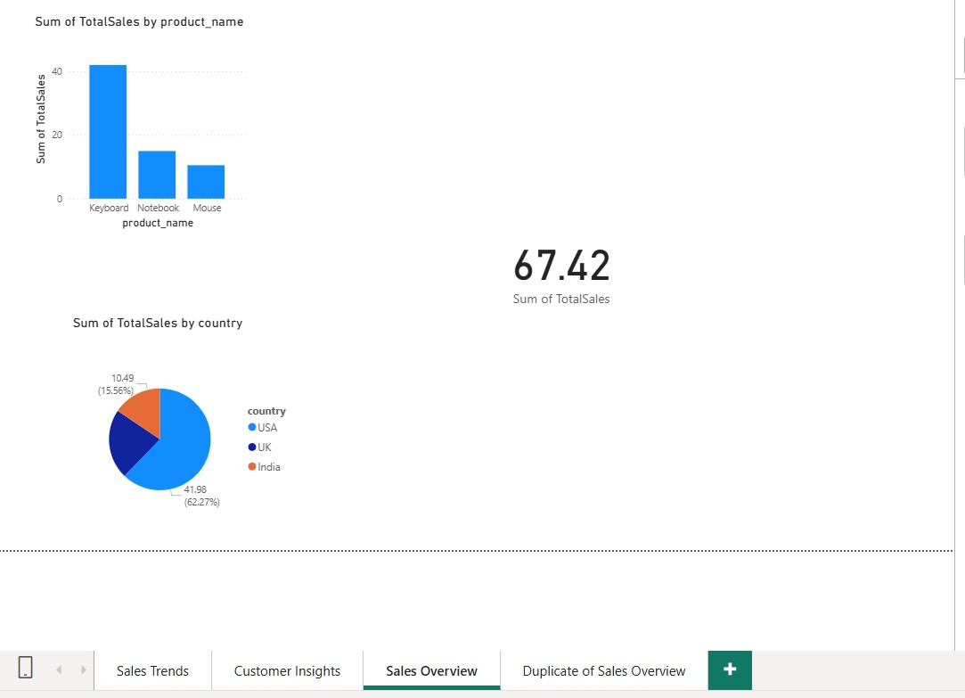

* Customer Insights Page

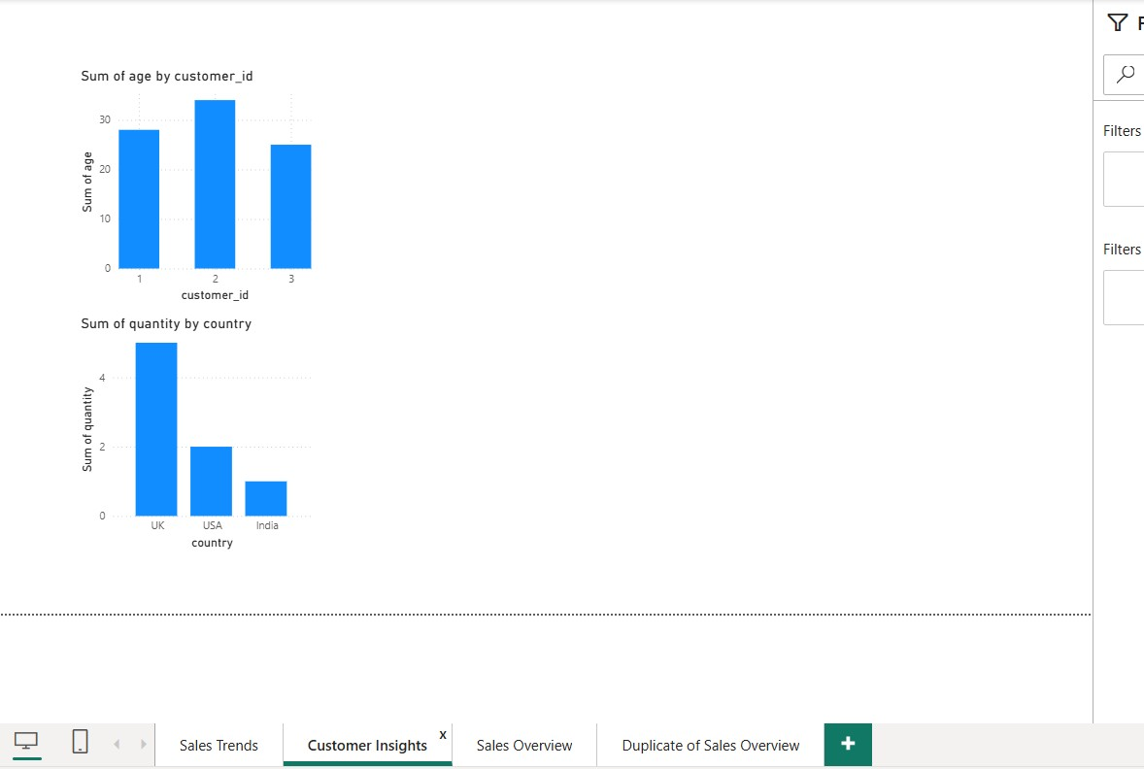

* Sales Trends Page

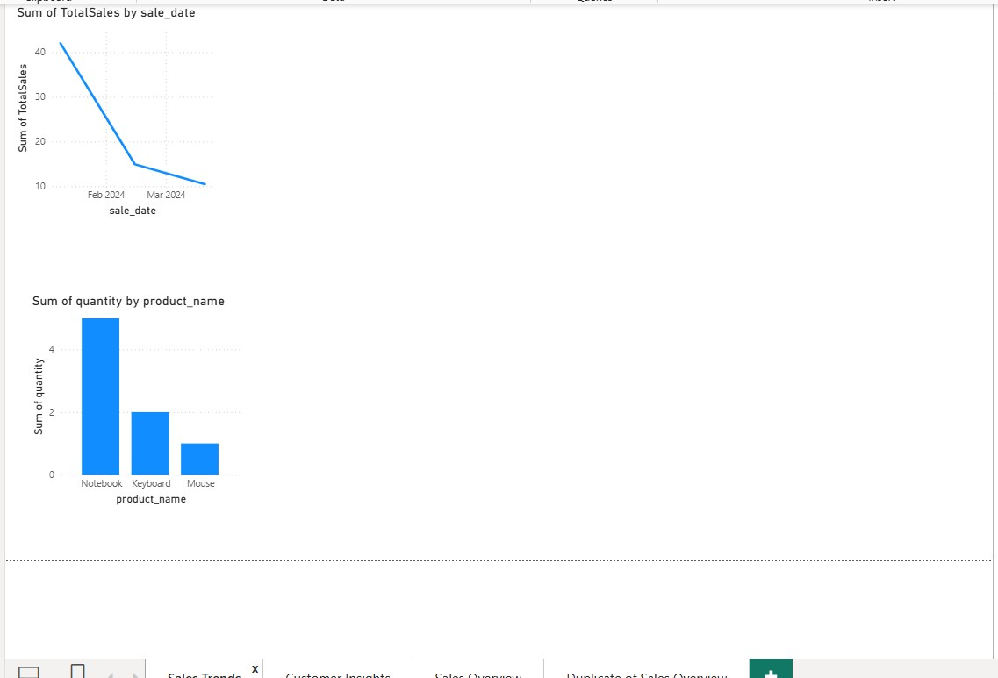

# Key Insights

* The product with the highest sales is displayed in the bar chart.
* Country-wise sales distribution highlights top-performing regions.
* Customer demographics indicate the dominant age groups driving sales.
* Sales trends help identify peak periods of customer purchases.

# Conclusion

This mini-project effectively showcases the integration of data engineering and visualization. It highlights practical use of SQL, Python, and Power BI to derive meaningful business insights from raw data. The final dashboard can support decision-makers in tracking sales, understanding customers, and optimizing product offerings.