**Problem Set – 01**

**Topic- Variables, input, output, operators**

1. Write a program to write the nth element and the sum of the n terms of the AP when the user inputs the required values.
2. Write a program to write the nth element and the sum of the n terms of the GP when the user inputs the required values.
3. Write a program to write the nth element and the sum of the n terms of the HP when the user inputs the required values.
4. Write a program to write the nth element of the AP from the end when the user inputs the required values.

**Topic- Control Statements**

1. Write a program to check where the given coordinates by the user lies on the 2D plane.
2. Write a program to check where the given coordinates by the user lies on the 3D plane.
3. Write a program to check whether the given parameters in the 2nd ordered equation is a circle or parabola or straight line or hyperbola or ellipse.

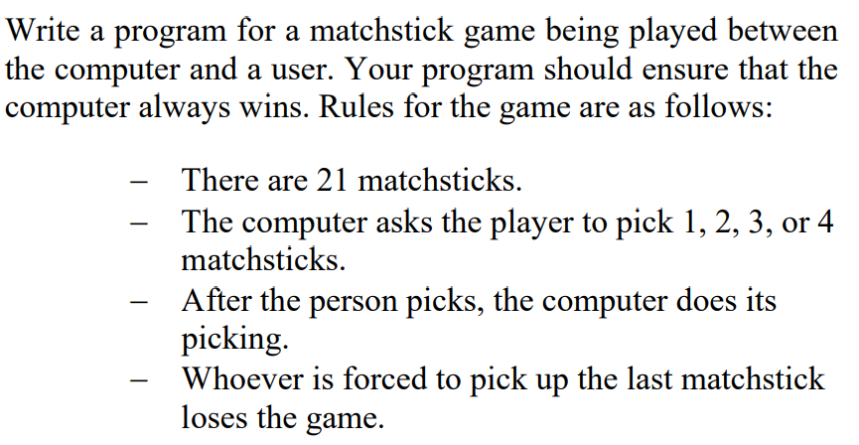

1. WAP to find the cofactor and minor of an element entered by the square matrix from user.
2. Find the inverse of a matrix.
3. Find the determinant of the user given matrix.
4. When the number is entered from the user find the 1’s complement and the 2’s complement of it.(full – adder ,half-adder , full-subtractor , half-subtractor).
5. When a decimal number is entered find the octal, binary, hexadecimal equivalents.
6. Create patterns using functions.
7. 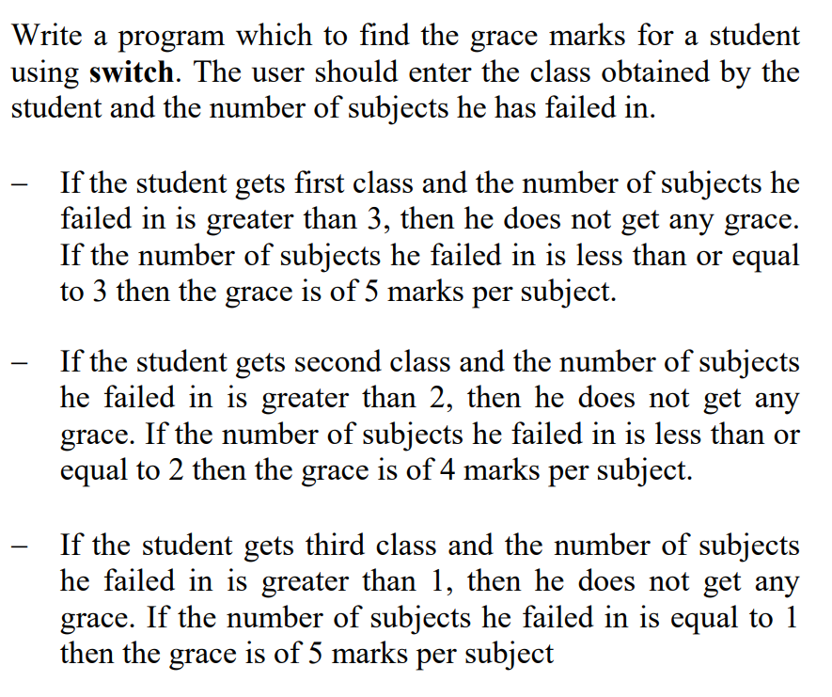
8. 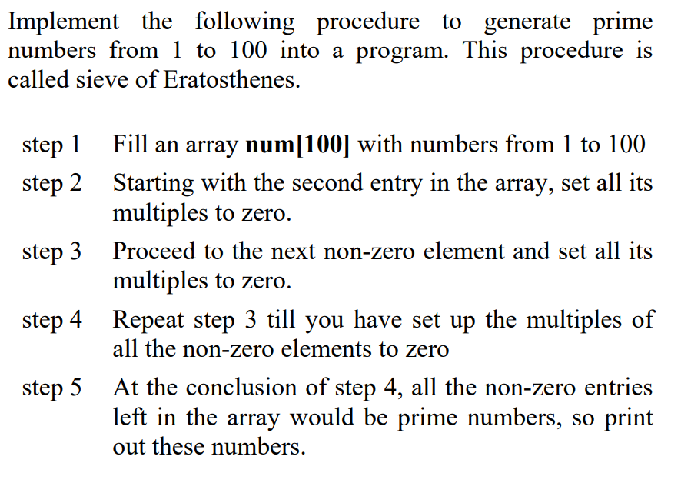

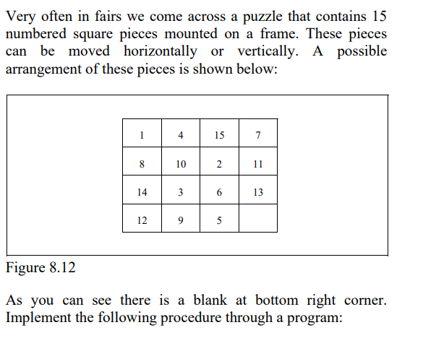

1. 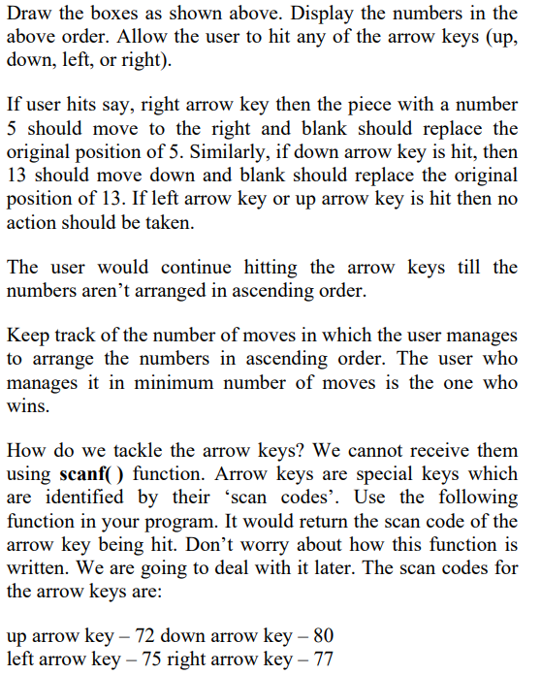
2. Write the programs for every statistics.