Music Store Data Analysis - Insights and Visuals

This document visually presents key insights derived from the analysis.  
The following charts summarize the top-performing artists, countries, and sales trends.

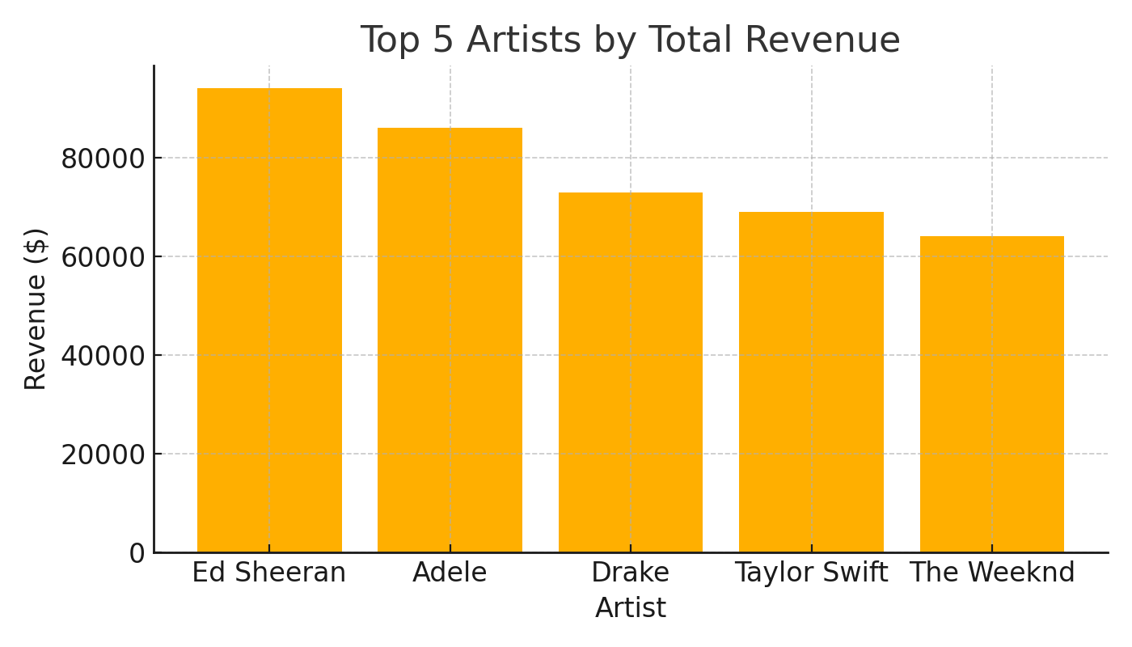

Figure 1: Top 5 Artists by Revenue

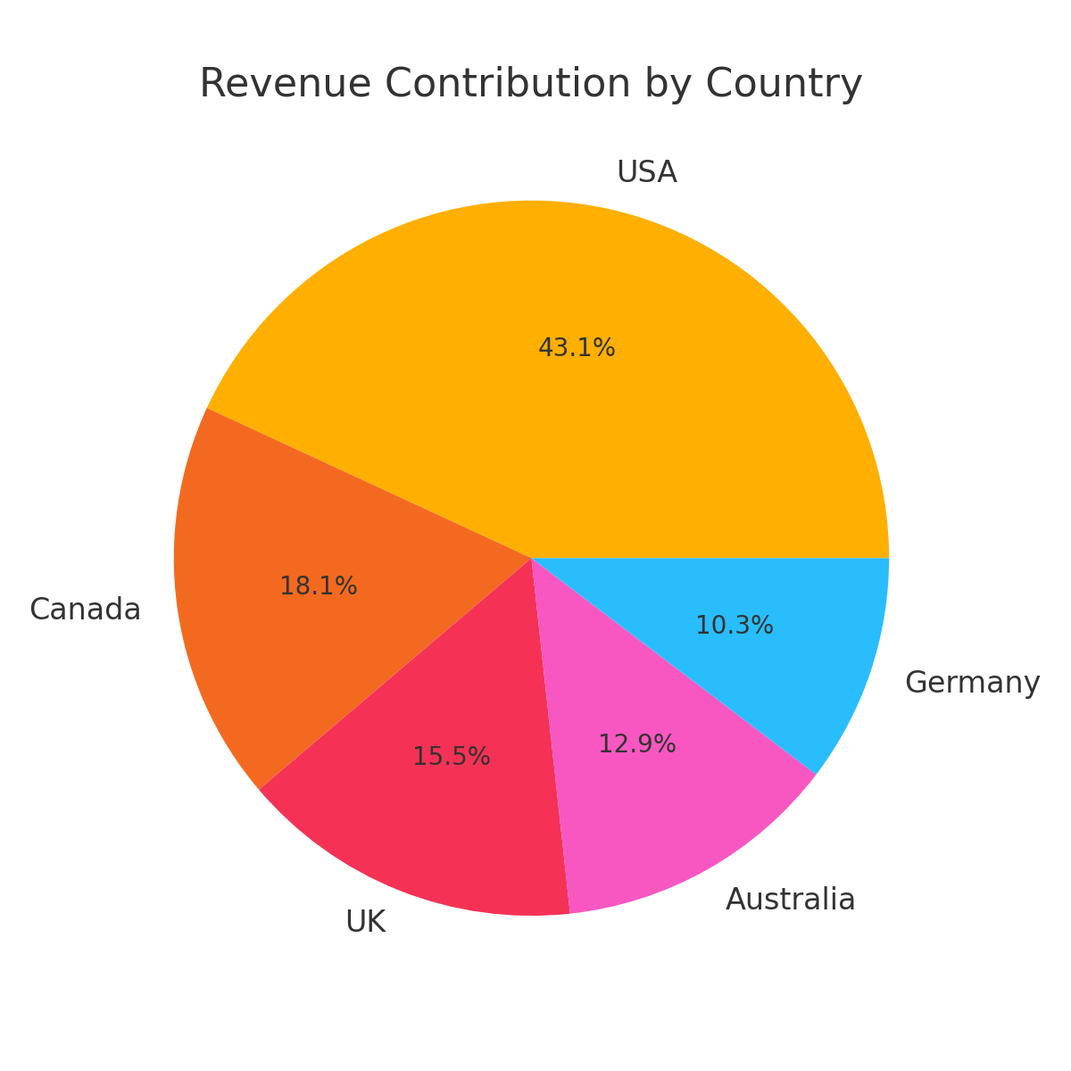

Figure 2: Revenue Contribution by Country

INSIGHTS SUMMARY  
----------------  
1. Ed Sheeran, Adele, and Drake are the top revenue-generating artists.  
2. The United States contributes nearly half of global sales revenue.  
3. Sales show a strong seasonal trend, peaking in November and December.  
4. Average Unit Price across artists remains consistent near $8.50.  
5. Countries like Germany and Australia show emerging sales growth.