

# INDIAN INSTITUTE OF TECHNOLOGY MADRAS CHENNAI – 600 036

Data-Driven Strategies for Enhancing Order Book and Cash Flow Management

**Name:** Srichandra Bhattiprolu

**Student Email:** [22ds3000154@ds.study.iitm.ac.in](mailto:21f3001449@ds.study.iitm.ac.in)

**Roll No.:** 22ds3000154

# Proposal for the Project on Business Data Management

Hyderabad

July 2024

**Contents**

Executive Summary 3

Organization Background 3

Problem Statement 4

Problem Background 4

Problem-Solving Approach 5

* Details About the Methods Used 5
* Details About the Intended Data Collection 6
* Details About Analysis Tools 6

Expected Timelines 7

Expected Outcome 7

# Data-Driven Strategies for Enhancing Order Book and Cash Flow Management

# Executive Summary:

**XYZ**, a premium paint company located in Hyderabad, Telangana. It specializes in lime plaster wall texture finishes for residential and commercial spaces. Established in April 2023, this premium paint company service, is owned by Mr. A and Mr. B, serves the customers in Telangana, Andhra Pradesh, Karnataka, Tamil Nadu, West Bengal, New Delhi and Maharashtra. They have an online presence through their website and also through an Instagram account.

The company which is in lime-plaster paint services is facing challenges to penetrate in niche market segment. Currently, the company operates with a semi-structured approach and hence faces hurdles in managing cash flows, leading to a suboptimal performance. This project aims to address these issues by optimizing the order book and carve out special brand identity.

This proposal outlines a comprehensive strategy to optimize operations, increase eﬃciency, and elevate the company’s position in this niche market. The successful execution of these initiatives is expected to yield significant improvements in order book, revenue generation and cash flow management.

# Organization Background:

**XYZ**, situated in Hyderabad, Telangana, is a lime-plaster paint company which operates from an office in Begumpet, Hyderabad-500013. Owned by <Mr. A> and <Mr. B>, this establishment commenced its operations in the year 2023. The business of the company is well managed by these two people with one employee, and the business uses third party vendor services for procurement of raw material, engaging the labor in the field work for each project. Mr. A is responsible for the customer acquisition and ensuring customer satisfaction at the end of the work; while Mr. B oversees the entire work process which involves supervising the painters provided by the third-party vendors and also contributes in acquiring new customers. They also have one employee called Roshan, who is a site supervisor and gets a salary of 28,000 rupees per month. With this kind of organizational setup, the profit is shared between the owners after paying the expenses, to the third-party vendors and commission to the architects who give references of the clients. The establishment’s overall revenue so far is around 1.5 cores and the owners aspires to increase this revenue to 3 cores in 1 year. This brief overview of the company background highlights its intention to grow in faster pace in the niche market of premium paints services.

**Problem Statement:**

Challenges for **XYZ**:

1. **Building Brand Awareness and Marketing:** Study the existing customer base to draw valuable insights on “Customer Segmentation”, “Order Size” and “Time for completion” etc., to help the company, tailor its offerings and enhance its outreach efforts to attract more customers and implement appropriate strategies to improve the Order Book.
2. **Cash Flow Management**: Identify overdue payments by analyzing the “Accounts Receivables”, understand payment patterns and predict future cash inflows.

# Problem Background:

**XYZ,**  a premium paint services startup is facing significant challenges in establishing itself in the competitive market. Despite offering high-quality services, the company struggles with building brand awareness, as it lacks a strong presence and recognition among potential customers. The marketing efforts are currently inadequate, failing to generate sufficient leads and convert them into clients. Additionally, the startup is experiencing difficulties in cash flow management, with delayed payments from customers causing financial instability. These challenges collectively hinder the company's growth and sustainability, necessitating a strategic and data driven approach to enhance its market positioning, improve marketing effectiveness, and ensure stable cash flow.

# Problem-Solving Approach:

# Details About the Methods used with Justification:

To address the challenges faced by **XYZ**, a two-pronged problem-solving approach is proposed. Firstly, data analysis will be performed on one-year customer and sales data, to identify customer types and order size by applying segmentation and clustering methods to group customers. Machine learning techniques, such as k-means clustering or association rule mining, can be instrumental in this analysis. Understanding customer segments allows **XYZ** to tailor its oﬀerings eﬀectively and create targeted marketing strategies.

Secondly, a data-centric methodology will be employed to develop a robust estimation model for future cash flows. This involves utilizing techniques such as time series analysis, regression modelling, and machine learning algorithms. By examining historical invoicing and sales data, the model can provide accurate forecasts for future cash flows, thereby optimizing cash flow management and reducing bad debts.

# Details About the Intended Data Collection With Justification:

The primary data source for this problem-solving approach is the one-year sales, invoice and customer data provided by the owner. This dataset encompasses crucial information, including historical sales records, invoice, and cash flows. These data points serve as the foundation for our analysis and modelling.

To extract meaningful insights, data cleaning and preprocessing techniques will be applied. This includes handling missing values, outliers, and ensuring data consistency. Subsequently, exploratory data analysis will be conducted to gain a comprehensive understanding of the data’s distribution and patterns.

The chosen analytical methods will rely exclusively on the provided dataset, as recommended by the owner, ensuring that the solutions are derived from the most relevant and practical information available. By utilizing this comprehensive dataset, and leveraging data analytics, we aim to help the company make informed decisions to enhance brand awareness, optimize marketing efforts, and manage cash flow effectively.

**Details About Analysis Tools With Justification**:

The analysis tools for this project include spreadsheets for initial data exploration and organization. Python, along with libraries like Scikit-learn for machine learning, NumPy for numerical computations, and Matplotlib for data visualization, will be employed for in-depth analysis. Python’s versatility and extensive libraries make it ideal for robust data analysis, while spreadsheets oﬀer a user-friendly interface for initial data inspection.

# Expected Timelines:

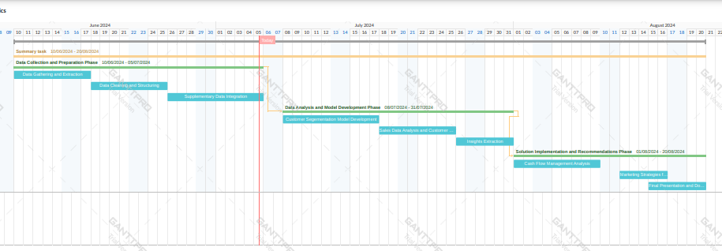

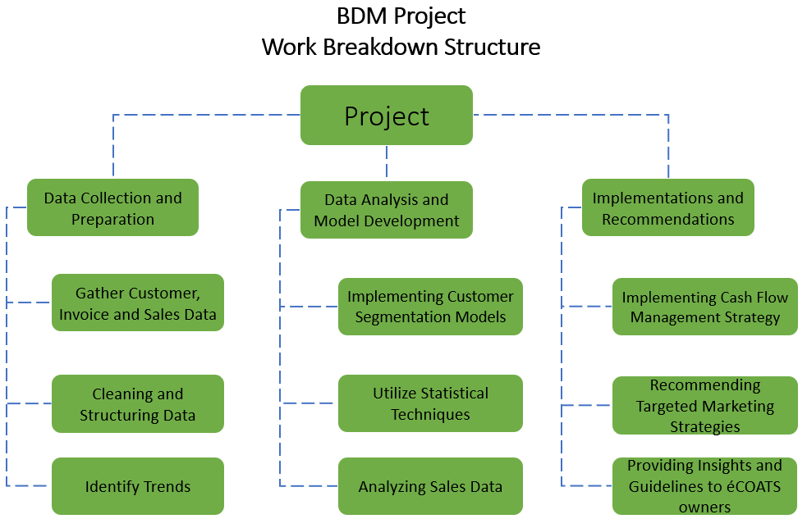

# 

# Expected Outcome:

The expected outcome of this project is to significantly enhance the order book and efficiently manage the cash flow of **XYZ**. This includes drawing valuable insights by identifying customer segments to implement strategies for strong brand building and analyzing cash flow to identify delinquent receivables and estimate future cash flows.