Course Login Page in LMS: Click Login button to logged in your account
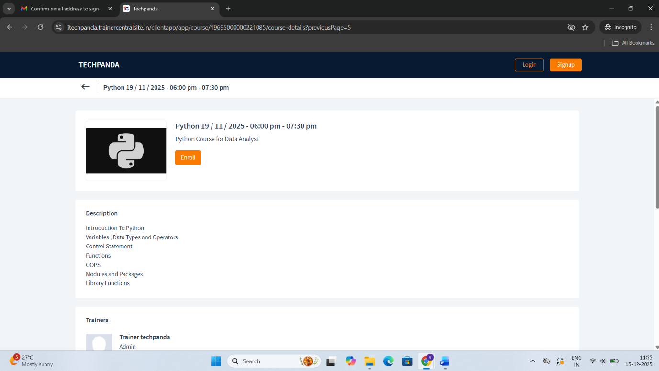

Give your E-mail ID of your account
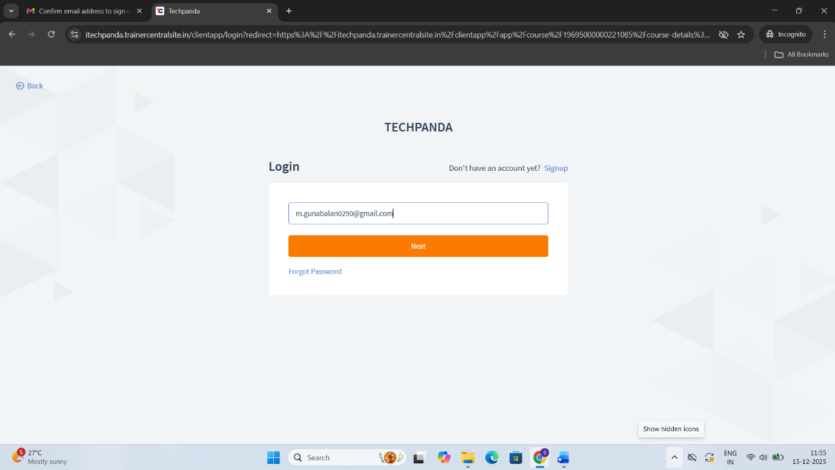

Give the password of your account
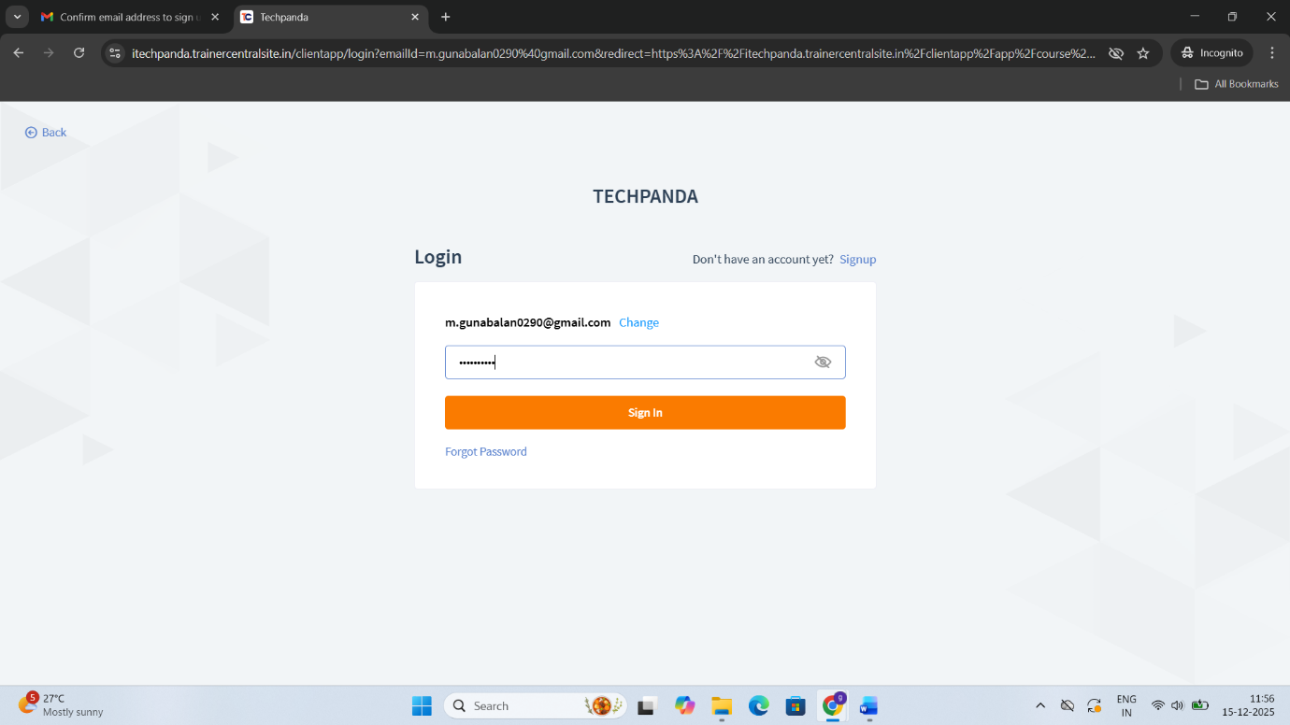

Click Send OTP button to get the OTP in E-mail
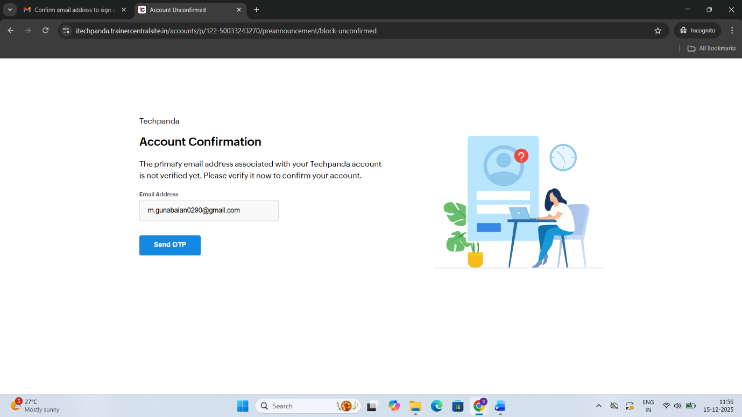

Get the OTP from your E-mail and Type the OTP for Verification
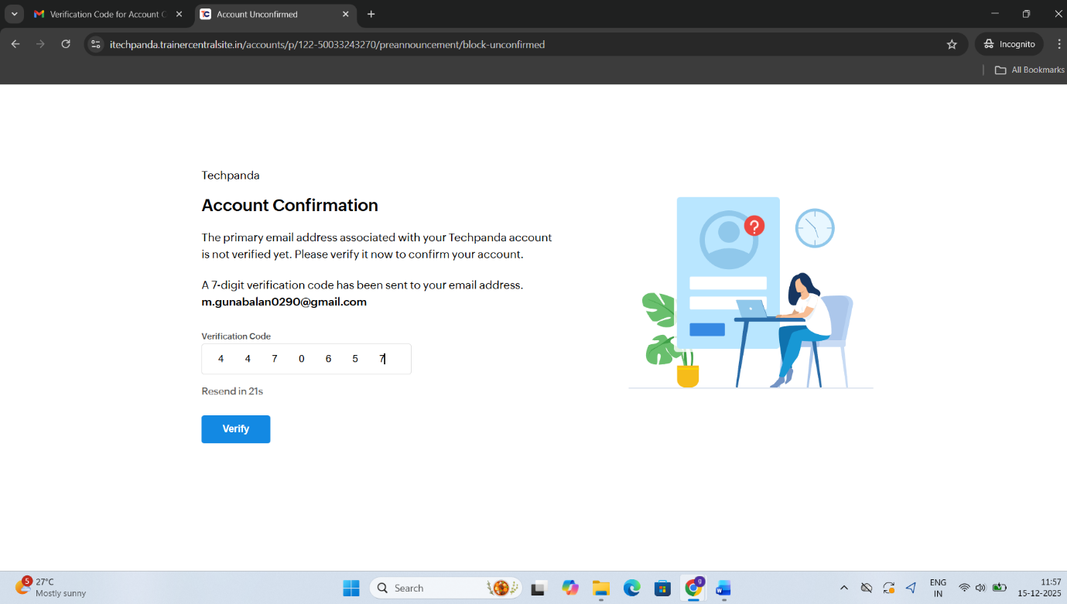

Configure the MFA for High Security
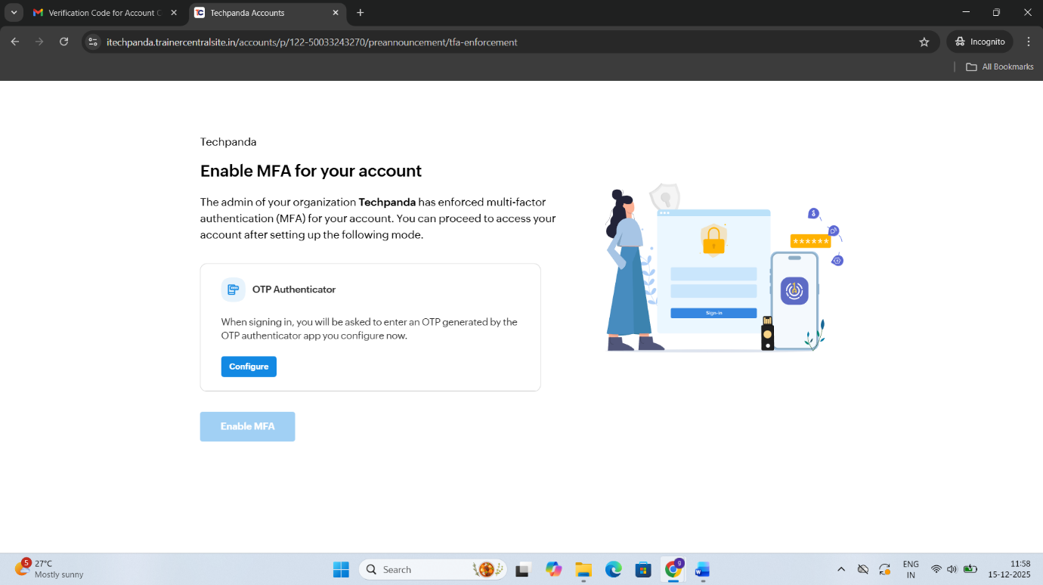

Install Google Authenticator and scan below QR
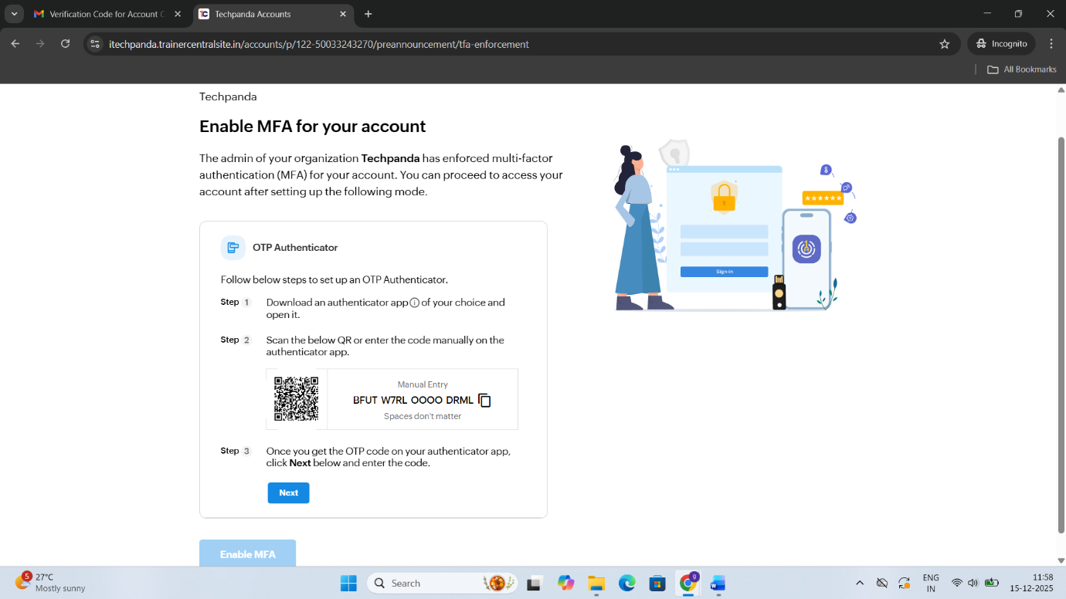

Get that OTP from the Google Authenticator and put the OTP
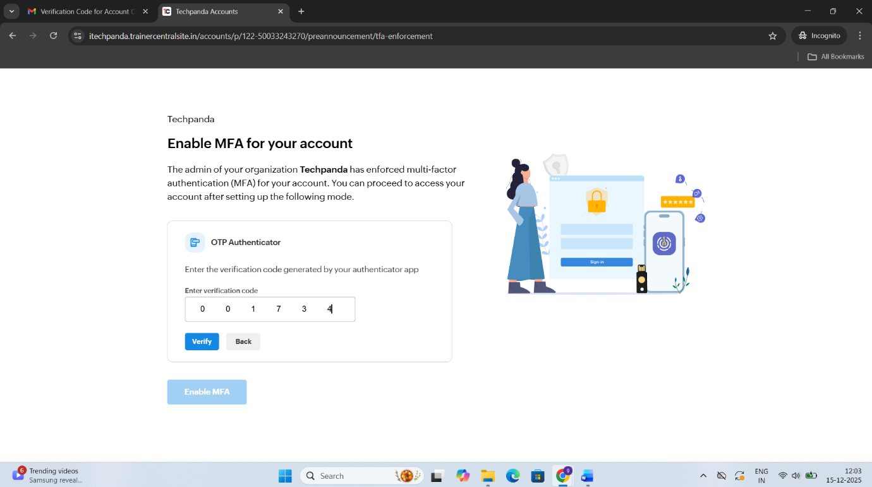

Click Enable MFA button to enable MFA security
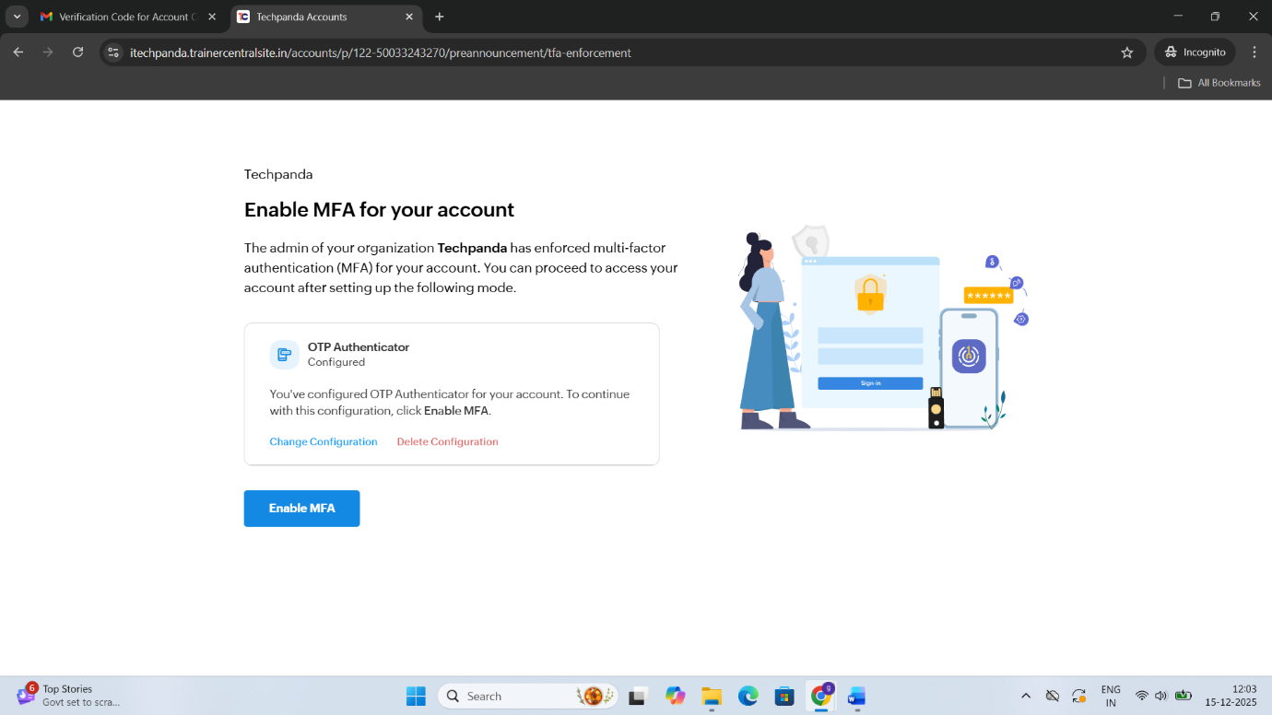

Generate Backup Codes after finish the MFA configuration
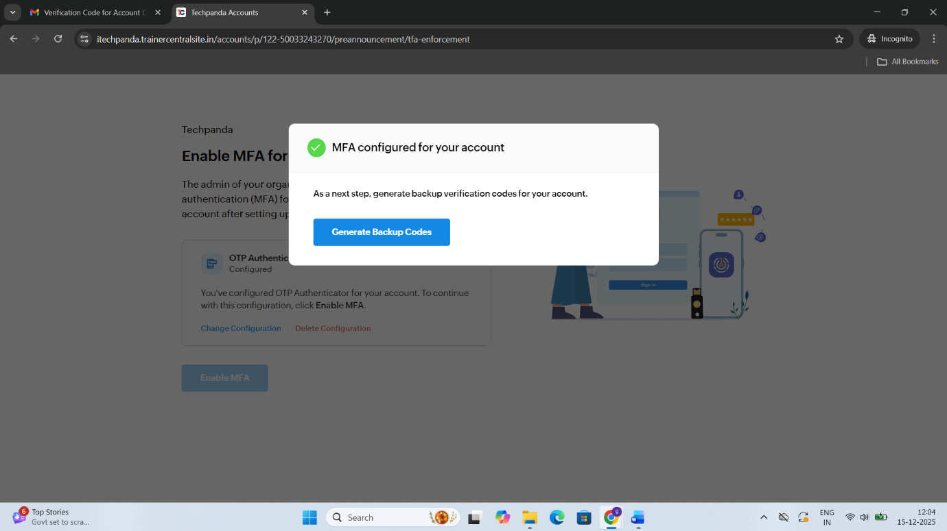

To view the Backup verification codes
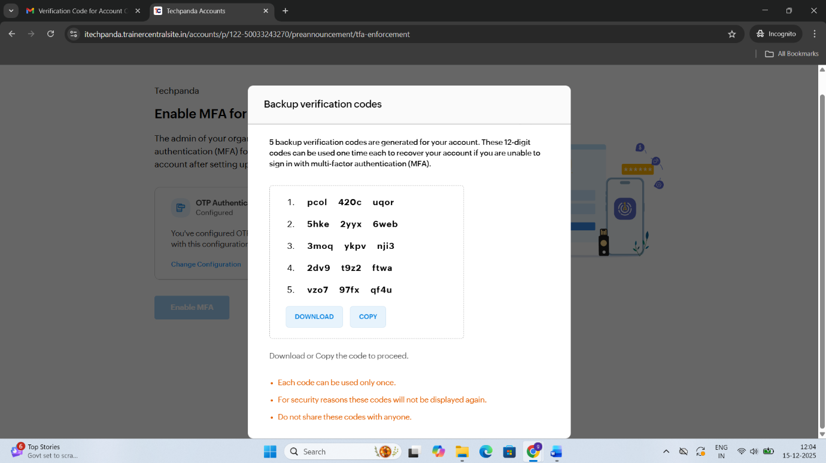

Click Continue to Sign In to logged-in your account
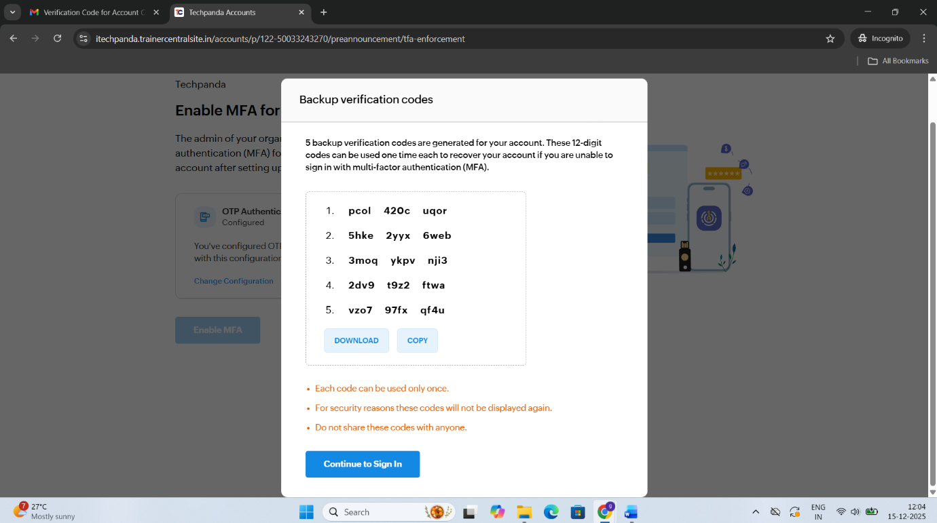

Click Enroll button to start the course enrollment in LMS
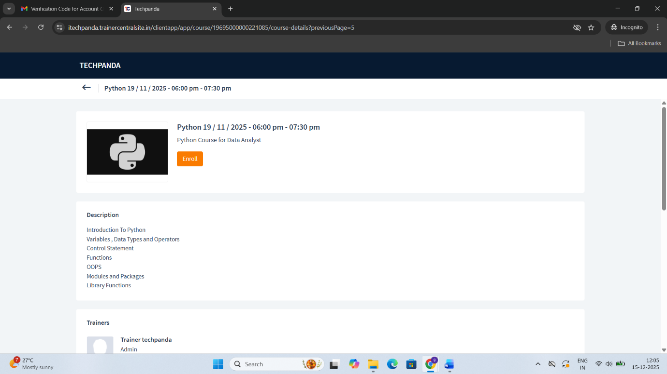

Skip this page and Click Continue button to go next page
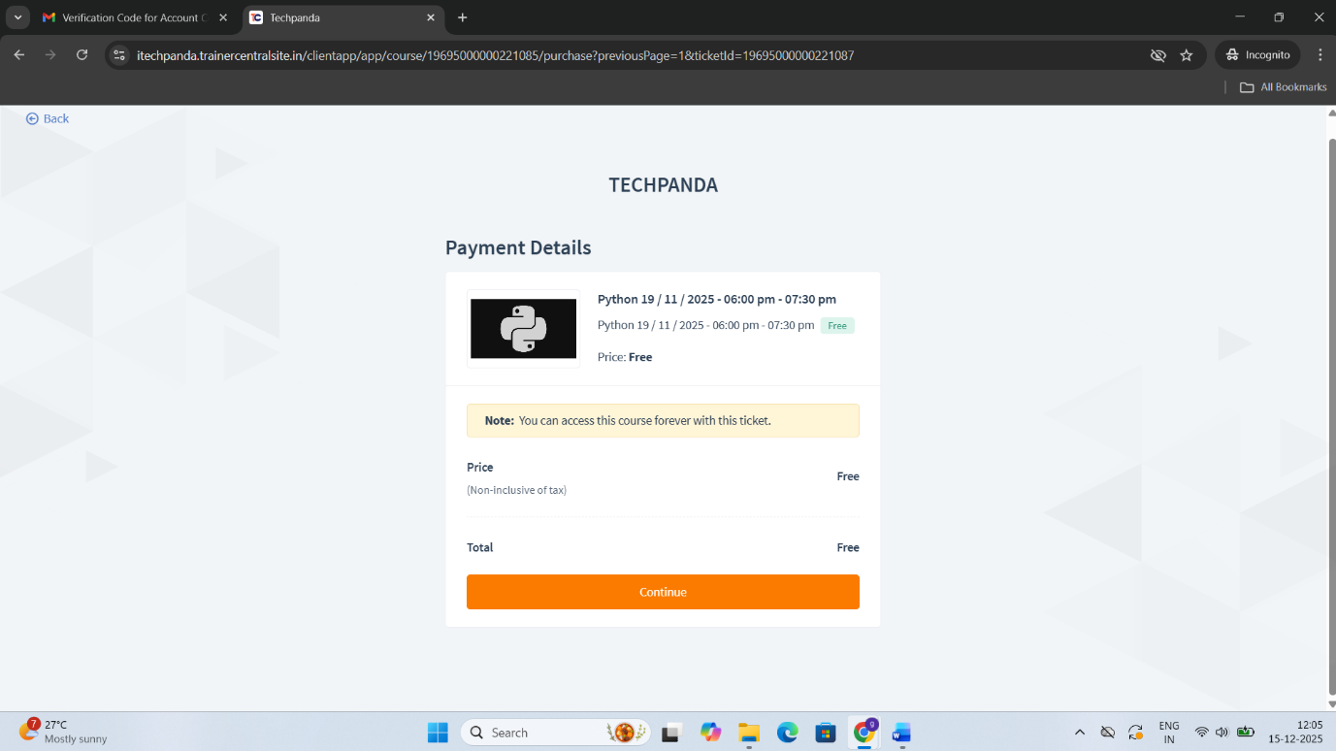

Enrollment have been done Successfully then click Proceed to the course button to enter
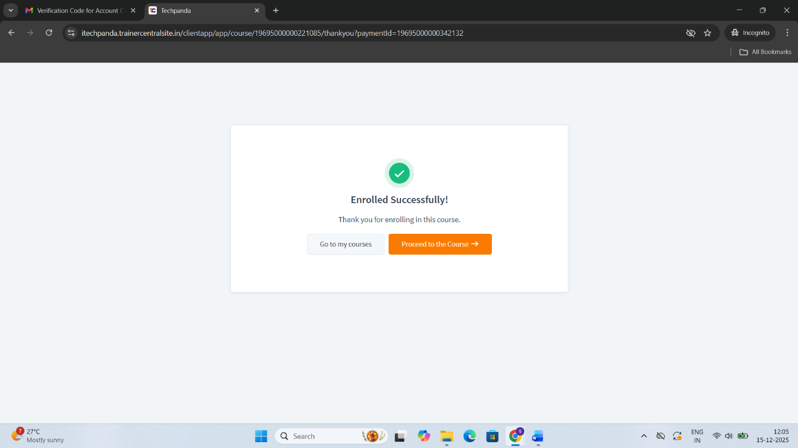

Click Next button to go to get the notes, test & assignment
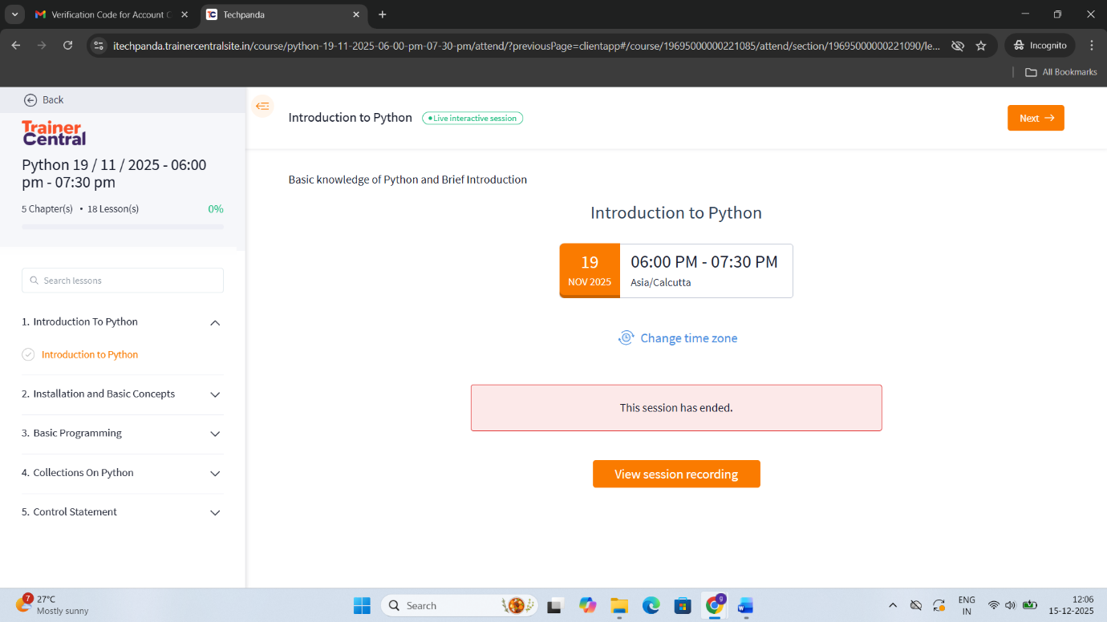

Click Complete & Continue to go next page
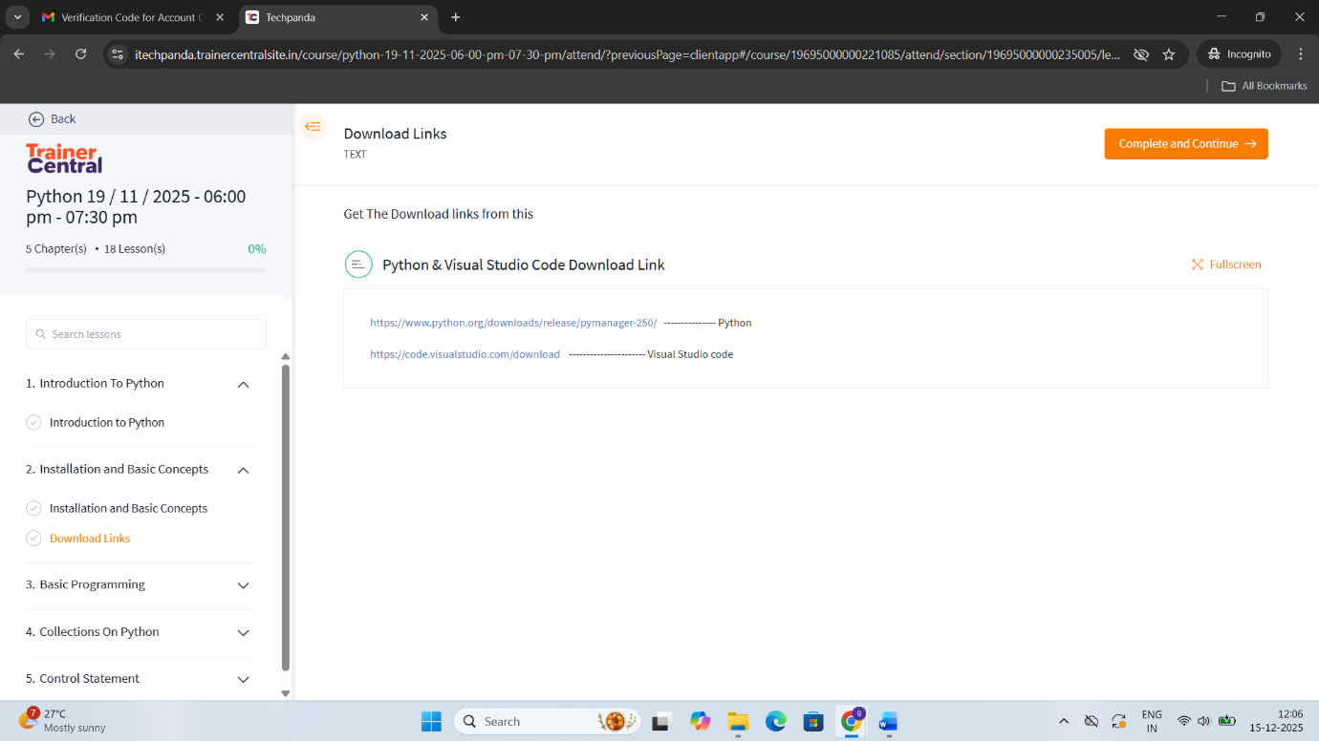

In this page for assignment has been viewed and Click Start Assignment button to Start
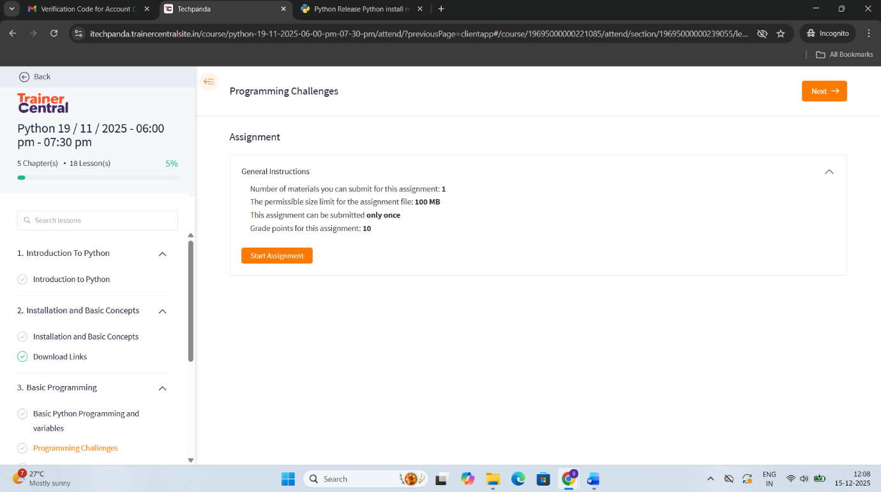

Again, Click Start Assignment to Start
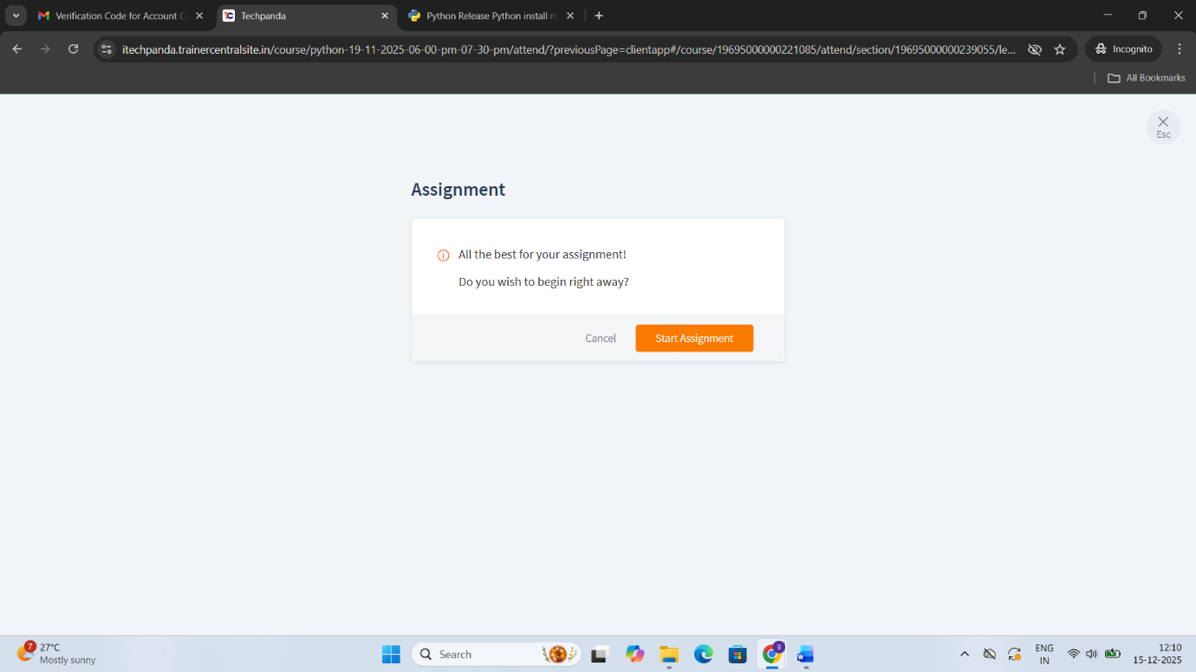

Get the instruction and get assignment
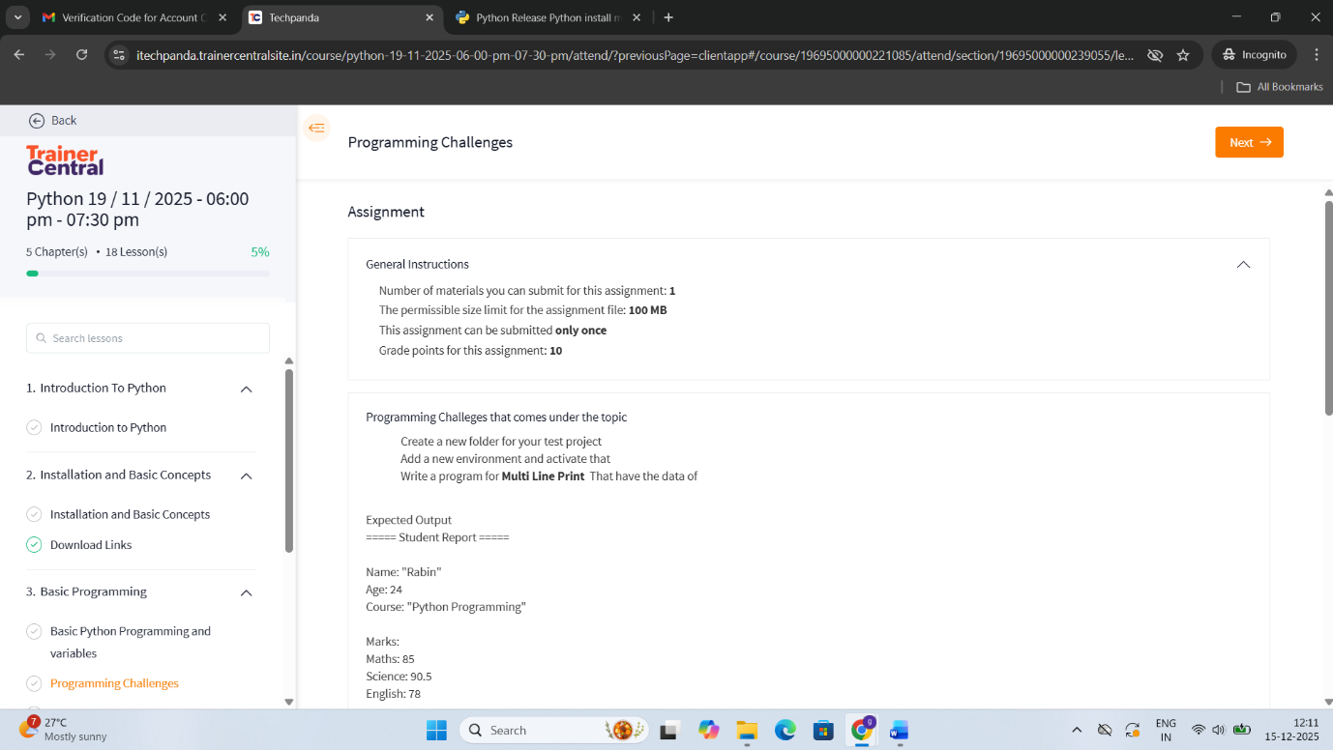

Finally, Upload the assignment and Click Submit Assignment button to submit your assignment
