insert the following documents into a movies collection.

title : Fight Club

writer : Chuck Palahniuk

year : 1999

actors : [

Brad Pitt

Edward Norton

]

title : Pulp Fiction

writer : Quentin Tarantino

year : 1994

actors : [

John Travolta

Uma Thurman

]

title : Inglorious Basterds

writer : Quentin Tarantino

year : 2009

actors : [

Brad Pitt

Diane Kruger

Eli Roth

]

title : The Hobbit: An Unexpected Journey

writer : J.R.R. Tolkein

year : 2012

franchise : The Hobbit

title : The Hobbit: The Desolation of Smaug

writer : J.R.R. Tolkein

year : 2013

franchise : The Hobbit

title : The Hobbit: The Battle of the Five Armies

writer : J.R.R. Tolkein

year : 2012

franchise : The Hobbit

synopsis : Bilbo and Company are forced to engage in a war against an array of combatants and keep the Lonely Mountain from falling into the hands of a rising darkness.

1. get all documents

Query: db.movies.find().pretty()

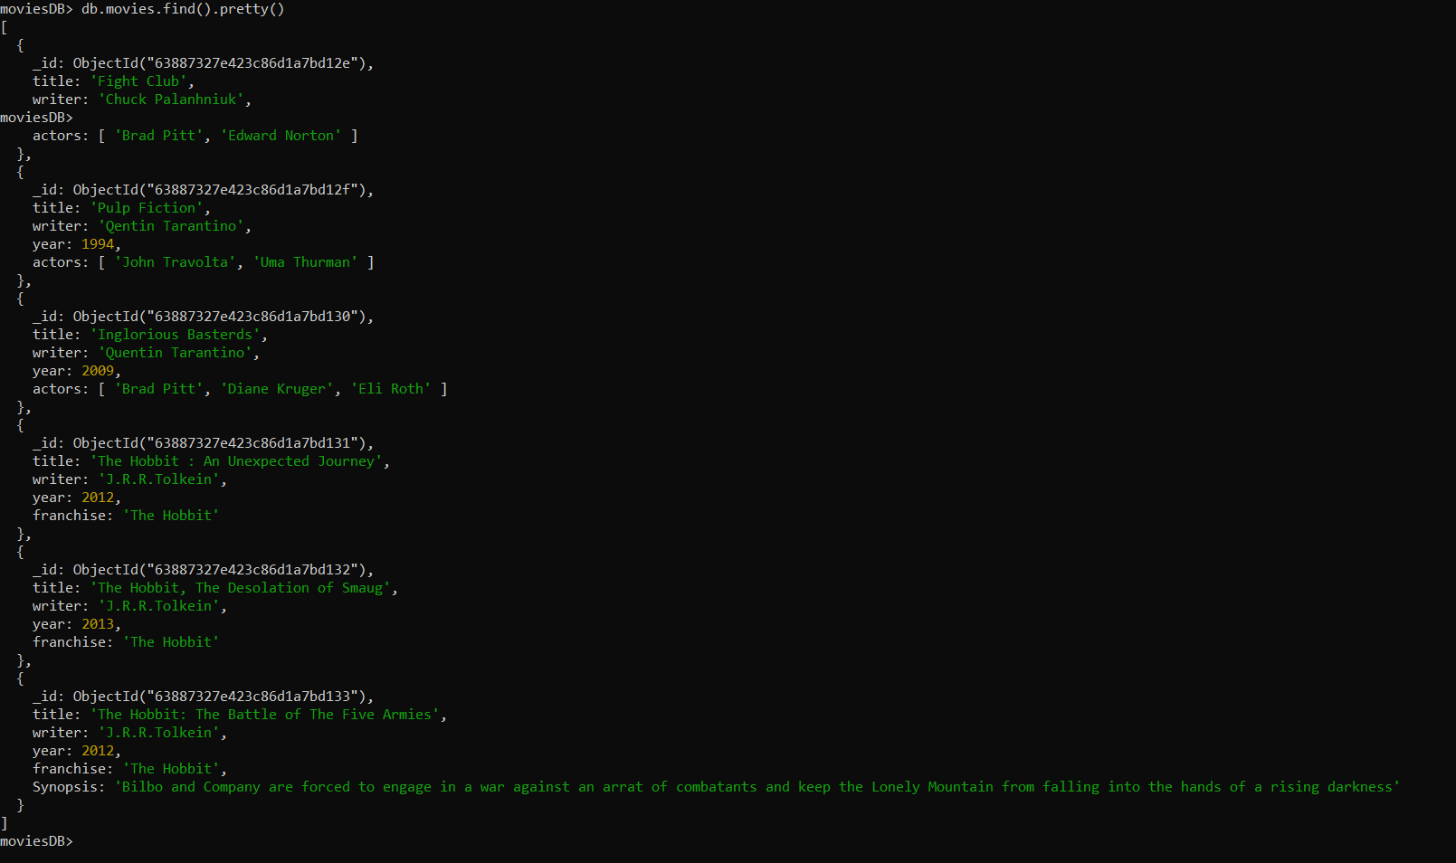

1. get all documents with writer set to "Quentin Tarantino"

Query: db.movies.find({writer:{$eq: “Quentin Tarantino”}})

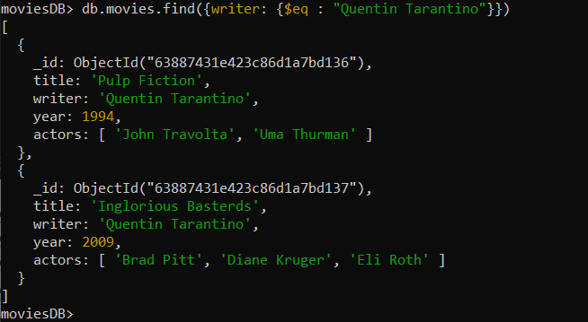

1. get all documents where actors include "Brad Pitt"

Query: db.movies.find({actors:{$in : [“Brad Pitt”}})

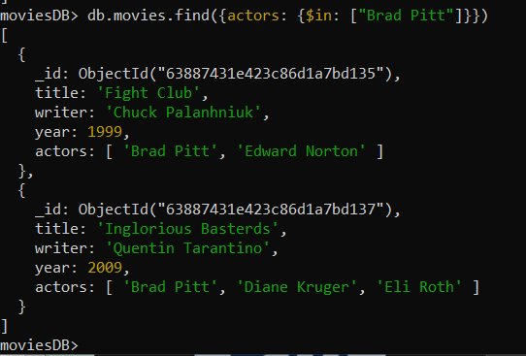

1. get all documents with franchise set to "The Hobbit"

Query: db.movies.find({franchise:{$eq: “The Hobbit”}})

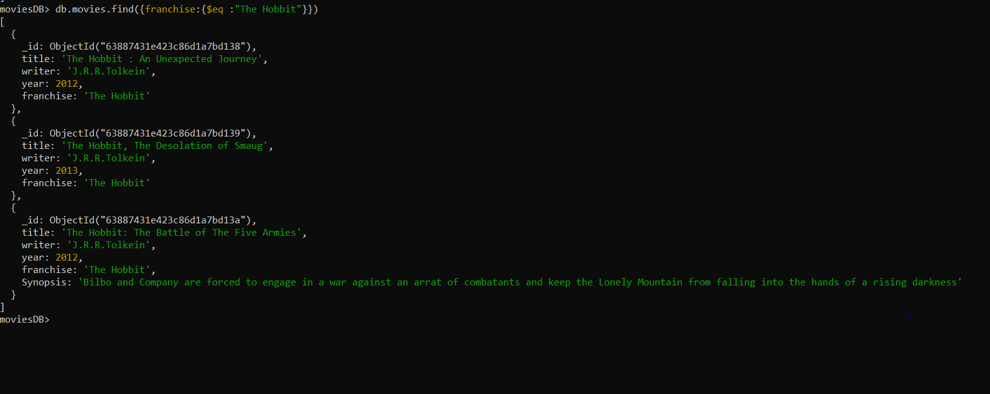

1. get all movies released in the 90s

Query: db.movies.find({year:{$lt:2000}})

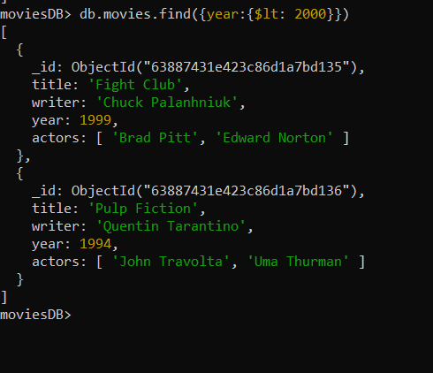

1. get all movies released before the year 2000 or after 2010

Query:db.movies.fid({$or:[{year:{$lt:2000}},{year:{$gt:2010}}]})

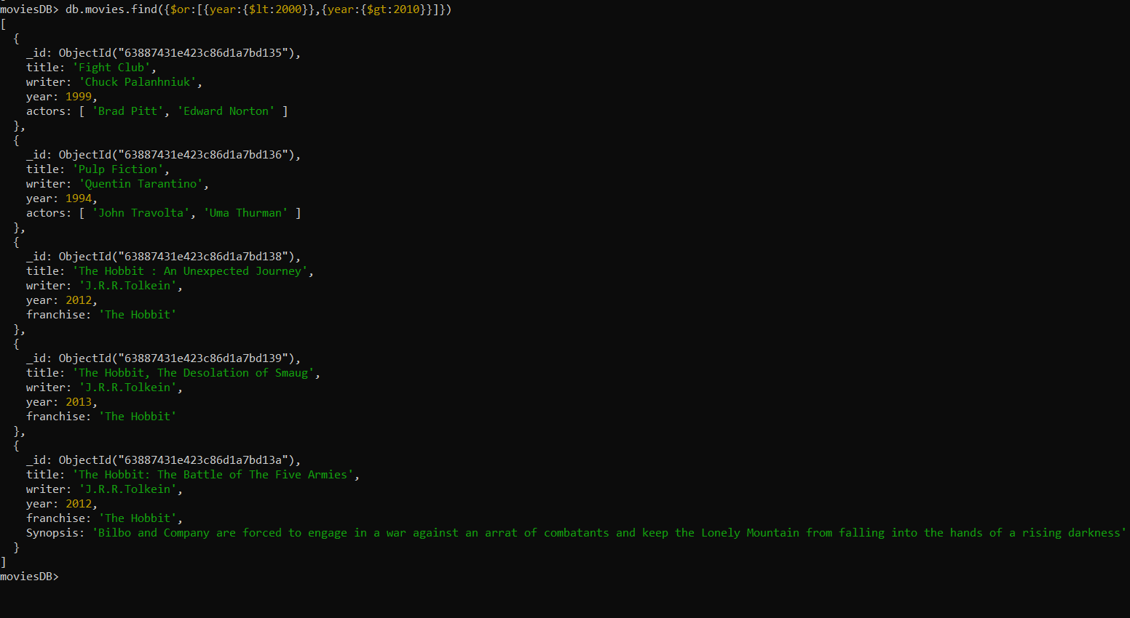

1. count the number of writer from the movie collection

Query:db.movies.distinct(“writer”).length

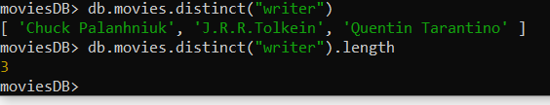

1. update an actor named "Samuel L. Jackson" to the movie "Pulp Fiction"

Query:db.movies.updateMany({title:”Pulp Fiction”},{$push:{“actors”:”Samuel L.Jackson”}})

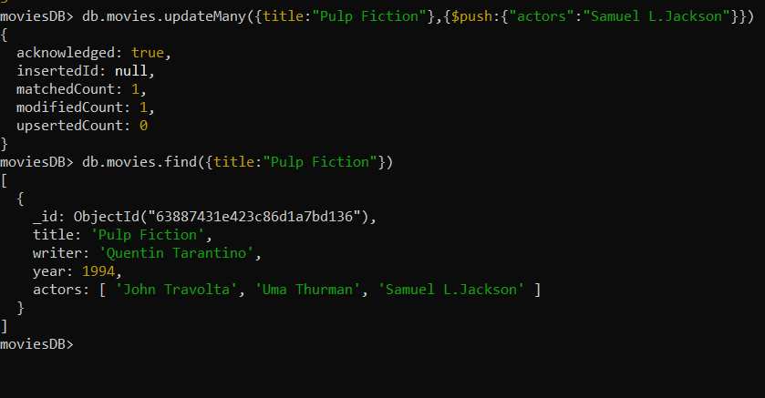

1. find all movies that have a synopsis that contains the word "Gandalf"

Query: db.movies.find({$text:{$search:”Gandalf”}})

Here, before using text search we need to create textIndex on the fields

Using db.movies.createIndex({“Synopsis”:”text”})

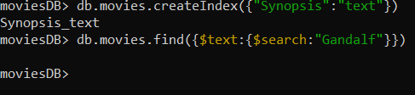

1. display the movie collection based on year in descending order.

Query:db.movies.find().sort({“year”:-1})

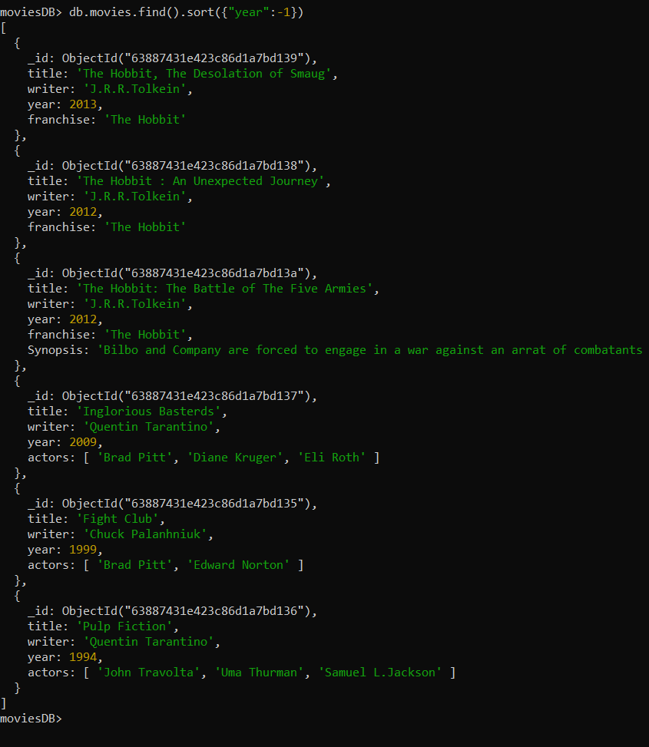

1. Display last two recent movie .

Query:db.movies.find().limit(2).sort({“year”:-1})

