Multilingual Story Generation & Speech System
In propose work we are designing AI and NLP based story generator where user can input desired keywords and then AI transformer algorithm will apply NLP (natural language API) to clean keywords and then generate precise story based on given keywords.
User can generate story in English, Telugu or Hindi Language and can make select to speech generated story in selected language.
To implement this project we have designed following modules
- User Login: user can login to system
- Generate Story: using this module user can enter desired keywords and then select desired language and speech mode to generate and speech story in desired language.
- NLP & AI algorithm: given keywords will be input to Transformer AI algorithm to clean keywords and then generate precise story based on keywords.
SCREEN SHOTS
To run project install python 3.7.2 and then install all packages given in requirements.txt file and then double click on ‘run.bat’ file to start python webserver and get below page
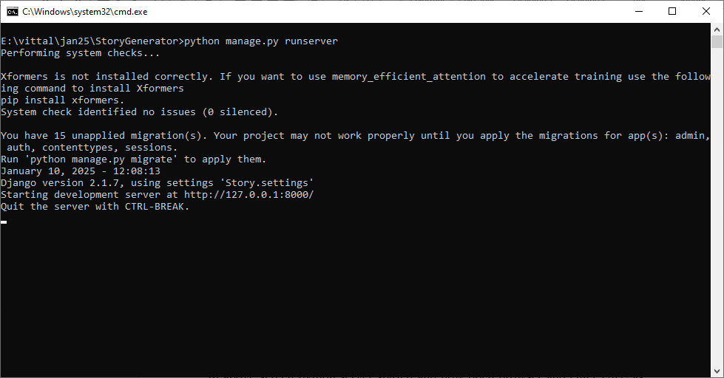
In above screen python server started and now open browser and enter URL as http://127.0.0.1:8000/index.html and then press enter key to get below page
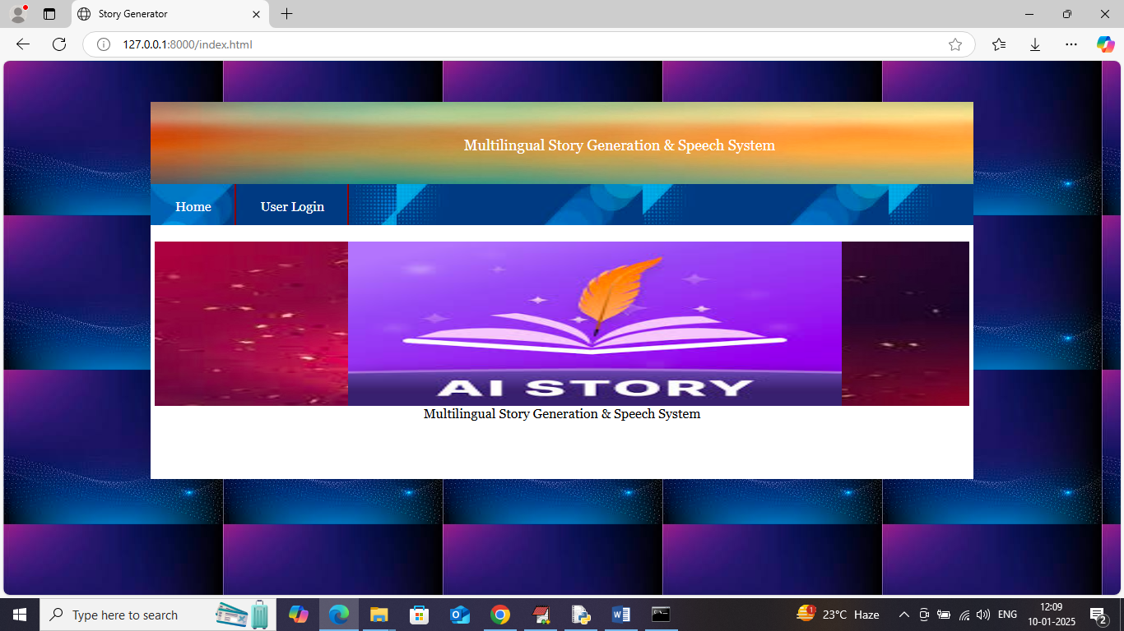
In above screen click on ‘User Login’ link to get below page
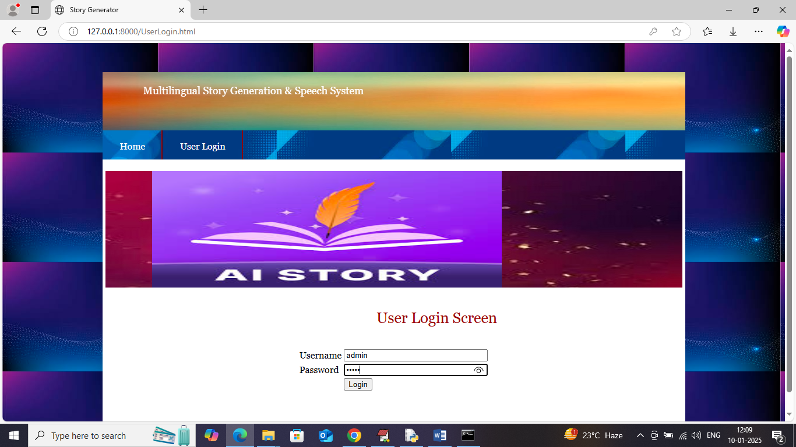
In above screen user is login by entering username and password as ‘admin and admin’ and then press button to get below page
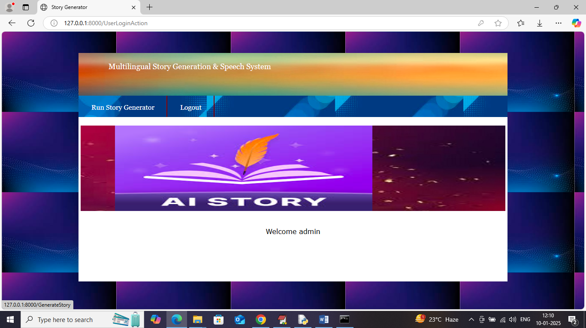
In above screen click on ‘Story Generator’ link to get below page
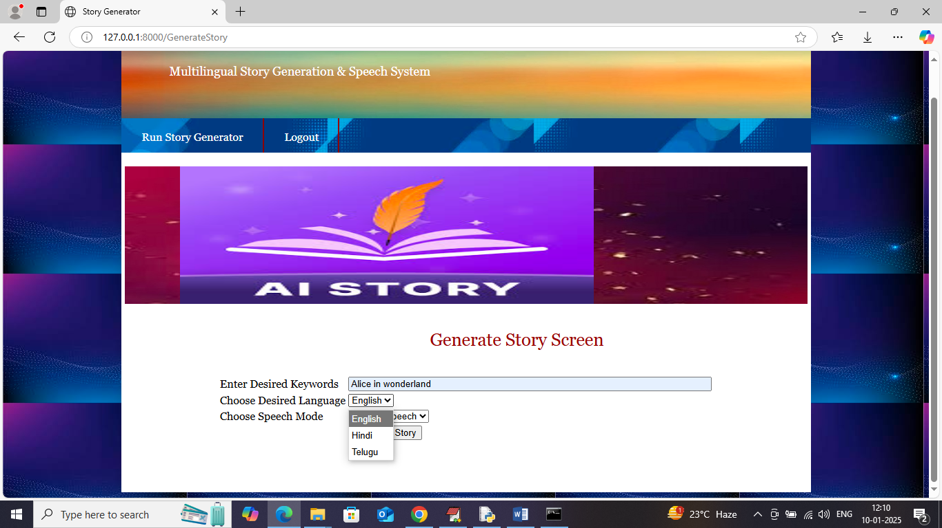
In above screen I entered some keywords as ‘Alice in wonderland’ and then select desired language and then choose speech option like below page
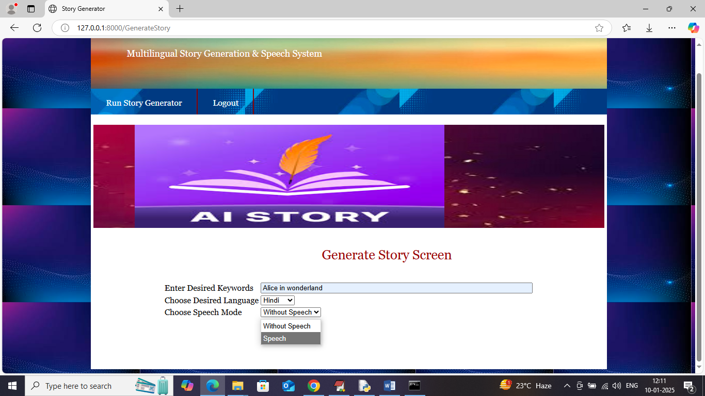
In above screen I selected language as ‘Hindi’ along with speech mode and then press button to get below page
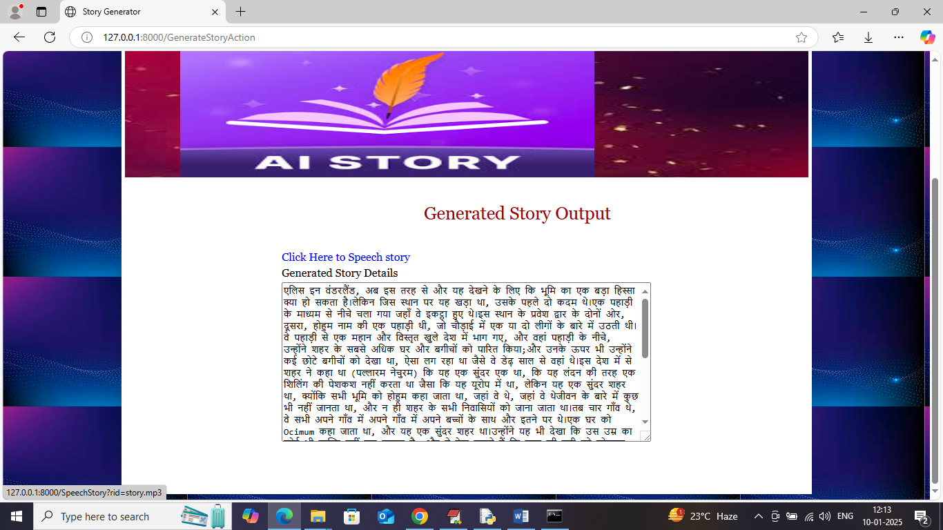
In above screen in text area can see generated story and can click on blue text ‘Click Here to speech story’ to start playing story and now try another language
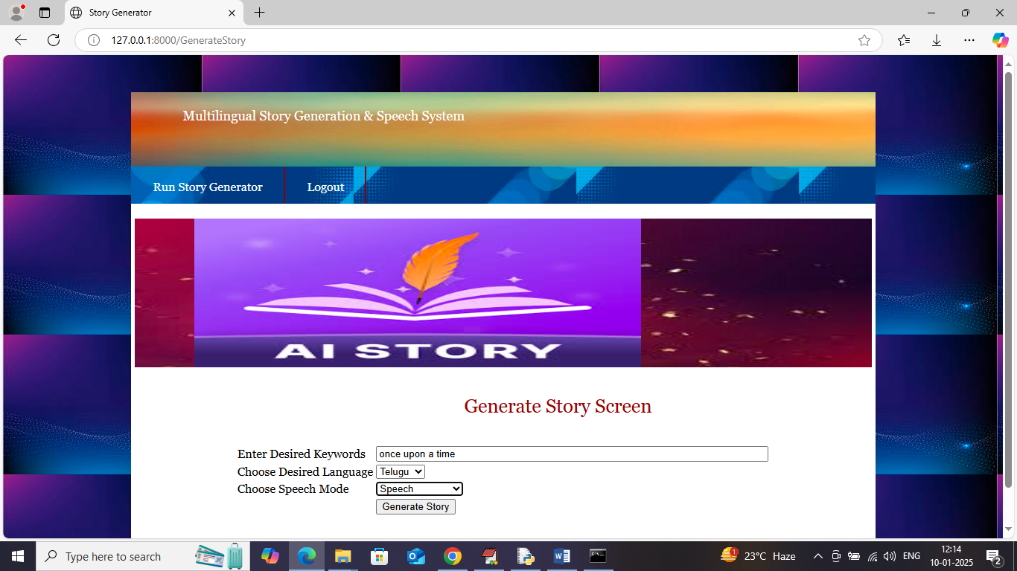
In above screen I gave some other keywords along with speech and Telugu language and below is the output
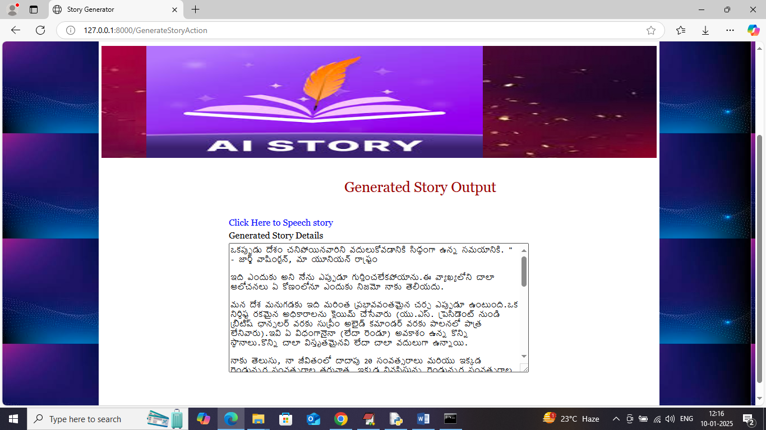
In above screen in text area can see story generated in Telugu and can click on ‘Blue colour text” to play story and now click generate story in English
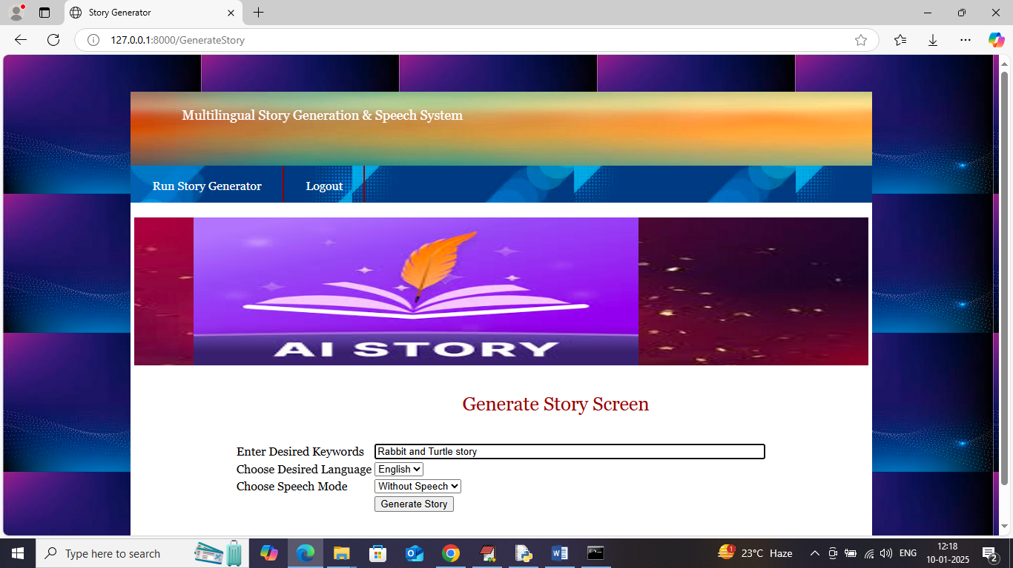
In above screen asking to generate story on ‘Rabbit and Turtle’ in English language without speech and below is the output
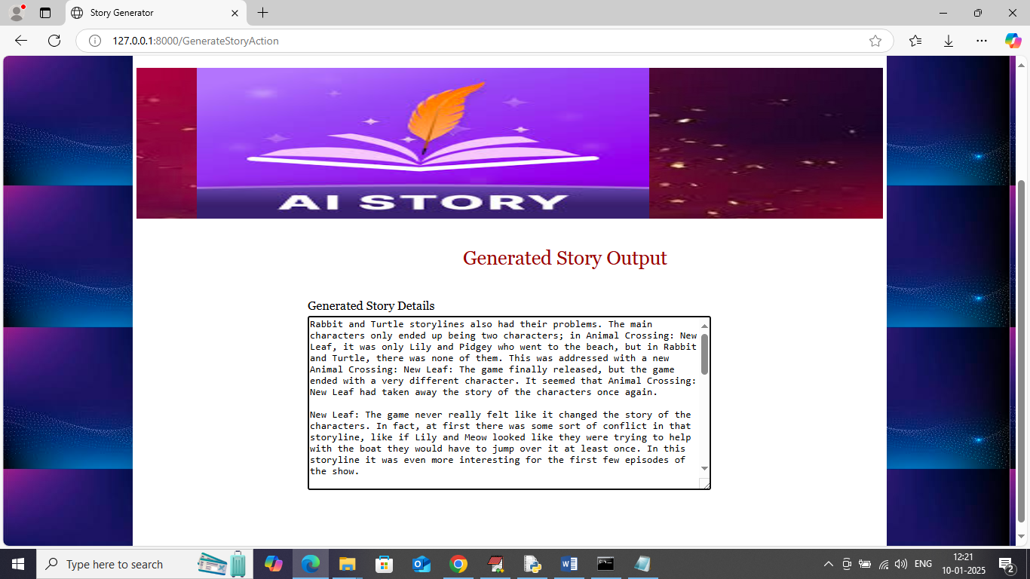
In above screen story generated on rabbit and turtle. Similarly enter any keywords and then generate story in desired language by following above screens

